
YEAR 9 Summer 2 WIDER READING LISTS

Students are encouraged to develop a wider understanding of the topics they will learn this half term. All texts listed are aspirational: you are not required by the school to buy any of these for your subjects.

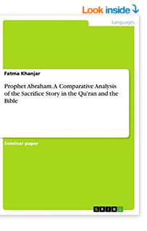
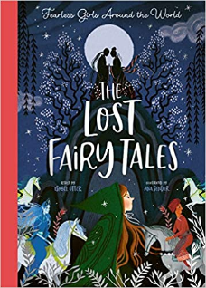

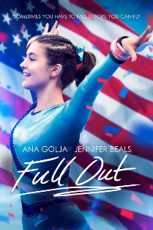
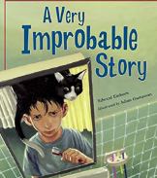
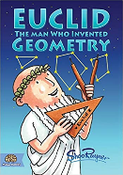
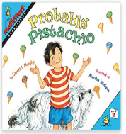

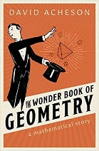
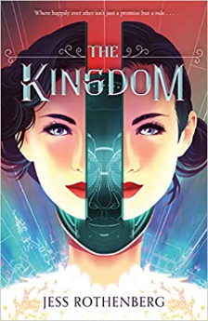



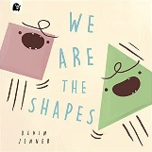
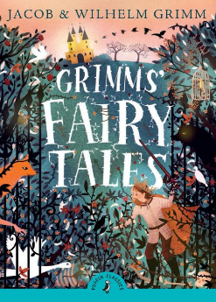

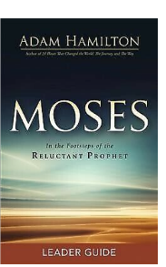
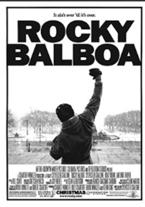
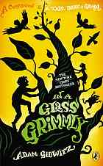
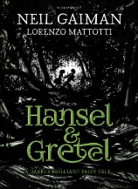
SUBJECT | THIS HALF TERM, STUDENT'S WILL BE WORKING ON… | READING MATERIAL
Art and Design | African Masks | African Tribal Artist - https://www.artyfactory.com/africanmasks/information/african-mask-artists.htm  Impact Of African Art In Modern Art Movement - https://www.artdex.com/historical-influence-of-african-art-in-the-modern-art-movement/  Pablo Picasso - https://www.pablopicasso.org/africanperiod.jsp  Jimoh Buraimoh - https://dawncommission.org/jimoh-buraimoh/  Baule African Tribal Mask - https://www.africanodyssey.co.uk/african-baule-tribal-mask-detail  African Masks - Bwa Mask - https://www.artyfactory.com/africanmasks/masks/bwa.htm
Computer Science |  | (Great coding and making magazine, pdf issues are free on a variety of topics for many ages)  https://hackspace.raspberrypi.com/issues  Search & sort Algorithms  https://www.bbc.co.uk/bitesize/guides/zpp49j6/revision/1  https://www.advanced-ict.info/theory/NC/index.html#programming  Future Technologies  https://idea.org.uk/
Design Technology
Drama
English
Geography | Geography of health | - http://thebritishgeographer.weebly.com/geography-of-health.html  - https://www.rcseng.ac.uk/library-and-publications/library/blog/mapping-disease-john-snow-and-cholera/  - https://www.youtube.com/watch?v=DaHTOFphlMY
History |  | Did the Atom Bomb really change everything?  - The Cold War – John Lewis Gaddis  - Animal Farm by George Orwell  - 1984 – George Orwell  - The Wall - Peter Sís  - Forty Autumns: A Family's Story of Courage and Survival on Both Sides of the Berlin Wall - Nina Willner  - Fallout: Spies, Superbombs and the Ultimate Cold War Showdown  - London Match - Len Deighton  - The Boy on the Bridge - Natalie Standiford  - The Cuban Missile Crisis – BBC Bitesize (https://www.bbc.co.uk/bitesize/topics/z8k9q6f/articles/zvrvf82)  - What was the Cold War – BBC Newsround (https://www.bbc.co.uk/newsround/47122488)
Mathematics

Modern Foreign Language | SPANISH - Festivals and traditions in the Spanish-speaking world.  FRENCH - Theme 1: Identity and culture | Mexican cooking story in Spanish - http://bibliotecadigital.ilce.edu.mx/Colecciones/index.php?clave=relajo&pag=4  Short stories on Hispanic culture - https://smalltownspanishteacher.com/simple-stories-in-spanish-season-4-celebraciones-hispanas/  Spanish short novel series - https://www.amazon.co.uk/dp/B094W56NWP?binding=paperback&ref=dbs_dp_rwt_sb_pc_tpbk  French short stories - https://www.thefrenchexperiment.com/stories  Cultural story about Paris (in English) - https://www.amazon.co.uk/French-Milk-Lucy-Knisley/dp/1416575340/ref=asc_df_1416575340/?tag=googshopuk-21&linkCode=df0&hvadid=310961947917&hvpos=&hvnetw=g&hvrand=4059408207701898558&hvpone=&hvptwo=&hvqmt=&hvdev=c&hvdvcmdl=&hvlocint=&hvlocphy=9046083&hvtargid=pla-452088557657&psc=1&th=1&psc=1  Spanish Argentina culture (in English) - https://www.amazon.co.uk/Sounds-Colours-Argentina-American-Culture/dp/0992704332/ref=sr_1_8?crid=3F35ACCUTY53P&keywords=latin+american+culture+book&qid=1675686625&s=books&sprefix=latin+american+culturae+book%2Cstripbooks%2C64&sr=1-8
Music | ‘Rule Breakers in music’ (Alternative creative techniques in music) | - Wisdom of the Ages  Listen, to the wisdom of the ages  Listen, to the words of many sages.  Live each day, as if it were your last.  It's written in the stars,  Your destiny is cast  Lyrics to Read:  https://www.smule.com/song/elvis-presley-wisdom-of-the-ages-karaoke-lyrics/7150050_7150050/arrangement  Music to Hear:  Wisdom of the Ages - Elvis Presley  - Castle on the Hill  I found my heart and broke it here,  made friends and lost them through the years.  And I've not seen the roaring fields in so long,  I know I've grown...  Lyrics to Read:  https://www.smule.com/song/ed-sheeran-castle-on-the-hill-karaoke-lyrics/3770560_3770560/arrangement  Music to Hear:  Ed Sheeran - Castle On The Hill [Official Lyric Video]
Physical Education | Developing the whole body – Holistic development | Book available via our e platform  The Mindful Athlete: Inspiration and Meditations for Pure Performance  By George Mumford  Podcasts  The England Athletics Podcast - Athletics
Religious Education
Science

