
YEAR 8 Summer 2 WIDER READING LISTS

Students are encouraged to develop a wider understanding of the topics they will learn this half term. All texts listed are aspirational: you are not required by the school to buy any of these for your subjects.

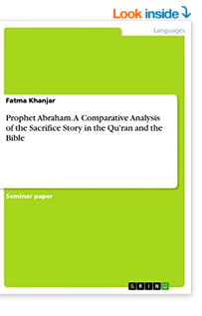
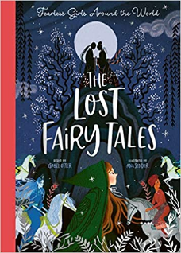

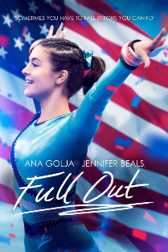
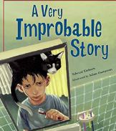
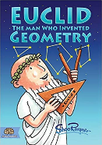
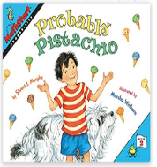

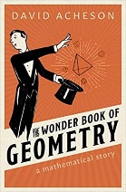
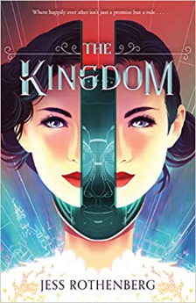

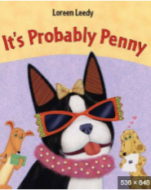
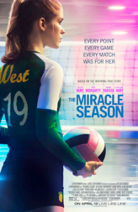
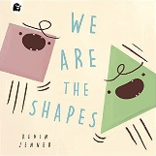
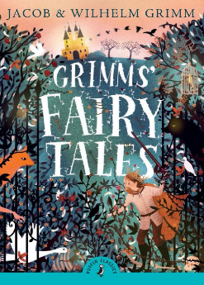

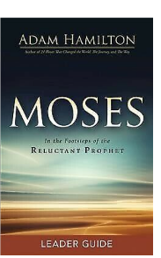
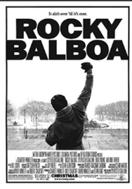
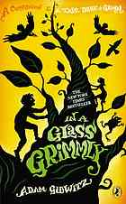
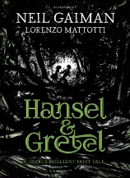
SUBJECT | THIS HALF TERM, STUDENT'S WILL BE WORKING ON… | READING MATERIAL
Art and Design | Surrealism | Surrealism - https://www.metmuseum.org/toah/hd/surr/hd_surr.htm  Surrealism - https://www.tate.org.uk/art/art-terms/s/surrealism  Surrealism Movement - https://www.theartstory.org/movement/surrealism/  Frida Kahlo - https://www.tate.org.uk/tate-etc/issue-4-summer-2005/frida-on-my-mind  Salvador Dali - http://www.salvadordali.com/  Rene Magaritte - https://www.renemagritte.org/  Pablo Picasso - https://www.pablopicasso.org/  André Breton - https://www.theartstory.org/artist/breton-andre/
Computer Science |  | (Great coding and making magazine, pdf issues are free on a variety of topics for many ages)  https://hackspace.raspberrypi.com/issues  Data Representation  https://www.advanced-ict.info/theory/NC/index.html#representation  Digital Graphics  https://www.bbc.co.uk/teach/class-clips-video/computing-ks3-ks4-megabits/zmp3nrd  https://www.bbc.co.uk/teach/class-clips-video/computing-ks3-ks4-gcse-coding-the-future-is-creative/z67bscw  https://www.csunplugged.org/en/at-home/squeezing-pictures/  https://www.bbc.co.uk/bitesize/guides/zv2v4wx/revision/1  https://www.bbc.co.uk/bitesize/guides/zvnp2sg/revision/1
Design Technology
Drama
English | Hidden Voices Poetry | Earth Verse – Sally M Walker  Under the Moon & Over the Sea – John Agard & Grace Nichols.  Let’s Celebrate: Festival Poems from around the World – Debanji Chatterjee, Brian D’Arcy, Shirin Adl.  Out of Wonder: Poems Celebrating Poets. - Kwame Alexander  Tomorrow is Beautiful – Sarah Crossan https://uxbridge.eplatform.co/title/9781526641908/epub?pid=100459043
Geography | Access to natural resources | - https://scdhec.gov/sites/default/files/Library/OR-0689.pdf  - https://www.bbc.co.uk/bitesize/topics/zshp34j/articles/z62qy9q  - https://education.nationalgeographic.org/resource/resource-library-distribution-natural-resources/
History |  | Have all migration stories to Britain been the same?  - Migration Nation by Aaron Wilkes  - BBC Teach – Migration: https://www.bbc.co.uk/teach/class-clips-video/history-ks3-migration/zf8wjhv  - Watling Street: Travels through Britain and Its Ever- Present Past by John Higgs  - Migration: Journeys through Black British History by Millie Mensah  - A Street through time: A 12,000 Year Journey Along the same street by DK and Steve Noon  - 99 Immigrants who made Britain Great by Louis Stewart and Naomi Kenyon  - The Emigrants by W.G. Sebald and Michael Hulse  - Migrations: A history of where we all came from by DK and David Olusoga  - Homecoming: Voices of the Windrush Generation by Colin Grant  - The Huguenots by Geoffrey Treasure
Mathematics

Modern Foreign Language | SPANISH - De paseo por el mundo  FRENCH - Culture | Spanish short cultural stories - https://smalltownspanishteacher.com/simple-stories-in-spanish-season-4-celebraciones-hispanas/  French short stories - https://www.thefrenchexperiment.com/stories  Bilingual (French/English) short story - https://www.amazon.co.uk/Frenglish-Boy-Gar%C3%A7on-Franglais-Bilingual/dp/1739937759/ref=asc_df_1739937759/?tag=googshopuk-21&linkCode=df0&hvadid=570288620391&hvpos=&hvnetw=g&hvrand=4289017532392049073&hvpone=&hvptwo=&hvqmt=&hvdev=c&hvdvcmdl=&hvlocint=&hvlocphy=9046083&hvtargid=pla-1644155787071&psc=1&th=1&psc=1  Bilingual (Spanish/English) short story - https://www.amazon.co.uk/Mexiglish-Girl-Chica-Bilingual-Childrens/dp/1739937708/ref=sr_1_17?crid=HNOZ7B3IJR4Q&keywords=beginner+cultural+spanish+stories&qid=1675686076&s=books&sprefix=beginner+cultural+spanish+stories%2Cstripbooks%2C61&sr=1-17
Music | Continuation of Music in Sport. | - This Time for Africa (by Shakira)  Lyrics to Read:  https://www.smule.com/song/shakira-waka-waka-this-time-for-africa-karaoke-lyrics/535746721_2695349/arrangement  Music to Hear:  Shakira - Waka Waka (This Time For Africa) (Lyrics)  - We are The Champions (by Queen)  Lyrics to Read:  https://www.smule.com/song/queen-we-are-the-champions-karaoke-lyrics/8226876_8226876/arrangement  Music to Hear:  Queen - We Are The Champions (RSD 2017) - Ltd. 12" 45 Vinyl Single
Physical Education | Developing the whole body – Holistic development | Book available via our e platform  The Mindful Athlete: Inspiration and Meditations for Pure Performance  By George Mumford  Podcasts  The England Athletics Podcast - Athletics
Religious Education
Science

