
YEAR 7 Summer 2 WIDER READING LISTS

Students are encouraged to develop a wider understanding of the topics they will learn this half term. All texts listed are aspirational: you are not required by the school to buy any of these for your subjects.


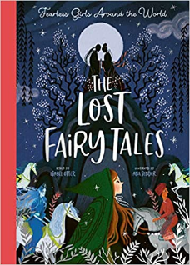

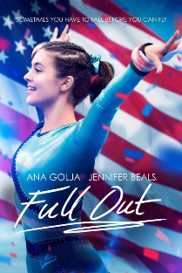
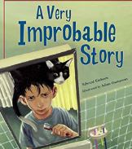

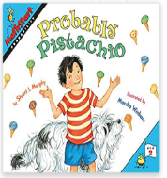

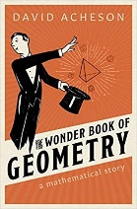
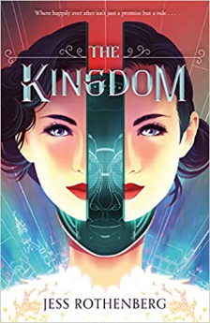



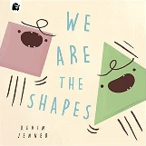
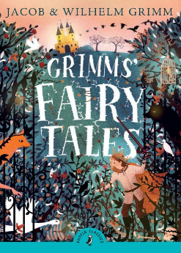

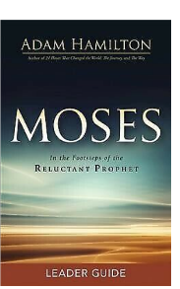
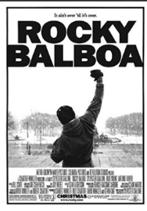
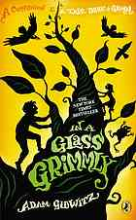
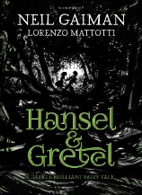
SUBJECT | THIS HALF TERM, STUDENT'S WILL BE WORKING ON… | READING MATERIAL
Art and Design | Cartoon Characters | Cartoon Fundamentals - https://design.tutsplus.com/articles/cartoon-fundamentals-how-to-draw-a-cartoon-face-correctly--vector-15792  Facial Expressions - https://design.tutsplus.com/articles/cartoon-fundamentals-create-emotions-from-simple-changes-in-the-face--vector-16278  How To Draw Cartoon Faces Step By Step - https://www.kdanmobile.com/blog/how-to-draw-cartoon-faces  How To Draw A Cartoon Body - https://design.tutsplus.com/articles/cartoon-fundamentals-how-to-draw-a-cartoon-body--vector-18651  How To Create A Dynamic Pose - https://www.pencilkings.com/how-to-create-a-dynamic-pose/  How To Create A Comic - https://www.bbc.co.uk/bitesize/topics/zkgcwmn/articles/zbk47nb
Computer Science |  | (Great coding and making magazine, pdf issues are free on a variety of topics for many ages)  https://hackspace.raspberrypi.com/issues  Computer Software  https://www.bbc.co.uk/bitesize/topics/z87mn39  https://www.bbc.co.uk/bitesize/topics/zmpsgk7
Design Technology
Drama
English | A Poetry Voyage | ‘Caged Bird’ - Maya Angelou  ‘Listen Mr Oxford Don’ - John Agard  ‘Praise Song for My Mother’ - Grace Nichols  Fairoz – Moniza Alvi  Everyone Sang – Emily Sutton
Geography | Urban areas | - https://www.bbc.co.uk/bitesize/topics/z96vr82  - https://courses.lumenlearning.com/suny-intro-to-sociology/chapter/reading-urbanization/  - https://www.londoncitybreak.com/history
History |  | Local History  - Uxbridge Though Time by Ken Pearce  - Uxbridge from Old Photographs by Ken Pearce  - Growing up in Wartime Uxbridge by James Skinner  - Local History and Heritage https://www.hillingdon.gov.uk/article/1244/Local-history-and-heritage  - Goodnight Mister Tom by Michelle Magorian  - City of Oxford Through Time by Stanley Jenkins  - The Battle of Britain: From the BBC Archives by Mark Jones  - Hurricane: Victor of the Battle of Britain by Leo McKinstry  - Daring Deeds – World War II Short Stories for Kids by KLG History  - His Dark Materials by Philip Pullman
Mathematics

Modern Foreign Language | SPANISH - Las fiestas  FRENCH - Culture | French comics - https://blog.lingoda.com/en/french-comics/  French comics - https://www.talkinfrench.com/french-comics-learn-french/#tab-con-20  Spanish comics - https://www.fluentu.com/blog/spanish/spanish-comic-books/  Short stories on Hispanic culture - https://smalltownspanishteacher.com/simple-stories-in-spanish-season-4-celebraciones-hispanas/  Short French stories - https://www.thefrenchexperiment.com/stories  Bilingual (French/English) short story - https://www.amazon.co.uk/Frenglish-Boy-Gar%C3%A7on-Franglais-Bilingual/dp/1739937759/ref=asc_df_1739937759/?tag=googshopuk-21&linkCode=df0&hvadid=570288620391&hvpos=&hvnetw=g&hvrand=4289017532392049073&hvpone=&hvptwo=&hvqmt=&hvdev=c&hvdvcmdl=&hvlocint=&hvlocphy=9046083&hvtargid=pla-1644155787071&psc=1&th=1&psc=1  Bilingual (Spanish/English) short story - https://www.amazon.co.uk/Mexiglish-Girl-Chica-Bilingual-Childrens/dp/1739937708/ref=sr_1_17?crid=HNOZ7B3IJR4Q&keywords=beginner+cultural+spanish+stories&qid=1675686076&s=books&sprefix=beginner+cultural+spanish+stories%2Cstripbooks%2C61&sr=1-17
Music | Programme Music | - Casey Jones  Headaches and heartaches and all kinds of pain  Are all the part of a railroad train…  Lyrics to Read:  https://www.traditionalmusic.co.uk/johnny-cash/pdf/casey-jones.pdf  Music to Hear:  Casey Jones Johnny Cash with Lyrics  - Hide and Seek  This moment of timing when your  Soul needs aligning,  It's me, you confide in,  Seeking and hiding...  Lyrics to Read:  https://www.google.com/search?q=hide+and+seek+by+stormzy+lyrics&source=lmns&bih=618&biw=1263&rlz=1C1GCEA_enGB1036GB1036&hl=en&sa=X&ved=2ahUKEwjv_93Gn8__AhV_nCcCHRZ3AkMQ_AUoAHoECAEQAA&safe=active&ssui=on  Music to Hear:  Stormzy - Hide & Seek (Lyrics)
Physical Education | Developing the whole body – Holistic development | Book available via our e platform  The Mindful Athlete: Inspiration and Meditations for Pure Performance  By George Mumford  Podcasts  The England Athletics Podcast - Athletics
Religious Education
Science

