
YEAR 9 Summer 1 WIDER READING LISTS

Students are encouraged to develop a wider understanding of the topics they will learn this half term. All texts listed are aspirational: you are not required by the school to buy any of these for your subjects.

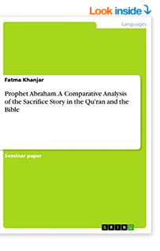
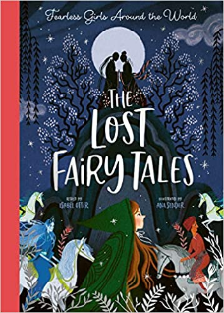

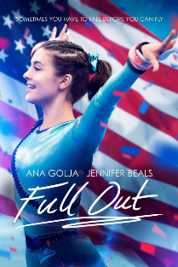
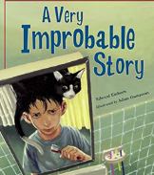
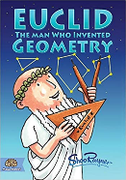
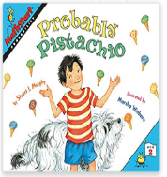

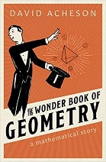
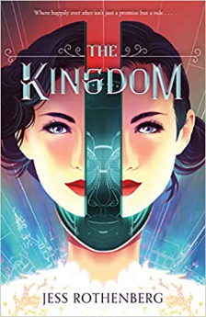

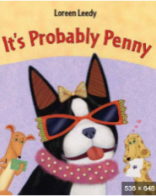
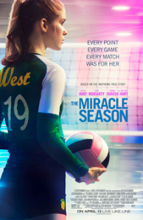
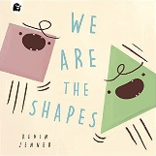
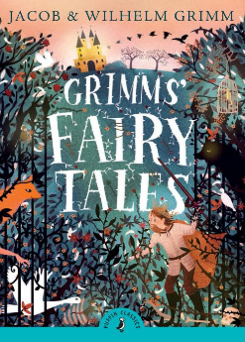

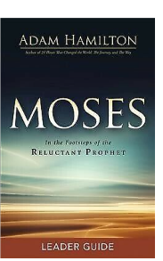
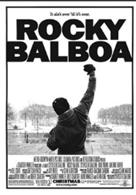
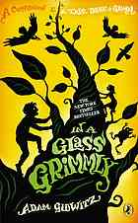
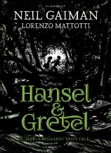
SUBJECT | THIS HALF TERM, STUDENT'S WILL BE WORKING ON… | READING MATERIAL
Art and Design | African Masks | African Symbols And Their Meaning - https://blog.yizzam.com/african-patterns-meaning-and-symbology/  African Patterns - https://www.contemporary-african-art.com/african-patterns.html  Adinkra Symbols and Their Hidden Meaning - https://www.youtube.com/watch?v=oqNac3Te0FI  Adinkra Symbols - https://www.adinkrasymbols.org/  Adinkra Symbols - https://www.youtube.com/watch?v=GQgXc0-aYRQ  Pattern - https://www.bbc.co.uk/bitesize/guides/z3c4jty/revision/1  Pattern/ Motif - https://www.bbc.co.uk/bitesize/guides/z3c4jty/video  Owusu Ankomah - https://octobergallery.co.uk/artists/owusu-ankomah
Computer Science |  | (Great coding and making magazine, pdf issues are free on a variety of topics for many ages)  https://hackspace.raspberrypi.com/issues  Hardware & Software  https://centurypast.org/magazine-directory/computer-magazines/  Networks  https://www.bbc.co.uk/bitesize/topics/zmpsgk7  https://www.bbc.co.uk/bitesize/guides/zrvyt39/revision/1  https://www.bbc.co.uk/bitesize/guides/zj88jty/revision/1
Design Technology
Drama
English
Geography | Geography of crime | - https://www.bbc.co.uk/bitesize/guides/zk2mf4j/revision/1  - https://www.bbc.co.uk/programmes/p00xd7vr  - https://www.theguardian.com/news/2018/jan/09/how-the-heroin-trade-explains-the-us-uk-failure-in-afghanistan
History |  | How similar/different were the British and American Civil Rights Movement?  - Natives – Akala  - Black and British – David Olusoga  - James Baldwin – The Fire Next Time  - The Louder I Will Sing – Lee Lawrence  - The Heart Of The Race- Black Women’s Lives In Britain- Beverly Bryan, Stella Dadzie, Suzanne Scafe  - March (Series) - John Lewis, Andrew Aydin and Nate Powell  - Turning 15 on the Road to Freedom: My Story of the 1965 Selma Voting Rights March - Lynda Blackmon Lowery  - Bearing the Cross: Martin Luther King Jr and the Southern Christian Leadership Conference by David J Garrow.  - Malcolm X Autobiography  - The Rock and the River - Kekla Magoon
Mathematics | Angles, trigonometry, quadratic function and averages | How Scientists Use Statistics, Samples, and Probability to Answer Research Questions  https://kids.frontiersin.org/articles/10.3389/frym.2019.00118  What to Do? Let’s Think It Through! Using the Analytic Hierarchy Process to Make Decisions  https://kids.frontiersin.org/articles/10.3389/frym.2020.00078  Geometry: A History from Practice to Abstraction  https://nrich.maths.org/6352  The History of Trigonometry- Part 1  https://nrich.maths.org/6843&part=  History of Trigonometry - Part 2:  https://nrich.maths.org/6853&part=  History of Trigonometry - Part 3  https://nrich.maths.org/6908&part=  The Development of Algebra – 1  https://nrich.maths.org/6485
Modern Foreign Language |  | Charles Dickens: French version of a Tale of two cities: https://www.ebooksgratuits.com/pdf/dickens_un_drame_sous_la_revolution.pdf  Charles Dickens: French version of Bleak House: https://www.ebooksgratuits.com/pdf/dickens_petite_dorrit_1.pdf  French daily newspaper:  https://www.lemonde.fr/  https://www.20minutes.fr/actus  https://www.francetvinfo.fr/  French national anthem La Marseillaise – history and lyrics in French and English:  https://www.french-online.de/literature/marseillaise/history.htm  French articles with audio and English translation:  https://www.french-online.de/literature/newspaper_texts/language_learning.htm  https://www.french-online.de/literature/newspaper_texts/la_baguette.htm  https://www.french-online.de/literature/newspaper_texts/globalisation.htm  Spanish text (with Spanish audio, English translation and grammar rules available):  https://spanish.kwiziq.com/learn/reading/calendario-de-adviento  https://spanish.kwiziq.com/learn/reading/espiritu-navideno  https://spanish.kwiziq.com/learn/reading/la-constitucion-espanola-1  https://spanish.kwiziq.com/learn/reading/gijon

Music | Curriculum Map Theme: Musical Cultures with Scales and Textures | - Dos Gardenas (from Cuba)  The flowers will live and will talk to you  Just as when you are with me...  Lyrics to Read:  https://lyricstranslate.com/en/dos-gardenias-two-gardenias.html  Music to Hear:  Buena Vista Social Club - Dos Gardenias(English Lyrics)  - Since I Met You Baby  I used to think I was better than the rest.  Ain't no doubt about it, I was no second best.  Didn't seem to matter what was right or what was wrong,  I did some crazy things before you came along.  Lyrics to Read:  https://mojim.com/usy103391x2x8.htm  Music to Hear:  Gary Moore - Since I met you baby
Physical Education | Game preparation and performance | A book available via our e platform  A Still quiet place for athletes – Mindfulness Skills for achieving peak performance and finding flow in sports and life  By Amy Saltzman, Jim Thompson and Coleen Marlo
Religious Education
Science

