
YEAR 8 Summer 1 WIDER READING LISTS

Students are encouraged to develop a wider understanding of the topics they will learn this half term. All texts listed are aspirational: you are not required by the school to buy any of these for your subjects.

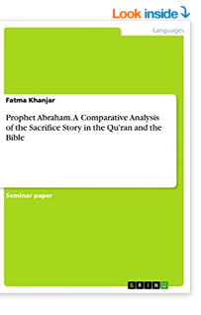
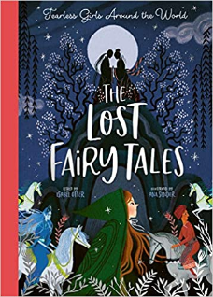

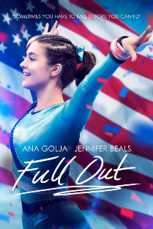
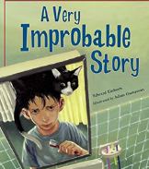
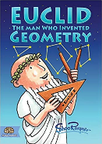
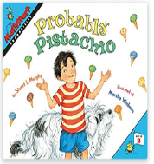

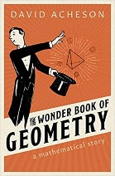
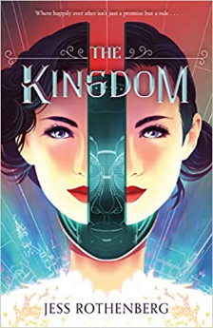
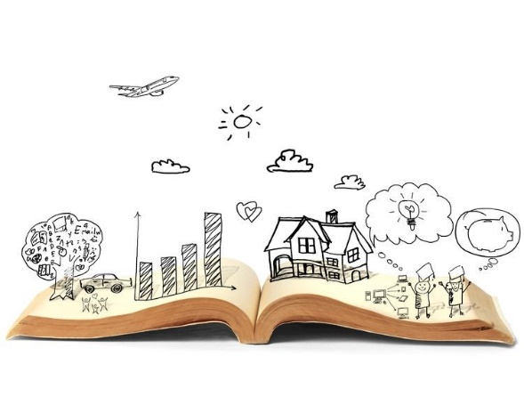


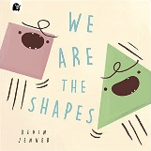
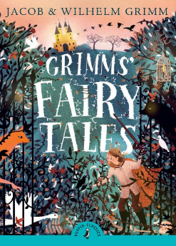

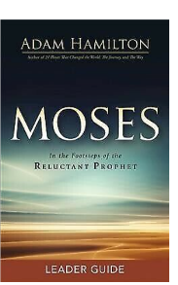
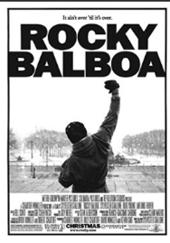
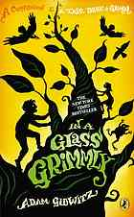
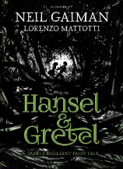
SUBJECT | THIS HALF TERM, STUDENT'S WILL BE WORKING ON… | READING MATERIAL
Art and Design | Seascapes | What You Should Know About Seascape - https://www.invaluable.com/blog/what-you-should-know-about-seascapes/  Insights On Painting Seascapes - https://www.artistsnetwork.com/art-techniques/insight-on-painting-seascapes/  English Seascape Artists - https://artuk.org/discover/stories/the-british-seaside-from-turner-to-nash-to-emin  Landscape Across The Centuries - https://www.tate.org.uk/art/art-terms/l/landscape  One-point Perspective - https://www.youtube.com/watch?v=XRrKohWdpeQ  Perspective - https://www.johnlovett.com/perspective-drawing  Basics Of Lineal Perspective - https://mymodernmet.com/perspective-drawing/  Introduction To Drawing With Perspective - https://www.jacksonsart.com/blog/2019/05/01/how-to-draw-with-perspective-2/  Claude Monet - https://www.claudemonetgallery.org/biography.html  Joseph Mallord William Turner - https://www.tate.org.uk/art/artists/joseph-mallord-william-turner-558
Computer Science |  | (Great coding and making magazine, pdf issues are free on a variety of topics for many ages)  https://hackspace.raspberrypi.com/issues  Cyber Security  https://idea.org.uk/  https://www.bbc.co.uk/bitesize/guides/zrtrd2p/revision/3  Data representation  https://www.bbc.co.uk/bitesize/topics/zxnfr82  https://www.bbc.co.uk/bitesize/guides/zpfdwmn/revision/1
Design Technology
Drama
English | Hidden Voices Poetry | Art of Being Normal - Lisa Williamson.  Auggie & Me: Three Wonder Stories – R.J. Palacio. https://uxbridge.eplatform.co/title/9781448197286/epub?pid=24263924  The Outrage – William Hussey https://uxbridge.eplatform.co/title/9781801310710/epub?pid=41090496  Refugee Boy – Benjamin Zephaniah https://uxbridge.eplatform.co/title/9781408825402/epub?pid=22444227  Note to Self – Gayle King.
Geography | Tectonic plates and hazards | - https://courses.lumenlearning.com/geo/chapter/reading-theory-of-plate-tectonics-2/  - The impossible (2012 film) on Netflix  - https://twinklsecondary.blog/the-challenges-of-natural-hazards-tectonic-hazards/
History |  | To what extent did the Industrial Revolution change people’s lives?  - BBC Bitesize – The Industrial Revolution: https://www.bbc.co.uk/bitesize/topics/zm7qtfr  - School History – The Industrial Revolution: https://schoolshistory.org.uk/topics/british-history/industrial-revolution/  - My name is Victoria by Lucy Worsley  - Constable and Toop by Gareth P Jones  - Pastworld by Ian Beck  - A dark trade by Mary Hooper  - A Brief history on how the Industrial Revolution changed the world by Thomas Crump  - The Age of Revolution: Europe 1789-1848 by Italo Calvino  - Ten Engineers who made Britain Great: The Men behind the Industrial Revolution by Anthony Burton  - Liberty’s Dawn: A people’s history of the Industrial Revolution by Emma Griffin
Mathematics | Probability, scale drawings, straight-line graphs, percentages, decimals and fractions | Articles:  Why Do We Need Maths in Medicine?  https://kids.frontiersin.org/articles/10.3389/frym.2021.678802  The Real Numbers: Not All Decimals Are Fractions  https://kids.frontiersin.org/articles/10.3389/frym.2020.00004  The Waiting-Time Paradox  https://kids.frontiersin.org/articles/10.3389/frym.2020.582433  Books:  Surprises in Probability: Seventeen Short Stories book by Henk Tijms  Pigs at Odds: Fun with Math and Games boby Amy Axelrod  That's a Possibility A Book about What Might Happen by Bruce Goldstone  Fractions in Disguise: A Math Adventure by Edward Einhorn  Lift-the-Flap Fractions and Decimals by Rosie Dickins
Modern Foreign Language |  | French daily newspaper:  https://www.lemonde.fr/  https://www.20minutes.fr/actus  https://www.francetvinfo.fr/  French audio books:  https://www.languageguide.org/french/readings/br/lycee/  https://www.languageguide.org/french/readings/br/brocant/  https://www.languageguide.org/french/readings/br/guillotine/  English article with some French on Easter celebrated in France:  https://www.frenchtoday.com/blog/french-culture/french-traditions-easter-egg-lamb-meal-traditional/  Spanish text (with Spanish audio, English translation and grammar rules available):  https://spanish.kwiziq.com/learn/reading/destinos-rurales-con-ninos  https://spanish.kwiziq.com/learn/reading/e-learning  https://spanish.kwiziq.com/learn/reading/el-canal-de-panama  https://spanish.kwiziq.com/learn/reading/el-dia-de-muertos-en-casa-de-guadalupe
Music | This Term, students in Year 8 will be looking at how music is used in different sports across the world. From stadiums to arenas or boxing rings to tennis courts. | Eye of the Tiger  Lyrics to Read:  https://www.smule.com/song/survivor-eye-of-the-tiger-karaoke-lyrics/743351538_1158197/arrangement  Music to Hear:  Survivor - Eye of the Tiger (Lyrics)  Seven Nation Army  Lyrics to Read:  https://www.smule.com/song/the-white-stripes-seven-nation-army-karaoke-lyrics/529747131_1578737/arrangement  Music to Hear:  The White Stripes - Seven Nation Army Lyrics
Religious Education
Science
Physical Education | Game preparation and performance | A book available via our e platform  A Still quiet place for athletes – Mindfulness Skills for achieving peak performance and finding flow in sports and life  By Amy Saltzman, Jim Thompson and Coleen Marlo  Podcasts  All stumped out – Cricket  The Analyst Inside Cricket - Cricket  The England Athletics Podcast - Athletics

