
YEAR 7 Summer 1 WIDER READING LISTS

Students are encouraged to develop a wider understanding of the topics they will learn this half term. All texts listed are aspirational: you are not required by the school to buy any of these for your subjects.

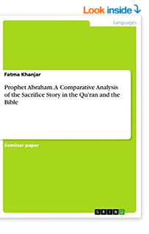
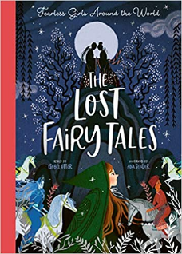

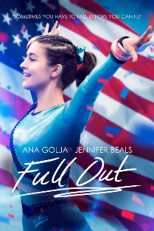
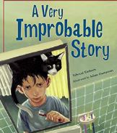
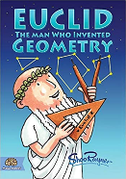
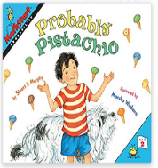

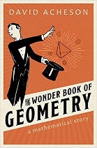
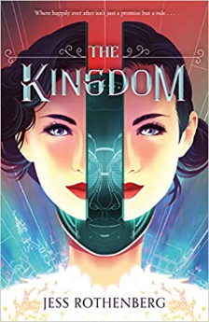



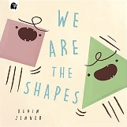
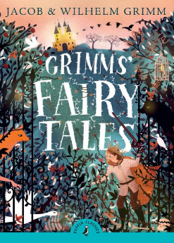

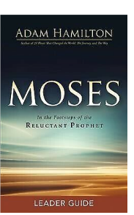

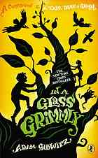
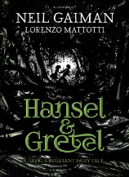
SUBJECT | THIS HALF TERM, STUDENT'S WILL BE WORKING ON… | READING MATERIAL
Art and Design | Pop Art | Pop Art - https://www.tate.org.uk/art/art-terms/p/pop-art  Think You Know Pop Art? - https://www.tate.org.uk/art/art-terms/p/pop-art/think-you-know-pop-art  Pop Art Movement - https://www.theartstory.org/movement/pop-art/  The Pop Art Movement - https://www.invaluable.com/blog/what-is-pop-art/  Michael Craig Martin - https://www.michaelcraigmartin.co.uk/  Andy Warhol - https://www.theartstory.org/artist/warhol-andy/  Roy Lichtenstein - https://www.theartstory.org/artist/lichtenstein-roy/  David Hockney - https://www.hockney.com/home  Colour, Colour Wheel - https://www.bbc.co.uk/bitesize/guides/z9bbk2p/revision/1  Colour Theory - https://www.bbc.co.uk/bitesize/guides/z9bbk2p/video  The Science Of Colour - https://www.bbc.co.uk/bitesize/topics/zw982hv/articles/z7rtng8
Computer Science |  | (Great coding and making magazine, pdf issues are free on a variety of topics for many ages)  https://hackspace.raspberrypi.com/issues  Computer Hardware  https://www.bbc.co.uk/bitesize/topics/zmpsgk7  https://www.bbc.co.uk/bitesize/guides/zxb72hv/revision/1  https://www.youtube.com/watch?v=Nsk1gS0jJ2I
Design Technology
Drama
English | A Poetry Voyage | Poetry Unbound – Padraig O Tuama  Poems for Life – Laura Barber  Poetry By Heart - Julie Blake  A Poem for Every Winter Day – Allie Esiri  Sun Time, Snow Time – Grace Nicholls. https://uxbridge.eplatform.co/title/9781408193013/epub?pid=21906579
Geography | Tropical rainforests | - https://www.bbc.co.uk/bitesize/topics/ztgw2hv/articles/zppthcw  - https://education.nationalgeographic.org/resource/rain-forest/  - Our Planet episodes: Jungles and Forests on Netflix
History |  | Henry VIII  - Who was Henry VIII by Ellen Labrecque  - Tudor by DK (Eyewitness)  - Henry VIII: The Quest for Fame by John Guy  - Who was Henry VIII https://www.bbc.co.uk/bitesize/topics/zwcsp4j/articles/zmst6g8  - Spy Master: First Blood by Jan Burchett  - My Story: Anne Boleyn and Me by Alison Prince  - The Queen’s Fool by Ally Sherrick  - The Lost Diary of King Henry VIII’s Executioner by Steve Barlow  - Henry VIII and his Chopping Block by Alan MacDonald  - The Life and Reign of King Henry VIII https://www.natgeokids.com/uk/discover/history/monarchy/henry-viii-facts/
Mathematics | Angles, sequences and ratio | Understanding The Odds: Statistics in Public Health  https://kids.frontiersin.org/articles/10.3389/frym.2022.926624  The Dangerous Ratio  https://nrich.maths.org/2671  Leonardo of Pisa and the Golden Rectangle  https://nrich.maths.org/2563  Mathematical Patchwork  https://nrich.maths.org/4878  What Does Math Have to Do With Patterns in Fish?  https://kids.frontiersin.org/articles/10.3389/frym.2022.834049  Connecting the Dots: Discovering the “Shape” of Data  https://kids.frontiersin.org/articles/10.3389/frym.2021.551557
Modern Foreign Language |  | French daily newspaper:  https://www.lemonde.fr/  https://www.20minutes.fr/actus  https://www.francetvinfo.fr/  French audio books:  https://www.languageguide.org/french/readings/br/cheremaman/ https://www.languageguide.org/french/readings/br/lebon/  https://www.languageguide.org/french/readings/br/cauchemar/  English article explaining the French tradition for the 1st of May:  https://www.renestance.com/blog/muguet-de-mai-a-french-tradition/  Spanish text (with Spanish audio, English translation and grammar rules available):  https://spanish.kwiziq.com/learn/reading/12-cosas-interesantes-sobre-nicaragua  https://spanish.kwiziq.com/learn/reading/cines-de-verano-al-aire-libre  https://spanish.kwiziq.com/learn/reading/consultorio-de-libros  https://spanish.kwiziq.com/learn/reading/curiosidades-de-paraguay
Music | Music for Theme Parks | - Here Comes the Sun  Little darling, I feel  that ice is slowly melting  Little darling, it seems like  years since it's been clear  Lyrics to Read:  https://www.smule.com/song/beatles-here-comes-the-sun-karaoke-lyrics/8612313_8612313/arrangement  Music to Hear:  The Beatles - Here Comes The Sun (2019 Mix)  - Rollercoaster  Everyday it's a-gettin' faster  Everyone said, "Go ahead and ask her"  Love like yours will surely come my way  Lyrics to Read:  https://www.smule.com/song/buddy-holly-everyday-karaoke-lyrics/460333_145676/arrangement  Music to Hear:  Buddy Holly - Everyday - Original
Physical Education | Game preparation and performance | A book available via our e platform  A Still quiet place for athletes – Mindfulness Skills for achieving peak performance and finding flow in sports and life  By Amy Saltzman, Jim Thompson and Coleen Marlo  Podcasts  All stumped out – Cricket  The Analyst Inside Cricket - Cricket  The England Athletics Podcast - Athletics
Religious Education
Science

