
YEAR Spring 2 WIDER READING LISTS

Students are encouraged to develop a wider understanding of the topics they will learn this half term. All texts listed are aspirational: you are not required by the school to buy any of these for your subjects.

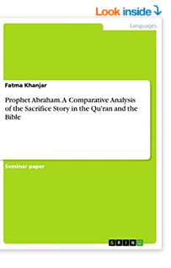
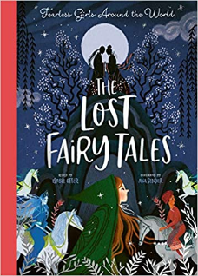
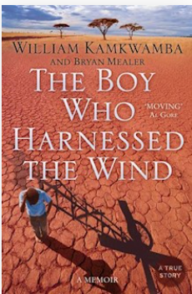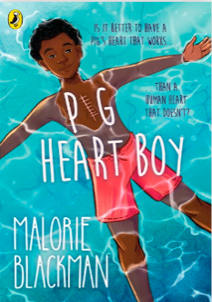
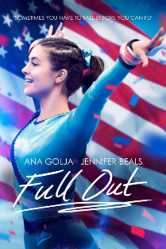
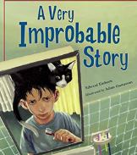
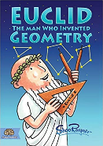
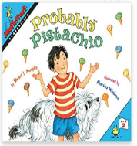

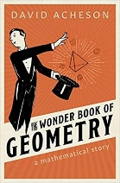
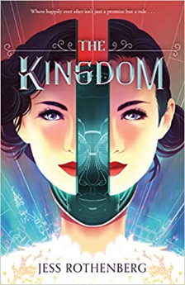
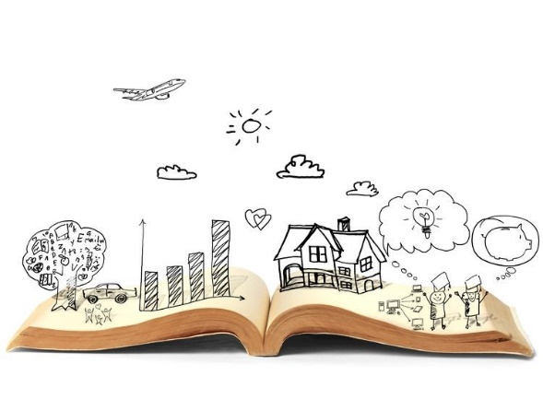
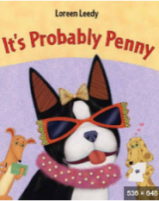
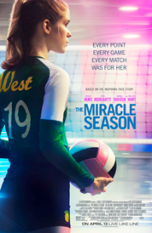
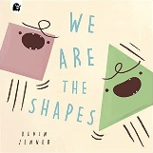
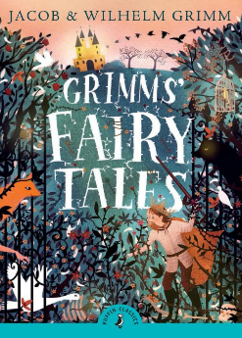

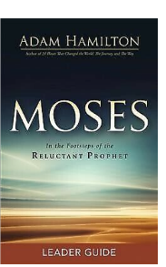
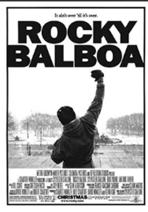
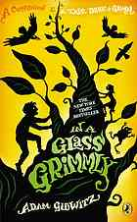
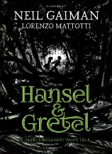
SUBJECT | THIS HALF TERM, STUDENT'S WILL BE WORKING ON… | READING MATERIAL
Art and Design | Architecture and Cityscapes | Iconic Buildings - https://www.architecturaldigest.com/story/most-iconic-buildings-around-the-world  Buildings That Redefined Architecture - https://www.architecturaldigest.com/story/buildings-redefined-architecture-past-5-years  Ian Murphy - https://www.ianmurphyartist.com/about/  How To Draw Buildings - https://cravepainting.com/blog/how-to-draw-streets-and-buildings  2 Point Perspective - https://www.thesprucecrafts.com/two-point-perspective-drawing-tutorial-1123413  https://makeamarkstudios.com/how-to-draw-a-2-point-perspective-city-for-beginners/
Computer Science
Design Technology
Drama
English | Shakespeare’s Works | ‘An Introduction to Shakespeare’s Comedies’ - John Mullan. https://www.bl.uk/shakespeare/articles/an-introduction-to-shakespeares-comedy  ‘Shakespeare and madness’ - Will Tosh. https://www.bl.uk/shakespeare/articles/shakespeare-and-madness  ‘Shakespeare’s Fools’ - Eric Rasmussen & Ian DeJong. https://www.bl.uk/shakespeare/articles/shakespeares-fools  Shakespeare’s Stories by Samantha Newman. https://uxbridge.eplatform.co/title/9781398810433/epub?pid=40581948  ‘King Lear’ by William Shakespeare. https://uxbridge.eplatform.co/title/9789629546885/mp3?pid=100095671
Geography | Contrasting/extreme environments | Same as last half term
History |  | What caused the Allies to win WW2?  - Goodnight Mr Tom – Michelle Magorian  - Carrie’s War – Nina Bawden  - The Extraordinary Life of Alan Turing - Michael Lee Richardson & Freda Chiu  - The Second World War – Anthony Beevor  - Daring Deeds - World War II Short Stories for Kids: Family-Friendly Stories About Friendship, Bravery, Kindness & Love for 8-14 Year Olds – KLG History  - Empire of the Sun by JG Ballard  - Last Train from Kummersdorf by Leslie Wilson  - The Machine Gunners by Robert Westall  - Rose Blanche by Ian McEwan (illustrated by Roberto Innocenti)  - The Girl in the Blue Coat - Monica Hesse
Mathematics

Modern Foreign Language | Jobs, careers and the importance of language learning  Easter celebrations in France | French online newspaper targeted at children:  https://www.jde.fr/  List of French comic books:  https://www.talkinfrench.com/french-comics-learn-french/#tab-con-20  https://lingua.com/french/reading/paques-en-france/  https://lingua.com/french/reading/les-metiers/  https://french.kwiziq.com/learn/reading/20-march-international-day-of-francophonie

Music | Curriculum Map Theme:  Music Technology Techniques | BOOKS:  Music Production for Beginners by Tommy Swindali  LINK  5 Music Production Techniques and how to create them  https://www.izotope.com/en/learn/5-popular-music-production-techniques-and-how-to-create-them.html  Computer Music Magazine  https://www.musicradar.com/computermusic  Sound on Sound Magazine  https://www.soundonsound.com/  LYRICS:  - Wake Me Up  I can't tell where the journey will end  But I know where to start  They tell me I'm too young to understand  They say I'm caught up in a dream  Well life will pass me by if I don't open up my eyes...  Lyrics to Read:  https://songmeanings.com/songs/view/3530822107859463209/  Music to Hear:  Avicii - WAKE ME UP (Lyrics)  - We Found Love  Yellow diamonds in the light.  Now we’re standing side by side  As your shadow crosses mine,  What it takes to come alive...  Lyrics to Read:  https://www.smule.com/song/rihanna-ft-calvin-harris-we-found-love-karaoke-lyrics/7215196_7215196/arrangement  Music to Hear:  Rihanna - We Found Love (Lyrics) ft. Calvin Harris
Physical Education | Benefits to eating well | Book available via our e platform  Eat well and Feel Great – The teenagers guide to nutrition and health by Tina Loud-Caulk
Religious Education
Science | Structure and bonding, Energy, Organisation | The boy who harnessed the wind – William Kamkwamba  Pug heart boy – Malorie Blackman – This book touches on some sensitive topics in science and ethics

