
YEAR 8 Spring 2 WIDER READING LISTS

Students are encouraged to develop a wider understanding of the topics they will learn this half term. All texts listed are aspirational: you are not required by the school to buy any of these for your subjects.

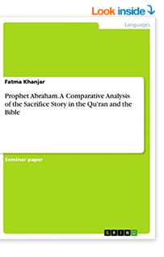
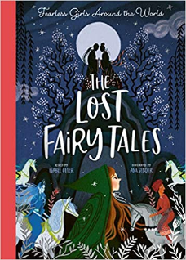
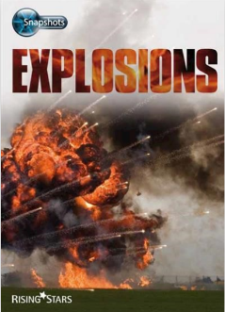
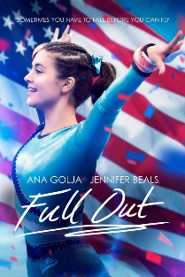
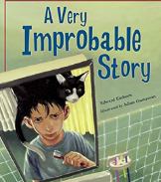
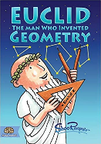
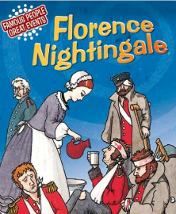
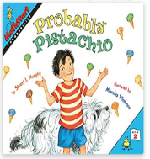

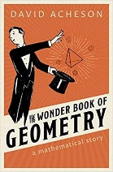
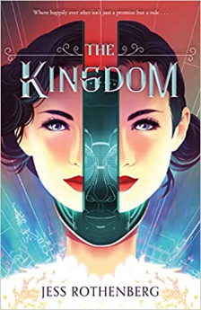
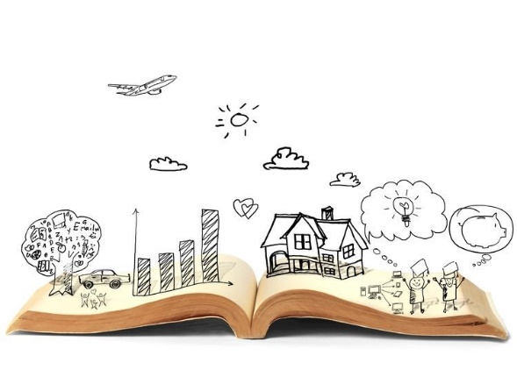
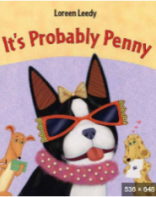
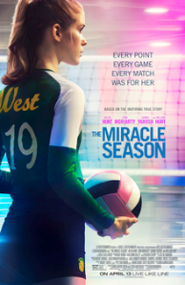
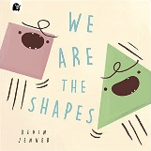
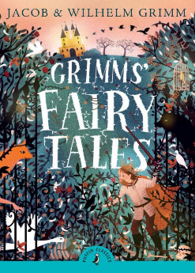

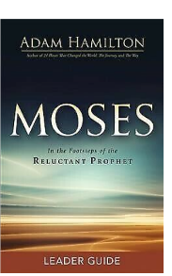
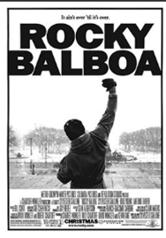
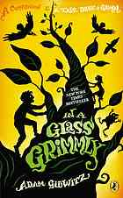
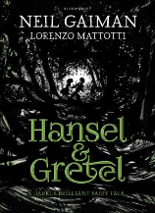
SUBJECT | THIS HALF TERM, STUDENT'S WILL BE WORKING ON… | READING MATERIAL
Art and Design | Cubism | What is Cubism - https://www.theartstory.org/movement/cubism/  Pablo Picasso - https://www.theartstory.org/artist/picasso-pablo/  Georges Braque - https://www.theartstory.org/artist/braque-georges/  How To Draw A Cubist Portrait - https://artbyro.com/cubism-portrait/  Cubism History - https://www.tate.org.uk/art/art-terms/cubism
Computer Science
Design Technology
Drama
English | William Shakespeare’s Romeo & Juliet. | The Merchant of Venice – William Shakespeare https://uxbridge.eplatform.co/title/gut1114/epub?pid=15133045  To Kill a Mockingbird – Harper Lee  Pride and Prejudice – Jane Austen  Wuthering Heights – Emily Bronte  Jane Eyre – Charlotte Bronte
Geography | Rivers and glaciers | - https://www.bbc.co.uk/bitesize/topics/zpcqxnb/articles/zdw8dp3  - https://www.antarcticglaciers.org/glacier-processes/  - https://education.nationalgeographic.org/resource/glacier/
History |  | What does Olaudah Equiano’s testimony teach us about the Trans-Atlantic slave trade?  - My Name’s not Friday by Jon Walter  - Chains by Laurie Halse Anderson  - Freedom by Catherine Johnson  - BBC Bitesize – the Transatlantic slave trade: https://www.bbc.co.uk/bitesize/topics/z2qj6sg  - The Transatlantic Slave Trade: A captivating guide to the Atlantic Slave Trade and Stories of the Slaves that were brought to the Americas (History of slavery) by Captivating history  - The Story of Slavery by Sarah Courtauld  - Enslaved: The sunken history of the Transatlantic slave trade by Sean Kingsley  - Unheard Voices: An Anthropology of stories and poems by Malorie Blackman  - Real Lives: Harriet Tubman by Deborah Chancellor  - Slavery (Civil rights stories) by Catherine Chambers and Toby Newsome
Mathematics

Modern Foreign Language | Holidays in Paris  Easter celebrations in French | French online newspaper targeted at children:  https://www.jde.fr/  List of French comic books:  https://www.talkinfrench.com/french-comics-learn-french/#tab-con-20  https://lingua.com/french/reading/vacances/  https://lingua.com/french/reading/tour-eiffel/  https://lingua.com/french/reading/paques/  https://lingua.com/french/reading/paris/
Music | Pop Music Techniques | - What’s Going On?  Lyrics to Read:  https://www.smule.com/song/marvin-gaye-whats-going-on-karaoke-lyrics/126615296_590977/arrangement  Music to Hear:  Marvin Gaye - What's Going On (Lyric Video)  - AS (by Stevie Wonder)  Lyrics to Read:  https://www.smule.com/song/stevie-wonder-as-karaoke-lyrics/221934008_124219/arrangement  Music to Hear:  Stevie Wonder - "As" (w/lyrics)
Physical Education | Benefits to eating well | Book available via our e platform  Eat well and Feel Great – The teenagers guide to nutrition and health by Tina Loud-Caulk
Religious Education
Science |  | Explosions – Sue Graves (Engineering)  Florence Nightingale – Emma Fischel – Her work ensured wounded soldiers got better with the reduction of bacteria in nursing practice

