
YEAR 7 Spring 2 WIDER READING LISTS

Students are encouraged to develop a wider understanding of the topics they will learn this half term. All texts listed are aspirational: you are not required by the school to buy any of these for your subjects.

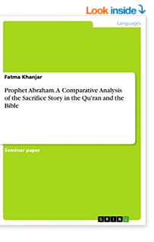
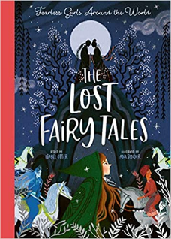
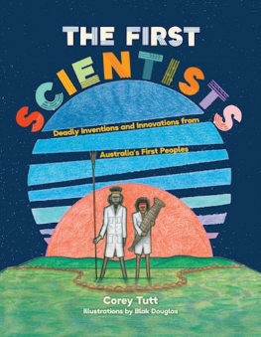

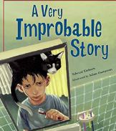
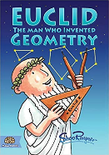
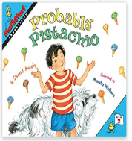
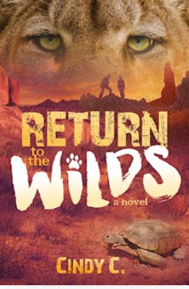
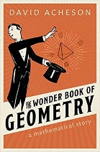
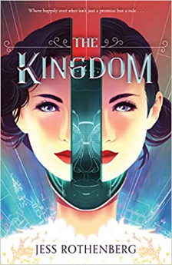

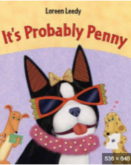

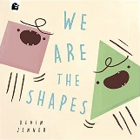
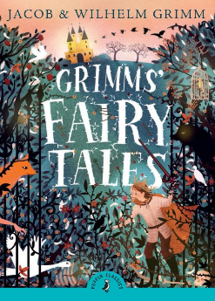

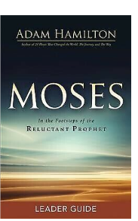

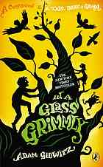
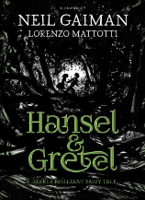
SUBJECT | THIS HALF TERM, STUDENT'S WILL BE WORKING ON… | READING MATERIAL
Art and Design | Rural Scapes | What is a Rural area - https://education.nationalgeographic.org/resource/rural-area  Monoprinting - https://www.nationalgalleries.org/art-and-artists/glossary-terms/monoprint-0  Principles of Art - https://www.thoughtco.com/principles-of-art-and-design-2578740  Charcoal - https://thevirtualinstructor.com/charcoal.html  Painting a Landscape - https://drawpaintacademy.com/10-landscape-painting-tips/
Computer Science
Design Technology
Drama
English | Ghost Boys by Jewell Parker Rhodes | When the Mountains Roared – Jess Butterworth  What Not to do if you Turn Invisible – Ross Wellford  Game Changer – Neal Chesterman https://uxbridge.eplatform.co/title/9781529500721/epub?pid=40522594  While the Storm Rages – Phil Earle  The Humans – Matt Haig
Geography | Africa and Kenya study | Same as last half term.
History | Did the Black Death change everything? | - The Black Death: The Intimate Story of a Village in Crisis 1345-50 by John Hatcher  - Key Stage 3 History by Aaron Wilkes: Invasion, Plague and Murder: Britain 1066-1509  - The Black Death by Rob Lloyd Jones  - Plague! By John Farndon  - The Peasants Revolt https://www.bbc.co.uk/bitesize/topics/z93txbk/articles/zyb77yc  - The Black Death https://www.bbc.co.uk/bitesize/topics/zqjwxnb/articles/zdkssk7  - Cause and Effects of the Black Death https://www.bbc.co.uk/bitesize/topics/zqjwxnb/articles/zdkssk7  - DK Findout! Black Death https://www.dkfindout.com/uk/history/black-death/  - The Peasants’ Revolt https://www.bbc.co.uk/bitesize/topics/z93txbk/articles/zyb77yc  - Peasants Revolt https://www.historyforkids.net/the-peasants-revolt.html?utm_content=cmp-true
Mathematics

Modern Foreign Language | School and my studies  Easter celebrations | https://lingua.com/french/reading/journee-avec-alice/  https://lingua.com/french/reading/routine-quotidienne/  https://lingua.com/french/reading/paques/  Journal des enfants, online French newspaper targeted for children:  https://www.jde.fr/  List of French comics:  https://www.talkinfrench.com/french-comics-learn-french/#tab-con-20
Music | Music in Advertising | - In the Air Tonight  I saw it with my own two eyes  So you can wipe off that grin,  I know where you've been.  It's all been a pack of lies.  Lyrics to Read:  https://www.smule.com/song/phil-collins-in-the-air-tonight-karaoke-lyrics/50469446_78007/arrangement  Music to Hear:  Cadbury Gorilla Advert - In The Air Tonight  - Alright Now  There she stood in the street  Smiling from her head to her feet…  Lyrics to Read:  https://www.azlyrics.com/lyrics/free/allrightnow.html  Music to Hear:  https://www.smule.com/song/free-all-right-now-karaoke-lyrics/18431217_18431217/arrangement  Wrigley's gum 'bus journey' advert 1990
Physical Education | Benefits to eating well | Book available via our e platform  Eat well and Feel Great – The teenagers guide to nutrition and health by Tina Loud-Caulk
Religious Education
Science |  | The First Scientists: Deadly Inventions and Innovations from Australia's First Peoples – Corrie Tutt  Read about the Australian aborigines who were interested in the planets and much more  Return to the wild – Cindy C. - a book about a girl trying to preserve animals

