
YEAR 9 SPRING 1 WIDER READING LISTS

Students are encouraged to develop a wider understanding of the topics they will learn this half term. All texts listed are aspirational: you are not required by the school to buy any of these for your subjects.

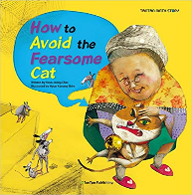
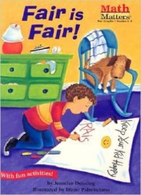
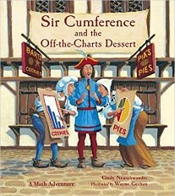
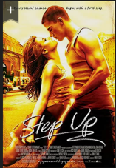
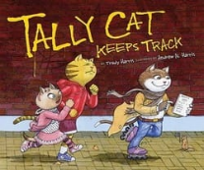

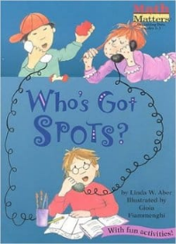
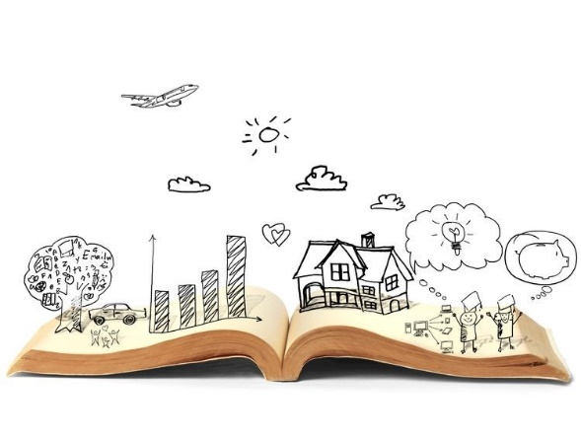
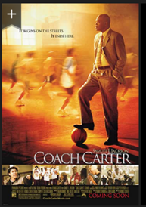
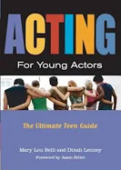
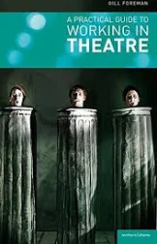
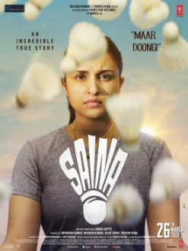

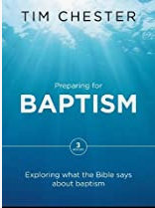
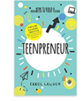
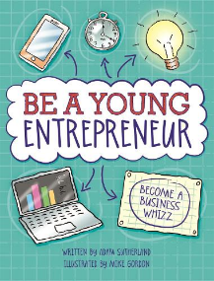
SUBJECT | THIS HALF TERM, STUDENT'S WILL BE WORKING ON… | READING MATERIAL
Art and Design | Cityscapes | One-point perspective - https://www.youtube.com/watch?v=XRrKohWdpeQ  Perspective - https://www.johnlovett.com/perspective-drawing  Basics of lineal perspective - https://mymodernmet.com/perspective-drawing/  Introduction to drawing with perspective - https://www.jacksonsart.com/blog/2019/05/01/how-to-draw-with-perspective-2/  Gustave Caillebotte - https://www.thoughtco.com/biography-of-gustave-caillebotte-french-impressionist-painter-4797962  Norbert Goeneutte - https://www.tate.org.uk/art/artists/norbert-goeneutte-1181  https://en.wikipedia.org/wiki/Norbert_Goeneutte
Computer Science | Networks and computer hardware | Computer Networks , by Andrew S Tanenbaum  Get ahead in Computing: Computer Networks, by Clive Gifford  The Nostalgia Nerd’s Tech: Computer, Consoles & Games (Tech Classics), by Peter leigh  How Computers work: The Evolution of Technology (How it works), by Ron White and Timothy Downs  Getting started with the BBC Microbit, by Mike Tooley
Design Technology |  | The Shape we`re in by Sarah Bosely.  https://blog.prototypr.io/technology-product-design-and-user-experience-7530d1390346  https://successatschool.org/advicedetails/335/Why-Study-Design-and-Technology%3F
Drama |  | Adam Sutherland  Mr Errol Lawson Lawson  Gill Foreman  Mary Lou Belli
English | Blood Brothers, Willy Russell | DNA – Dennis Kelly  http://www.castlefordacademy.com/wp-content/uploads/2021/03/DNA-Script.pdf  Stone Cold – Robert Swindells  A View from the Bridge – Arthur Miller  Oliver Twist – Charles Dickens  Homecoming – Cynthia Voigt  Educating Rita – Willy Russell
Geography | Extreme environments | Life in the desert by Gerald Legg.  Tropical rainforest ecology, diversity and conservation by Jaboury Ghazoul.  Tundra Geography detective by Phillip Steele.
History |  | How and why should we remember the Holocaust?  - The diary of Anne Frank  - The Boy in the Striped Pyjamas  - The tattooist of Auschwitz  - The Book Thief by Marcus Zusak  - Ire­na’s Chil­dren: A True Sto­ry of Courage, Tillar Mazzeo; adapt­ed by Mary Cronk Farrell  - Defying the Nazis, The Life of German Hofficer Wilm Hosenfeld, Young Readers Edition  - 28 Days: A Novel of Resistance in the Warsaw Ghetto, David Safier, Helen MacCormac (trans.)  - Bluebird, Sharon Cameron  - The Holocaust, 1939 – 1945 – BBC Bitesize (https://www.bbc.co.uk/bitesize/topics/zk94jxs/articles/zt48dp3)  - What is Holocaust Memorial Day – Holocaust Memorial Day Trust (https://www.hmd.org.uk/what-is-holocaust-memorial-day/)
Mathematics | Transformations, Decimals and Ratio | Sir Cumference  Tally cat keeps track  How to avoid the fearsome cat  Fair is fair  Who’s got spots
Modern Foreign Language | Students of Spanish are working on the topic of everyday activities and life at school and at home. Students of French are working on the topic of healthy living and ways to improve your lifestyle | https://www.best-languagewebsites.com/french  https://storylearning.com/learn/french/french-tips/french-books-for-beginners  https://snippetsofparis.com/french-comics/  https://spanishboom.com/spanish-comics-translation/  https://www.spanishplayground.net/spanish-comics-language-learners/  https://lingua.com/spanish/reading/dia/
Music | Theory of harmony and chords | How Music Works: A listener's guide to harmony, keys, broken chords, perfect pitch and the secrets of a good tune (Penguin classics) by John Powell  Chords For Kids: Easy to Read, Easy to Play, For Guitar & Keyboard by Jake Jackson
Physical Education |  | Step Up  Coach Carter  Saina
Religious Education |  | Preparing for Baptism: Exploring what the Bible says about baptism  by Tim Chester | 1 Feb 2017
Science |  | Caesar's Last Breath: Decoding the Secrets of the Air Around Us - Sam Kean  After Dolly: The Uses and Misuses of Human Cloning by Professor Ian Wilmut  This book provides a timely and important discussion of the potential value of cloning and of the ethical choices that this radical new technology has raised, including the issues surrounding the current status of stem-cell research.  Bad Science by Ben Goldacre  We are constantly bombarded with inaccurate, contradictory and sometimes misleading information - until now.

