
YEAR 8 SPRING 1 WIDER READING LISTS

Students are encouraged to develop a wider understanding of the topics they will learn this half term. All texts listed are aspirational: you are not required by the school to buy any of these for your subjects.

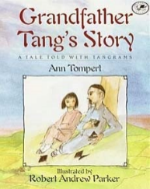
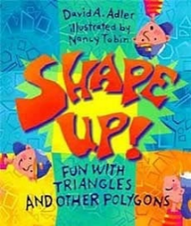
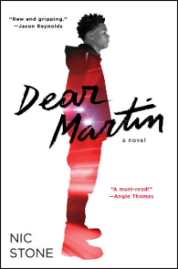
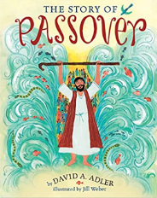

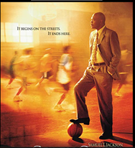

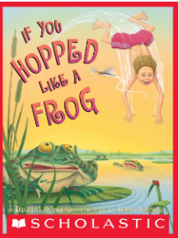

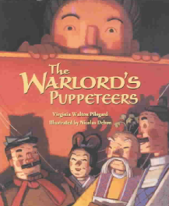

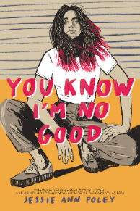
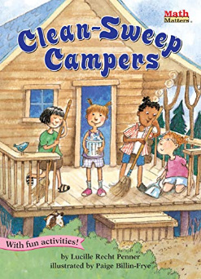

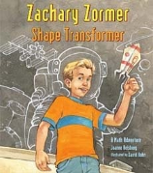
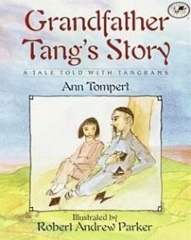
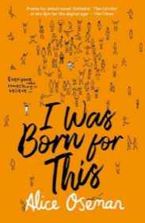

SUBJECT | THIS HALF TERM, STUDENT'S WILL BE WORKING ON… | READING MATERIAL
Art and Design | Portraiture | Facial Proportions - How to Draw a Face https://thevirtualinstructor.com/facialproportions.html  How to draw eyes - https://thevirtualinstructor.com/Graphiteeye1.html  How to draw a portrait - https://drawingacademy.com/how-to-draw-a-portrait  https://www.tate.org.uk/art/art-terms/p/portrait  Frida Khalo - https://www.tate.org.uk/tate-etc/issue-4-summer-2005/frida-on-my-mind  Leonardo Da Vinci - https://www.leonardo-da-vinci.net/drawings/  Portrait in pencil - https://www.artistsandillustrators.co.uk/how-to/drawing/how-to-draw-a-portrait-in-pencil/
Computer Science | Python programming and cyber security | Ghost In The Wires: My Adventures as the World's Most Wanted Hacker, by Kevin Mitnick and William Simon  https://cybergamesuk.com/cybergames  https://cyberskillslesson.com/  Python for kids, a playful introduction to programming, by Jason. R. Briggs  Coding Projects in Python, by DK
Design Technology |  | https://successatschool.org/advicedetails/335/Why-Study-Design-and-Technology%3F  https://cat.org.uk/info-resources/zero-carbon-britain/
Drama |  | Nic Stone  Jessie Ann Foley  by Malorie Blackman  by Alice Oseman  by Tiffany D Jackson
English | Rome and Juliet, William Shakespeare | Our Town – Thornton Wilder  Daz 4 Zoe – Robert Swindells  Rani and Sukh – Bali Rai  The Translator – Leila Aboulela  Peacock Spring – Rumer Godden  Peter Pan – J. M. Barrie - https://uxbridge.eplatform.co/title/9789629543808/mp3?pid=100090813  A Midsummer Night’s Dream – William Shakespeare - https://uxbridge.eplatform.co/title/9789629546915/mp3?pid=100087496
Geography | Coastal features | Waves and beaches: The powerful dynamics of sea and coast by Kim McCoy  Disappearing Destinations: Climate Change and Future Challenges For Coastal Tourism by A Jones.
History | Mansa Musa | Why has Mansa Musa been described as the greatest Mansa in history?  - Mansa Musa: The Richest Man In History, by Mike McCraw  - Mansa Musa and Timbuktu: A Fascinating History ... by World Changing History  - Ancient African Kingdoms: A Captivating Guide to Civilizations of Ancient Africa  - Mansa Musa (c.1280-c.1337) and the Mali Empire: https://www.pearson.com/content/dam/one-dot-com/one-dot-com/uk/documents/subjects/humanities/history-topic-of-the-month-mansa-musa-print-worksheet.pdf  - BBC Bitesize – Mali and Mansa Musa: https://www.bbc.co.uk/bitesize/topics/zj4fn9q/articles/zjch6g8  - Mansa Musa and the Empire of Mali: A true Story of Gold and Greatness from Africa by P. James Oliver  - Amazing Muslims who changed the world by Burhana Islam  - Africa kingdoms: West Africa by Katie Amery, Teni Gogo and Aaron Wilkes  - Children of the Benin kingdom by Dinah Orji  - The Mali Empire: The complete history of the Mali Empire by J P Martin
Mathematics | Transformations, Decimals and Ratio | Shape up  Grandfather Tang’s story  Shape transformer  Clean-sweep camp  Warlord’s puppeteers  If you hopped like a frog
Modern Foreign Language | The topic of holidays and special occasions in both French and Spanish. This includes developing students’ awareness of different French-speaking and Spanish-speaking locations. | https://snappyspanish.com/  https://lingua.com/spanish/reading/sevilla/  https://spanish.kwiziq.com/learn/reading  https://lingua.com/french/reading/  https://www.thoughtco.com/vocabulary-lesson-french-for-travelers-4079084  https://parisoclock.com/2019/02/14/read-french-books-to-learn-french/
Music | Popular music techniques | The Top 100 Albums of All Time, by Dave Whitaker  Rolling Stone Music Magazine: https://www.rollingstone.com/music/Sing Vocal Warm-Ups for All Styles Vce (Book & Download code for music backing) by Paul Knight  Mojo Chart of best ever albums https://www.besteveralbums.com/thechart.php?c=5
Physical Education |  | Fittest in Dubai  Coach Carter
Religious Education |  | The Story of Passover Paperback – Picture Book, 15 Jan. 2015
Science |  | ‘The Periodic Table’ by Primo Levi. This book combines Levi’s two loves- chemistry and writing  The Pleasure of Finding Things Out - Richard Feynman  Caesar's Last Breath: Decoding the Secrets of the Air Around Us - Sam Kean

