
YEAR 7 SPRING 1 WIDER READING LISTS

Students are encouraged to develop a wider understanding of the topics they will learn this half term. All texts listed are aspirational: you are not required by the school to buy any of these for your subjects.

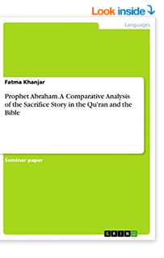
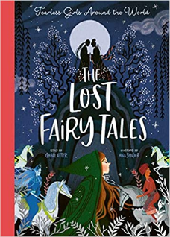

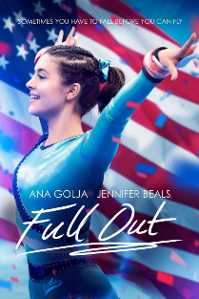
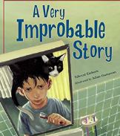
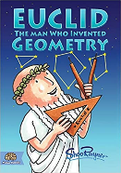
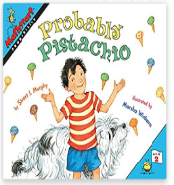

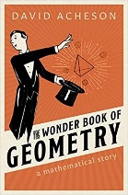
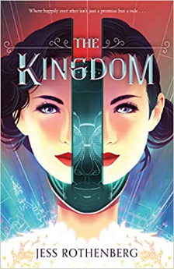



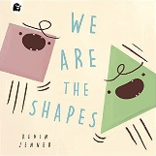
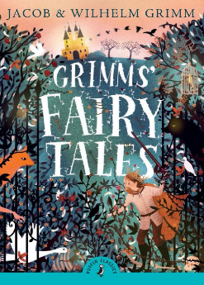

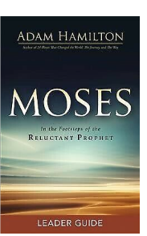
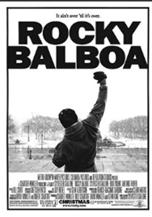
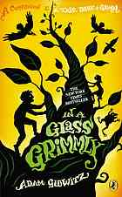
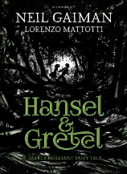
SUBJECT | THIS HALF TERM, STUDENT'S WILL BE WORKING ON… | READING MATERIAL
Art and Design | Landscapes | One-point perspective - https://www.youtube.com/watch?v=XRrKohWdpeQ  Perspective - https://www.johnlovett.com/perspective-drawing  Basics of lineal perspective - https://mymodernmet.com/perspective-drawing/  Introduction to drawing with perspective - https://www.jacksonsart.com/blog/2019/05/01/how-to-draw-with-perspective-2/  Gustave Caillebotte - https://www.thoughtco.com/biography-of-gustave-caillebotte-french-impressionist-painter-4797962  Claude Monet - https://www.claudemonetgallery.org/biography.html
Computer Science | Game development & Web awareness | Minecraft: The End, Catherynne, by M. Valente  Fortnite: The Essential Guide to Battle Royale and Other Survival Games  The Gaming Overload Workbook: A Teen's Guide to Balancing Screen Time, Video Games, and Real Life, by Randy Kulman  Social Media Survival Guide (Usborne Life Skills), by Hollie Bathie  The teenage Guide to life online, by Nicola Morgan
Design Technology | Product design and processes  www.technologystudent.com | https://successatschool.org/advicedetails/335/Why-Study-Design-and-Technology%3F  http://www.design-technology.info/home.htm  https://www.thetech.org/search?search=grabber
Drama |  | Cruikshank, George  Haig, Matt  Gaiman, Neil  Gidwitz, Adam  Jess Rothenberg  Isabel Otter
English | Ghost Boys by Jewell Parker Rhodes | Boys Don’t Cry – Malorie Blackman https://uxbridge.eplatform.co/title/9781448194551/mp3?pid=100143020  Sheets – Brenna Thummler  Boy in the Tower – Polly Ho-Yen  Escape Room – Christopher Edge  The Stars Beneath our feet – David Barclay Moore  When the Sky Falls – Phil Earle
Geography | Africa and Kenya | Lonely Planet Kenya (Travel Guide) by Anthony Ham  Africa is not a country: Breaking stereotypes of modern Africa by Dipo Faloyin  The Power of Geography: Ten Maps that reveal the future of our world by Tim Marshall  One of them by Eti Dayan
History | The Crusades | - The Third Crusade 1191: Richard the Lionheart, Saladin and the struggle for Jerusalem by David Nicolle  - The Crusades: The War for the Holy Land by Thomas Asbridge  - Chronical of the Crusades by Jean Joinville  - The First Crusade: The Call from the East by Peter Frankopan  - What were the Crusades? https://www.historyforkids.net/the-peasants-revolt.html?utm_content=cmp-true  - KS3 History 4th Edition: Invasion, Plague and Murder: Britain 1066-1558 Student Book by Aaron Wilkes  - What’s in Jerusalem? The Story of the Crusades by Baby Professor  - The Crusades Explained for Kids: The English Reading Tree by Keith Goodman  - Richard the Lionheart: The Life of a King and Crusader by David West and Gaff Jackie  - Saladin: The Muslim Warrior who Defended his People by Flora Geyer
Mathematics | Geometry and probability | Euclid, the man who invented geometry  We are the shapes  Probable Pistachio  The wonder book of geometry  A very probably story  It’s probably Penny
Modern Foreign Language | French - Describing their school and talking about their school subjects and their life at school. In Spanish, students are learning to talk about their free time and social activities, and how they spend time with their family and friends. | https://french.kwiziq.com/learn/reading  https://blog.lingoda.com/en/french-comics/  https://www.talkinfrench.com/french-comics-learn-french/#tab-con-20  https://www.fluentu.com/blog/spanish/spanish-comic-books/  https://lingua.com/spanish/reading/tiempo-libre/  https://snappyspanish.com/
Music | Music in advertising | Strike The Right Chord: A DIY Guide to Global Success in Today's Music Industry by Paul AlexanderTV Ad Music Website: https://www.tvadmusic.co.uk/2013/04/the-very-best-tv-ad-songs/  NME best songs used in advertising:  https://www.nme.com/features/the-best-songs-in-tv-advert-history-3234784
Physical Education |  | Rocky Balboa  Stick It  Full Out  The Miracle Season
Religious Education |  | Moses : In the Footsteps of the Reluctant Prophet, Paperback by Hamilton, AdamProphet Abraham. A Comparative Analysis of the Sacrifice Story in the Qu'ran and the ible
Science |  | Frankenstein's Cat (2013) by Emily Anthes  From the petri dish to the pet shop, meet the high-tech menagerie of the near future, as humans reinvent the animal kingdom  A Short History Of Nearly Everything (2003) by Bill Bryson  Bill Bryson describes himself as a reluctant traveller: but even when he stays safely in his own study at home, he can’t contain his curiosity about the world around him.  Uncle Tungsten by Oliver Sacks. Read about Oliver Sacks’ chemical boyhood

