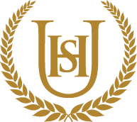

Year 7
WIDER READING LISTS
Organised by subject
Autumn 2

- Students are encouraged to develop a wider understanding of the topics that they will be taught this Half Term.

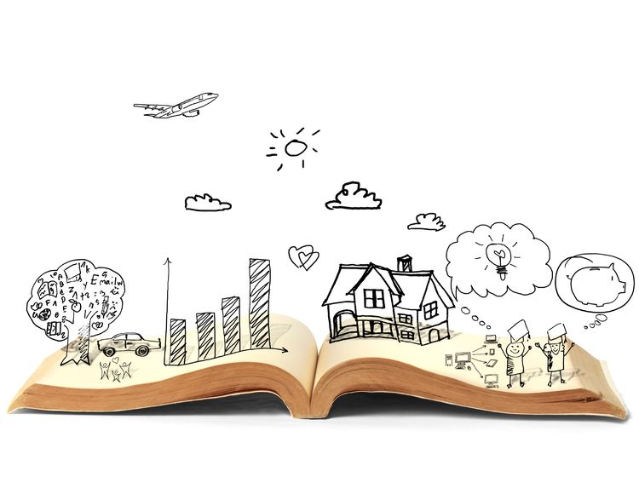
All texts listed are aspirational: you are not required by the school to buy any of these for your subjects.

Art and Design
This half term, students working on

Computer Science
This half term, students will be working on Game Development & web awareness. Suggested wider reading to widen their learning is;

https://www.bbc.co.uk/bitesize/articles/zb38y9q
https://www.bbc.co.uk/bitesize/guides/z2g7p39/revision/1
https://www.bbc.co.uk/bitesize/topics/zf2f9j6/articles/zw96tfr
https://www.bbc.co.uk/bitesize/clips/zqvbr82
https://www.bbc.co.uk/bitesize/guides/z9p9kqt/revision/1
https://www.bbc.co.uk/bitesize/guides/zrtrd2p/revision/1
https://www.bbc.co.uk/bitesize/topics/z3tbwmn/articles/zgwnsbk
https://www.bbc.co.uk/bitesize/topics/zs7s4wx/articles/z3tbgk7

Design and Technology
This half term, students will be working on . Suggested wider reading to widen their learning is;

Drama
This half term, students will be exploring the theme

English

This half term, students will be studying My Sister Lives on

Geography

This half term, students will be studying the concept of weather and climate change. Suggested wider reading for this topic includes:

- https://www.bbc.co.uk/bitesize/topics/zx38q6f
- https://www.youtube.com/watch?v=cl4Uv9_7KJE
- There is no planet B: a handbook for the make or break years by Mike Berners-Lee.
History
- Medieval Life by John Guy
- Robin Hood and the Magna Carta by Reynold Jay
- Rough Ride to Runnymede: A Magna Carta Adventure by Cat Glass
- Medieval Life by DK
- Medieval Knights by Louise Park
- What was it like in a Medieval Society? https://www.bbc.co.uk/bitesize/topics/zbn7jsg/articles/zwyh6g8
- Medieval Life https://www.historyonthenet.com/category/medieval-life
- Life in a Medieval Village https://www.youtube.com/watch?v=yq3q7KMlvw0
- Don’t let the Barber Pull your Teeth: Could you Survive Medieval Medicine? By Carmen Bredeson
- There is a Rat in my Soup: Could you Survive Medieval Food? By Chana Stiefel

Silk Road
- Life Along the Silk Road by Susan Whitfield
- The Silk Roads: The Extraordinary History that created your World - Illustrated Edition by Peter Frankopan
- The Silk Road https://www.bbc.co.uk/programmes/p03qb130/clips
- The Silk Road: Connecting the Ancient World Through Trade https://www.youtube.com/watch?v=vn3e37VWc0k
- Empires of the Silk Road: A History of Central Eurasia from the Bronze Age to Present by Christopher Beckwith
- The Three Hares: The Gold Monkey Key: The Gold Monkey Key 2 by Scott Lauder and David Ross
- The Silk Roads: The Present and Future of the World by Peter Frankopan
- Timeless on the Silk Road: An Odyssey from London to Hanoi
- Story of the Silk Road: Discover how the Secrets of Silk Changed the World Forever, Explore the Route Connecting the Ancient East and West by Damon Luxifey
- Stories from the Silk Road by Cherry Gilchrist

Music

This half term, students will be studying how festive times create thought provoking music:

- War is Over
War is over,
if you want it.
War is over now…
Lyrics to Read:
https://www.smule.com/song/john-lennon-the-plastic-ono-band-happy-xmas-war-is-over-karaoke-lyrics/3770411_3770411/arrangement
Music to Hear:
Happy Christmas (War Is Over) - John Lennon • Lyrics •

- Walking in The Air
We're walking in the air
We're floating in the moonlit sky
The people far below
are sleeping as we fly…
Lyrics to Read:
https://www.smule.com/song/connie-talbot-walking-in-the-air-karaoke-lyrics/337781091_304117/arrangement
Music to Hear:
SNOWMAN WITH LYRICS

Physical Education
This half term, students will be working on the muscles and bones of the body.

https://www.bbc.co.uk/bitesize/guides/zpkr82p/revision/1

https://www.bbc.co.uk/bitesize/guides/zq3sbk7/revision/1

Religious Education
This half term, students will be working on

Science

This half term, students will be working on

