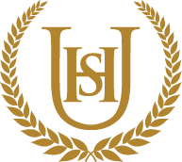

Year 9
WIDER READING LISTS
Organised by subject
Autumn 2

- Students are encouraged to develop a wider understanding of the topics that they will be taught this Half Term.

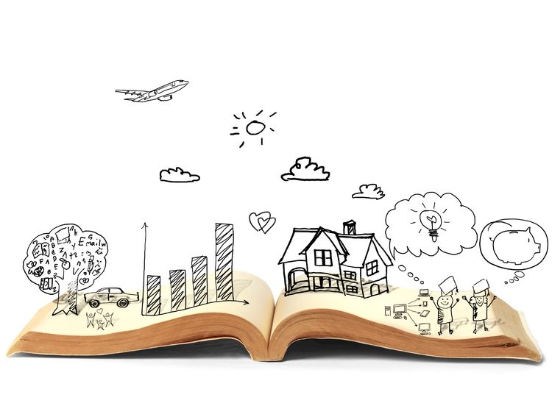
All texts listed are aspirational: you are not required by the school to buy any of these for your subjects.

Art and Design
This half term, students working on a Pattern Project, inspired by Yayoi Kusama. Suggested wider reading to widen their learning is;

- Infinity Net: The Autobiography of Yayoi Kusama by Yayoi Kusama
- We are Artists: Women who made their mark on the world by Kari Herbert
- Pattern Design by Elizabeth Wilhide
- Principles of Pattern Design by Proctor, Richard M.
- History of Clay - https://www.lakesidepottery.com/HTML%20Text/brief%20history%20of%20clay_pottery.htm
- Clay Tips - https://www.artistsandillustrators.co.uk/how-to/sculpture/beginners-guide-to-sculpting-in-clay/
- How To Make A Clay Pumpkin - https://www.instructables.com/Clay-Pumpkins/
- Yayoi Kusama - https://www.tate.org.uk/kids/explore/who-is/who-yayoi-kusama
- https://www.tate.org.uk/whats-on/tate-modern/yayoi-kusama-infinity-mirror-rooms

Computer Science
This half term, students will be working on Networks and Hardware/software . Suggested wider reading to widen their learning is;

https://www.bbc.co.uk/bitesize/guides/zc6rcdm/revision/1
https://www.bbc.co.uk/bitesize/guides/zc6rcdm/test
https://www.bbc.co.uk/bitesize/topics/zs7s4wx/articles/z78nydm

Design and Technology
This half term, students will be working on . Suggested wider reading to widen their learning is;

Drama
This half term, students will be working . Suggested wider reading to widen their learning is;

The Riots: From Spoken Evidence
By Gillian Stove
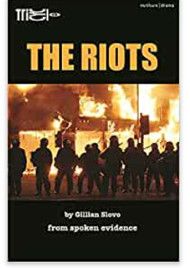

Introducing George The Poet: Search Party: A Collection of Poems
by George the Poet
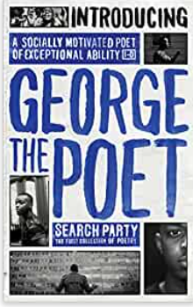

English

This half term, students will be studying Of Mice and Men. Suggested wider reading to widen their learning is;

Lord of the Flies – William Golding

A Separate Peace – John Knowles

The Great Gatsby – F. Scott Fitzgerald

Animal Farm – George Orwell

The Nickel Boys – Colson Whitehead

Purple Hibiscus – Chimamanda Ngozi Adichie

Fahrenheit 451 – ray Bradbury

The Catcher in the Rye – J. D. Salinger

The Outsiders – S. E. Hinton

Roll of Thunder, Hear my Cry – Mildred D. Taylor

Between Shades of Grey – Ruta Sepetys

Little Women – Louisa May Alcott

The Old Man and the Sea – Ernest Hemingway

The Secret Life of Bees – Sue Monk Kidd

A Farewell to Arms – Ernest Hemingway

Life of Pi – Yann Martel

The Book Their – Markus Zusak

Geography

This half term, students will be working on Global Issues. Suggested wider reading to widen their learning is;

- https://www.bbc.co.uk/bitesize/topics/z8xvr82
- https://oceanservice.noaa.gov/hazards/marinedebris/plastics-in-the-ocean.html
- Plastic soup: An atlas of ocean pollution by Michiel Roscam Abbing
- It’s Up To Us: A Children’s Terra Carta for Nature, People and Planet by HRH King Charles III.
- https://www.youtube.com/watch?v=K48IsUdUKUs
- Down to Earth with Zac Efron (Netflix)

History
This half term, students will be working on World War One. Suggested wider reading to widen their learning is; Was World War One ‘Lions led by donkeys’?
- A Short History of the First World War – Gary Sheffield
- The Collected Poems of Wilfred Owen, Wilfred Owen
- Five Children on the Western Front- Kate Saunders
- War Horse- Michael Morpurgo
- Private Peaceful- Michael Morpurgo
- What Happened During The Battle Of The Somme? – Imperial War Museum (https://www.iwm.org.uk/history/what-happened-during-the-battle-of-the-somme)
- Were World War One Soldiers Really ‘Lions Led By Donkeys’? – Peter Curry (https://www.historyhit.com/were-world-war-one-soldiers-really-lions-led-by-donkeys/)
- The Winter Soldier – Daniel Mason
- Band of Sisters - Lauren Willig
- My Brother’s Shadow - Monika Schroder

Mathematics
This half term, students will be working on algebra. Suggested wider reading to widen their learning is;

The Number Devil: A Mathematical Adventure

Hans Magnus Enzensberger,

Alex's Adventures in Numberland by Alex Bellos
Who Invented Algebra? The History One of Mathematical Symbols (magnifymind.com)

Modern Foreign Languages

This half term, students will be working on what they like to do in their free time (French) and future plans and careers (Spanish). Suggested wider reading to widen their learning is;

https://www.twinkl.ca/resource/t3-fr-334-hobbies-translation-activity-sheet

https://globalcomix.com/browse/fr/comics/
https://french.kwiziq.com/blog/french-comics/
https://www.twinkl.com.au/resource/t3-sp-143-jobs-and-career-choices-spanish-translation-matching-cards-spanish
https://globalcomix.com/browse/es/comics/
https://spanishboom.com/spanish-comics-translation/
Music

This half term, students will be working on Film Music and music for Media. Suggested wider reading to widen their learning is;

Books:

The Foley Grail: The Art of Performing Sound for Film, Games, and Animation by Vanessa Ament

A History of Film Music by Mervyn Cooke

A Composer's Guide to Game Music by Winifred Phillips

Lyrics:
- The Power of Love (by Huey Lewis)
Don't need money,
don't take fame.
Don't need no credit card
to ride this train.
It's strong and it's sudden
and it's cruel sometimes,
but it might just save your life...
Lyrics to Read:
https://www.smule.com/song/huey-lewis-and-the-news-power-of-love-karaoke-lyrics/131667491_124973/arrangement
Music to Hear:
Huey Lewis and the News - The Power of Love (Lyrics)

- Ghostbusters
If there's something
strange in your neighborhood,
Who you gonna call?
Lyrics to Read:
https://www.smule.com/song/ray-parker-jr-ghostbusters-karaoke-lyrics/854040984_1426111/arrangement
Music to Hear:
Ray Parker Jr - Ghostbusters - Arista - 1984 - 7 Record (45 Rpm)

Physical Education
This half term, students will be working on: Netball, Table tennis, Rugby, Fitness. Suggested wider reading to widen their learning is;

Netball
- Geva Mentor – the Leap

Handball
- Handball, the story of Wales the first national sport by Kevin Dicks

Fittest in Dubai
- The first CrossFit sanctional event in the world. First place email and male competitors qualify for a position on the CrossFit games in the USA.

Religious Education
This half term, students will be working on. Suggested wider reading to widen their learning is;

The Case for the Resurrection of Jesus

Christian Beliefs Study Guide

Science
This half term, students will be working on Cell structure, Atoms and Energy stores. Suggested wider reading to widen their learning is;

The Disappearing Spoon by Sam Kean
The periodic table is a crowning scientific achievement, but it's also a treasure trove of adventure, greed, betrayal, and obsession. The fascinating tales in The Disappearing Spoon follow elements on the table as they play out their parts in human history, finance, mythology, conflict, the arts, medicine, and the lives of the (frequently) mad scientists who discovered them.
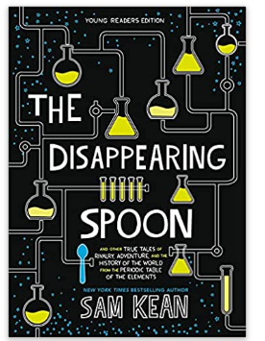

Z is for Zachariah by Richard O’Brian
Nuclear war has devastated America, except for the valley where Ann Burden has been living alone for over a year - until Loomis, a scientist in a radiation-proof suit, arrives. She hopes they will be companions but his behaviour towards her becomes increasingly threatening as he attacks her and then cuts off her food supply and tries to bring her under his control. Although there may be no one else alive, Ann steals his suit and leaves the valley in search of humanity.

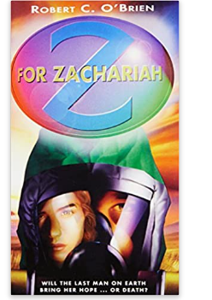

Shadow Jumper by J.M Forster
The truth is out there somewhere . . . but how far is Jack willing to jump to find it? Jack Phillips's allergy to sunshine confines him to the shadows, leaving him lonely and at risk of life-threatening burns every time he steps into the light. Shadow jumping on the rooftops at dusk makes him feel alive. And free. But Jack's condition is suddenly worse than ever and only his missing scientist dad can save him. As Jack and his new friend, Beth, begin their frantic search and delve into his dad's past for clues, they have no idea what they are about to uncover. Shocking rumours and dark secrets bombard them at every turn. Jack is brave on the roofs. But can he find the courage to face the truth?


