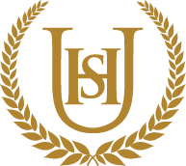

Year 8
WIDER READING LISTS
Organised by subject
Autumn 2

- Students are encouraged to develop a wider understanding of the topics that they will be taught this Half Term.

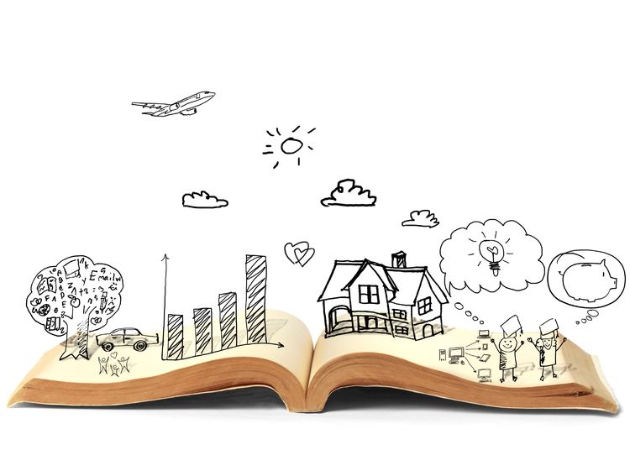
All texts listed are aspirational: you are not required by the school to buy any of these for your subjects.

Art and Design
This half term, students working on Natural Form Project. Suggested wider reading to widen their learning is;

- Drawing - A Complete Guide: Nature by Giovanni Civardi
- The Laws Guide to Nature Drawing and Journaling by John Muir Laws
- Drawing and Painting Insects by Andrew Tyzack
- How to be a wallpaper designer - https://www.skillshare.com/en/blog/how-to-be-a-wallpaper-designer/
- Make Your Own Wallpaper - https://www.canva.com/create/wallpapers/
- How To Create a Repeat Pattern - https://www.skillshare.com/en/blog/5-steps-to-illustrating-a-repeat-pattern-by-hand/
- Guide To Surface Design - https://www.skillshare.com/en/blog/a-guide-to-surface-design-and-pattern-design/
- How To Draw a Butterfly - https://www.wedrawanimals.com/how-to-draw-a-butterfly/

Computer Science
This half term, students will be working on Python coding and understanding Cyber Security . Suggested wider reading to widen their learning is;
Coding for Beginners: Using Python (Coding for Beginners) Louie Stowell

Computer Coding Python Projects for Kidsby Carol Vorderman
https://www.bbc.co.uk/bitesize/guides/zts8d2p/revision/1
https://www.bbc.co.uk/bitesize/topics/zhy39j6
https://www.bbc.co.uk/bitesize/guides/znnny4j/revision/1
https://www.bbc.co.uk/bitesize/guides/zbgg4qt/revision/2

Design and Technology
This half term, students will be working on . Suggested wider reading to widen their learning is;

Drama
This half term, students will be exploring the theme transformations through practical exercises. Suggested wider reading to widen there learning is;

The strange case of Dr. Jekyll and Mr. Hyde
by Robert Louis Stevenson

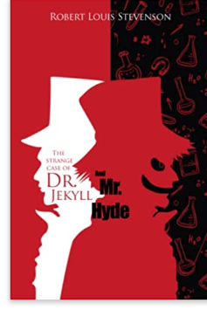

Macbeth
By William Shakespeare
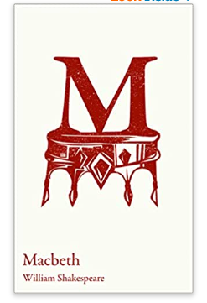

The Pants Project
by Cat Clarke
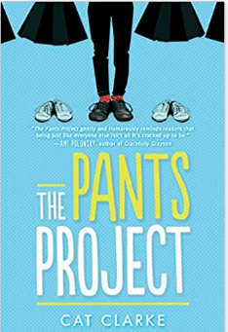

English

This half term, students will be studying My Sister Lives on the Mantelpiece. Suggested wider reading to widen their learning is;

The Boy at the back of the Class – Onjali Q. Rauf

Girl in Pieces – Kathleen Glasgow

Refugee Boy – Benjamin Zephaniah

I am Thunder- Muhammad Khan

Guantanamo Boy- Anna Perera

The Trap- Alan Gibbons

Eleven – Tom Rogers

Goldfish Boy – Lisa Thompson

Illegal – Andrew Donkin

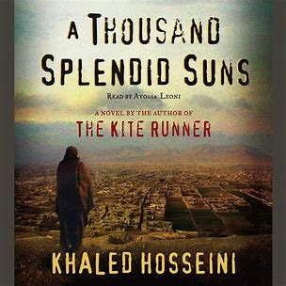

A Thousand Splendid Suns- Khaled Hosseini

The Boy with the Tiger’s Heart – Linda Coggin

The Proudest Blue- Ibtihaj Muhammad

Summer Bird Blue- Akemi Dawn Bowman

Sunny G’s Series of Rash Decisisons- Navdeep Singh Dhillon

The Island of Missing Trees- Elif Shafak

Geography

This half term, students will be working on Middle Eastern geography. Suggested wider reading to widen their learning is;

- https://www.britannica.com/place/Middle-East
- https://www.globalissues.org/article/119/the-middle-east-conflict-a-brief-background
- https://www.youtube.com/watch?v=fiscuIUz2EQ
- http://www.pbs.org/wgbh/globalconnections/mideast/themes/geography/index.html
- https://www.everyculture.com/Africa-Middle-East/Introduction-to-the-Middle-East-Physical-and-Human-Geography.html
- https://www.youtube.com/watch?v=Jlr_cp7News

History
This half term, students will be working on the English Civil War. Suggested wider reading to widen their learning is;

Why did the English fight the English in 1642?
- Revolution, Industry and Empire: Britain 1558-1901 by Aaron Wilkes
- The English Civil Wars (Beginner’s Guide) by Patrick Little
- The English Civil War Armies by Peter Young
- BBC Bitesize – The English Civil Wars: https://www.bbc.co.uk/bitesize/topics/zk4cwmn/articles/zxxgg7h
- Britannica Kids – English Civil War: https://kids.britannica.com/kids/article/English-Civil-War/476240
- Witch Child by Celia Rees
- British Civil Wars: https://britishcivilwars.ncl.ac.uk/
- No shame, No Fear by Ann Turnbull
- Rivalry and Conflict: Britain, Ireland and Europe, 1570- 1745 by Austin Logan, Kathleen Gormley and John Brogan

Maths

Murderous Equations – evil answers
The Secret Life of Equations: The 50 Greatest Equations and How They Work
The Ten Equations that Rule the World: And How You Can Use Them Too
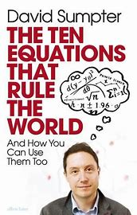

Modern Foreign Languages

This half term, students will be working on what they like to do in their free time (French) and healthy living and food and drink (Spanish). Suggested wider reading to widen their learning is;

https://www.twinkl.ca/resource/t3-fr-334-hobbies-translation-activity-sheet

https://lingua.com/french/reading/
https://www.fluentu.com/blog/french/easy-french-reading/
https://www.twinkl.co.uk/resource/t2-l-553-foods-i-like-and-dislike-activity-sheet
http://onlinespanishclub.com/easy-spanish-readers-and-spanish-english-parallel-texts/
https://www.spanish.academy/blog/20-free-spanish-books-novels-and-stories-in-pdf-and-printables/

Music

This half term, students will be working on Music from around the world. Suggested wider reading to widen their learning is;

- Govinda (by Kula Shaker)
Lyrics to Read:
https://lyricstranslate.com/en/govinda-lord-govind.html
Music to Hear:
Kula Shaker - Govinda (Live on 2 Meter Sessions)

- Release It (by Afro Celt Sound System)

Lyrics to Read:
https://www.streetdirectory.com/lyricadvisor/song/elpljo/release/
Music to Hear:
Afro Celt Sound System - Live

Physical Education
This half term, students will be working on Handball, Netball and Fitness. Suggested wider reading to widen their learning is;

Netball
- Geva Mentor – the Leap

This half term, students will also be working on the muscles and bones of the body.

https://www.bbc.co.uk/bitesize/guides/zpkr82p/revision/1

https://www.bbc.co.uk/bitesize/guides/zq3sbk7/revision/1
Religious Education
This half term, students will be working on world religions. Suggested wider reading to widen their learning is;

Simply Jesus - Who He Was, What He Did, Why it Matters

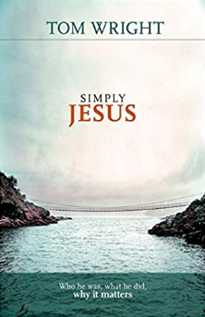

ZEALOT: The Life and Times of Jesus of Nazareth

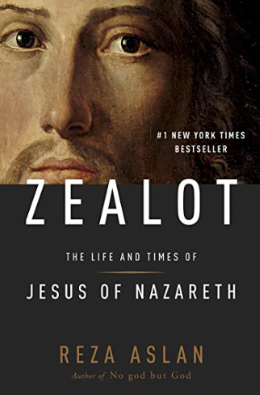

Muhammad: His Life Based on the Earliest Sources

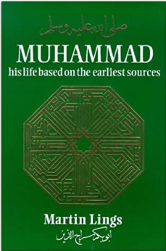

Science

This half term, students will be working on Organisms, Forces and Matter. Suggested wider reading to widen their learning is;

The Element in the room by Mike Barfield

Did you know that without the ‘lead’ in your pencil, there would be no life on Earth? Just about everything in the universe is made from only 92 elements – and from aluminium to zinc, many of them are hiding in your very own home! Packed-full with beautiful and quirky illustrations by Lauren Humphrey and written by multi-talented Mike Barfield, this is a unique and novel introduction to the elements in the periodic table that will excite all young readers as they join Sherlock Ohms on his investigations to solve the mystery of how absolutely everything came to exist!

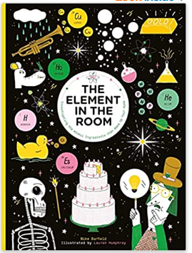

The Pig Heart Boy by Malorie Blackman
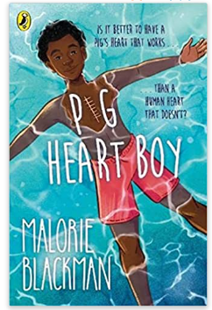

Cameron is thirteen, and all he wants is a 'normal' life - friends, swimming, school, family.
But his life is far from normal. Not every thirteen-year-old desperately needs a new heart because theirs doesn't work properly. Finally, one doctor offers hope.
Cameron could - if he and his parents agree - take part in a radical and controversial procedure involving the transplant of a pig's heart into his human body.It's risky. And it's never been done before . . .While Cameron comes to terms with the idea, he finds the world around him is much less accepting. But surely everyone will understand that it's better to have a pig's heart that works than a human heart that doesn't - won't they . . .?

The Fart that changed the World by Stephen Mangan
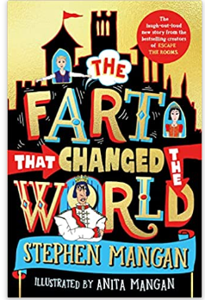
It's the most important day of the year for King Fabian as he is hosting all the neighbouring rulers. Everything simply must go perfectly.King Fabian wakes up, stretches, and...farts.His wife's fury is so huge that he panics and blames the butler, who is carted off to the dungeons. Leaving behind a big problem: Fabian isn't really the brains behind the crown: it is the butler... how will dithery Fabian manage to pull off this high-pressure event alone? His small and smelly fart looks like it will kick off a crisis...Frank - a kitchen boy with a big imagination - is drafted in as an emergency butler. As the banquet descends into a food fight and processions catapult out of control, Frank finds himself in an all-out farty farce. Can he save the day?

