
YEAR 9 Autumn 1 WIDER READING LISTS

Students are encouraged to develop a wider understanding of the topics they will learn this half term. All texts listed are aspirational: you are not required by the school to buy any of these for your subjects.

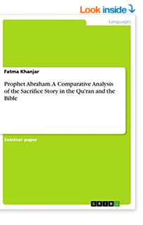
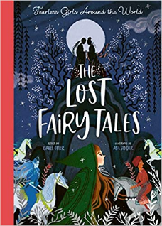

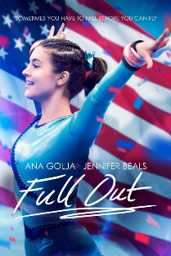
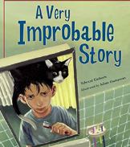
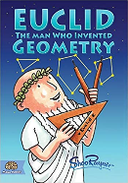
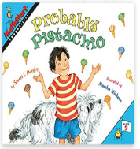

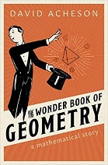
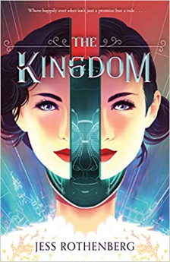

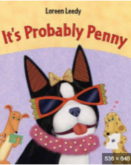

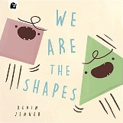
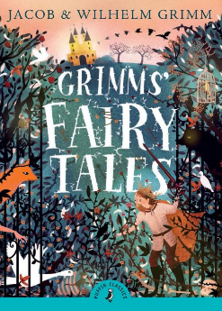
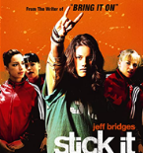
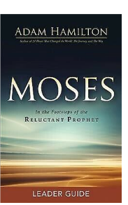
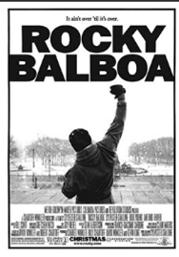
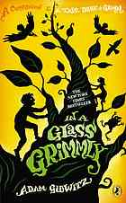
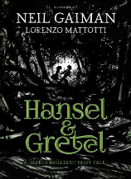
SUBJECT | THIS HALF TERM, STUDENT'S WILL BE WORKING ON… | READING MATERIAL
Art and Design
Computer Science | Computational thinking  Multimedia Products | https://www.bbc.co.uk/bitesize/guides/zp92mp3/revision/1  https://www.bbc.co.uk/bitesize/topics/z7tp34j  https://www.bbc.co.uk/bitesize/guides/z4rbcj6/revision/1  https://www.bbc.co.uk/bitesize/topics/z3mtsbk  https://www.bbc.co.uk/bitesize/guides/zcbqrwx/revision/1  https://www.bbc.co.uk/bitesize/topics/zsb797h
Design Technology
Drama
English | Merchant of Venice | https://www.bl.uk/shakespeare/articles/how-were-the-jews-regarded-in-16th-century-england  https://www.bl.uk/shakespeare/articles/an-introduction-to-shakespeares-comedy  https://www.bl.uk/shakespeare/articles/a-jewish-reading-of-the-merchant-of-venice  https://www.bbc.co.uk/bitesize/topics/z3nc4xs/articles/zbq3cxs
Geography | The geography of conflict, looking at how war can shape both human and physical characteristics of a place. | - https://www.bbc.co.uk/bitesize/topics/zjsc87h/articles/zjqwjsg  - Prisoners of Geography by Tim Marshall  - A long way gone by Ishmael Bear
History |  | What can sources tell us about the British Empire?  - Partition Voices – Kavita Puri  - Empireland – Sathnam Sanghera  - Stolen History: The truth about the British Empire and how it shaped us - Sathnam Sanghera  - The Hungry Empire: How Britain’s Quest for Food Shaped the Modern World - Lizzie Collingham  - Barmy British Empire – Terry Deary  - Empire: What Ruling the Word Did to the British – Jeremy Paxman  - The British Empire: An overview – BBC Bitesize (https://www.bbc.co.uk/bitesize/topics/z7kvf82/articles/zpjv3j6)  - Old Filth – Jane Gardam  - The Piano Teacher – James Mason  - Burmese Days – George Orwell
Mathematics

Modern Foreign Language

Music | Curriculum Map Theme:  Music in Media  (Film, Games, Marketing) | - Kiss from a Rose  There used to be a greying tower alone on the sea.  You became the light on the dark side of me...  Lyrics to Read:  https://www.smule.com/song/seal-kiss-from-a-rose-karaoke-lyrics/3770289_3770289/arrangement  Music to Hear:  Kiss from A Rose - Seal ( Lyrics )  - It Had to be You  Some others I've seen  Might never be mean,  Might never be cross,  or try to be boss,  but they wouldn't do...  Lyrics to Read:  https://www.smule.com/song/frank-sinatra-1943-it-had-to-be-you-karaoke-lyrics/14299249_14299249/arrangement  Music to Hear:  Harry Connick Jr. - It Had to Be You (Lyrics)
Physical Education | Muscular System | https://www.bbc.co.uk/bitesize/guides/zpkr82p/revision/1
Science |  | - The Periodic Tales: The Curious Lives of the  Elements  - http://www.bbc.co.uk/news/science_and_environment - The BBC news page for Science and the Environment | Hugh Aldersey-Williams (ISBN: 978-0141041452)  - S.T. Beckett
  - The Science of Chocolate

