
YEAR 8 Autumn 1 WIDER READING LISTS

Students are encouraged to develop a wider understanding of the topics they will learn this half term. All texts listed are aspirational: you are not required by the school to buy any of these for your subjects.

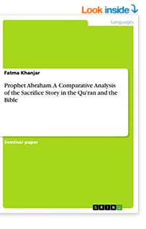
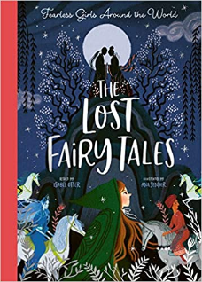

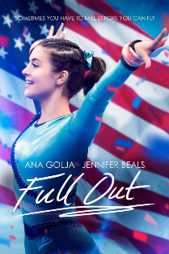
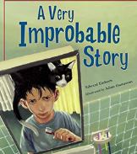
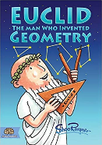
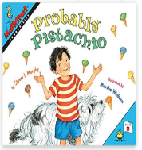

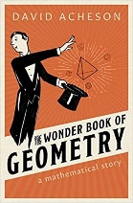
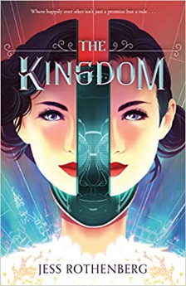



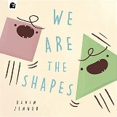
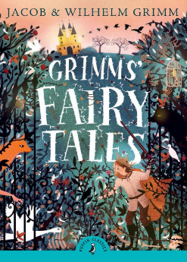

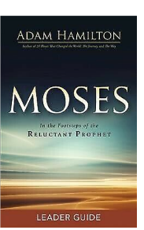
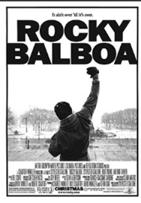
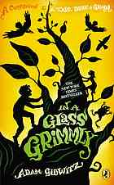
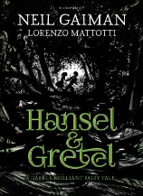
SUBJECT | THIS HALF TERM, STUDENT'S WILL BE WORKING ON… | READING MATERIAL
Art and Design |  | I
Computer Science | Cryptography  Data (Spreadsheets) | https://www.bbc.co.uk/bitesize/guides/zycm97h/revision/2  https://www.bbc.co.uk/bitesize/guides/zf3bcj6/revision/3  https://www.bbc.co.uk/bitesize/guides/zdydmp3/revision/1  https://www.bbc.co.uk/bitesize/guides/z8f82hv/revision/3
Design Technology
Drama
English | Romeo and Juliet | https://www.bl.uk/shakespeare/articles/daughters-in-shakespeare-dreams-duty-and-defiance  https://www.bl.uk/shakespeare/articles/character-analysis-benvolio-mercutio-and-tybalt-in-romeo-and-juliet  https://www.bbc.co.uk/bitesize/topics/zfdj6sg  https://www.bl.uk/shakespeare/articles/character-analysis-romeo-and-juliet  https://www.rsc.org.uk/shakespeare-learning-zone/romeo-and-juliet
Geography | Development and globalisation, with a focus on India. | - https://www.bbc.co.uk/bitesize/guides/zc72frd/revision/2  - https://www.cgdev.org/blog/future-globalization  - https://www.youtube.com/watch?v=8UbKpTwGuSs
History |  | Was the reign of Elizabeth I a ‘golden age’?  - Revolution, Industry and Empire: Britain 1558-1901 by Aaron Wilkes  - Elizabeth I & The Elizabethan Settlement by Oaka Books  - BBC Bitesize – Who was Elizabeth I: https://www.bbc.co.uk/bitesize/topics/zwcsp4j/articles/zg7d8hv  - BBC Bitesize – Elizabethan Rule: https://www.bbc.co.uk/bitesize/topics/zwcsp4j/articles/zsysn9q?topicJourney=true  - History KS3: To what extent was life changing in Elizabethan England? https://www.bbc.co.uk/teach/class-clips-video/history-ks3-to-what-extent-was-life-changing-in-elizabethan-england/zj6mnrd  - Dangerous days in Elizabethan England by Terry Deary  - The Time Traveller’s guide to Elizabethan England by Ian Mortimer  - Tudor by DK (Eyewitness)  - Tudors & Stuarts (Usborne History of Britain) by Fiona Patchett  - Tarnish by Katherine Longshore
Mathematics

Modern Foreign Language
Music | Focus on the Orchestra by looking at its use in video games and media. | Florence & The Machines cover of ‘Stand by Me’ made for the game Final Fantasy 15. - Lyric Video https://www.youtube.com/watch?v=qv6aw5a8oY8&ab_channel=PazyPlayz  Lyrics - https://genius.com/Florence-the-machine-stand-by-me-lyrics
Physical Education | Focus on our diet and nutrition | Anita Bean— The complete Guide to Sports Nutrition
Science |  | - Horrible Science by Nick Arnold and Phil Gates  - Pig Heart Boy by Malorie Blackman

