
YEAR 7 Autumn 1 WIDER READING LISTS

Students are encouraged to develop a wider understanding of the topics they will learn this half term. All texts listed are aspirational: you are not required by the school to buy any of these for your subjects.

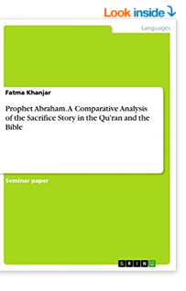
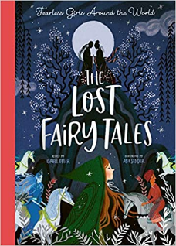

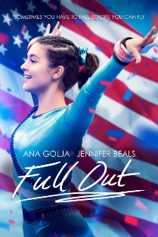
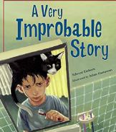
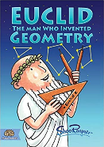
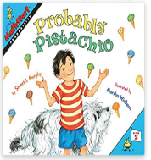

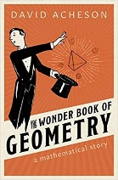
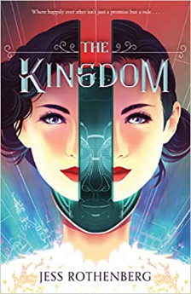
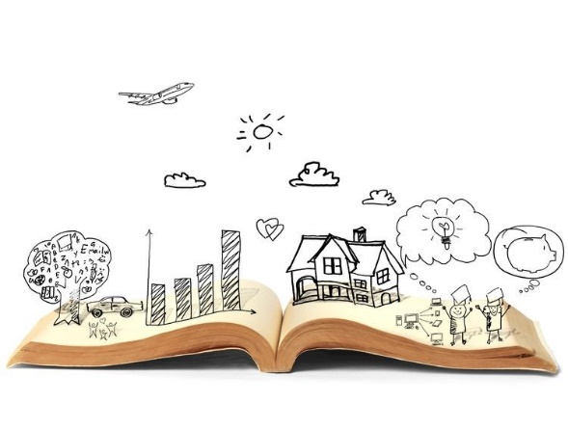
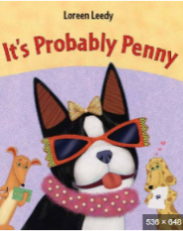

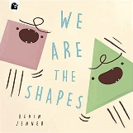
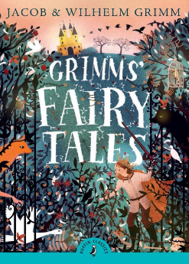

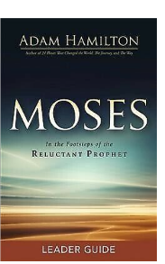
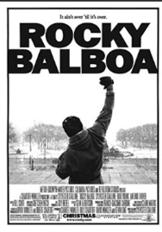
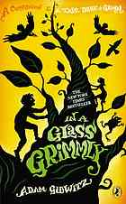
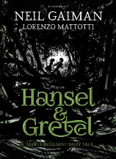
SUBJECT | THIS HALF TERM, STUDENT'S WILL BE WORKING ON… | READING MATERIAL
Art and Design
Computer Science | Cyber Safety  Computer Control | https://families.google/external/interland/  https://beinternetlegends.withgoogle.com/en_uk/parents/adventure  https://www.bbc.co.uk/bitesize/guides/zrtrd2p/revision/1  https://www.bbc.co.uk/bitesize/guides/zfjsgk7/revision/1  https://www.bbc.co.uk/bitesize/guides/zh27kmn/revision/1  https://www.youtube.com/watch?v=alWdhfVs2vk
Design Technology
Drama
English | Arctic Explorers | Survivors- David Long  The Polar Bears Explorer Club- Alex Bell  Shackleton’s Journey- William Grill  The Wild Silence- Raynor Winn  Great Expeditions: 50 Journeys that changed our world-Mark Seward  Explorers: Amazing Tales of the World's Greatest Adventurers-Nelly Huang  The Last Bear-Hannah Gold  Race to the Frozen North: The Matthew Henson Story-Catherine Johnson  The Arctic Railway Assassin- M.G Leonard  Travelling Wild: Expedition to the Arctic-Alex Woolf  Incredible Journeys: Discovery, Adventure, Danger, Endurance- Levison Wood  Alone on the Ice: The Greatest Survival Story in the History of Exploration-David Roberts  The Impossible Rescue: The True Story of an Amazing Arctic Adventure Paperback-Martin Sandler
Geography | Fantastic places – exploring the wonders of geography around the world, with a focus on map skills. | - https://www.bbc.co.uk/bitesize/topics/zd3dwnb  - https://kids.nationalgeographic.com/geography/countries/article/iceland  - https://kids.nationalgeographic.com/geography/countries/article/egypt  - https://www.bbc.co.uk/bitesize/guides/zp46sg8/revision/5
History | Battle of Hastings | - William The Conqueror Becomes King of England - History for Kids Books | Children's European History by Baby Professor  - I Was There… 1066 by by Jim Eldridge  - Stormin' Normans by by Terry Deary  - Hastings (Battles that Changed the World) by Samuel Willard Crompton  - Norman Britain for Kids by Keith Goodman  - The Battle of Hastings https://www.bbc.co.uk/bitesize/topics/zshtyrd/articles/z9mw8hv  - Normans https://www.bbc.co.uk/history/british/normans/  - The Fighting Man: A 1066 Adventure by Thomas Croft  - Battle of Hastings (Why do we Remember?) by Claudia Martin  - William the Conqueror’s Secret Diary by Terry Deary and Mike Phillips
Mathematics

Modern Foreign Language
Physical Education | Exploring the importance of staying healthy and what that looks like in teenagers | - https://www.niddk.nih.gov/health-information/weight-management/take-charge-health-guide-teenagers
Music | Curriculum Map Theme:  Superheroes and Music | - Something Just Like This by Coldplay  I’ve been reading books of old  The legends and the myths  Achilles and his gold  Hercules and his gifts…  Lyrics to Read:  https://www.coldplay.com/song/something-just-like-this/  Music to Hear:  The Chainsmokers & Coldplay - Something Just Like This (Lyric)  - We Don’t Need Another Hero by Tina Turner  Out of the ruins  Out from the wreckage  Can't make the same mistake this time  We are the children  The last generation  We are the ones they left behind…  Lyrics to Read:  https://www.smule.com/song/tina-turner-we-dont-need-another-hero-karaoke-lyrics/9952192_9952192/arrangement  Music to Hear:  Tina Turner - We Don't Need Another Hero (LYRICS)
Science |  | - The Body: Bill Bryson  - This Going to Hurt: Adam Kay  - https://www.nhm.ac.uk/discover/news/2023/july/cambrian-apex-predator-probably-preferred-soft-bodied-prey.html The London Natural History Museum’s website with lots of interesting science news.

