


Sixth Form Transition Pack
A-LEVEL ECONOMICS

COURSE INTRODUCTION
Possibly without realising it you are already an active part of the global economic system: whether you are buying clothes that cost 50 percent more than their manufacturing cost, lamenting the price of petrol, paying more for flights at the weekends, not getting paid enough for your weekend job, employing someone else to do your homework, avoiding your taxes or wondering just why some people are far richer than you. Well, what better way to stay afloat, get ahead or help others than by studying economics?

Studying economics will help you understand why prices fluctuate, where your taxes go, how government legislation can push people to change their spending habits (or not), why some companies dominate their market, how global or societal changes like climate change and ageing can have an impact on a country’s economy, why people fight for resources and why certain economies grow faster than others.

You will also learn how to analyse complex issues, create strategies, monitor the political climate, understand commercial incentives, problem solve, interpret statistics and data, explain your ideas clearly and be ready for any eventuality – all highly desirable and transferable skills.

Economics is an intellectually challenging subject that universities hold in high regard. The answers to these questions will provide an insight to the strategies of some of the most successful organisations in the world. A-level economics is not only a qualification; it’s a handbook for anyone thinking of entering the complex world of commerce.

“Economics is everywhere, and understanding economics can help you make better decisions and lead a happier life.”
Tyler Cowen, economics professor and New York Times columnist.

In the first year, you will be introduced to the basic economic problem of scarcity, unlimited wants, and how the market allocates scarce resources. You will consider the government’s

role in managing the economy and how it achieves the macroeconomic objectives of economic growth, reducing unemployment, and equality in the distribution of income.

In the second year, you learn about the economics of business behaviour. For example, you will study how firms make price and output decisions and how the behaviour of one firm is affected by the actions of another. You will also study global economics and consider issues such as trade, globalisation, and development. Furthermore, you will learn about the role of banks and financial markets in the global economy.

Throughout the course you will develop knowledge of the main economic trends over the past 25 years and be able to compare recent and historical economic events. You will also be introduced to different economic thinkers and look at how these thinkers have influenced economic policy and debate.

Expectations of you
The economics A-level course is the next step after successfully completing GCSEs. A-levels are designed to build on your previous learning and knowledge and assist you in developing the necessary skills to complete the course. In order for you to excel at A-Level and achieve your targets, you need to acknowledge and agree to the following;

- Attendance = attainment. Attend all lessons, arrive on time and bring all the necessary equipment and resources. Do not book appointments during lesson hours.
- Work to the best of your ability in class and focus on the lesson
- Listen respectfully to the views of other students and consider how your own views are developing
- Complete all homework on time – this includes printing out resources
- Keep up-to-date with economics in the news either online or via newspapers
- Complete all necessary research (as directed)
- Make sure you check your emails and are part of the relevant email groups for additional resources and tasks.
- Attempt all work. If you are unsure of what to do, of course you may ask questions, but you must develop greater independence
- Take advantage of any spare time to work develop your ideas or seek help on areas you’re unsure of
- Keep to deadlines!

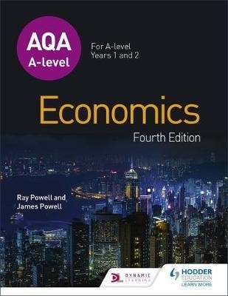
Essential summer reading
There is an official textbook (covering the AS and A Level units) available for you to read ahead and develop an initial understanding of our topics.

We study for the AQA exam board qualification, use their website to see the specification. http://www.aqa.org.uk/subjects/economics/as- andalevel/economics-7135-7136

And you can look online at additional resources, especially here: www.tutor2u.net/economics

Check the BBC News website for breaking news under the ‘UK economy’ tab once a week. Alternatively, the school has free Financial Times online access via the following link: https://www.ft.com/corp-signup/join?token=36fddb98-6bc1-4a7e-a735-3109a4e044a6 (Please note that you must be on the school’s network to access this link.
Print off stories that link to specific areas of the course, read and annotate them, and add to your file at the relevant point. Keeping up-to-date with current affairs is essential for Business Studies and we expect students to regularly read newspapers and magazines, and watch programmes like Newsnight and Question Time.

Task to be completed
If you’ve just finished your GCSE in Business Studies, you’ll be familiar with the exam technique and structure.

The following tasks are designed to develop your exam technique for A-level standard, highlight your current strengths in writing and developing an answer and provide you with an example of the types of questions you may be asked in an A-Level economics exam. You should attempt to answer all of the questions (the multiple choice questions have come from a past A-Level paper!) Questions and terminology you are unfamiliar with should be researched and an answer must be given for all questions.

Section One
Multiple choice questions. Highlight one answer from the possible options – you may have to look up some of the terms and theory. Answer all ten questions.
1. Which one of the following applies to merit goods?
a) Their marginal private benefit is greater than their marginal social benefit. | ❑
b) They are likely to be provided by the market. | ❑
c) They can only be supplied by the government. | ❑
d) They have the characteristics of non-excludability and non-rivalry. | ❑

2. At the start of the financial year, an economy’s national debt stands at £1000 billion. Over the course of the year, the government plans to spend an extra £100 billion and borrow an extra £40 billion. If the government achieves its spending and borrowing targets, by the end of the financial year the national debt will have increased by…
a) 4% | ❑
b) 10% | ❑
c) 14% | ❑
d) 40% | ❑

3. All other things being equal, an increase in the ratio of capital to labour resulting from an increase in investment is most likely to lead to a…
a) Decline in labour productivity. | ❑
b) Fall in the size of the labour force. | ❑
c) Negative demand-side shock to the economy. | ❑
d) Supply-side improvement. | ❑

4. Which one of the following indicates a contractionary monetary policy?
a) Fall in the budget deficit. | ❑
b) A rise in the money supply. | ❑
c) An increase in the national debt. | ❑

d) Appreciation of the exchange rate. | ❑

5. The following table shows the planned changes to injections into and withdrawals from the circular flow of income for one year.

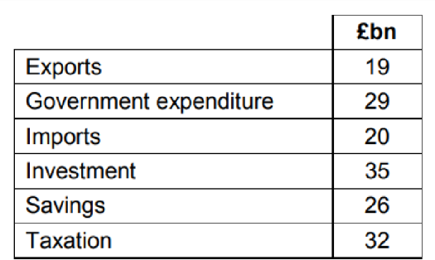

Other things remaining the same, these changes would cause…
a) Consumer expenditure to decrease. | ❑
b) National income to increase. | ❑
c) The balance of trade deficit to decrease. | ❑
d) The budget deficit to rise. | ❑

6. A government wants to increase the economy’s rate of long-run economic growth by implementing a supply-side policy. Which one of the following is a government policy aimed at stimulating the supply side of the economy?
a) A new scheme to help young people buy their own homes. | ❑
b) Greater provision of care homes for the elderly. | ❑
c) Measures to promote competition between businesses. | ❑
d) More generous welfare benefits for unemployed workers. | ❑

7. A government reduces its budget deficit. Other things remaining the same, the most likely short-run impact of this policy is…
a) A reduction in the current account deficit. | ❑
b) A reduction in unemployment. | ❑
c) An increase in the rate of economic growth. | ❑

d) An increase in the rate of inflation. | ❑

8. The central purpose of the production of goods and services is to…
a) Achieve more technological innovation. | ❑
b) Maximise exports. | ❑
c) Maximise profits. | ❑
d) Satisfy consumer wants. | ❑

9. In an economy, competitive firms supply electricity that is generated using coal-fired power stations. If the government tries to reduce pollution by imposing an indirect tax on the firms, this would…
1. Shift the market demand curve to the left. | ❑
2. Shift the market demand curve to the right. | ❑
3. Shift the market supply curve to the left. | ❑
4. Shift the market supply curve to the right. | ❑

10. The price elasticity of demand (PED) for petrol used by car drivers in an economy is estimated to be –0.2. Which one of the following is the most likely reason for the low PED?
a) A tax on petrol | ❑
b) Cycle lanes on many roads | ❑
c) Few bus and rail services | ❑
d) Low household incomes | ❑

Section Two
Case study and research. Read the case study, look up relevant theorists and answer all five questions. Remember – think PEAL (point, explain, analyse, link) (and look at videos on Tutor2U or Taking The Biz on YouTube on how to maximize marks for 16-25 mark questions).

Cleaning up in China

2014 seems the year for China to get serious about industrial pollution. For several years, air pollution in Beijing and Shanghai has been an embarrassment to the Chinese government. The main problem is PM2.5 (Particulate Matter)1 which can be dangerous to breathe – especially when mixed with smoke and fog to form ‘smog’.

Now the Chinese state is clamping down on pollution from the steel industry. In the past, Chinese steel has been smelted from low-grade iron ore. This emits far more pollutants than the higher-grade, more expensive ores. In the steel-making regions near to Beijing, steel plants are under pressure to comply with new air pollution standards following several summer smog crises in 2013. As a result, they are buying higher quality ore that can be loaded into blast furnaces without ‘sintering’, a process that is a major source of carbon dioxide and other pollutants.

The US embassy in Beijing regularly reports on the level of PM2.5. For 1st February 2014 its reading was 225 on the Air Quality Index, which registered as ‘very unhealthy’. In the summer, readings can rise to 500, which is ‘hazardous’, meaning that ‘everyone should avoid outdoor exertion’. In the short-term these levels of pollution represent a risk to health; in the longer term they contribute to greenhouse gas emissions and therefore, perhaps, to global warming.

In 2000 China made 15% of the world’s steel. By 2013 that figure had risen to 48%. Because China makes nearly half the world’s steel, it buys half the world’s iron ore. So purchasing decisions can move markets. The price of high-grade iron ore has moved from a premium of $8 per tonne in mid-2013 to $18 in early 2014. For top-grade iron ore the price premium has jumped from $10 to $40. As the base price of iron ore is around
$120 a tonne, these price premiums are significant – especially as steel is a commodity, i.e. a homogenous product.

For some years China has been trying to diversify its purchases of iron ore away from its 70% dependence on high-cost Australia and Brazil. The move to buy higher-grade iron ore undermines that – as these two countries dominate production of higher-grade ores.


Global iron ore 'spot price' Jan 04
$s per tonne
200
180
160
140
120
100
80
60
40
20
0
indexmundi.com
-Dec 13 Source:

Note:
1. Air pollution in China
The US embassy in Beijing regularly reports on the level of PM2.5. For February 1st 2014 its reading was 225 on the Air Quality Index, which registered as ‘very unhealthy’. In the summer, readings can rise to 500, which is ‘hazardous’, meaning that ‘everyone should avoid outdoor exertion’. In the short-term these levels of pollution represent a risk to health; in the longer term they contribute to greenhouse gas emissions and therefore, perhaps, to global warming.

Section Two
Answer all five questions. There are thirty marks available; we recommend you spend 35-40 minutes answering these questions.

Question 1
From the graph, explain the changes that have happened to the price of iron ore between January 2004 and December 2013. (5 marks)

Question 2
Use a diagram to help explain why the price premium on top grade iron ore rose to $40 in early 2014. (6 marks)

Question 3
Outline the positive and negative externalities that would have arisen in China as a result of the remarkable growth of its steel industry. (5 marks)

Question 4
In the circumstances outlined in the article, what is the significance of the statement that steel is ‘a homogenous product’. (5 marks)

Question 5
In China, a pollution problem can be addressed by the government telling steel plants to reduce pollution. In a free market system how might this market failure be addressed? Use a diagram to support your argument. (9 marks)

Section Three
Numeracy tests – you may have to look up some of the terms and theory. Answer all thirty questions.

- Milano’s Pizza is a large-scale frozen pizza manufacturer based in Newcastle. They have 4 pizza machines. 1 machine can make 500 margarita pizzas an hour OR 400 ham and pineapple pizzas per hour. The manager currently has 2 machines making margarita pizzas and 2 machines making ham and pineapple pizzas. Assuming there are no defects or production problems, what is the maximum number of pizzas the firm makes in 12 hours.

- The regional demand for Milano’s ham and pineapple pizzas increases after two prominent Newcastle footballers post a photo of themselves on Instagram eating them. To satisfy the extra demand, the manager at Milano’s decides that she will use 3 machines to make ham and pineapple pizzas and 1 machine to make margarita pizzas. Calculate the new maximum number of pizzas made in 12 hours.

- After a few weeks, the manager decides that the only way she can cope with the surging demand is to buy 2 more machines (6 in total). She uses 1 to make margarita pizzas (2 in total) and 1 to make ham and pineapple pizzas (4 in total). Calculate the percentage change in production in both types of pizza.

- Geoff sells a house for £650,000 in Harrogate. The estate agent is paid 1.5% of the selling price for her services. Calculate how much she is paid.

- Geoff buys a new 1-bed apartment in London with the proceeds from his house sale in Harrogate. The apartment costs him £500,000 to buy. This time he has to pay Stamp Duty tax on his purchase. Stamp Duty at this price is 3%. How much tax does he pay?

- Over the next five years, London house prices go up by 45%. House prices in Harrogate decrease by 1.25%

Calculate how much Geoff’s London apartment is worth five years later.

  - Calculate how much his house in Harrogate would have been worth if he hadn’t sold it.
- A and B are two points on a straight line. If we move from A to B, how many X units do we gain and how many Y units do we lose?
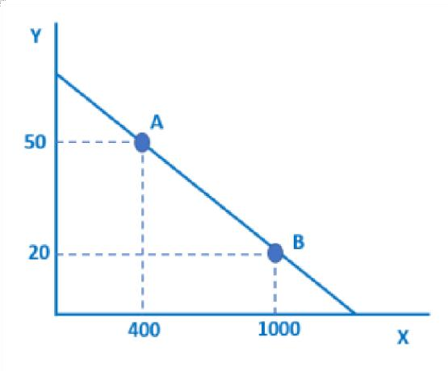

- Calculate the area of each of the shaded rectangles.

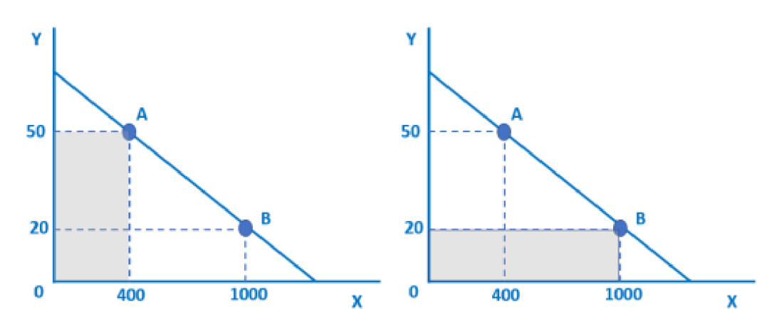

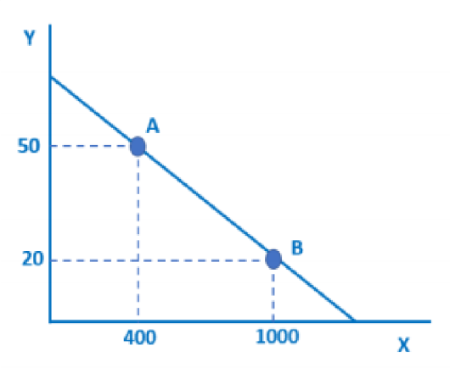
- The gradient does not change but the relationship between Y and X changes. At each amount of Y there are now 400 more units of X. Adapt the diagram above to illustrate the change.

- The owner of a small carpet cleaning business looks at the annual salaries of his five employees.

Employee 1 (duty manager) | £32,000
Employee 2 | £14,000
Employee 3 | £14,000
Employee 4 | £16,000
Employee 5 | £18,000

  - Calculate the total expenditure on labour costs.

  - Calculate mean average and median average salary for the five employees.

- The boss hires a sixth employee to the business. The employee is highly experienced and very skilled. As a result, she commands a relatively high salary of £26,000.

  - Calculate the extra cost of the additional employee.
  - Calculate the change in the mean average salary in the business.

  - Calculate the new median average salary for the employees of the carpet cleaning business.

- A British-made car costs £20,000. The current exchange rate is £1 (UK pound) to $1.30 (US dollars). 6 months ago, the exchange rate was £1 to $1.50. Calculate how much the £20,000 car costs in US dollars i) now and ii) 6 months ago.

- The exchange rate of UK pounds (£) to Euros (€) changes from £1 = €1.10 to £1 =
€1.25.

  - Calculate the percentage increase of €1.1 to €1.25.

  - Calculate the UK price (£) of a €500 washing machine made in Italy, after the exchange rate change.

- Of the selected countries in the graph below, i) what percentage of UK migrants live in Spain?

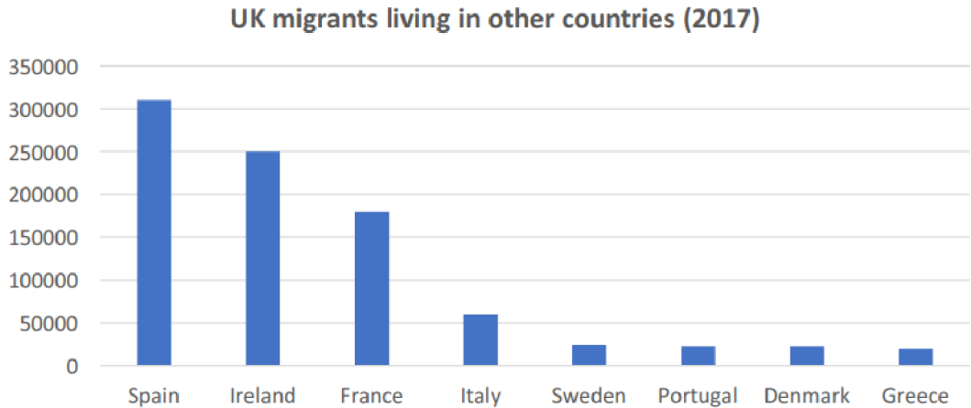
ii) Compare the number of UK migrants living in Ireland compared to the number living in Portugal.

- The graph shows the number of people in work in the UK over time.

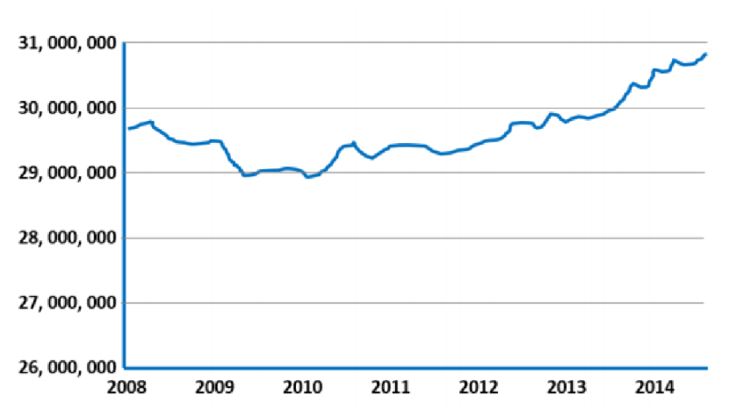
  - Calculate the percentage change from the lowest point to the highest point. ii)Assuming the UK population was constant at 63m throughout this period (it wasn’t, but
assume it was!), calculate the number of people in work as a percentage of the population in both 2008 and 2014.

- Simon owns a small juice bar. His two most popular juices are ‘red juice’ and ‘green juice’. Each juice has different ingredients. The cost of ingredients for ‘red juice’ is 60p per juice. The cost of ingredients for ‘green juice’ is 40p per juice. Simon sells 50 ‘red

juices’ and 80 ‘green juices’ per day. Calculate the daily cost of making the two juices.

- The price of each juice drink is £2.30. Assuming Simon sells the quantities stated in Q1,
  - Calculate how much revenue Simon earns in one day from selling ‘red juice and ‘green juice’. (revenue = price x quantity)

  - Using your answer from Q16, then calculate the profit Simon makes (profit = revenue – costs).

- Simon decides to increase the price of his juice drinks by 20%. Sales of ‘red juice’ fall by 10% and sales of ‘green juice’ fall by 5%. Calculate Simon’s new level of revenue.

- Income tax in the UK is applied in bands. Nobody pays tax on the first £11,850 that they earn. People pay 20% tax on the next £34,500 earned above £11,850. People pay 40% tax on the next £103,659 after that. If Evelyn earns £60,000 per year as a lawyer, prove that she has to pay £12,360 in income tax.

- If the top rate of tax increases to 50%, calculate

  - how much tax Evelyn pays now

  - how much income she has left over after paying her income tax.

Assume that Evelyn’s income does not change and the other tax bands remain the same.

- Nomo takes a loan from a payday company. Nomo takes a £300 loan at 0.8% per day. How much will Nomo owe the lender after a week?

- A and B are two points on a straight line.

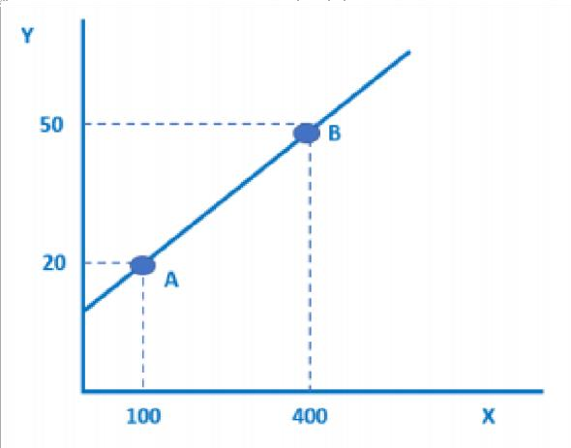
If we move from A to B, how many Y units do we gain and how many X units do we lose?

- The gradient does not change but the relationship between Y and X changes. For every value of Y there are now 50 fewer units of X.
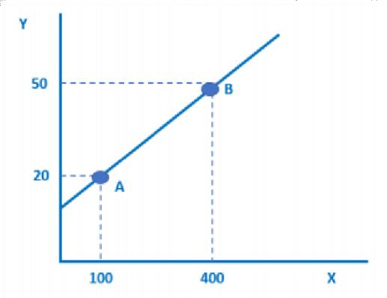

Adapt the diagram above to illustrate the change.

- A currency investor thinks that she can make a profit by buying Russian Roubles. She exchanges £10,000 to Roubles when the exchange rate is £1 = 96 Roubles. Later in the year, the exchange rate changes to £1 = 55 Roubles and she changes her Roubles back to Pounds. How much profit did she make?

- George likes to spend his income in the same way every month; 20% savings; 40% necessities and household bills, 10% on watching football, 30% on luxuries. If George earns £28,000 a year (after tax), calculate how much he spends on these 4 areas per year.

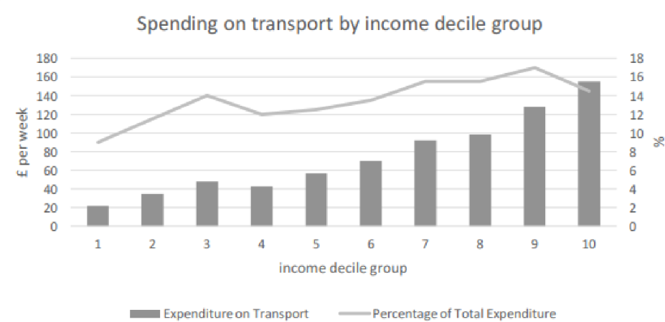
- Income decile group is a way of splitting up the population for statistical analysis: imagine lining up the population from poorest to richest; income decile group 1 would contain the poorest 10% of people, income decile group 2 would contain the next poorest 10%, and so on.

  - Calculate the mean average expenditure on transport of the lowest 3 income deciles.
  - Calculate the mean average expenditure on transport of the highest 3 income deciles.

- The table below shows the total output figures for a firm as it adds more workers to its production process. Fill in the right-hand column.
Workers | Total Output | Output per worker
1 | 18
2 | 24
3 | 36
4 | 44
5 | 48

- Gunter brews beer. He brews 100 pints of beer per week. Rosa makes wine. She bottles 125 bottles of wine per week. However, Gunter likes wine and Rosa likes beer. So, they agree to trade. They trade at a ratio of 5 beers: 2 wine. Every week Gunter trades 20 pints of beer for bottles of wine. After 4 weeks, how many pints of beer and bottles of wine does Gunter have?

- Canada has a population of 36.2 million people. Canada has a total national income of $1.6 billion. Calculate the average income per person.

- The chart below shows Government spending by area 2015/16:

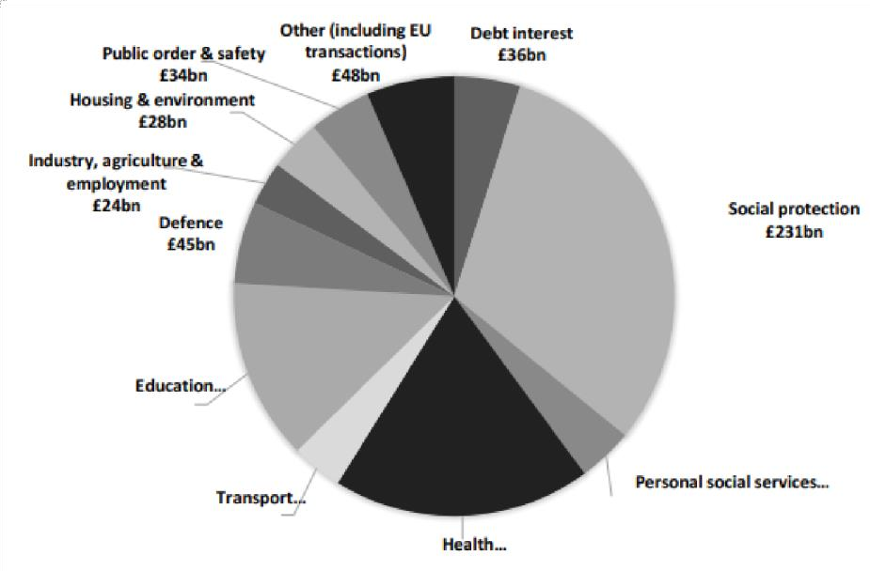

Total Government spending in the 2015/16 financial year was £722bn. Calculate the
% of Government spent on Social Protection, Health and Education in that year.

Section Four
Read and review.

BBC Caribbean With Simon Reeve

You will need to watch from 22min 40 – 41minutes and you are likely to need to pause, rewind and perhaps watch some parts more than once.
BBC Caribbean with Simon Reeve episode 2
- Identify 2 reasons why Venezuela should b e ‘one of the world’s r richest countries’?

- Which other countries have large oil reserves? Think before you click!
map countries most oil reserves
How does each country’s GDP compare?

How to economists make use of GDP data? Watch this video Changing world economy - use of GDP data

Where does Venezuela rank in GDP/ capita data? Do any countries have higher or lower GDP/ capita than you were expecting?
https://www.usatoday.com/story/money/2019/05/22/largest -oil-reserves-in-world-15-countries-that-control-the-worlds-oil/39497945/

- Before you continue watching the BBC video, think of reasons WHY
Venezuela’s GDP per capita might not be as high as expected
( given the oil reserves)? You will find out some possible answers as you watch the video.

- List examples of Venezuela’s worsening l living standards.

  - 1 in 3 Venezuelans are poor

- Simon comments that ‘wealth is in the hands of the few in
Venezuela’. How do economists measure inequality using Lorenz curves/ Gini coefficient’

Lorenz curve and Gini coefficient tutorial

Think about what it means for a country to have high levels of inequality and the impact it has on society. Is inequality inevitable in ( free market) economies?

- 32min 20 Some of the reasons given for Venezuela’s economic decline are given as ‘restrictions on foreign currency meaning that businesses don’t want to import and ‘ Soviet - style’ controls on prices meaning that shops don’t want to sell.

Read/ watch the explanations about the objectives of producers / functions of the price mechanism . . Explain why Venezuelan shops might be behaving rationally if prices are set below the free market equilibrium?

- 33min 20 How much does it cost to fi ll a tank of petrol? How does this compare to your local petrol station?
What reasons are given for why petrol is so cheap?

- How does the government policy lead to a more unequal distribution of income in Venezuela?

- 34 min 45. Simon visits a family living with an oil pump outside their house. What problems have the family suffered/ witnessed as a result?

- 36min 15. Petrol in Columbia costs 100 t times the price in Venezuela and large numbers of people i l legally smuggle petrol at the border.
Explain the impact of this smuggling on the Venezuelan economy. Consider the impact of the lost tax revenue? How does it change the incentives for the taxi driver to seek work?

- What is the recent situation in Venezuela? Watch these 4 videos.
In particular, focus on the impact of inflation. What does inflation mean? inflation definition
What impact does it have on day to day l iving and
working in Venezuela?

https://www.tutor2u.net/economics/reference/economic -crisis-in-venezuela What is inflation?
https://www.tutor2u.net/economics/reference/why -is-high-inflation-a-problem

The story of Venezuela's collapse

Finding out more/ further investigation

1. Look at the 2 charts below. What impact might the current oil price of
$25 per barrel have on the Venezuelan economy?

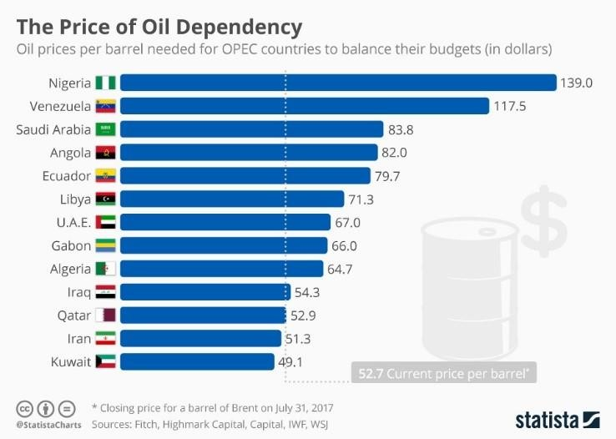
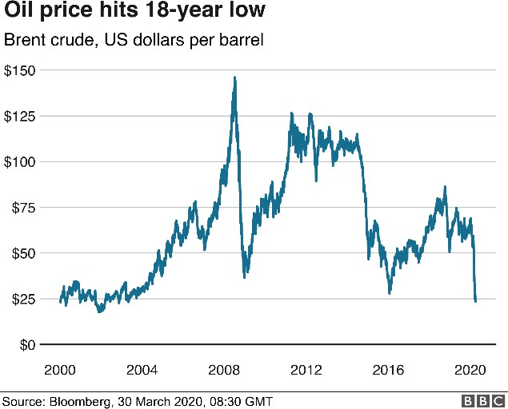

The Story of Chocolate

2. Watch The story of chocolate: unwrapping the bar
Use it to help you answer the questions below. Name two of the world’s largest producers of cocoa.

- How long does it take for a cocoa pod to grow?

- Watch the harvesting of the cocoa pod and explain w hat is meant by specialisation and division of labour.

- Explain what is meant by a labour intensive industry? With reference to cocoa, how does this impact the farmers’ ability to grow more ( expand
supply)? How might this impact a farmer’s standard of l iving?

- What external threats are there to the cocoa harvest? Eg drought. What impact would this have on a cocoa farmer’s annual earning

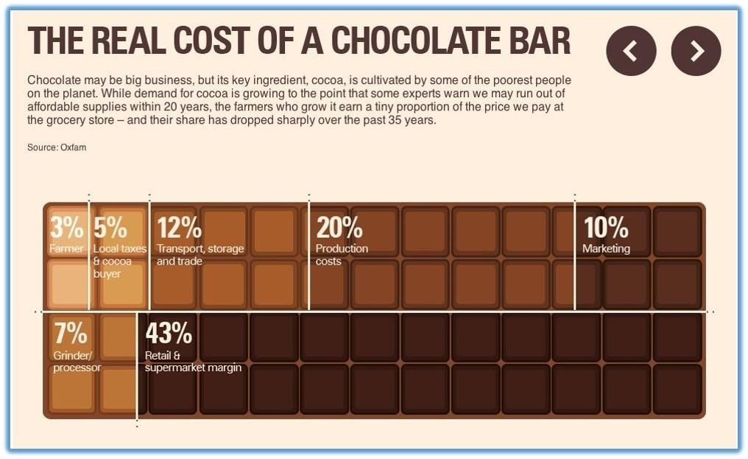
- Look at the real cost of a chocolate bar and using your own knowledge, explain why the farmer receives such a small percentage of the sales price ( and thereby lives under the poverty l ine)?

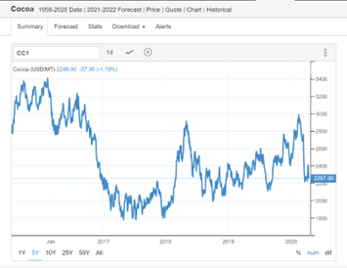
- Extension question: Look at the world cocoa price graph and describe what has happened to the price over the past 5 years.

- Explain 3 factors that might influence the world cocoa price.
Eg a rise in price in 2018 from 1800 USD/ MT to 2900 USD/ MT might be due to a crop disease that kills 80% of the Ivory Coast’s cocoa pods. This leads to a shortage of cocoa and the market price will r ise

- Explain what is meant by a minimum price ( for cocoa)?
How will this help the Ivory Coast’s farmers?

- Explain 2 benefits to the Ivory Coast of investing the Fairtrade premium in building nursery schools and installing water
pumps? ( consider the wider economic benefits eg to workers/ parents/ the government?)

