
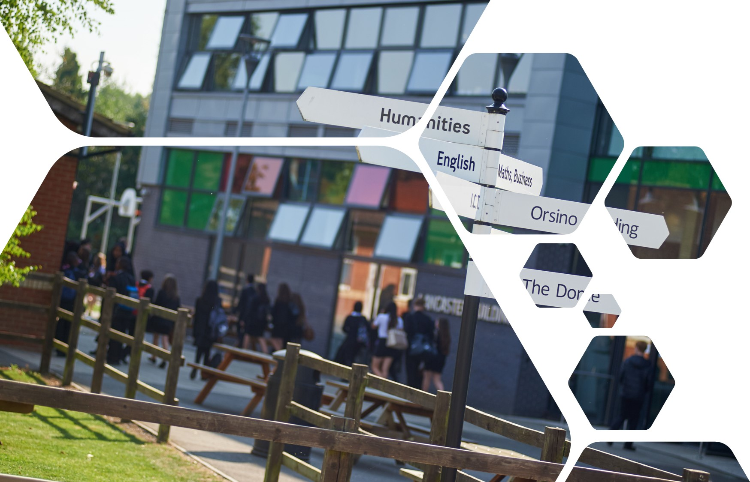

Sixth Form Transition Pack
BTEC Sport (Level 3) -

cOURSE INTRODUCTION
BTEC Sport provides an introduction to the sports sector for learners looking to build a career in sport. This can include careers in exercise and fitness, coaching and leadership, sports development and management and sports education.

The BTEC Sport Foundation Diploma is structured to allow learners maximum flexibility in selecting optional units, so that particular interests and career aspirations within the sport and active leisure sector can be reflected in the choice of unit combinations.
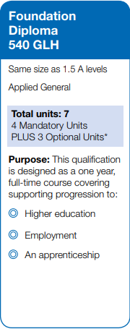
Essential summer reading
- BTEC National Sport, Student Book 1 (Pearson, 2016)
- BTEC Sport Level 3, Revision Guides (Pearson, 2017)
- Exercise Physiology And Functional Anatomy (Feltham Press, 1995)
- Mechanics And Sport Performance (Feltham Press, 1998)
- Sports rule books and coaching guides
- Sports Biographies / Autobiographies

Essential summer viewing/listening
- Skeletal system https://www.youtube.com/watch?v=rDGqkMHPDqE
- Muscular system https://www.youtube.com/watch?v=Ktv-CaOt6UQ
- Respiratory System https://www.youtube.com/watch?v=bHZsvBdUC2I
- Cardiovascular System https://www.youtube.com/watch?v=_lgd03h3te8
- Energy System https://www.youtube.com/watch?v=00jbG_cfGuQ

cOURSE Details

The Foundation Diploma BTEC is equivalent to 1.5 A-Levels, and you will be awarded a Pass, Merit or Distinction based on your coursework units and exam units.
There are four mandatory units which you will complete. Details of these are as follows:

Unit 1: Anatomy and Physiology
This Unit is externally assessed through an exam, lasting 90 minutes. The unit requires a deep understanding of the body systems and how they work together for optimal sports performance. The task on page 2 will help you create a foundation; however, make sure you go into more detail than you would at GCSE level.

Unit 2: Fitness Training and Programming
Unit 2 involves another external exam, being 2.5 hours in duration. During the exam, you are required to answer 6 questions relating to the scenario you have been given. This will be an individual who needs to improve their health and fitness. You will need to cover lifestyle factors, diet and nutrition, methods of training, components of fitness, and different screening methods.

Unit 3: Professional Development in the Sports Industry
This unit is internally assessed through tasks including presentations and word documents. You will be looking in depth at the range and type of sports jobs and opportunities available. You will also be exploring your own skills, and how these would transition to a selected career in the sports industry. This is an excellent unit to explore potential careers for you and gain an understanding of the day-to-day role that different sports jobs can play.

Unit 7: Practical Sports Performance
This unit focuses on developing and demonstrating skills, techniques, and tactics in selected sports. Learners examine National Governing Body (NGB) rules and regulations and then apply this knowledge by participating in and analyzing their own performance in chosen sports.

How does the qualification provide employability skills?

In the BTEC National units there are opportunities during the teaching and learning phase to give learners practice in developing employability skills. Where employability skills are referred to in this specification, we are generally referring to skills in the following three main categories:
- cognitive and problem-solving skills: use critical thinking, approach non-routine problems applying expert and creative solutions, use systems and technology
- intrapersonal skills: communicating, working collaboratively, negotiating and influencing, self-presentation
- interpersonal skills: self-management, adaptability and resilience, self-monitoring and development.

There are also specific requirements in some units for assessment of these skills where relevant, for example, where learners are required to undertake real or simulated activities. How does the qualification provide transferable knowledge and skills for higher education?

All BTEC Nationals provide transferable knowledge and skills that prepare learners for progression to university. The transferable skills that universities value include:
• the ability to learn independently
• the ability to research actively and methodically
• being able to give presentations and being active group members.

BTEC learners can also benefit from opportunities for deep learning where they are able to make connections among units and select areas of interest for detailed study.

BTEC Nationals provide a vocational context in which learners can develop the knowledge and skills required for degree courses, including:
- reading technical texts
- effective writing
- analytical skills
- creative development
- preparation for assessment methods used in degrees.

What could this qualification lead to?

Learners who have completed this qualification in two years may progress to further learning at Level 3. The qualification carries UCAS points and is recognized by higher education providers as meeting, or contributing to, admission requirements for many relevant courses. Learners can progress to higher education on full degree single or combined courses, for example:

BA (Hons) in Sports Development and Management, BSc (Hons) in Sports Management, BSc (Hons) Sports Business Management, BSc (Hons) Sport and Leisure Management, BSc (Hons) Sports Science (Outdoor Activities), BSc (Hons) in Exercise, Health and Fitness, BSc (Hons) in Sport and Exercise Psychology.

Tasks to complete ready for year 12:

The Head of Physical Education (PE) at the UHS secondary school has contacted your course tutor me (Mr Corry).

After the success of the Olympic Games (Paris 2024) the PE team would like to introduce two new sports to the Key Stage 3 curriculum at the school. In order to do this the Head of PE would like to educate the children in Years 7, 8 and 9 about the rules and regulations and skills, techniques and tactics in one Olympic Individual Sport, and one Olympic Team Sport.
Task 1
Pick a team sport i.e. Football, netball etc & Pick a individual sport: Table tennis, badminton etc at least 5 rules per sport.
Create a table researching the rules and regulations and fill out each box.
At the end, there should be two tables: one for your team sport and one for your individual sport.
TEAM SPORT
Sport |  | e.g Football
Rules |  |  | Official(s) in charge of applying the rule | Reason why / how the rule was broken | Action taken by official(s) | Form of communication to stop/restart play | Sanctions applied when the rule is broken
e.g. | Double foul |  | Umpire closest to the foul | A double foul is a situation in which 2 opponents commit personal or unsportsmanlike/ disqualifying fouls on each other at approximately the same time. | A personal or unsportsmanlike/disqualifying foul shall be charged on each offender | Whistle and umpire signal to stop play  Whistle to restart play | The team who had control of the ball or was entitled to the ball will be awarded a throw-in from the place nearest to the infraction.
1
2
3
4
5

Reference List
e.g. | FIBA 2020 Official Basketball Rules  http://www.fiba.basketball/documents/summary-rules-changes/2020.pdf
1
2
3
4
5

INDIVIDUAL SPORT
Sport |  | E.g Badminton
Rules |  |  | Official(s) in charge of applying the rule | Reason why / how the rule was broken | Action taken by official(s) | Form of communication to stop/restart play | Sanctions applied when the rule is broken
1 | Badminton serves must be hit underarm and below the waist |  | Umpire | The player has served overarm or from above the waist | Award serve to opposition | Verbal direction | Serve goes to the opposition meaning they may have the chance to win the point
2
3
4
5

Reference List
1
2
3
4
5

You information should be referenced using Harvard referencing.

