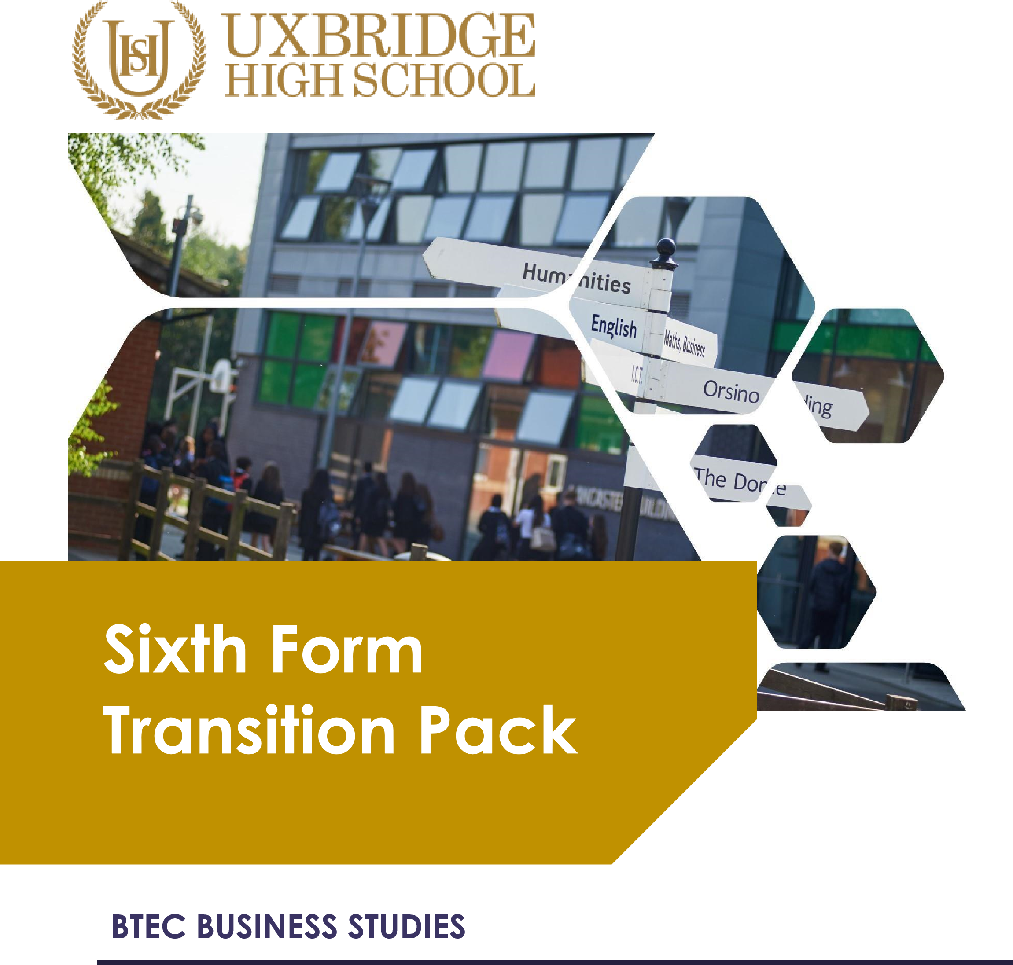

September 2026 Year 13

COURSE UPDATE
Businesses are all around us; we all know and can recognise them instantly. Brands like Coca Cola, Cadbury and McDonalds are sold on every high street, in every city, every day across the country. But how do businesses like these work?

Our BTEC Business courses teach you how business operates. One day you will be learning about accounting: where accuracy and number skills are paramount to analyse cash flow, costs and profit. The next day you could be measuring how creativity ensures a product will sell. Our course is incredibly varied and covers the essential skills, such as communication and leadership, which you will need to one day manage or lead a business yourself.

If someone offers you an amazing opportunity but you are not sure you can do it, say yes – then learn how to
do it later.
Sir Richard Branson, founder of Virgin

You are doing either two qualification pathways, the Level 3 extended certificate which is worth one A-Level and the diploma course, worth two A-Levels.

Level 3 extended certificate students will complete four units over the two years, two pieces of coursework and two exams; while diploma students complete eight units over the two years, three are exams and five are via coursework.
Of the units undertaken, You have completed the following:
Unit 1: Exploring business (coursework, certificate and diploma)
Unit 3: Personal and business finance (exam, certificate and diploma)
Unit 4: Managing an event (coursework, diploma only)
Unit 5: International business
You are still to complete in Year 13 the following Units:
Unit 6: Principles of management (exam, Diploma only)
Unit 2: Developing a marketing campaign (exam, certificate and diploma)

In addition to the compulsory units, both Level 3 groups will also do
Unit 8: Recruitment and selection, with the diploma class completing and
Unit 14 Customer Service.

Upon successful completion of the Level 3 course, students often go on to university to study business-related courses, or are well-placed to forge a career in the business-world, particularly in areas such as business administration, human resources, production, and finance.

Essential summer reading
Check the BBC News website for breaking news under the ‘business’ tab once a week. Print off stories that link to specific areas of the course, read and annotate them, and add to your file at the relevant point.

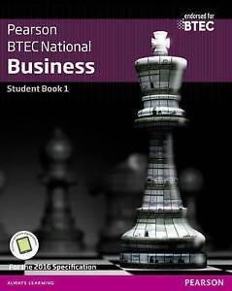
Keeping up-to-date with current affairs is essential for
Business Studies and we expect students to regularly read newspapers and magazines, and watch programmes like Newsnight and Question Time.

There is also the official textbook available for you to read ahead and develop an initial understanding of our topics.
Make sure you get the book appropriate to your course.

Task to be completed
You have just completed Year 12 in BTEC Business Studies, you’ll be familiar with the exam technique and structure.
The following tasks are designed to develop your research and analysis technique, and to highlight your current strengths in writing and developing an answer. BTEC coursework is preferably completed on computers, so you should type up your work and bring this back completed in September for your first lesson.
Answer these questions in preparation for your Units in Year 13
Unit 6: Principles of management (exam, Diploma only)

Question 1
Describe the different management styles used by two selected businesses. You should explain how each management style is applied in practice and how it influences employees.

Unit 2: Developing a marketing campaign (exam, certificate and diploma)

Question 2
Describe the key components of a marketing campaign for two selected businesses. You
should outline elements such as aims, target market, messaging, and channels used.

Unit 8: Recruitment and selection

Question 3
Describe the different recruitment methods used by two selected businesses.
You should outline internal and external recruitment methods and how each business uses them.
Unit 14: Customer Service

Question 4
To what extent is high-quality customer service the most important factor in
building customer loyalty? You should write a longer essay using relevant
real-life examples to support your argument.

Check and send
When you’ve finished the work, proof-read it. Does it make sense? Have done a spell-check
You will be judged on your SPAG.

Save your work with your full name and bring to it to Mrs Matharu & Miss Polat – The
Business Teachers on the first day back at school in September.

