






From September 2026 Teaching

Sixth Form

Transition Pack

A

-

LEVEL BUSINESS STUDIES

COURSE INTRODUCTION

Businesses impact on our lives day to day. They supply the goods and services we buy, provide employment for millions of people and even deliver many public services such as refuse collection and care for the elderly.
To the untrained eye, businesses can appear to behave in slightly peculiar ways. Why have Cadburys decided to pay more for Fair Trade cocoa beans? Why have Apple released two versions of the same phone? Why has Hotel Chocolat opened more ‘bricks and mortar’stores when ecommerce is becoming more popular?
The answers to these questions will provide an insight to the strategies of some of the most successful organisations in the world. A-Level Business Studies is not only a qualification; it’s a handbook for anyone thinking of entering the complex world of commerce.
In our business courses, you will apply knowledge and understanding to real-life business contexts, with updated content to reflect the issues impacting on modern businesses in our specification and real business case studies in all our assessments.
You will develop transferable skills that support higher education study and the transition to employment, including numeracy, communication, an understanding of the business environment and commercial awareness.
The common question that gets asked in business is, 'why?' That's a good question, but an equally valid question is, 'why not?'
Jeff Bezos, founder of Amazon

In the first year of the course you will cover two topics:
Unit 1‘What is business?’
Unit 2 “Managing People & Operations”

This is designed to give you an overview of the important functional areas in business. In the second year of the course you learn about businesses more holistically and how they come up with overall strategies.

Expectations of you

The Business A-Level course is the next step after successfully completing GCSEs. A-Level is designed to build on your previous learning and knowledge and assist you in developing the necessary skills to complete the course. In order for you to excel at A-Level and achieve your targets, you need to acknowledge and agree to the following;

- Attendance = attainment. Attend all lessons, arrive on time and bring all the necessary equipment and resources. Do not book appointments during lesson hours.
- Work to the best of your ability in class and focus on the lesson
- Listen respectfully to the views of other students and consider how your own views are developing
- Complete all homework on time – this includes printing out resources
- Keep up-to-date with business in the news either online or via newspapers
- Complete all necessary research (as directed)
- Make sure you check your emails and are part of the relevant email groups for additional resources and tasks.
- Attempt all work. If you are unsure of what to do, of course you may ask questions, but you must develop greater independence
- Take advantage of any spare time to work develop your ideas or seek help on areas you’re unsure of
- Keep to deadlines!

Resources

There is also the official textbook (covering the AS units) which will be available for you to read and develop an initial understanding of our topics. However, this is the current one as the new specification book is still being written.
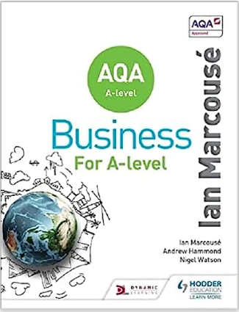

We study for the AQA exam board qualification, use their website to see the specification. https://cdn.sanity.io/files/p28bar15/green/7e74a8fba96db86595475605db1e400ebaa60a90.pdf?_gl=1*eyzu25*_gcl_au*NzgyNTgwMTk3LjE3NzU3MzI4MzU.

Online
We recommend you follow useful business news providers such as the BBC, Tutor2U, BizConSesh. The Independent, The Guardian, The Economist, Marketing magazine, SKY News etc. Others such as The Times, Telegraph and The Financial Times are good but they limit your access if you do not pay for a subscription.
A good quality newspaper (Particularly the business section) such as; The Guardian, The Times, The Telegraph and The Independent.
Journals and magazines may also be useful to read to broaden your knowledge such as; The Economist and The Grocer. The school library subscribes to Business Review so you can access this once you start your course.
Podcasts – Business Daily, The Bottom Line and More or Less are a great place to start.

Recommended Television shows/videos to watch
BBC Panorama – www.bbc.co.uk/programmes/b006t14n - The long running BBC current affairs programme, featuring interviews and investigative reports on a wide variety of subjects but often business related.

Useful websites
www.tutor2u.net – Tutor2u is an essential Business Studies resource for all students. It contains an excellent Blog with relevant news stories, exam advice and analysis of topical events. It also has various quizzes, revision notes and Power Points for free.
www.bbc.co.uk/news/business - Keep up to date with current events in the business world through the BBC website Business news section. Very easy to read and many helpful articles to gain real examples of the theory learnt in class. Vital for success in A2.
www.guardian.co.uk/business/uk-edition - The Guardian newspaper Business section. Slightly more in-depth look at business current events and still free to access on-line.
www.independent.co.uk/news/business - The Independent newspaper Business section. Another great source for business stories and again still free on-line. www.thetimes100.co.uk - The Times 100 contains case studies, revision notes and quizzes on a range of
businesses.

Optional Films To Watch

Watch films/documentaries such as
- The Internship,
- The Social Network,
- The Social Dilemma,
- The Rise of Abercrombie & Fitch
All available on Netflix Watch Dragon’s Den:

Optional Books To Read

- The Toyota Way: 14 Management Principles form the World’s Greatest Manufacturer – Jeffrey Liker
- How I Made it: 40 Successful Entrepreneurs reveal How They Made Millions – Rachel Bridge
- The Google Story – David A Vise
- The Everything Store: Jeff Bezos and the Age of Amazon – Brad Stone
- The Upstarts: How Uber and Airbnb are changing the world – Brad Stone
- The Everything Store: Jeff Bezos and the Age of Amazon (Brad Stone)
- The Great Convergence: Information Technology and the New Globalisation (Richard Baldwin)
- The Upstarts: How Uber and Airbnb are Changing the World (Brad Stone)
- The 7 Habits of Highly Effective People (Steven Covey)

Task to be completed
If you’ve just finished your GCSE in Business Studies, you’ll be familiar with the exam technique and structure. However, if you have not studied GCSE Business before then that is fine as it is not a requirement.
A-Level Business Studies is similar, to GCSE but now you have to develop your answers and opinions more – adding counter-arguments and referencing theorists like Maslow and Herzberg etc.

The following tasks are designed to develop your exam technique, highlight your current strengths in writing and developing an answer and provide you with an example of the types of questions you may be asked in an A-Level business exam.

Activity 1 –

Burger King Case Study
Read the article and write a paragraph stating whether Burger King were being misleading or not. Burger King Article

Activity 2 –

Business Profiles
Have a look at the Business Section of the BBC News website www.bbc.co.uk/news/business
Find stories about 3 different businesses and create profiles for each of the businesses, using the BBC News article and other information you can find on the internet. In each profile, you should include the following information:

- Details about the history of the business, where and when was it founded? By whom?
- Who owns the business now? What type of ownership does it have – sole trader/partnership/LTD/PLC?
- What are the key activities of the business – what do they sell or manufacture? Or are they a service based business? Do they have more than one activity?
- Why was the business you have chosen in the news – give a brief summary of the article.
- Can you explain some of the external factors that may have been affecting this business? (Covid and Brexit are obvious examples, can you think of any more?)
- Each of the 3 profiles should be at least half a page of A4

Activity 3 – Entrepreneur’s stories

Read the two case studies below about the entrepreneurs and their business start-up stories. Then answer the questions below.


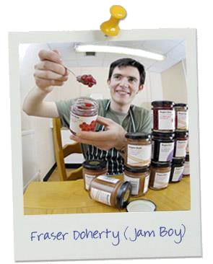


Entrepreneur 1: Fraser Doherty – Super Jam
Fraser Doherty always loved jam, especially his Gran’s jam made to her very own secret recipes. So much so, that when Fraser turned fourteen his Gran shared her jam secrets with him and he soon started making it himself, selling his produce at farmers markets and to local shops.

Thing was, Fraser loved eating jam as much as he loved selling it. In fact, he was getting through a few jars of his own jam every week. He quickly realised that all of that sugar probably wasn’t doing his health a lot of good. So Fraser had an idea…

He decided he was going to make the healthiest jam possible using only the most nutritious fruits and without adding any sugar or sweeteners. Originally, his customer base was limited to neighbours and friends from his church, but business picked up quickly, and by age 16, he left school to work on his jams full time.

He tweaked his recipes and came up with a name for his product: Super Jam. Orders picked up faster than he could produce the jam--made from only fruit and fruit juice--in his parents' kitchen, so Doherty started renting out a factory a few days each month.

In early 2007, Waitrose approached Doherty hoping to sell his Super Jam products in their stores. Within months there were Super Jam jars on the shelves of 184 Waitrose stores.

Doherty borrowed £5,000 from a bank to cover general expenses and more factory time to produce three flavours: Blueberry & Blackcurrant, Rhubarb & Ginger, and Cranberry & Raspberry. Tesco followed, adding Doherty's products to 300 stores across the U.K.

In 2008, Super Jam hit $1.2 million in sales, a 60% jump from 2007. "I can't be preoccupied with the money," says Doherty. "I make jam because it's what I love to do." Success is pretty sweet too.

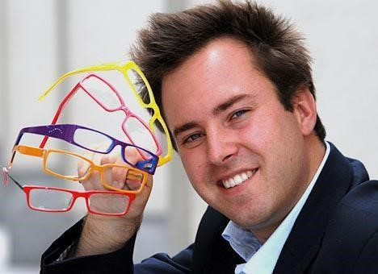

Entrepreneur 2: Jamie Murray Wells – Glasses Direct
Jamie Murray Wells is the founder and Executive Chairman of Glasses Direct, which he started at university. Studying for his final exams at university, Jamie discovered he needed to wear glasses. After visiting his local optician he was so staggered by the £150 price tag. “I got fleeced £150 for a pair of glasses.
I looked at them and thought, it’s just a bit of wire and glass, why does it need to cost so much? So I looked into the costs and found that they could be made for around £15 a pair. I sent my prescription to the lab and then had two pairs that looked the same; the difference was that one cost £150 and the other £15.
I realised there was an opportunity here to pass on these savings to customers, so I got together with some university friends, hired a web developer and used the last £1,000 of my student loan to get it started. “

After finding a laboratory to support his idea for providing better value prescription glasses, he set up shop in his parents' front room with friends and family helping out. Word began to spread and within two months of trading, the phone was ringing constantly, and the orders began pouring in.

With thousands of enquiries by the end of his summer holidays, what had begun as a sideline had become a real business meeting a real need. Glasses Direct, the first online prescription glasses retailer was born.

The business grew in popularity and he raised £700,000 through various business angels (venture capitalists) as well as friends and family. They moved to new premises and hired a team of staff to help with the operations. In the first year they had turned over in excess of £1m and probably saved the UK public many times that amount on their prescription glasses.

Despite early threats of legal action, and pressure on his suppliers from high street brands, Jamie fought to fully establish Glasses Direct in the optical market place, and eight years later, the 29 year-old has seen the company grow to become the largest online retailer of prescription glasses in Europe. The company now ships a pair of glasses every few minutes round the clock, and has saved the UK public in excess of £40 million pounds on their glasses.

According to Jamie it was possible to start up with so little capital thanks to their suppliers – “they would hold the stock for us, send the completed glasses out to customers and invoice us 30 days later. As we were taking payments upfront from customers, this enabled us to get the business going.

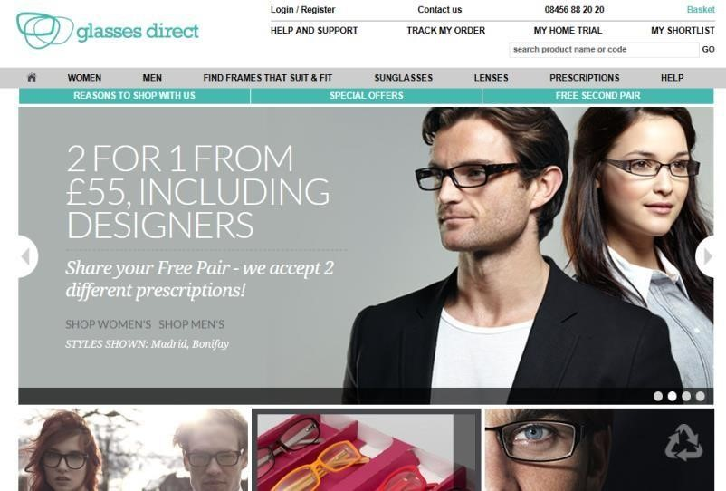

I watched cash flow like a hawk and was also helped by the diminishing costs of technology and software at the time, after the dot com bubble. Other than this, I had all my friends working for me and even kicked my sister out if her bedroom so I could use it as an office. I was the customer services, marketing, PR and accounts departments rolled into one.

We handed out flyers etc, but word of mouth really made it fly, and we were selling fifty or more pairs of glasses a day pretty quickly. After that it was a question of scaling the business and getting logistics etc. into place. If you want something to work on a £1,000, you can do it, it’s only necessary to prove that the concept works.”

Questions : Answer the questions below based on the examples above and your own knowledge:
- What is an entrepreneur?
- What characteristics did each of these entrepreneurs have that made them successful?
- How important is market research in ensuring new business ideas are successful?
- What methods can entrepreneurs use to raise the finance necessary to start up?
- Both entrepreneurs spotted a gap in market:
  - What gap did they spot?
  - How important do you think it is to spot a gap in the market for a new small business?
- What are the biggest obstacles to starting up a successful new business venture?
- “Without the entrepreneurial skills demonstrated by those in the case studies, these businesses would not have succeeded.” To what extent do you agree with this statement?
Deadline- first lesson back in September – Hand to Mrs Matharu & Miss Polat

