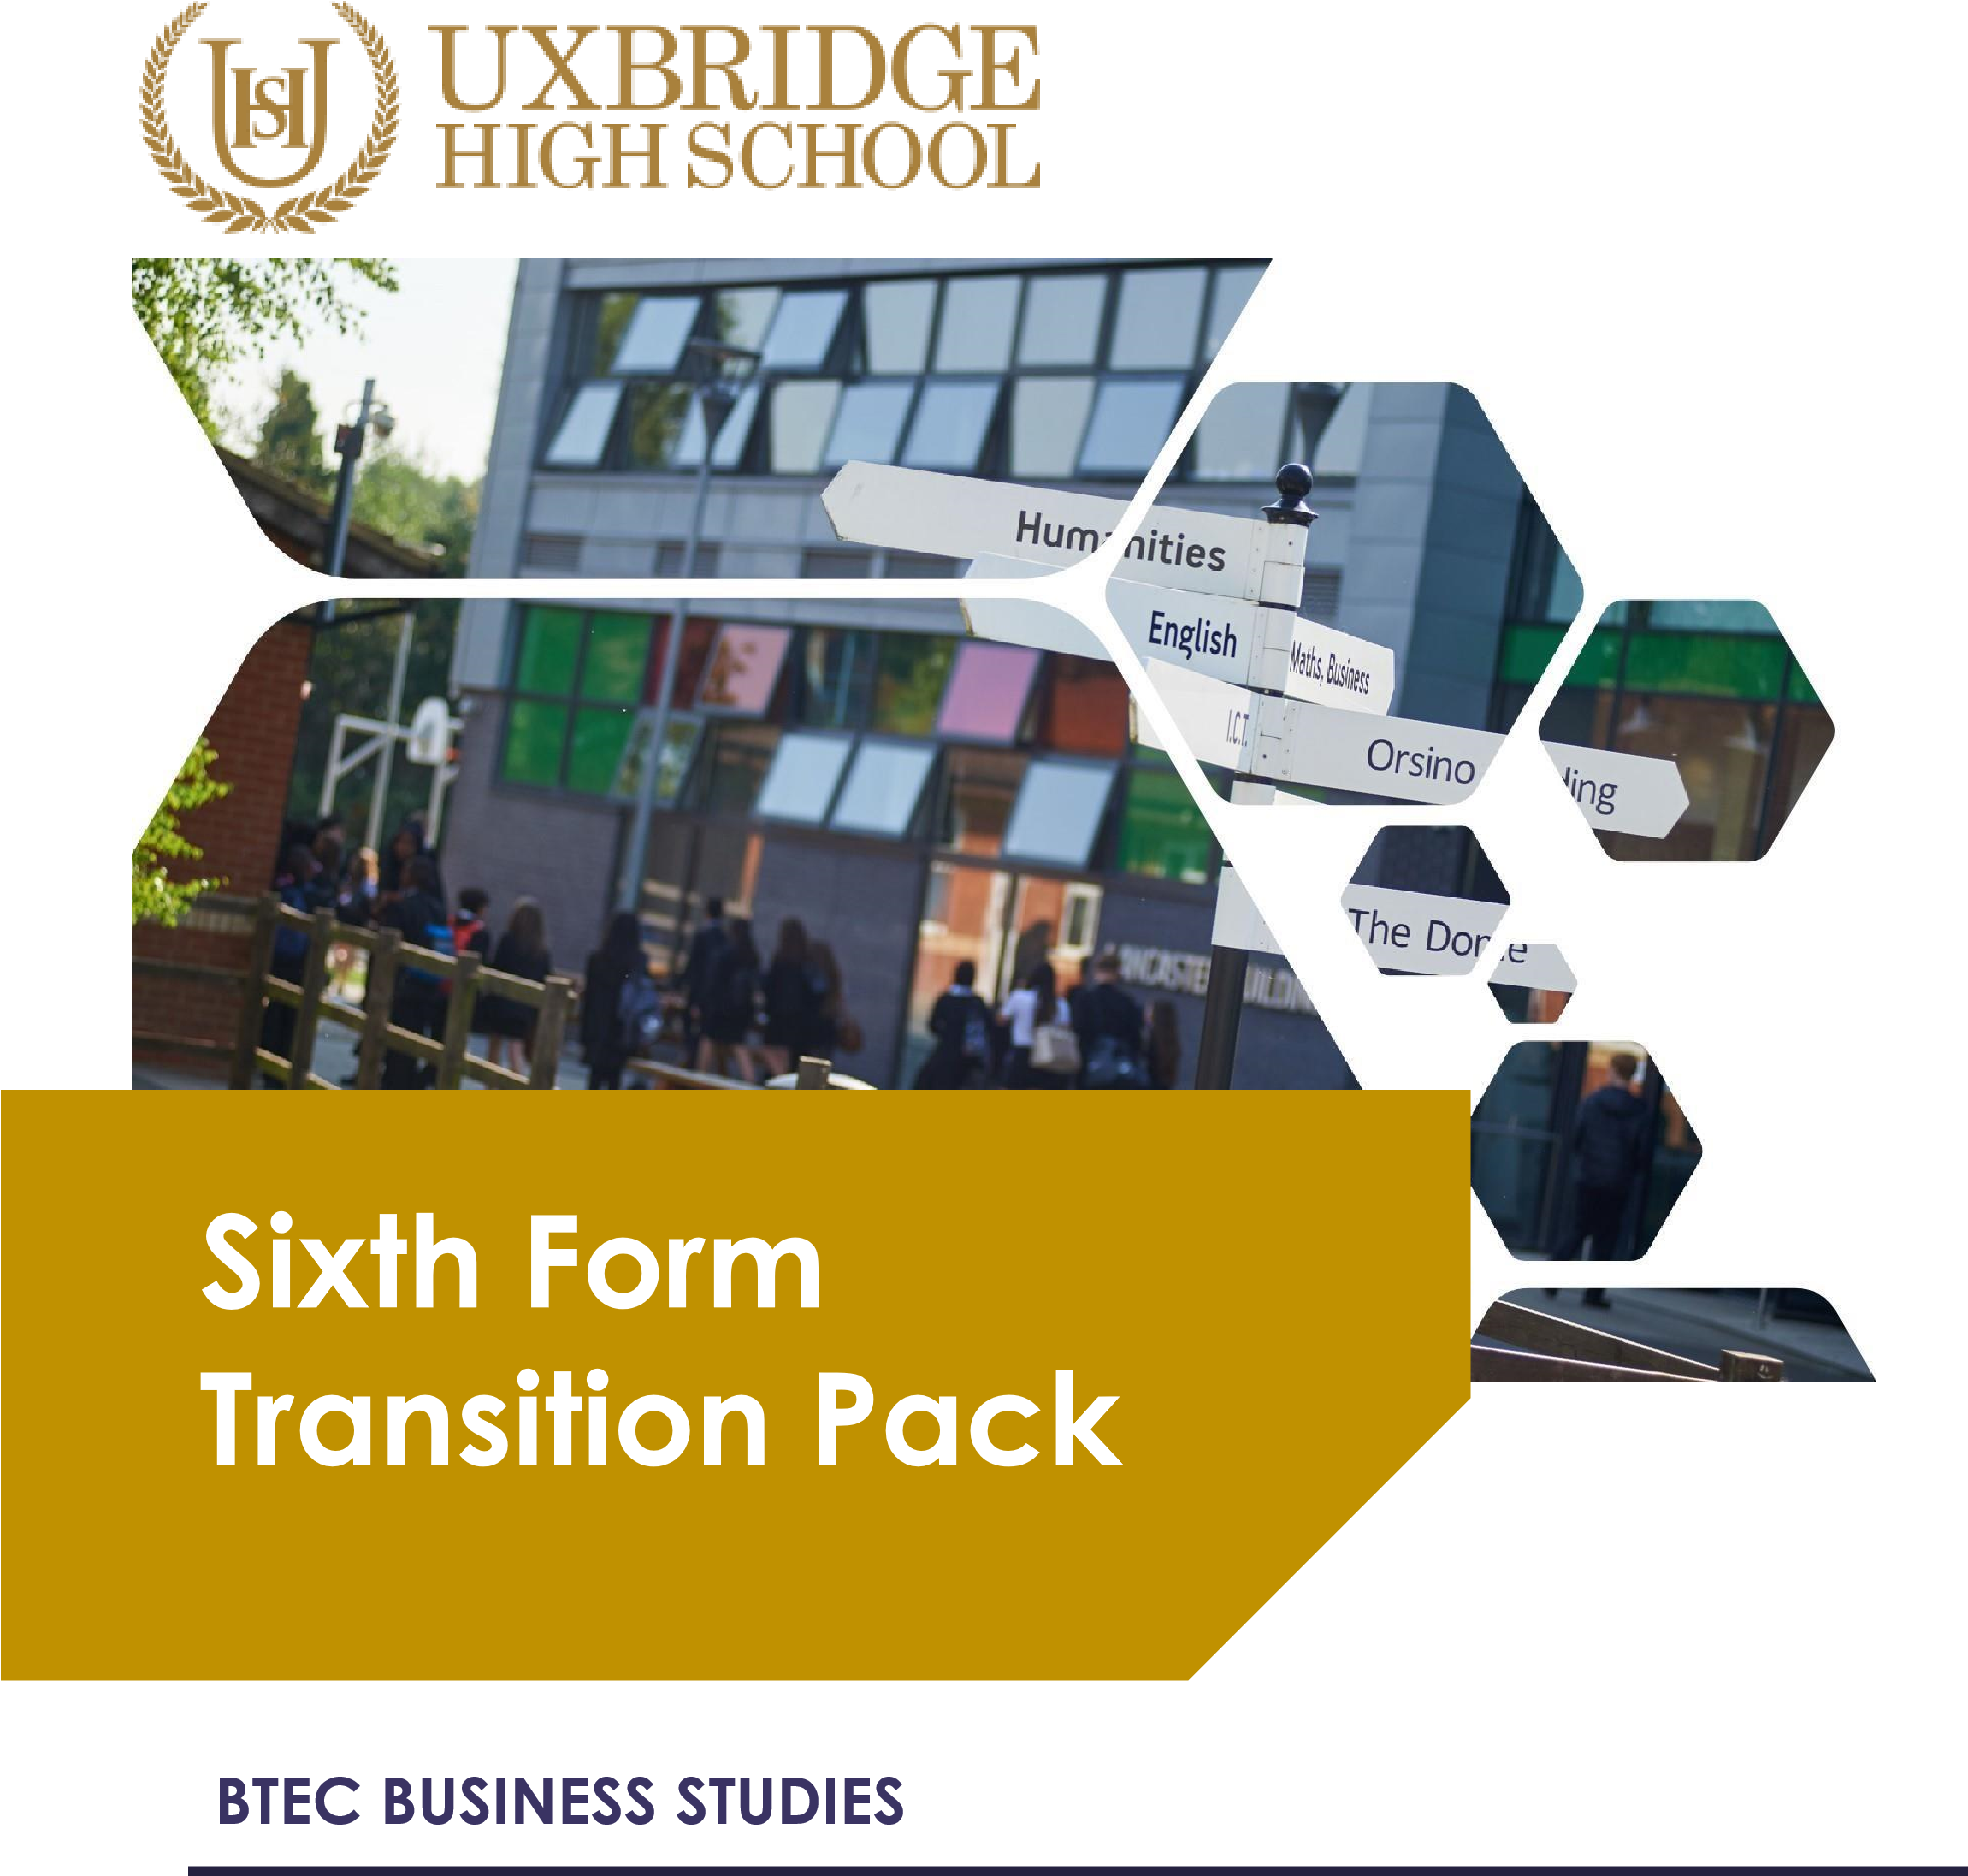

From September 2026 Teaching

COURSE INTRODUCTION
Businesses are all around us; we all know and can recognise them instantly. Brands like Coca Cola, Cadbury and McDonalds are sold on every high street, in every city, every day across the country. But how do businesses like these work?

Our BTEC Business courses teach you how business operates. One day you will be learning about accounting: where accuracy and number skills are paramount to analyse cash flow, costs and profit. The next day you could be measuring how creativity ensures a product will sell. Our course is incredibly varied and covers the essential skills, such as communication and leadership, which you will need to one day manage or lead a business yourself.

If someone offers you an amazing opportunity but you are not sure you can do it, say yes – then learn how to
do it later.
Sir Richard Branson, founder of Virgin

We offer two qualification pathways, the Level 3 extended certificate which is worth one A-Level and the diploma course, worth two A-Levels.

Level 3 extended certificate students will complete four units over the two years, two pieces of coursework and two exams; while diploma students complete eight units over the two years, three are exams and five are via coursework.

Of the units undertaken, several are mandatory and include:

Unit 1: Exploring business (coursework, certificate and diploma)
Unit 2: Developing a marketing campaign (exam, certificate and diploma)
Unit 3: Personal and business finance (exam, certificate and diploma)
Unit 4: Managing an event (coursework, diploma only)
Unit 6: Principles of management (exam, Diploma only)

In addition to the compulsory units, both Level 3 groups will also do Unit 8: Recruitment and selection, with the diploma class completing Unit 5: International business and Unit 14 Customer Service.

Upon successful completion of the Level 3 course, students often go on to university to study business-related courses, or are well-placed to forge a career in the business-world, particularly in areas such as business administration, human resources, production, and finance.

Expectations of you
The BTEC course is the next step after successfully completing GCSEs. A-Level is designed to build on your previous learning and knowledge and assist you in developing the necessary skills to complete the course. In order for you to excel at A-Level and achieve your targets, you need to acknowledge and agree to the following;

- Attendance = attainment. Attend all lessons, arrive on time and bring all the necessary equipment and resources. Do not book appointments during lesson hours.
- Work to the best of your ability in class and focus on the lesson
- Listen respectfully to the views of other students and consider how your own views are developing
- Complete all homework on time – this includes printing out resources
- Keep up-to-date with business in the news either online or via newspapers
- Complete all necessary research (as directed)
- Make sure you check your emails and are part of the relevant email groups for additional resources and tasks.
- Attempt all work. If you are unsure of what to do, of course you may ask questions, but you must develop greater independence
- Take advantage of any spare time to work develop your ideas or seek help on areas you’re unsure of
- Keep to deadlines!

Essential summer reading
Check the BBC News website for breaking news under the ‘business’ tab once a week. Print off stories that link to specific areas of the course, read and annotate them, and add to your file at the relevant point.

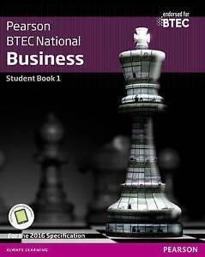
Keeping up-to-date with current affairs is essential for
Business Studies and we expect students to regularly read newspapers and magazines, and watch programmes like Newsnight and Question Time.

There is also the official textbook available for you to read ahead and develop an initial understanding of our topics.
Make sure you get the book appropriate to your course.

We study for the Edexcel Pearson exam board qualification, use their website to see the specification.

Level 3: http://qualifications.pearson.com/en/qualifications/btec-nationals/business2016.html

And you can look online at additional resources, especially here: www.tutor2u.net/business

Task to be completed
If you’ve just finished your GCSEs, particularly in Business Studies, you’ll be familiar with the exam technique and structure. However, if you’ve never done a BTEC course before, they’re slightly different in regard to the coursework.

The written exams will draw upon your knowledge of theory and application of formulae, but the coursework requires extensive research, dissemination of information and for you to be able to explain key terms and relate them specifically to real-world examples. For example, you may look up different departments that are commonly found in a business, such as human resources, finance, IT, sales and marketing.

You would need to explain what they do and to support your evidence you would have to explain what they do at different companies. The companies need to be different in size and the market they sell in, like McDonalds (large, food) and your local newsagents (small). To push for higher grades, you compare the difference between the two. McDonalds have a large advertising budget and can afford national marketing campaigns on TV, while Tony’s across the road from the school don’t advertise, except maybe a poster in the window.

The following tasks are designed to develop your research and analysis technique, and to highlight your current strengths in writing and developing an answer. BTEC coursework is preferably completed on computers, so you should type up your work and submit it electronically BEFORE the start of term in September. Do not forget to add your name in the footer. If you’ve no idea what that means, then that can be your first research task!
Answer these questions

Question 1

Describe the different types of customer service provided by two selected businesses. You should describe the different types of customer service provided by two selected businesses.

Question 2
To what extent is customer service the most important part of a company’s toolkit for maintaining high revenue? You should write a longer essay explaining, with relevant, real-life examples, the importance of customer service.

How to do it
Start by writing a definition of what customer service is.

Then research and, in general terms, describe the different ways in which companies communicate with customers and provide customer service. You should consider in-person, over the phone, online, printed materials. Give examples of each to explain what you mean (MEEL for each).
M= make your point, E=Explain your point, E=Effect of what you are saying, L=Link back to the question/case study

Having explained them in detail, you can now add the context. Choose two real companies and explain what customer service looks like in their company. If you said that in person means a customer talks to a sales advisor, and you’ve picked McDonalds – what is the equivalent to the in-person/face-to-face customer service provided?

Presuming you’ve written that up in detail, you’d have ticked off a pass level task from a standard BTEC assignment. A pass is the same as a C grade (old GCSE or current A-Level) depending upon your course.

Question 3
Now to write a essay using the structure of MEEL
Explain the importance of customer service. Make sure you give real life examples
M= make your point, E=Explain your point, E=Effect of what you are saying, L=Link back to the question/case study

So you may wish to write an introduction sentence, explaining your opinion that customer service is (or isn’t) the most important factor. Then write your PEALs.

You may wish to consider the following ideas and expand on them. If you’re thinking about how much analysis to add – just keep going (in A-Level Business, they have 25-mark questions!)

- Do you think it is the most important aspect of maintaining sales? Why do you think that?
- What impact does good or bad service have on the business?
- If it’s not the most important factor – what is?
- You need to consider the role of customer service, how it affects customer attitudes and then throw in some other (counter-) arguments.

Check and send
When you’ve finished the work, proof-read it. Does it make sense? Have done a spell-check
You will be judged on your SPAG.

Save your work with your full name and bring to it to Mrs Matharu & Miss Polat – The Business Teachers on the first day back at school in September 2025.

