THE GREAT GATSBY

AQA ENGLISH LITERATURE B: ASPECTS OF TRAGEDY
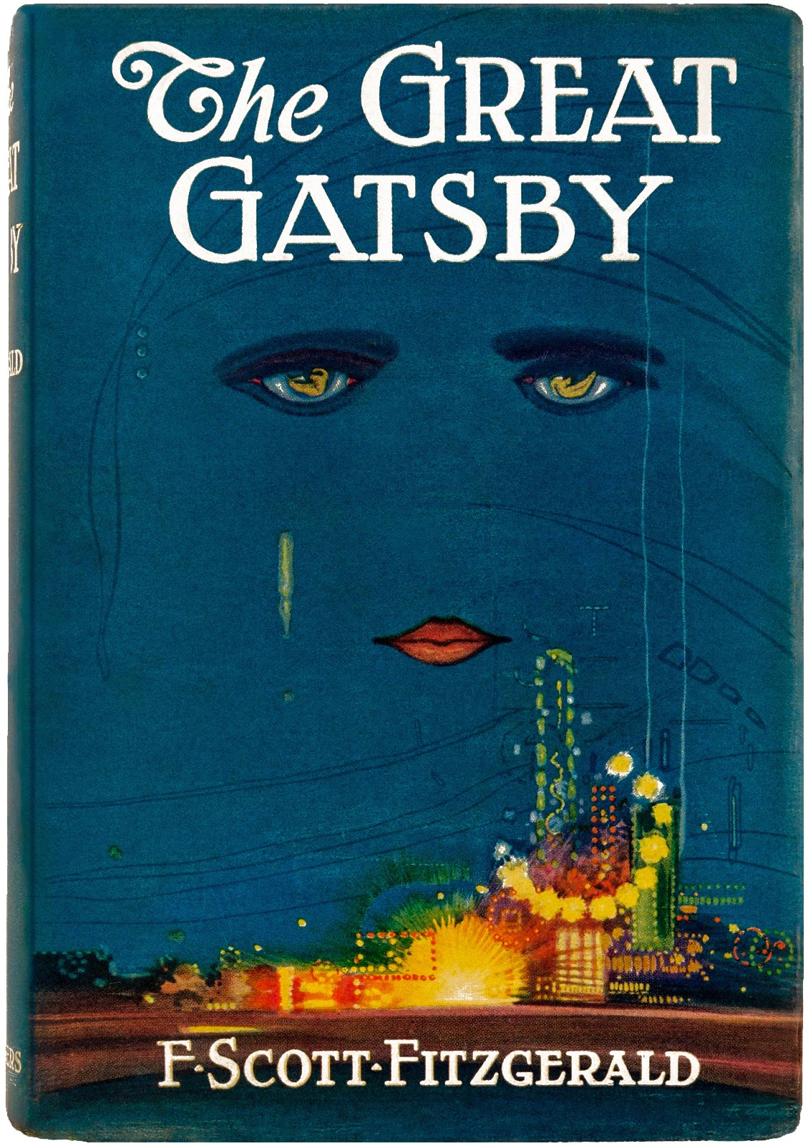

Before September, you must have:
• Read all nine chapters of The Great Gatsby.
• Completed the guided chapter journals in the second half of this booklet.
• Created quotation lists for Gatsby, Daisy, Tom, Nick, class, the American Dream, time, illusion, settings and symbols.
• Chosen 20 "golden quotations" that you can explain in relation to tragedy.
• Tracked at least five tragic tropes across the novel: hamartia, hubris, peripeteia, anagnorisis and catharsis.
• Answered the section questions using the success criteria, not one-sentence responses.

HOW TO READ THIS BOOKLET
This reader is divided into three parts. Part One gives you the conceptual and contextual knowledge you need before and during reading. Part Two guides you through each chapter. Part Three helps you organise your quotation banks and final thinking. Do not skip the context: Fitzgerald’s tragedy only becomes fully visible when you understand the world of 1920s America.

QUICK SELF-AUDIT: WHAT KIND OF READER WILL I BE?
Prompt | Student notes
How will I stop myself from just following the plot? | __________________________________  __________________________________  __________________________________
Where will I keep my quotation lists? | __________________________________  __________________________________  __________________________________
What will I do when I do not understand a passage? | __________________________________  __________________________________  __________________________________
Which big question will I keep returning to as I read? | __________________________________  __________________________________  __________________________________

HOW TO BUILD QUOTATION LISTS
BIG QUESTION
How do strong literature students collect evidence?
A-Level students do not memorise random quotations. They build quotation pathways. A quotation pathway is a sequence of quotations that shows how an idea develops from the beginning of the novel to the end. This is essential for tragedy, because tragedy is a movement: hope becomes pressure, pressure becomes conflict, conflict becomes reversal, and reversal becomes loss.
Every quotation you collect should be labelled with:
• Who says it or who is being described.
• Chapter number and moment in the plot.
• Method: image, symbol, setting, narrative voice, dialogue, structure, motif or contrast.
• Meaning: what it reveals at that point.
• Tragedy link: flaw, dream, illusion, fate, power, villainy, social force or catharsis.

TASK: EXPLAIN WHY QUOTATION CHAINS ARE MORE POWERFUL THAN ISOLATED QUOTATIONS.
1. What does a quotation chain allow you to prove about structure?
2. Why is this especially important for tragedy?
3. How could a quotation chain help you avoid retelling the plot?
Success criteria
• Explains development across the whole text.
• Uses the word structure accurately.
• Links evidence to tragedy rather than just character.
Response space
_______________________________________________________________________________________________
_______________________________________________________________________________________________
_______________________________________________________________________________________________
_______________________________________________________________________________________________
_______________________________________________________________________________________________
_______________________________________________________________________________________________
_______________________________________________________________________________________________

The original cover is used here instead of a theatrical mask: Gatsby’s tragedy begins with vision, distance, and desire.

PART ONE: WHAT MAKES A LIFE TRAGIC?
BIG QUESTION
Can a person be destroyed by the very qualities that make them admirable?

READING: TRAGEDY IS NOT JUST SADNESS
Most students begin by thinking that tragedy means death, suffering or disaster. Literary tragedy is more demanding than this. In tragedy, suffering usually reveals something serious about human beings: our pride, our hunger for status, our self-deception, our desire to control what cannot be controlled, or the cruelty of the societies in which we live.
Classical tragedy often centres on an exceptional figure whose fall matters beyond the individual. Aristotle argued that tragedy should produce pity and fear: pity because the suffering is painful to witness, and fear because the audience recognises that the tragic error is not entirely alien. The tragic hero is not simply bad. Often the hero has qualities we admire, but those qualities become excessive, distorted or dangerously attached to the wrong object.
The Great Gatsby is a modern tragedy. Gatsby is not a king or general. He is a self-made man in twentieth-century America. His tragedy is linked to private longing, money, class, social performance and the American Dream. Fitzgerald modernises tragedy by asking whether society itself can become the force that destroys the hero.
Key tragic vocabulary
• Hamartia: a fatal flaw or error in judgement. In Gatsby, this may be his idealisation of Daisy and his refusal to accept time.
• Hubris: excessive confidence or pride. In Gatsby, this may be the belief that money and willpower can remake reality.
• Peripeteia: a reversal of fortune. In Gatsby, look for the moment when the dream begins to collapse.
• Anagnorisis: recognition or painful insight. Ask whether Gatsby ever fully recognises the truth.
• Catharsis: the pity, sadness and moral reflection produced by the ending.
• Social tragedy: modern tragedy in which social systems, class, money or ideology help destroy individuals.

SECTION QUESTIONS: TRAGEDY
1. Why is a tragic hero usually more complicated than a purely good or purely bad character?
2. How can hope become tragic rather than heroic?
3. Why might a modern tragedy focus on society rather than gods or fate?
4. Before reading Gatsby, predict one way money could become a tragic force.
Success criteria
• Uses at least three tragic terms accurately.
• Explains both individual flaw and social pressure.
• Makes a prediction that can later be tested against the novel.
Response space
_______________________________________________________________________________________________
_______________________________________________________________________________________________
_______________________________________________________________________________________________
_______________________________________________________________________________________________
_______________________________________________________________________________________________
_______________________________________________________________________________________________
_______________________________________________________________________________________________
_______________________________________________________________________________________________
_______________________________________________________________________________________________
_______________________________________________________________________________________________

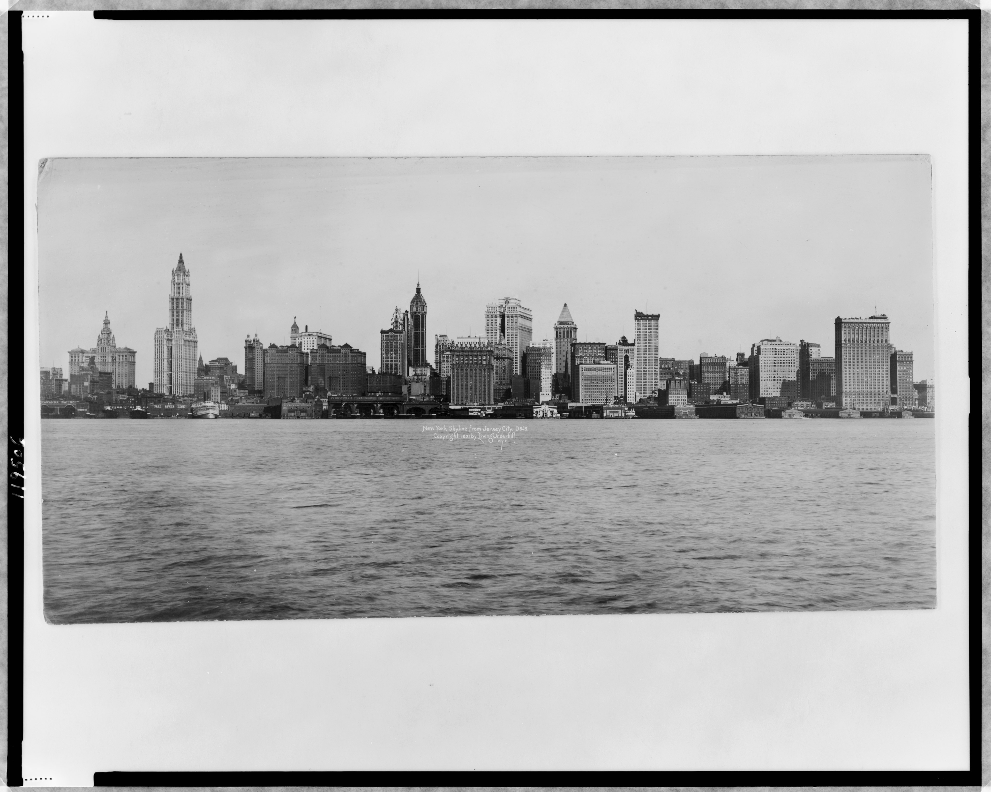
New York skyline, 1921: modern America as aspiration, spectacle and social promise.

PART ONE: THE AMERICAN DREAM
BIG QUESTION
Why do societies create dreams that most people can never achieve?

READING: THE PROMISE AND THE PROBLEM
The American Dream is the belief that individuals can improve their lives through work, ambition and self-invention. It is tied to the idea that America is a land of opportunity: a nation in which birth should not permanently determine destiny. This matters because Gatsby’s life appears to embody the dream. He begins as James Gatz, the son of poor farmers, and reinvents himself as the wealthy Jay Gatsby.
However, Fitzgerald questions whether the dream is genuine. By the 1920s, American life was increasingly shaped by consumer culture, inherited privilege, advertising and visible displays of wealth. The dream promised freedom, but it also encouraged people to measure success through money, property and status. Gatsby gains wealth, but the novel asks whether he can ever gain belonging.
The tragedy of the American Dream is that it offers desire without guaranteeing fulfilment. It tells individuals to strive, but it does not remove class barriers. It promises reinvention, but it cannot erase the past. Gatsby believes he can transform himself, buy proximity to Daisy and repeat history. Fitzgerald’s question is whether this is heroic aspiration or tragic self-deception.
What you must know before reading
• The Dream is both inspiring and dangerous: it encourages hope, but can turn hope into obsession.
• Gatsby’s wealth is not the same as Tom and Daisy’s inherited status.
• Fitzgerald presents America as a place where the language of opportunity hides deep inequality.
• The green light becomes a symbol of desire, distance and the future Gatsby believes he can reach.

SECTION QUESTIONS: THE AMERICAN DREAM
1. What does the American Dream promise?
2. Why might Fitzgerald see the Dream as both beautiful and destructive?
3. Why is Gatsby a useful figure through whom to test the Dream?
4. Is Gatsby’s failure likely to be his own fault, society’s fault, or both? Explain your prediction.
Success criteria
• Defines the American Dream precisely.
• Explores contradiction: hope versus illusion.
• Connects social mobility to tragedy.
• Uses tentative language: might, suggests, implies, perhaps.
Response space
_______________________________________________________________________________________________
_______________________________________________________________________________________________
_______________________________________________________________________________________________
_______________________________________________________________________________________________
_______________________________________________________________________________________________
_______________________________________________________________________________________________
_______________________________________________________________________________________________
_______________________________________________________________________________________________
_______________________________________________________________________________________________
_______________________________________________________________________________________________
_______________________________________________________________________________________________

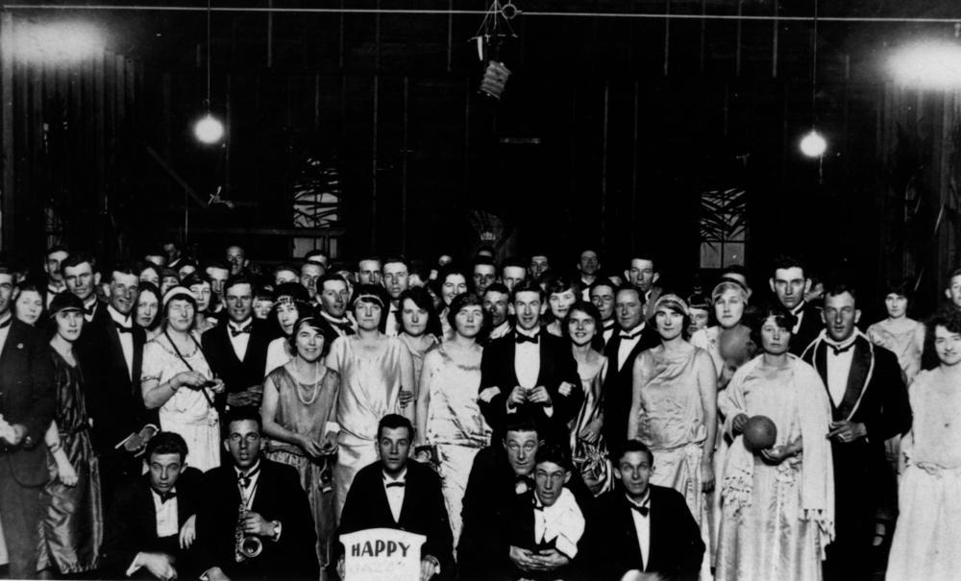
A 1920s jazz dance: glamour, performance and collective pleasure.

PART ONE: THE JAZZ AGE AND CONSUMER CULTURE
BIG QUESTION
What happens when pleasure becomes a society’s main value?

READING: GLAMOUR AND EMPTINESS
Fitzgerald called the 1920s the Jazz Age. It was associated with parties, music, dancing, alcohol, celebrity, fashion and rapid social change. After the First World War, many Americans experienced economic expansion and new forms of consumption. Advertisements encouraged people to buy identities as much as products. To look successful became almost as important as being successful.
This matters because Gatsby’s parties are not simply exciting settings. They are social performances. Guests consume his food, drink his alcohol, repeat rumours about him, and then disappear. The party world creates spectacle without intimacy. It looks full, but it is emotionally empty.
Fitzgerald is not merely condemning pleasure. He is asking what happens when pleasure replaces responsibility. In a society committed to surfaces, people can become careless with one another. This is central to the tragedy: Gatsby’s dream is surrounded by noise, music and light, but at the centre of it is loneliness.

SECTION QUESTIONS: JAZZ AGE
1. Why might a party be a useful setting for social criticism?
2. What is the difference between pleasure and fulfilment?
3. How could consumer culture encourage people to perform rather than reveal identity?
4. Predict: what might Gatsby’s parties reveal about his character before we know his history?
Success criteria
• Connects context to setting.
• Distinguishes appearance from reality.
• Uses the phrase social performance accurately.
• Predicts how a setting can develop tragedy.
Response space
_______________________________________________________________________________________________
_______________________________________________________________________________________________
_______________________________________________________________________________________________
_______________________________________________________________________________________________
_______________________________________________________________________________________________
_______________________________________________________________________________________________
_______________________________________________________________________________________________
_______________________________________________________________________________________________
_______________________________________________________________________________________________
_______________________________________________________________________________________________

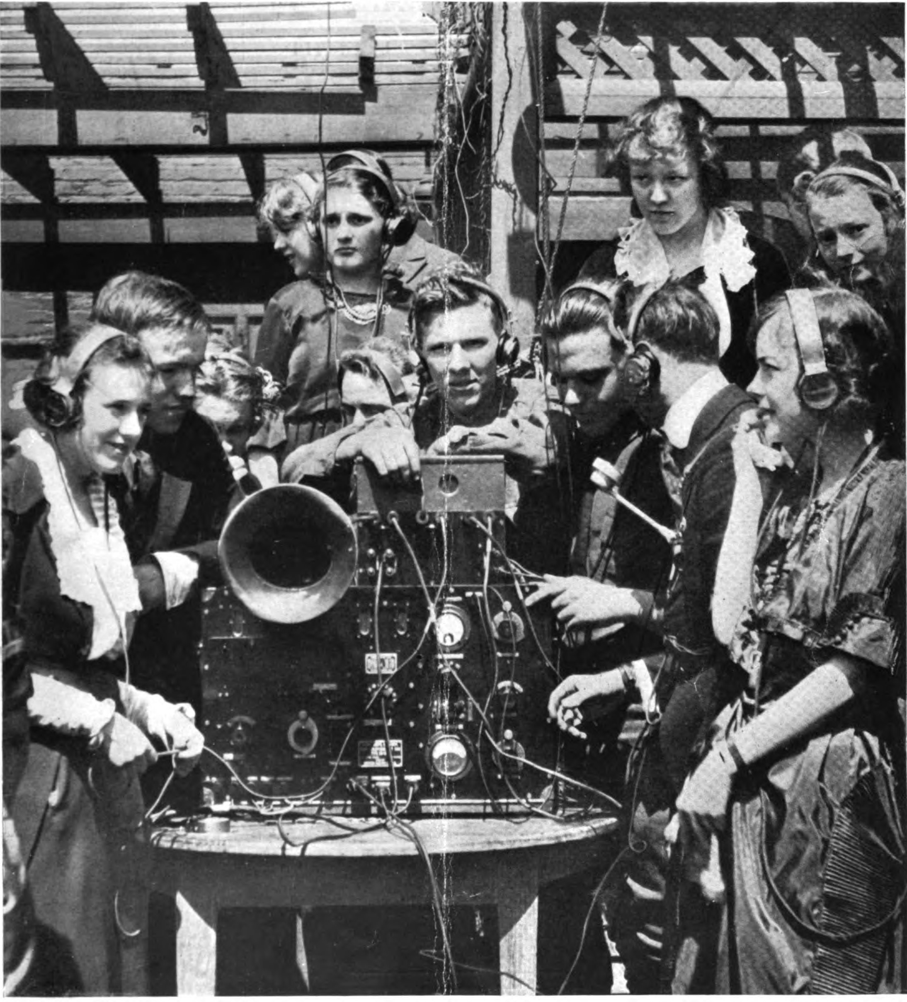
Early radio dance culture, 1920: modern entertainment after war and social change.

PART ONE: THE LOST GENERATION
BIG QUESTION
What happens when people stop trusting old values?

READING: AFTER WAR, BEFORE EMPTINESS
The First World War shook confidence in traditional beliefs. Many young people returned from war or grew up in its aftermath feeling that inherited values no longer explained the modern world. Writers such as Fitzgerald are often linked to the Lost Generation: a group associated with disillusionment, restlessness and suspicion of conventional morality.
In The Great Gatsby, characters often seem detached from stable moral principles. They drift between parties, affairs, rumours and money. Religion appears weakened. Community seems fragile. Even love is often mixed with status, possession or fantasy.
This background is important because tragedy requires a moral universe. In classical tragedy, gods, fate or ethical order may punish wrongdoing. In Gatsby’s world, punishment is uneven. Some characters suffer terribly; others retreat into wealth. Fitzgerald’s modern tragedy therefore asks whether moral order still exists in a world governed by money and carelessness.

SECTION QUESTIONS: THE LOST GENERATION
1. What does disillusionment mean?
2. Why might the aftermath of war lead people towards pleasure, cynicism or emptiness?
3. Why is moral disorder important in tragedy?
4. How might a world without stable values allow careless people to survive?
Success criteria
• Explains historical context without turning it into biography.
• Links disillusionment to moral emptiness.
• Considers uneven punishment as a feature of modern tragedy.
Response space
_______________________________________________________________________________________________
_______________________________________________________________________________________________
_______________________________________________________________________________________________
_______________________________________________________________________________________________
_______________________________________________________________________________________________
_______________________________________________________________________________________________
_______________________________________________________________________________________________
_______________________________________________________________________________________________
_______________________________________________________________________________________________

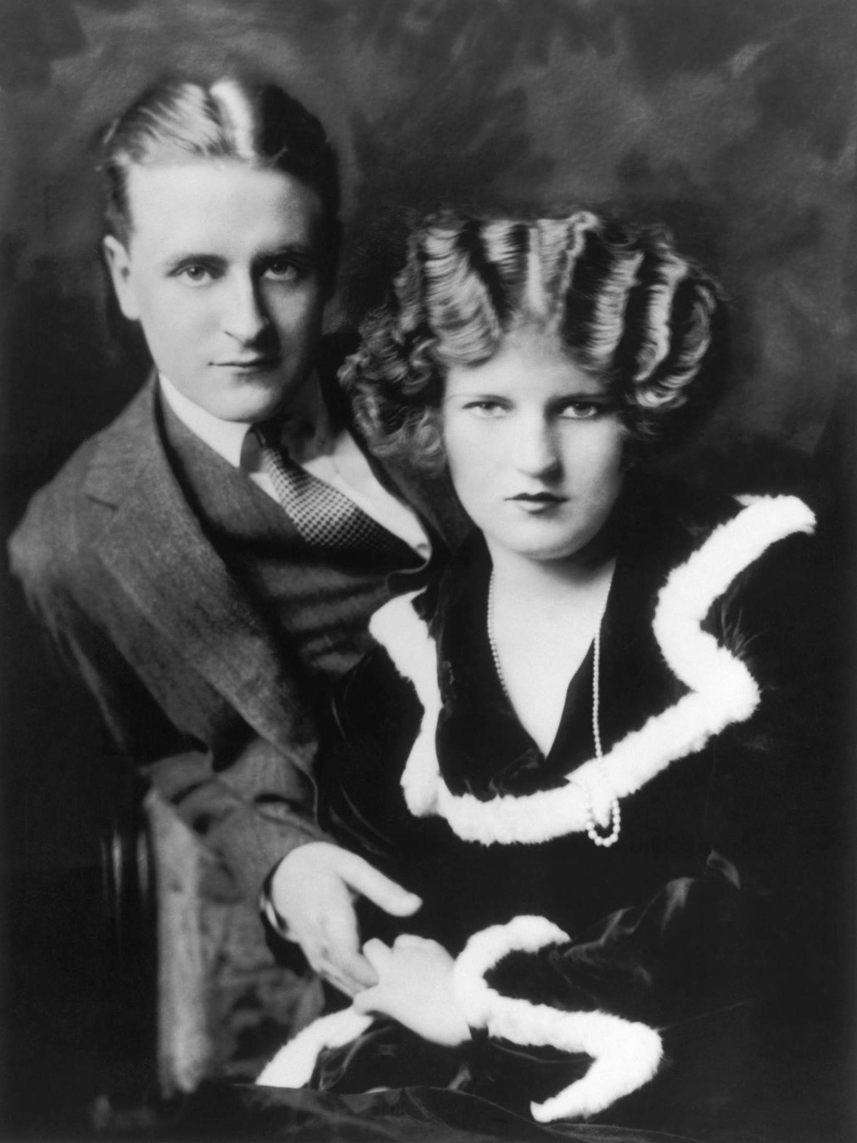
F. Scott and Zelda Fitzgerald, 1923: biography helps illuminate aspiration, love and performance.

PART ONE: FITZGERALD, ZELDA AND SELF-INVENTION
BIG QUESTION
Can love become a form of ambition?

READING: BIOGRAPHY AS INTERPRETATION, NOT GOSSIP
F. Scott Fitzgerald’s life is not the same as Gatsby’s, but it helps us understand the emotional world of the novel. Fitzgerald was fascinated by wealth, glamour and social status. His relationship with Zelda Sayre was shaped by love, ambition and the pressure to succeed. He knew what it meant to desire entry into a glittering world and to fear that he was not enough for it.
This does not mean that Daisy simply equals Zelda or Gatsby simply equals Fitzgerald. A-Level analysis should avoid that kind of simplistic matching. Instead, biography helps us see why Fitzgerald writes so intensely about longing, performance, money and the desire to become someone else.
Gatsby’s self-invention is one of the most important elements of the novel. He changes his name, creates a persona, builds a mansion and stages parties. But the tragedy is that reinvention can become a prison. If the invented self depends on one dream, what happens when that dream fails?

SECTION QUESTIONS: FITZGERALD AND SELF-INVENTION
1. Why should students use biography carefully rather than treating the novel as simple autobiography?
2. How might love and status become connected?
3. What is admirable about self-invention?
4. What is dangerous about self-invention?
Success criteria
• Avoids simplistic “Fitzgerald equals Gatsby” claims.
• Explores biography as a lens, not proof.
• Links self-invention to both ambition and illusion.
Response space
_______________________________________________________________________________________________
_______________________________________________________________________________________________
_______________________________________________________________________________________________
_______________________________________________________________________________________________
_______________________________________________________________________________________________
_______________________________________________________________________________________________
_______________________________________________________________________________________________
_______________________________________________________________________________________________
_______________________________________________________________________________________________


Oheka Castle, Long Island: the scale of elite wealth behind Gatsby’s world.

PART ONE: CLASS, MONEY AND POWER
BIG QUESTION
Can money buy belonging?

READING: OLD MONEY, NEW MONEY AND NO MONEY
One of the most important distinctions in the novel is between old money, new money and no money. Old money refers to inherited wealth, social confidence and established privilege. Tom and Daisy Buchanan belong to this world. New money refers to recently acquired wealth. Gatsby has money, but he does not have the social history that makes Tom secure. No money refers to those excluded from glamour altogether: George and Myrtle Wilson in the Valley of Ashes.
Fitzgerald’s tragedy depends on the fact that wealth is not the same as class power. Gatsby can buy a mansion, shirts, parties and a car. He cannot buy Daisy’s past, Tom’s security, or complete acceptance into the old-money world. This makes the novel a tragedy of social mobility: Gatsby appears to rise, but the social structure remains closed.
A Marxist reading would ask who has power, who is exploited, who survives and who dies. In Gatsby, the lower-status characters suffer most visibly, while the wealthy can move away from consequence. This is why tragedy in the novel is not just personal. It is social.
Class map to remember
• Old money: Tom, Daisy, Jordan. Secure, inherited, socially protected.
• New money: Gatsby. Wealthy, spectacular, but socially insecure.
• No money: George and Myrtle. Trapped in labour, poverty and dependency.
• Nick is complicated: connected to old-money circles but positioned as observer and judge.

SECTION QUESTIONS: CLASS
1. What is the difference between wealth and status?
2. Why might old money feel threatened by new money?
3. How can class operate as a tragic force?
4. Who do you predict will be most vulnerable in the novel, and why?
Success criteria
• Uses old money, new money and no money accurately.
• Explains class as a system, not just a personal attitude.
• Links inequality to vulnerability.
Response space
_______________________________________________________________________________________________
_______________________________________________________________________________________________
_______________________________________________________________________________________________
_______________________________________________________________________________________________
_______________________________________________________________________________________________
_______________________________________________________________________________________________
_______________________________________________________________________________________________
_______________________________________________________________________________________________
_______________________________________________________________________________________________
_______________________________________________________________________________________________

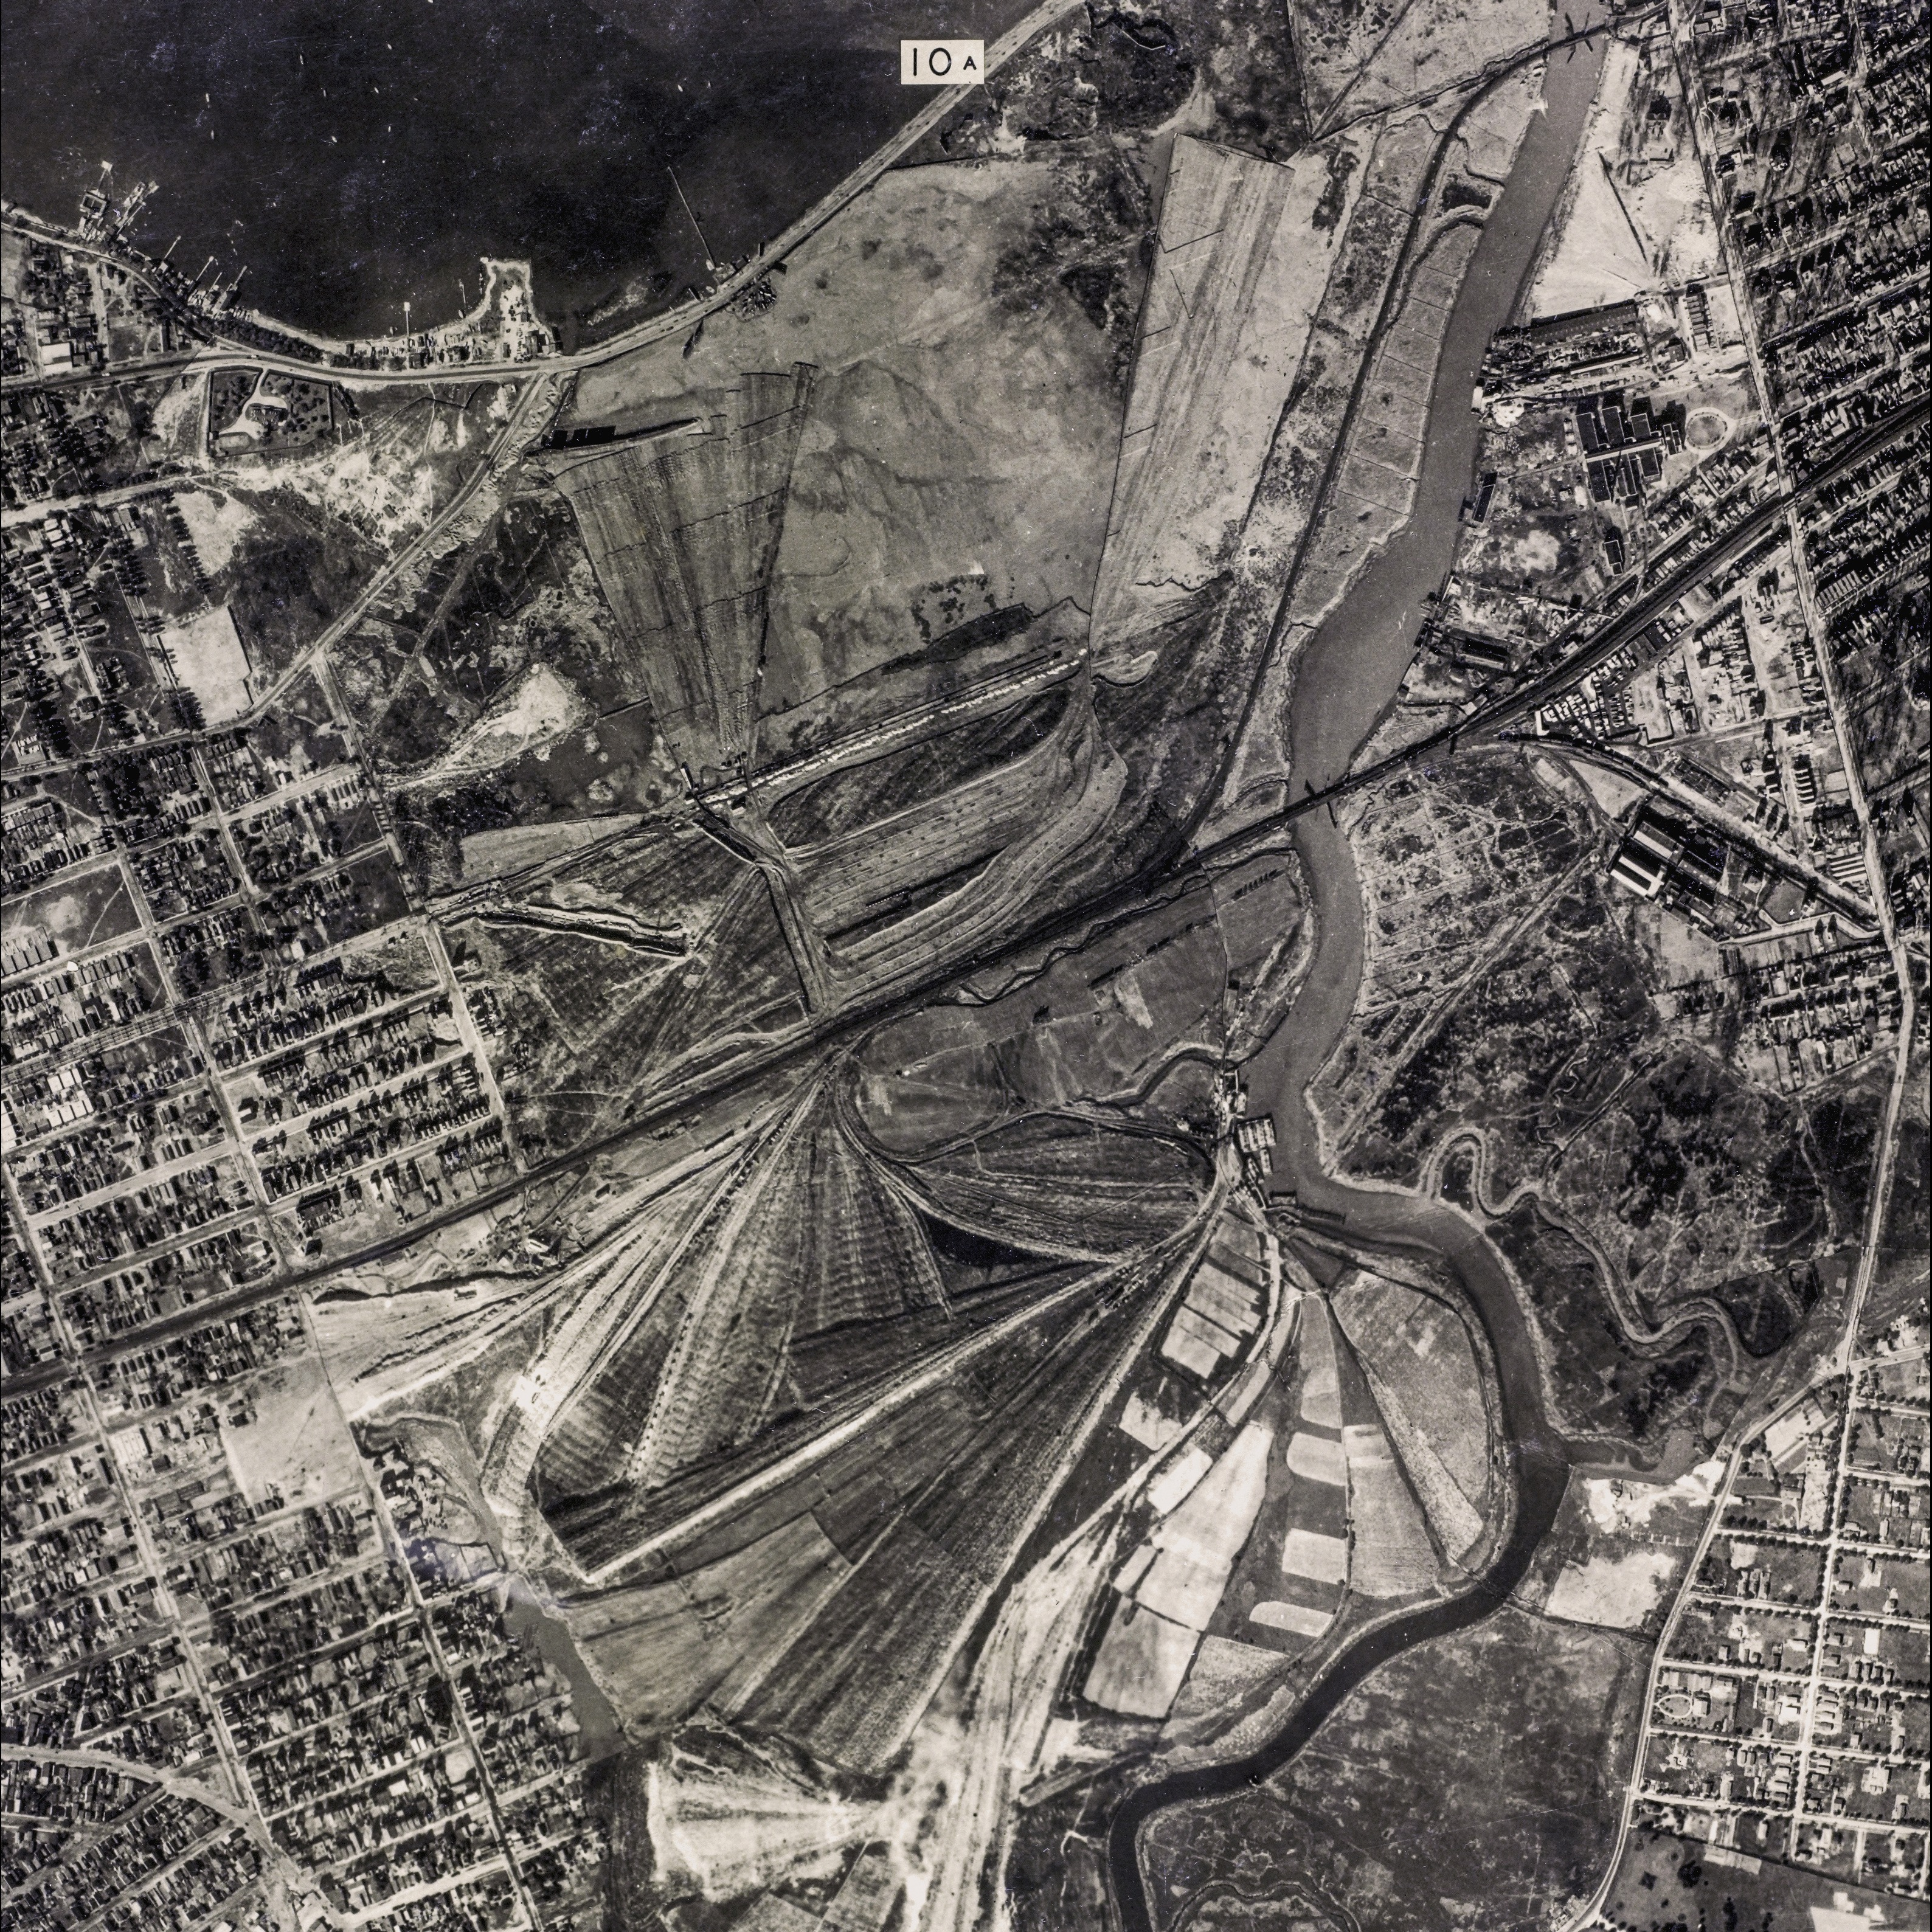
The Corona ash dumps, 1924: a historical image behind Fitzgerald’s Valley of Ashes.

PART ONE: SETTINGS AND SYMBOLS BEFORE READING
BIG QUESTION
How can a place become part of a tragedy?

READING: SYMBOLIC GEOGRAPHY
The geography of The Great Gatsby is symbolic. West Egg represents new money, performance and aspiration. East Egg represents old money, inherited privilege and social authority. Manhattan represents excitement, corruption and escape. The Valley of Ashes represents waste, poverty and the human cost of wealth.
Three symbols require particular attention. The green light represents Gatsby’s dream, but also distance and the future. The eyes of Doctor T. J. Eckleburg suggest watching, judgement and the replacement of religion by advertising. Cars represent modernity, status and danger. These symbols are not decorative: they help Fitzgerald construct tragedy.
As you read, do not just ask what a symbol means. Ask how it changes. A symbol at the beginning of a tragedy may feel hopeful; by the end it may feel hollow, corrupt or unreachable.

SECTION QUESTIONS: SETTINGS AND SYMBOLS
1. Why is the contrast between East Egg and West Egg important before we even know the plot?
2. How can the Valley of Ashes expose the cost of wealth?
3. Why might an advertisement replace God in a modern tragedy?
4. What should you track about the green light as you read?
Success criteria
• Connects setting to class.
• Explains symbolism as developing across the novel.
• Avoids one-word symbol meanings.
Response space
_______________________________________________________________________________________________
_______________________________________________________________________________________________
_______________________________________________________________________________________________
_______________________________________________________________________________________________
_______________________________________________________________________________________________
_______________________________________________________________________________________________
_______________________________________________________________________________________________
_______________________________________________________________________________________________
_______________________________________________________________________________________________
_______________________________________________________________________________________________

PART ONE: TRAGIC TROPES MASTERCLASS
BIG QUESTION
Which tragic patterns should I track as I read?

HAMARTIA
A fatal flaw or serious error in judgement. In Gatsby, this may involve idealising Daisy, confusing wealth with worth, and refusing to accept that time has passed.
Track this as you read
Where does a dream become a mistake?
One example I will look for
_______________________________________________________________________________________________
_______________________________________________________________________________________________
_______________________________________________________________________________________________
_______________________________________________________________________________________________

HUBRIS
Excessive confidence in one’s own power. Gatsby’s version may not be arrogance in a simple sense; it may be the belief that his will, money and imagination can remake reality.
Track this as you read
When does ambition become a refusal of reality?
One example I will look for
_______________________________________________________________________________________________
_______________________________________________________________________________________________
_______________________________________________________________________________________________
_______________________________________________________________________________________________

PERIPETEIA
A reversal of fortune. You should learn the term now, but you should not make a final judgement about Gatsby’s peripeteia until you have read the whole novel. As you read, simply keep notes on moments when Gatsby’s dream appears to move from possibility towards collapse.
Track this as you read
Where does hope begin to turn into disaster?
One example I will look for
_______________________________________________________________________________________________
_______________________________________________________________________________________________
_______________________________________________________________________________________________
_______________________________________________________________________________________________

ANAGNORISIS
A moment of recognition. This is one of the most difficult questions in Gatsby, so do not try to answer it too early. After Chapter 9, you will decide whether Gatsby recognises the truth, whether Nick recognises it for him, or whether the novel denies any clear moment of recognition.
Track this as you read
Who understands the tragedy most clearly?
One example I will look for
_______________________________________________________________________________________________
_______________________________________________________________________________________________
_______________________________________________________________________________________________
_______________________________________________________________________________________________

CATHARSIS
The emotional and moral response produced by the ending. Gatsby’s death should make readers judge not only Gatsby but the society around him.
Track this as you read
What do we feel, and who do we blame?
One example I will look for
_______________________________________________________________________________________________
_______________________________________________________________________________________________
_______________________________________________________________________________________________
_______________________________________________________________________________________________

TRAGIC VILLAIN
The antagonist or destructive force. Tom can be read as a villain, but so can class privilege, carelessness and the corrupted American Dream.
Track this as you read
Is the villain a person or a system?
One example I will look for
_______________________________________________________________________________________________
_______________________________________________________________________________________________
_______________________________________________________________________________________________
_______________________________________________________________________________________________

VICTIMS OF TRAGEDY
Modern tragedies often harm those around the hero. Track Myrtle, George, Nick and Daisy as well as Gatsby.
Track this as you read
Who pays the price for dreams and privilege?
One example I will look for
_______________________________________________________________________________________________
_______________________________________________________________________________________________
_______________________________________________________________________________________________
_______________________________________________________________________________________________

FATE VERSUS FREE WILL
Classical tragedy often uses fate. Modern tragedy often uses social systems, history and ideology.
Track this as you read
Are characters choosing freely, or trapped by their world?
One example I will look for
_______________________________________________________________________________________________
_______________________________________________________________________________________________
_______________________________________________________________________________________________
_______________________________________________________________________________________________

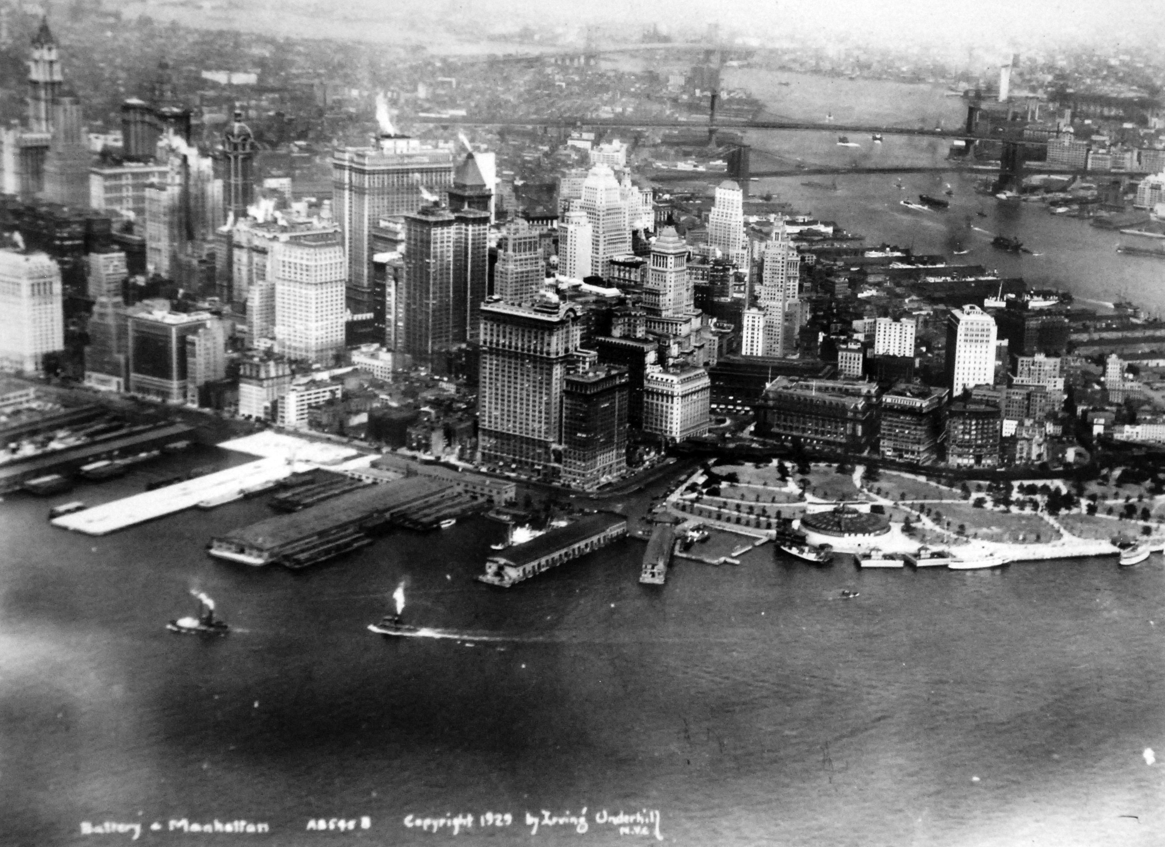
Lower Manhattan, 1929: the city Gatsby moves towards and cannot truly possess.

PART TWO: GUIDED FIRST READING
BIG QUESTION
How do I read the novel without getting lost?
This section assumes you have not read the novel before. Each chapter guide gives you enough information to know what to notice, but you still need to discover the chapter yourself. Read the “Before Reading” page first, then read the chapter, then complete the “After Reading” tasks. Your aim is not to understand everything immediately. Your aim is to build a record of evidence.
Chapter routine
• Before reading: read the chapter preview and focus questions.
• During reading: annotate for the listed characters, settings, symbols and tragic patterns.
• After reading: complete the guided questions and add at least two quotations to your banks.
• Re-read: go back to one key scene and add one extra annotation about tragedy.

CHAPTER 1: GUIDED READING
BIG QUESTION
How does Fitzgerald make Gatsby fascinating before he even speaks?

CHAPTER 1: EAST EGG, TOM AND DAISY, AND GATSBY AT A DISTANCE
Before reading: what happens in this chapter?
• Nick Carraway introduces himself as a narrator and looks back on events from the previous summer.
• We meet Tom and Daisy Buchanan in East Egg, a world of inherited privilege.
• Jordan Baker appears as detached, modern and difficult to read.
• Gatsby appears only at the end, reaching towards a green light across the water.
During reading: look for evidence of...
• Tom’s physical power and racist arrogance.
• Daisy’s charm and dissatisfaction.
• Nick’s mixture of attraction and judgement.
• The contrast between East Egg and West Egg.
• The green light as a first symbol of desire and distance.
Context spotlight
East Egg represents old money: wealth that is inherited, socially confident and protected. Gatsby’s position across the bay already makes him close to Daisy and yet separated from her.
Tragedy spotlight
The delayed tragic hero. Fitzgerald withholds Gatsby so that he becomes an object of mystery, judgement and desire before readers meet him properly.

QUOTE HUNT: ADD AT LEAST TWO OF THESE TO YOUR QUOTATION BANKS
☐ "extraordinary gift for hope"
☐ "foul dust"
☐ "a single green light"

AFTER READING: GUIDED QUESTIONS
1. What does Nick admire about Gatsby before we know Gatsby’s story?
2. How does Tom represent inherited power?
3. What does Daisy seem to know about the world that makes her unhappy?
4. Why is the green light a stronger ending image than a direct description of Gatsby?
Success criteria
• Answers use evidence from this chapter.
• At least one answer connects to tragedy.
• At least one answer connects to context.
• At least two quotations are added to your quote banks.
Response space
_______________________________________________________________________________________________
_______________________________________________________________________________________________
_______________________________________________________________________________________________
_______________________________________________________________________________________________
_______________________________________________________________________________________________
_______________________________________________________________________________________________
_______________________________________________________________________________________________
_______________________________________________________________________________________________
_______________________________________________________________________________________________
_______________________________________________________________________________________________
_______________________________________________________________________________________________
_______________________________________________________________________________________________

CHAPTER 1 MINI QUOTATION BANK
Quotation | Chapter | Method / image | What it reveals | Link to tragedy/context

WHO / WHAT / WHERE / WHEN SUMMARY
Prompt | Student notes
WHO matters most in this chapter? | __________________________________  __________________________________  __________________________________
WHAT changes by the end of the chapter? | __________________________________  __________________________________  __________________________________
WHERE are we, and why does the setting matter? | __________________________________  __________________________________  __________________________________
WHEN does this chapter sit in Gatsby’s tragic arc? | __________________________________  __________________________________  __________________________________

CHAPTER 2: GUIDED READING
BIG QUESTION
How does Fitzgerald show the human cost of wealth?

CHAPTER 2: THE VALLEY OF ASHES AND MYRTLE WILSON
Before reading: what happens in this chapter?
• This chapter moves from Long Island glamour to the Valley of Ashes.
• Tom introduces Nick to Myrtle Wilson, his mistress.
• The chapter contrasts poverty, desire and careless privilege.
• The apartment party in New York exposes vulgar imitation and moral disorder.
During reading: look for evidence of...
• Descriptions of ash, dust and grey bodies.
• The eyes of Doctor T. J. Eckleburg.
• Myrtle’s desire to escape her class position.
• Tom’s violence towards Myrtle.
• Nick’s discomfort and unreliable participation.
Context spotlight
The Valley of Ashes represents the waste produced by modern wealth. It is not just a setting; it is a moral landscape. The poor live among the consequences of other people’s consumption.
Tragedy spotlight
Social tragedy. Myrtle and George are trapped by class long before the plot turns violent.

QUOTE HUNT: ADD AT LEAST TWO OF THESE TO YOUR QUOTATION BANKS
☐ "valley of ashes"
☐ "ash-grey men"
☐ "the eyes of Doctor T. J. Eckleburg"

AFTER READING: GUIDED QUESTIONS
1. How does the Valley of Ashes challenge the glamour of the Jazz Age?
2. Why is Myrtle both a victim and morally flawed?
3. What does Tom’s violence reveal about power?
4. How does this chapter widen the tragedy beyond Gatsby?
Success criteria
• Answers use evidence from this chapter.
• At least one answer connects to tragedy.
• At least one answer connects to context.
• At least two quotations are added to your quote banks.
Response space
_______________________________________________________________________________________________
_______________________________________________________________________________________________
_______________________________________________________________________________________________
_______________________________________________________________________________________________
_______________________________________________________________________________________________
_______________________________________________________________________________________________
_______________________________________________________________________________________________
_______________________________________________________________________________________________
_______________________________________________________________________________________________
_______________________________________________________________________________________________
_______________________________________________________________________________________________
_______________________________________________________________________________________________

CHAPTER 2 MINI QUOTATION BANK
Quotation | Chapter | Method / image | What it reveals | Link to tragedy/context

WHO / WHAT / WHERE / WHEN SUMMARY
Prompt | Student notes
WHO matters most in this chapter? | __________________________________  __________________________________  __________________________________
WHAT changes by the end of the chapter? | __________________________________  __________________________________  __________________________________
WHERE are we, and why does the setting matter? | __________________________________  __________________________________  __________________________________
WHEN does this chapter sit in Gatsby’s tragic arc? | __________________________________  __________________________________  __________________________________

CHAPTER 3: GUIDED READING
BIG QUESTION
What is the difference between popularity and intimacy?

CHAPTER 3: GATSBY’S PARTY AND THE PERFORMANCE OF WEALTH
Before reading: what happens in this chapter?
• Nick attends one of Gatsby’s parties.
• The party is full of guests who enjoy Gatsby’s wealth but know little about him.
• Rumours circulate, making Gatsby seem mysterious and perhaps criminal.
• Nick finally meets Gatsby, but the meeting is surprisingly understated.
During reading: look for evidence of...
• Lists of guests and social spectacle.
• Rumours about Gatsby’s past.
• Owl Eyes in the library.
• Gatsby’s smile and controlled self-presentation.
• The emptiness beneath abundance.
Context spotlight
The Jazz Age party culture allows Fitzgerald to show consumption without responsibility. Gatsby’s parties are full of life, but they also reveal loneliness and social shallowness.
Tragedy spotlight
The hero as spectacle. Gatsby is surrounded by people but remains unknown.

QUOTE HUNT: ADD AT LEAST TWO OF THESE TO YOUR QUOTATION BANKS
☐ "men and girls came and went like moths"
☐ "he killed a man"
☐ "one of those rare smiles"

AFTER READING: GUIDED QUESTIONS
1. How does the party setting expose social emptiness?
2. Why do rumours make Gatsby more powerful and more vulnerable?
3. What does Owl Eyes notice in the library, and why might it matter?
4. How does Nick’s first meeting with Gatsby complicate our expectations?
Success criteria
• Answers use evidence from this chapter.
• At least one answer connects to tragedy.
• At least one answer connects to context.
• At least two quotations are added to your quote banks.
Response space
_______________________________________________________________________________________________
_______________________________________________________________________________________________
_______________________________________________________________________________________________
_______________________________________________________________________________________________
_______________________________________________________________________________________________
_______________________________________________________________________________________________
_______________________________________________________________________________________________
_______________________________________________________________________________________________
_______________________________________________________________________________________________
_______________________________________________________________________________________________
_______________________________________________________________________________________________
_______________________________________________________________________________________________

CHAPTER 3 MINI QUOTATION BANK
Quotation | Chapter | Method / image | What it reveals | Link to tragedy/context

WHO / WHAT / WHERE / WHEN SUMMARY
Prompt | Student notes
WHO matters most in this chapter? | __________________________________  __________________________________  __________________________________
WHAT changes by the end of the chapter? | __________________________________  __________________________________  __________________________________
WHERE are we, and why does the setting matter? | __________________________________  __________________________________  __________________________________
WHEN does this chapter sit in Gatsby’s tragic arc? | __________________________________  __________________________________  __________________________________

CHAPTER 4: GUIDED READING
BIG QUESTION
How do stories create identity?

CHAPTER 4: GATSBY’S STORY AND THE PAST WITH DAISY
Before reading: what happens in this chapter?
• Gatsby tells Nick a version of his life story.
• Nick meets Meyer Wolfsheim, connecting Gatsby to criminal networks.
• Jordan reveals Gatsby and Daisy’s romantic history.
• The chapter begins to connect Gatsby’s wealth to his desire for Daisy.
During reading: look for evidence of...
• Details that seem rehearsed or unbelievable.
• Gatsby’s need for Nick to believe him.
• Wolfsheim and the world of corruption.
• Daisy before marriage and Daisy now.
• The idea that Gatsby’s entire life has been shaped towards one reunion.
Context spotlight
Prohibition created opportunities for illegal wealth. Fitzgerald links Gatsby’s rise to corruption, but also asks whether the old-money world is morally any cleaner.
Tragedy spotlight
Identity as construction. Gatsby is creating a heroic version of himself, but tragedy may emerge from the gap between story and reality.

QUOTE HUNT: ADD AT LEAST TWO OF THESE TO YOUR QUOTATION BANKS
☐ "educated at Oxford"
☐ "fixed the World’s Series"
☐ "he came alive to me"

AFTER READING: GUIDED QUESTIONS
1. Which parts of Gatsby’s story seem designed to impress Nick?
2. How does Wolfsheim change our view of Gatsby?
3. Why does Daisy become more than a person in Gatsby’s imagination?
4. How does this chapter make Gatsby both more sympathetic and more suspect?
Success criteria
• Answers use evidence from this chapter.
• At least one answer connects to tragedy.
• At least one answer connects to context.
• At least two quotations are added to your quote banks.
Response space
_______________________________________________________________________________________________
_______________________________________________________________________________________________
_______________________________________________________________________________________________
_______________________________________________________________________________________________
_______________________________________________________________________________________________
_______________________________________________________________________________________________
_______________________________________________________________________________________________
_______________________________________________________________________________________________
_______________________________________________________________________________________________
_______________________________________________________________________________________________
_______________________________________________________________________________________________
_______________________________________________________________________________________________

CHAPTER 4 MINI QUOTATION BANK
Quotation | Chapter | Method / image | What it reveals | Link to tragedy/context

WHO / WHAT / WHERE / WHEN SUMMARY
Prompt | Student notes
WHO matters most in this chapter? | __________________________________  __________________________________  __________________________________
WHAT changes by the end of the chapter? | __________________________________  __________________________________  __________________________________
WHERE are we, and why does the setting matter? | __________________________________  __________________________________  __________________________________
WHEN does this chapter sit in Gatsby’s tragic arc? | __________________________________  __________________________________  __________________________________

CHAPTER 5: GUIDED READING
BIG QUESTION
What happens when a dream meets reality?

CHAPTER 5: THE REUNION WITH DAISY
Before reading: what happens in this chapter?
• Nick arranges tea so that Gatsby and Daisy can meet again.
• Gatsby is nervous and awkward, which contrasts with his usual performance.
• The chapter moves from embarrassment to emotional intensity.
• Gatsby shows Daisy his mansion and possessions.
During reading: look for evidence of...
• Weather and mood.
• The clock scene.
• Gatsby’s shirts and Daisy’s tears.
• Nick’s language about illusion.
• The difference between Daisy as a woman and Daisy as Gatsby’s dream.
Context spotlight
Consumer culture encourages Gatsby to prove love through objects. His mansion and shirts become evidence of desire, status and performance.
Tragedy spotlight
The dream almost fulfilled. This is a high point, but Fitzgerald plants signs that reality cannot match Gatsby’s imagination.

QUOTE HUNT: ADD AT LEAST TWO OF THESE TO YOUR QUOTATION BANKS
☐ "defunct mantelpiece clock"
☐ "beautiful shirts"
☐ "colossal vitality of his illusion"

AFTER READING: GUIDED QUESTIONS
1. Why is Gatsby nervous before Daisy arrives?
2. How does the clock symbolise Gatsby’s relationship with time?
3. Why does Daisy cry over the shirts?
4. What does Nick mean by the “colossal vitality” of Gatsby’s illusion?
Success criteria
• Answers use evidence from this chapter.
• At least one answer connects to tragedy.
• At least one answer connects to context.
• At least two quotations are added to your quote banks.
Response space
_______________________________________________________________________________________________
_______________________________________________________________________________________________
_______________________________________________________________________________________________
_______________________________________________________________________________________________
_______________________________________________________________________________________________
_______________________________________________________________________________________________
_______________________________________________________________________________________________
_______________________________________________________________________________________________
_______________________________________________________________________________________________
_______________________________________________________________________________________________
_______________________________________________________________________________________________
_______________________________________________________________________________________________

CHAPTER 5 MINI QUOTATION BANK
Quotation | Chapter | Method / image | What it reveals | Link to tragedy/context

WHO / WHAT / WHERE / WHEN SUMMARY
Prompt | Student notes
WHO matters most in this chapter? | __________________________________  __________________________________  __________________________________
WHAT changes by the end of the chapter? | __________________________________  __________________________________  __________________________________
WHERE are we, and why does the setting matter? | __________________________________  __________________________________  __________________________________
WHEN does this chapter sit in Gatsby’s tragic arc? | __________________________________  __________________________________  __________________________________

CHAPTER 6: GUIDED READING
BIG QUESTION
Can a person truly invent themselves?

CHAPTER 6: JAMES GATZ, SELF-INVENTION AND THE IMPOSSIBLE PAST
Before reading: what happens in this chapter?
• Nick reveals Gatsby’s real background as James Gatz.
• We learn about Dan Cody and Gatsby’s early desire for transformation.
• Tom and Daisy attend one of Gatsby’s parties.
• Gatsby is disappointed because Daisy does not respond as he imagined.
During reading: look for evidence of...
• The contrast between James Gatz and Jay Gatsby.
• Dan Cody as a model of wealth and possibility.
• Daisy’s discomfort at the party.
• Gatsby’s belief that the past can be repeated.
• Nick’s warnings and Gatsby’s refusal.
Context spotlight
The American Dream celebrates self-invention, but Fitzgerald asks whether reinvention can erase class origins or emotional history.
Tragedy spotlight
Hubris. Gatsby believes he can recover and perfect the past through willpower.

QUOTE HUNT: ADD AT LEAST TWO OF THESE TO YOUR QUOTATION BANKS
☐ "Platonic conception of himself"
☐ "he invented just the sort of Jay Gatsby"
☐ "Can’t repeat the past?"

AFTER READING: GUIDED QUESTIONS
1. What does the name change from James Gatz to Jay Gatsby reveal?
2. Why is Dan Cody important to Gatsby’s imagination?
3. Why does Daisy dislike the party world Gatsby has built for her?
4. Why is “Can’t repeat the past?” one of the most important tragic moments in the novel?
Success criteria
• Answers use evidence from this chapter.
• At least one answer connects to tragedy.
• At least one answer connects to context.
• At least two quotations are added to your quote banks.
Response space
_______________________________________________________________________________________________
_______________________________________________________________________________________________
_______________________________________________________________________________________________
_______________________________________________________________________________________________
_______________________________________________________________________________________________
_______________________________________________________________________________________________
_______________________________________________________________________________________________
_______________________________________________________________________________________________
_______________________________________________________________________________________________
_______________________________________________________________________________________________
_______________________________________________________________________________________________
_______________________________________________________________________________________________

CHAPTER 6 MINI QUOTATION BANK
Quotation | Chapter | Method / image | What it reveals | Link to tragedy/context

WHO / WHAT / WHERE / WHEN SUMMARY
Prompt | Student notes
WHO matters most in this chapter? | __________________________________  __________________________________  __________________________________
WHAT changes by the end of the chapter? | __________________________________  __________________________________  __________________________________
WHERE are we, and why does the setting matter? | __________________________________  __________________________________  __________________________________
WHEN does this chapter sit in Gatsby’s tragic arc? | __________________________________  __________________________________  __________________________________

CHAPTER 7: GUIDED READING
BIG QUESTION
Where does the dream finally break?

CHAPTER 7: THE PLAZA CONFRONTATION AND MYRTLE’S DEATH
Before reading: what happens in this chapter?
• This is the structural crisis of the novel.
• The heat creates pressure and discomfort.
• Gatsby wants Daisy to say she never loved Tom.
• Tom attacks Gatsby’s class, criminality and legitimacy.
• After the confrontation, Myrtle is killed by Gatsby’s car.
During reading: look for evidence of...
• Heat and claustrophobia.
• Daisy’s inability to meet Gatsby’s demand.
• Tom’s hard malice and social confidence.
• Gatsby’s loss of control.
• The car as a symbol of modern destruction.
Context spotlight
Old money protects itself. Tom can expose Gatsby because social power is not just about facts; it is about authority, confidence and class position.
Tragedy spotlight
Peripeteia. Gatsby’s fortune reverses because the dream of Daisy as perfect and recoverable collapses.

QUOTE HUNT: ADD AT LEAST TWO OF THESE TO YOUR QUOTATION BANKS
☐ "Her voice is full of money"
☐ "I did love him once"
☐ "made a short deft movement"

AFTER READING: GUIDED QUESTIONS
1. Why does Gatsby need Daisy to say she never loved Tom?
2. How does Tom use class as a weapon?
3. Why is Daisy’s confession devastating for Gatsby?
4. How does Myrtle’s death connect the private love triangle to wider social tragedy?
Success criteria
• Answers use evidence from this chapter.
• At least one answer connects to tragedy.
• At least one answer connects to context.
• At least two quotations are added to your quote banks.
Response space
_______________________________________________________________________________________________
_______________________________________________________________________________________________
_______________________________________________________________________________________________
_______________________________________________________________________________________________
_______________________________________________________________________________________________
_______________________________________________________________________________________________
_______________________________________________________________________________________________
_______________________________________________________________________________________________
_______________________________________________________________________________________________
_______________________________________________________________________________________________
_______________________________________________________________________________________________
_______________________________________________________________________________________________

CHAPTER 7 MINI QUOTATION BANK
Quotation | Chapter | Method / image | What it reveals | Link to tragedy/context

WHO / WHAT / WHERE / WHEN SUMMARY
Prompt | Student notes
WHO matters most in this chapter? | __________________________________  __________________________________  __________________________________
WHAT changes by the end of the chapter? | __________________________________  __________________________________  __________________________________
WHERE are we, and why does the setting matter? | __________________________________  __________________________________  __________________________________
WHEN does this chapter sit in Gatsby’s tragic arc? | __________________________________  __________________________________  __________________________________

CHAPTER 8: GUIDED READING
BIG QUESTION
Does Gatsby recognise the truth before it is too late?

CHAPTER 8: WAITING, MEMORY AND GATSBY’S DEATH
Before reading: what happens in this chapter?
• Gatsby waits outside Daisy’s house, still hoping.
• Nick gives us more of Gatsby and Daisy’s earlier romance.
• George Wilson grieves Myrtle and searches for someone to blame.
• Gatsby is killed in his pool.
During reading: look for evidence of...
• Gatsby’s loyalty to Daisy.
• Nick’s sympathy and final compliment.
• Images of autumn, waiting and emptiness.
• Wilson’s religious interpretation of the eyes.
• Whether Gatsby has anagnorisis or remains trapped in illusion.
Context spotlight
Modern tragedy often lacks fair justice. Gatsby is punished for a death he did not cause, while the old-money world withdraws.
Tragedy spotlight
Possible anagnorisis. The reader must decide whether Gatsby recognises Daisy’s emptiness, or whether Nick imagines that recognition for him.

QUOTE HUNT: ADD AT LEAST TWO OF THESE TO YOUR QUOTATION BANKS
☐ "You’re worth the whole damn bunch"
☐ "the holocaust was complete"
☐ "a new world"

AFTER READING: GUIDED QUESTIONS
1. Why does Gatsby continue to protect Daisy?
2. Why is Nick’s compliment important?
3. What role do the eyes of Eckleburg play in Wilson’s thinking?
4. What might Nick want us to think Gatsby understands at this point? Keep notes only; make your final anagnorisis judgement after Chapter 9.
Success criteria
• Answers use evidence from this chapter.
• At least one answer connects to tragedy.
• At least one answer connects to context.
• At least two quotations are added to your quote banks.
Response space
_______________________________________________________________________________________________
_______________________________________________________________________________________________
_______________________________________________________________________________________________
_______________________________________________________________________________________________
_______________________________________________________________________________________________
_______________________________________________________________________________________________
_______________________________________________________________________________________________
_______________________________________________________________________________________________
_______________________________________________________________________________________________
_______________________________________________________________________________________________
_______________________________________________________________________________________________
_______________________________________________________________________________________________

CHAPTER 8 MINI QUOTATION BANK
Quotation | Chapter | Method / image | What it reveals | Link to tragedy/context

WHO / WHAT / WHERE / WHEN SUMMARY
Prompt | Student notes
WHO matters most in this chapter? | __________________________________  __________________________________  __________________________________
WHAT changes by the end of the chapter? | __________________________________  __________________________________  __________________________________
WHERE are we, and why does the setting matter? | __________________________________  __________________________________  __________________________________
WHEN does this chapter sit in Gatsby’s tragic arc? | __________________________________  __________________________________  __________________________________

CHAPTER 9: GUIDED READING
BIG QUESTION
What remains after the tragedy?

CHAPTER 9: FUNERAL, JUDGEMENT AND THE FINAL VISION
Before reading: what happens in this chapter?
• Nick tries to arrange Gatsby’s funeral.
• Very few people attend.
• Gatsby’s father appears and reveals Gatsby’s youthful ambition.
• Nick reflects on the East, the West, the American Dream and the impossibility of fully escaping the past.
During reading: look for evidence of...
• Absence and abandonment.
• Nick’s judgement of Tom and Daisy.
• Henry Gatz’s pride and sadness.
• The final return to the green light.
• The famous closing image of boats against the current.
Context spotlight
The ending turns Gatsby’s private dream into a national myth. Fitzgerald links Gatsby’s longing to America’s larger history of dreaming, expansion and disappointment.
Tragedy spotlight
Catharsis. Readers feel pity for Gatsby but are also invited to judge the careless society that survives him.

QUOTE HUNT: ADD AT LEAST TWO OF THESE TO YOUR QUOTATION BANKS
☐ "careless people"
☐ "green light"
☐ "borne back ceaselessly into the past"

AFTER READING: GUIDED QUESTIONS
1. Why is the funeral so important to our judgement of Gatsby’s world?
2. How does Nick judge Tom and Daisy?
3. Why does Fitzgerald return to the green light at the end?
4. What does the final sentence suggest about human beings and the past?
Success criteria
• Answers use evidence from this chapter.
• At least one answer connects to tragedy.
• At least one answer connects to context.
• At least two quotations are added to your quote banks.
Response space
_______________________________________________________________________________________________
_______________________________________________________________________________________________
_______________________________________________________________________________________________
_______________________________________________________________________________________________
_______________________________________________________________________________________________
_______________________________________________________________________________________________
_______________________________________________________________________________________________
_______________________________________________________________________________________________
_______________________________________________________________________________________________
_______________________________________________________________________________________________
_______________________________________________________________________________________________
_______________________________________________________________________________________________

CHAPTER 9 MINI QUOTATION BANK
Quotation | Chapter | Method / image | What it reveals | Link to tragedy/context

WHO / WHAT / WHERE / WHEN SUMMARY
Prompt | Student notes
WHO matters most in this chapter? | __________________________________  __________________________________  __________________________________
WHAT changes by the end of the chapter? | __________________________________  __________________________________  __________________________________
WHERE are we, and why does the setting matter? | __________________________________  __________________________________  __________________________________
WHEN does this chapter sit in Gatsby’s tragic arc? | __________________________________  __________________________________  __________________________________

PART THREE: FINAL QUOTATION BANKS
BIG QUESTION
What evidence must I bring to class?
Use these pages after every chapter. You are not expected to complete them perfectly on a first reading. You are expected to begin collecting evidence. The most useful quotation banks contain short quotations, accurate chapter references, and explanations that link to tragedy.

GATSBY: HOPE, DREAMS AND SELF-INVENTION
Quotation | Chapter | Method / image | What it reveals | Link to tragedy/context

GATSBY: TIME, ILLUSION AND DOWNFALL
Quotation | Chapter | Method / image | What it reveals | Link to tragedy/context

DAISY: VOICE, MONEY, CARELESSNESS AND DESIRE
Quotation | Chapter | Method / image | What it reveals | Link to tragedy/context

TOM: POWER, VIOLENCE, CLASS AND VILLAINY
Quotation | Chapter | Method / image | What it reveals | Link to tragedy/context

NICK: NARRATION, JUDGEMENT AND RELIABILITY
Quotation | Chapter | Method / image | What it reveals | Link to tragedy/context

THE AMERICAN DREAM: HOPE, MONEY AND FAILURE
Quotation | Chapter | Method / image | What it reveals | Link to tragedy/context

CLASS: OLD MONEY, NEW MONEY AND NO MONEY
Quotation | Chapter | Method / image | What it reveals | Link to tragedy/context

SETTINGS: EAST EGG, WEST EGG, MANHATTAN AND THE VALLEY OF ASHES
Quotation | Chapter | Method / image | What it reveals | Link to tragedy/context

SYMBOLS: GREEN LIGHT, EYES, CARS, PARTIES AND HOUSES
Quotation | Chapter | Method / image | What it reveals | Link to tragedy/context

TRAGIC TROPES: HAMARTIA, HUBRIS, REVERSAL, RECOGNITION AND CATHARSIS
Quotation | Chapter | Method / image | What it reveals | Link to tragedy/context

FINAL SYNTHESIS
BIG QUESTION
Is Gatsby destroyed by himself or by America?
By the time you have finished your first reading, you should be able to offer a provisional answer to the central enquiry. Your answer should not be simplistic. Gatsby is flawed, but Fitzgerald also exposes a world that encourages dreams and then punishes those who believe in them too completely.

FINAL WRITTEN RESPONSE
1. To what extent is Gatsby responsible for his own downfall?
2. To what extent is Tom, Daisy and old-money society responsible?
3. How does Fitzgerald use symbols and settings to make the tragedy feel larger than one man?
4. Which three quotations best support your current interpretation?
Success criteria
• Creates a balanced argument rather than blaming one person only.
• Uses at least three quotations from different chapters.
• Uses at least three key terms from the tragedy masterclass.
• Links context to interpretation, not as a bolt-on fact.
• Ends with a clear judgement that could become an essay thesis.
Response space
_______________________________________________________________________________________________
_______________________________________________________________________________________________
_______________________________________________________________________________________________
_______________________________________________________________________________________________
_______________________________________________________________________________________________
_______________________________________________________________________________________________
_______________________________________________________________________________________________
_______________________________________________________________________________________________
_______________________________________________________________________________________________
_______________________________________________________________________________________________
_______________________________________________________________________________________________
_______________________________________________________________________________________________
_______________________________________________________________________________________________
_______________________________________________________________________________________________
_______________________________________________________________________________________________
_______________________________________________________________________________________________
Bring to your first A-Level lesson
• This completed booklet.
• Your copy of The Great Gatsby with annotations.
• Your 20 golden quotations.
• One paragraph answering: Is Gatsby destroyed by his own dream or by America?
• Three questions you still have about the novel.

FINAL TRAGIC STRUCTURE TASK: PERIPETEIA AND ANAGNORISIS
Complete this task only after you have read Chapter 9. Earlier in the booklet you learned the terms, but you cannot judge reversal and recognition properly until you can see the whole shape of Gatsby’s tragedy.

BIG QUESTION
Where does Gatsby’s dream truly begin to collapse, and does anyone fully recognise the truth before the end?
1. Identify the moment you think functions as the novel’s peripeteia. Is it the reunion with Daisy, the failed party, the Plaza confrontation, Myrtle’s death, or Gatsby’s lonely death? Justify your choice.
2. Build a three-part evidence chain: one quotation before the reversal, one quotation during the reversal, and one quotation after the reversal.
3. Decide whether Gatsby experiences anagnorisis. Does he recognise Daisy’s limitations, the failure of the American Dream, or the impossibility of repeating the past?
4. Consider an alternative: does Nick, rather than Gatsby, experience the recognition? What does Nick understand by the end that Gatsby may not?
5. Final judgement: is Fitzgerald’s tragedy more powerful because recognition arrives too late, or because it never arrives clearly at all?

SUCCESS CRITERIA
☐ Use evidence from at least three chapters.
☐ Make a precise judgement, not a list of possibilities.
☐ Use the terms peripeteia and anagnorisis accurately.
☐ Consider Gatsby and Nick as possible centres of recognition.
☐ Connect the individual tragedy to class, the American Dream and time.

My peripeteia judgement

Evidence chain: before / during / after

My anagnorisis judgement

Alternative interpretation

Final evaluative paragraph

