Sociology Transition pack year 12

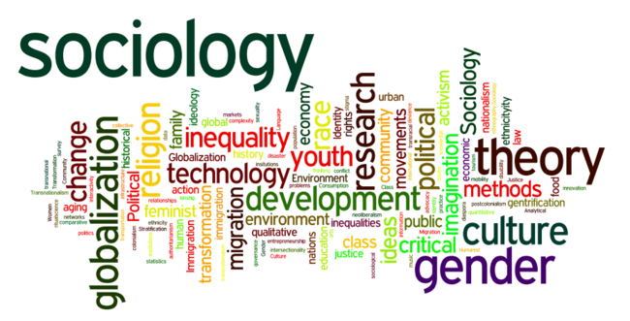

Introduction to Sociology – Year 12 at Uxbridge High School (300 words)
Sociology at Uxbridge High School has become one of the most popular and exciting subject choices among Year 12 students, and for good reason. As a discipline that explores how society works, how social structures shape our lives, and how individuals influence the world around them, sociology offers a rich and thought-provoking experience for learners. At its core, sociology helps students make sense of the world, from issues of inequality, identity, and power, to the role of institutions like the family, education, and the criminal justice system.
What makes sociology especially appealing to students at Uxbridge is its relevance to real life. The subject encourages learners to question assumptions, think critically about the society they live in, and develop informed opinions about current social issues. It also supports the development of transferable skills such as essay writing, analytical thinking, and research interpretation, all of which are highly valued in higher education and future careers.

Main Topics in Year 12 Sociology at Uxbridge College School
- Families and Households, and Research Methods
In this topic, students explore the evolving role of the family within wider society and how it has changed over time. Key areas of focus include shifts in patterns of marriage, cohabitation, separation, divorce, and the life course. Students will also examine gender roles within the family, the changing nature of childhood, and major demographic trends since 1900. Alongside this, students will be introduced to core sociological research methods, learning how sociologists collect and interpret data.
- Education and Research Methods
This unit looks at the role and purpose of education in society. Students investigate why educational outcomes vary across different social groups, including those based on class, gender, and ethnicity. They will also study how internal school factors, such as pupil subcultures, teacher expectations, and the hidden curriculum, influence student achievement. In addition, the module covers key education policies and continues to develop students’ understanding of sociological research methods

Main Topics in Year 13 Sociology – Uxbridge College
- Beliefs in Society
In this module, students explore a range of sociological perspectives on religion and belief systems. Topics include the purpose and role of religion in society, comparisons between different religious organisations, and how religion interacts with various social groups. The course also examines debates around secularisation, whether religion is declining or simply changing form and the relevance of belief in modern society.
- Crime and Deviance with Theory and Methods
This module focuses on sociological theories of crime and deviance, investigating why certain behaviours are labelled as deviant and how crime is distributed across different social groups. Students will study current issues such as the impact of globalisation, media representations of crime, and patterns of criminal behaviour. The course also looks at the criminal justice system, including sociological perspectives on punishment and control, as well as an in-depth study of suicide from a sociological standpoint. Throughout the module, students continue to develop their understanding of key sociological theories and research methods.

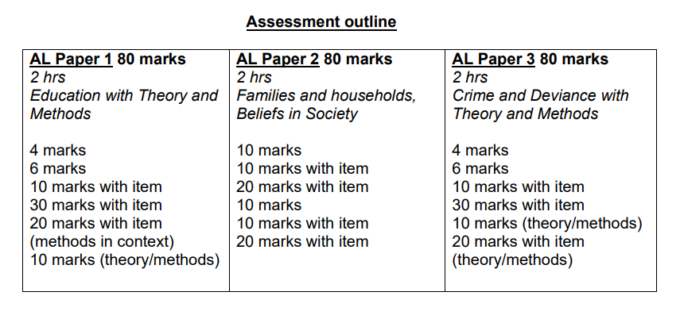
Please note that there will be extensive monitoring of progress throughout year 12 which will lead to an important mock exam in summer term.
Although not an external exam, it is vital that this is passed to ensure success on the two-year course and progression onto to year 13.
There is no coursework in sociology.

Year 12 Induction work programme
The following programme is designed to prepare you for A level Sociology for the following Year 12 topics: Sociological Theory Education Families and Households You must complete all sections of the programme to ensure that you have a thorough understanding of the background for these Year 12 topics.
Evidence of completing each section should be handed in to your teacher in September, these must be handwritten. The work should be set out in an organised manner. It is suggested that you complete a task each week, creating a 6-week programme. Suggested website links are included.

Task 1:
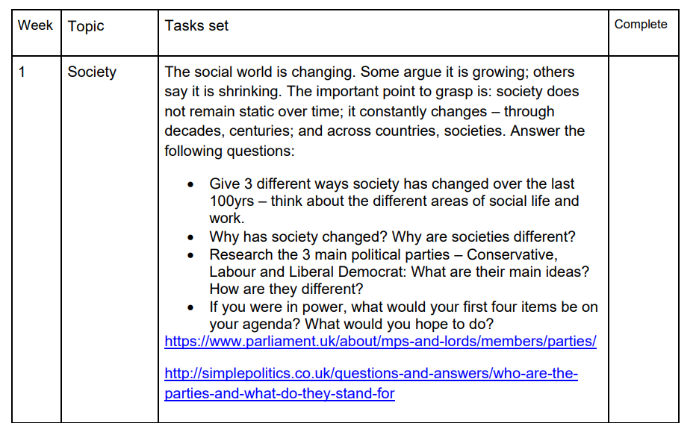

Task 2: What is Sociology? Watch the video clip on YouTube: What is Sociology? Crash Course Sociology:
https://www.youtube.com/watch?v=YnCJU6PaCio and make notes on what you understand about Sociology. Find the definitions for the following key sociological terms:
  - Socialisation (primary socialisation and secondary socialisation)
  - Norms
  - Values
  - Beliefs
  - Culture
  - Social Class
  - Gender
  - Ethnicity

Task 3:
Main Sociological Theories A theory, for our purpose, is something that explains the relationship between two or more things.
A perspective can be defined as a way of looking at and seeing something. To have a perspective, therefore, means to look at something (whatever that thing might be) in a particular way. When we talk about the sociological perspective, therefore, we are talking about the particular way those sociologists try to understand human social behaviour. Use the internet to find out about the main sociological theories. For each one explain the main idea and concepts and the key sociologists:
• Functionalism
• Marxism
• Feminism
• Action Theories
• Postmodernism
• New Right
• Which sociological perspective do you agree with? Why? The YouTube channel below is good for summaries of the main theories:
https://www.youtube.com/playlist?list=PL8dPuuaLjXtMJAfB_7J1538YKWkZAnGA https://revisesociology.com/sociology-theories-a-level/ https://www.tutor2u.net/sociology/topics/group/theory-methodskey-terms

Task 4: Write up the following: Education definitions for the following key education terms:
• Absolute aspirations
• Academies
• Cultural deprivation
• Deferred gratification
• Education Action Zones
• Educational Maintenance Allowance
• Further education
• Hidden curriculum
• Higher education
• Immediate gratification
• Material deprivation
• Relative aspirations
• Sink schools
• Tripartite system

