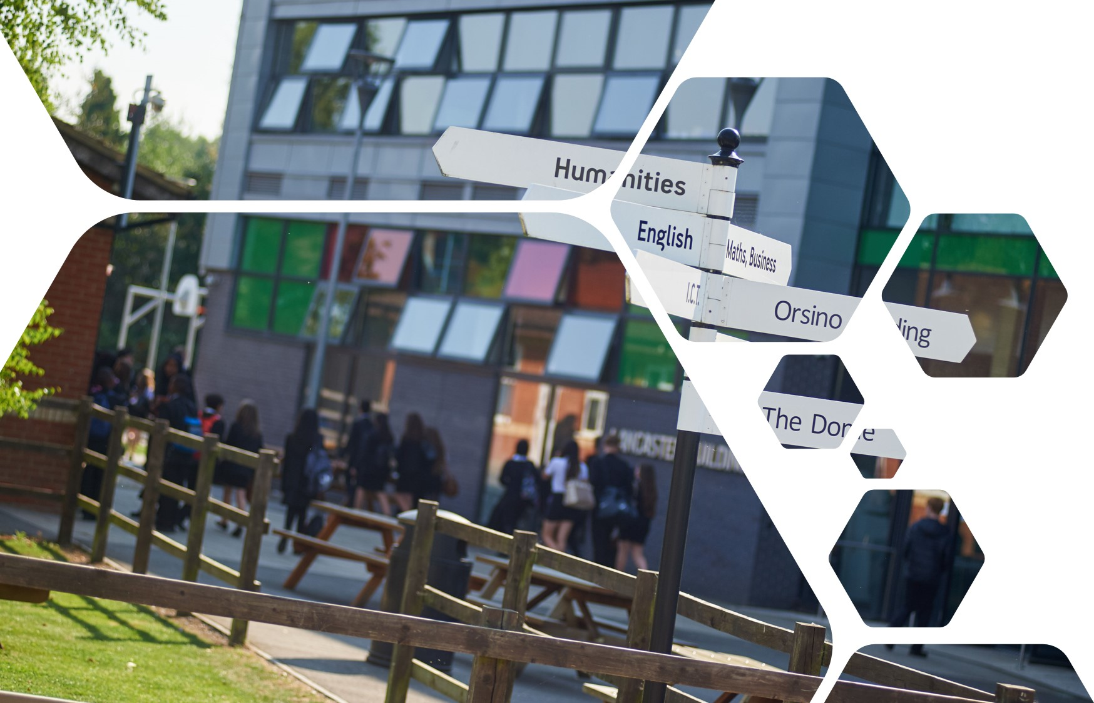
Sixth Form Transition Work – Geography

Welcome message:
We are delighted to welcome you to the A Level Geography course. It is a testament to your hard work and resilience that you are reading this and preparing to embark upon sixth form study. This booklet will talk you through some key information, advice and expectations for studying AQA A Level Geography at UHS and will set out some preparation work to complete for September. The aim of this work is to ensure that you feel confident in Geographical research methods and academic writing styles before we begin in September. A Level study is rigorous but highly rewarding and will take huge amounts of dedication to get to your next destination. With this said, it is a fantastic opportunity to explore the depth of your geographical knowledge and global citizenship. We very much look forward to embarking on this journey with you and fulfilling your full potential over the next two years.
Course Specifics:
Title:
- AQA A Level Geography
How you’re assessed:
- Paper 1 (Physical Geography) – Water and Carbon cycles, Coasts and Hazards – 40% of overall grade.
- Paper 2 (Human Geography) – Global Systems and Global Governance, Changing Places and Contemporary Urban Environments – 40% of overall grade.
- Non-Examined Assessment (NEA) aka. coursework – 20% of overall grade.
Revision Guide Suggestions:
- CGP A Level Geography Revision Guide - https://www.cgpbooks.co.uk/secondary-books/as-and-a-level/geography/ger72-a-level-and-as-geography-edexcel?gad_source=1&gad_campaignid=22151731344&gbraid=0AAAAADuMZW2-RyTZLSPdZzrYs5kdrzTd2&gclid=CjwKCAjwvO7CBhAqEiwA9q2YJZ9nFG8o8eSRM_GiT0fZ-QAMOGmJAegsBBZvHvQPb3BD-lkajD9_xBoCR90QAvD_BwE
- Oxford Revise AQA A Level Geography - https://global.oup.com/education/product/9781382052429/?region=uk&gad_source=1&gad_campaignid=22663058778&gbraid=0AAAAADFRmJngx3G4Av88RAc94pu4FJ1qc&gclid=CjwKCAjwvO7CBhAqEiwA9q2YJWW0nr1f181TeNVSnMwoCXjSWeFXlduTB-iq7F45IT_ejK0jJP5iuxoCWuIQAvD_BwE
A Level Geography Non-Negotiables:
All A Level Geography expectations align to those utilised by the sixth form team however, here is a quick reminder of good classroom practice.
- You arrive to all lessons on time and fully equipped.
- Phones are not visible and switched off in your bag.
- You attend all timetabled lessons.
- Any lessons missed due to sickness or other absence must be caught up on independently. Please email your classroom teacher to arrange this.
- All coursework deadlines must be met.
- Regularly check Microsoft Teams/Outlook email for key messages and independent practice tasks.
These non-negotiables are you ensure that you feel as confident as possible to achieve your best when you sit your final exams in two years’ time!

Summer Preparation Work:
Section 1: Understanding the AQA A level Geography course in detail.
Type the following into YouTube - AQA A-Level Geography: Course Information and Exam Structure – and complete the following table below.

What are the three main components of the AQA A Level Geography course? | How is the course split between physical geography and human geography? | Name at least two physical topics and two human topics included in the specification.
What is the purpose of the NEA (Non-Examined Assessment)? | What does AO1 attempt to address within the AQA A level Geography course? | What does AO2 attempt to address within the AQA A level Geography course?
What does AO3 attempt to address within the AQA A level Geography course? | What part of the AQA A level Geography course are you most interested in? Explain why.

Optional reading around the subject:
Please chose one of the following books to read/listen over the summer break. All of these books are available on Spotify (premium account)
- Prisoners of Geography by Tim Marshall – Explores how physical geography influences political realities.
- Factfulness by Hans Rosling - provides a data-driven perspective on global development and challenges.
- Adventures in the Anthropocene by Gaia Vince – Examines the impact of human activity on the planet.
Section 2: Coastal systems and landscapes (physical unit)
You will spend approximately 60 – 75 minutes on this task.
Follow the steps to complete your preparation work for your first AQA A level Geography physical topic.
Step 1 - Type into your search engine the following information - PMT AQA A level Geography coastal systems and landscapes detailed notes.
Step 2 – Click on the first link shown in your search engine and it should bring up a document which looks like this:
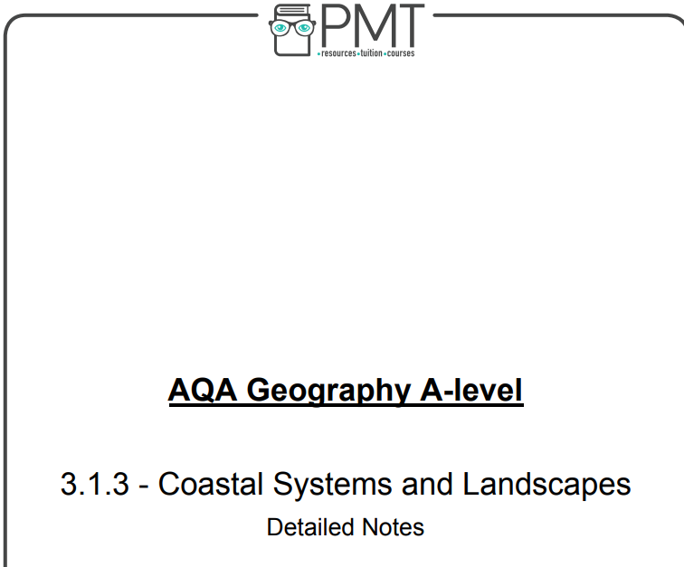

Step 3 – Read through the information and complete the following questions into the booklet below.

What is meant by the term coastal system?

……………………………………………………………………………………………………………………………..
……………………………………………………………………………………………………………………………..
……………………………………………………………………………………………………………………………..
……………………………………………………………………………………………………………………………..

Outline the differences between constructive and destructive waves.

……………………………………………………………………………………………………………………………..
……………………………………………………………………………………………………………………………..
……………………………………………………………………………………………………………………………..
……………………………………………………………………………………………………………………………..
Explain the different types of erosion which take place along the coastline.

……………………………………………………………………………………………………………………………..
……………………………………………………………………………………………………………………………..
……………………………………………………………………………………………………………………………..
……………………………………………………………………………………………………………………………..
……………………………………………………………………………………………………………………………..
……………………………………………………………………………………………………………………………..
……………………………………………………………………………………………………………………………..
……………………………………………………………………………………………………………………………..

Draw out in the space below an annotated diagram of the formation of a sea stack.

Suggest how climate change is an ever-growing problem for coastal areas.

……………………………………………………………………………………………………………………………..
……………………………………………………………………………………………………………………………..
……………………………………………………………………………………………………………………………..
……………………………………………………………………………………………………………………………..
……………………………………………………………………………………………………………………………..
……………………………………………………………………………………………………………………………..
……………………………………………………………………………………………………………………………..
……………………………………………………………………………………………………………………………..
Section 3: Global systems and global governance (human unit)
You will spend approximately 60-75 minutes on this activity.
Your task:
You will build a clear overview of how the world is interconnected and governed. This will be done through the creation of a spider diagram. Your spider diagram/mind map must show the following things…
- Key concepts around globalisation and global governance.
- Real world examples. (Where applicable)
- Links between ideas.
Spend approximately 30 minutes gathering information on the following strands:
Globalisation
- Definition
- How countries are connected
- Examples (e.g. trade, culture, technology)

2. Trade & Flows
- What moves around the world?
- Goods, people, money, information
- Example of a global company (e.g. Apple, Nike)

3. Global Governance
- What does it mean?
- Who makes global decisions?
- Key organisations (e.g. UN, WTO, World Bank)

4. Inequality
- Winners and losers of globalisation
- Differences between developed and developing countries

5. Environment (Link to Geography)
- How global systems impact the environment
- Examples (climate change, resource use)

Once you have that information, on the final page of this booklet, create a spider diagram/mind map which displays this information.

How is the world is interconnected and governed?

