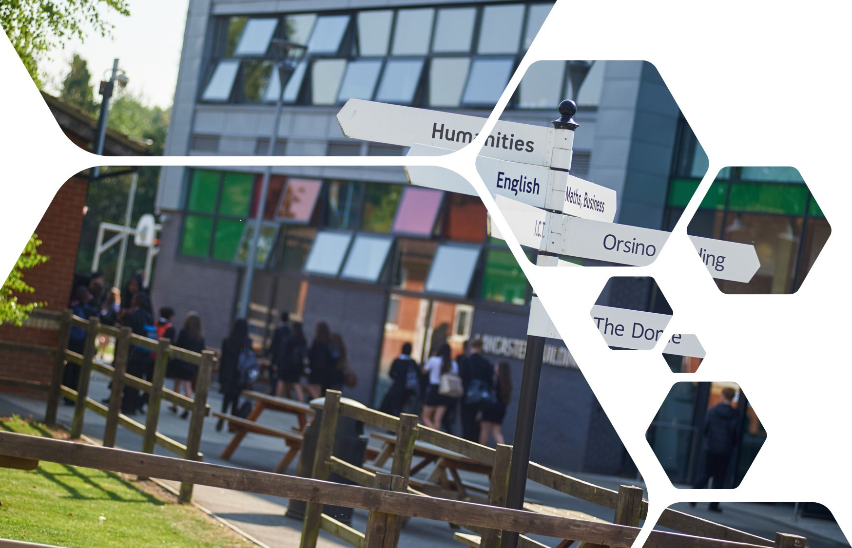
Sixth Form
Transition Pack

A Level
English Literature

Contents
In this pack, you’ll find:

1 – Course introduction
What is English Literature all about?

2 – Career opportunities with an English Literature A level
What can you do with the A Level besides fantastic university offers?

3 – The A level specification at a glance
What does the course look like and how much is coursework worth?

4 – Recommended reading for any Year 12 literature student
What can I read to prepare for my A Level and throughout Year 12 to be top of the class?

5 – Transition homework tasks
These are tasks you need to complete before beginning your A Level. They’ll give you a taste of what it’s like.

COURSE INTRODUCTION

What is English Literature all about?
In English literature, you’ll study a range of literary forms. But what’s literature?
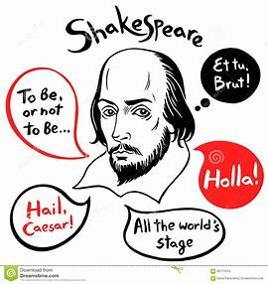

What skills will I use?
Reading, discussing and writing are key. You will be expected not just to read, but to develop the skill of thinking critically about what you read and of analysing texts to work out how the author's use of situation and language create powerful impressions. You will need to explore your own emotional response to writing and be able to discuss it, in class and through your own writing, and to argue constructively for your point of view.

What skills will I learn?
It is also very effective in developing transferrable skills such as interpretive abilities, communication, an understanding of how language works, close analysis, and the ability to construct a well-argued case. These are highly valued in a range of graduate careers such as Teaching, Business and Finance, Journalism, and Publishing.

Studying literature
The study of English Literature at A Level helps you to develop a number of subject-specific as well as transferable skills by encouraging in-depth, critical and contextual thinking in response to a range of literary works. A level English Literature courses can develop all sorts of skills.

What can I use Literature for?
English Literature is a highly respected A level. As well as an English Literature degree itself, students of Literature might go on to study for University degrees in a range of subjects including: History, Sociology, Psychology, Drama and Theatre Studies and Law. Even Medical Schools value the subject highly.
A level English Literature studies how great writing enables the exploration of many of life's fundamental themes: love, loneliness, prejudice, bravery and perseverance to name but a few.
Skills you develop through the study of English Literature (effective written and verbal communication, time-management, organisational skills, team-work, independent study and research, developing persuasive arguments …to name but a few), are marketable in a wide variety of professional areas.
What are the career opportunities?
What have some people gone on to do after studying
English Literature?

- Journalism
- Law
- Copywriting
- Politics
- Psychology
- Information officer
- Drama
- The arts including writing and script writing
- Medicine
- PPC specialist (Internet advertising)
- Police and armed forces
- Publishing
- Social media manager
- Teaching
- Historian

Ezra Pound: "Great literature is simply language charged with meaning to the utmost possible degree."

A level English Literature Specification

Official specification:

https://www.aqa.org.uk/subjects/english/as-and-a-level/english-literature-b-7716-7717/changes-for-2022
We will be studying AQA A Level Literature Specification B

Course Overview

- Drama
- Prose
- Poetry
- Coursework
- Wider reading

 | Year 12 Subject Content |  | Year 13 Subject Content
 | Othello  Death Of A Salesman  The Kite Runner  A Doll’s House  Songs Of Innocence and Experience  Preparation for coursework |  | Complete coursework  Richard III  Exam preparation

Paper 1 Aspects of Tragedy; Othello by William Shakespeare, Death of A Salesman Arthur Miller and Richard III 40%

Paper 2 Elements of Political and Social Protest writing; The Kite Runner, Unseen Prose, Songs of Innocence and Experience William Blake and A Doll’s House Henrik Ibsen 40%
Paper 3 Poetry; Poems of the Decade and Rossetti Selected Poems 30%

Non-examined Assessment (Coursework)

This counts for 20% of your final grade and consists of;

Non-examination assessment will be assessed via two texts. There are no prescribed texts but centres must select complete texts which may be drawn from poetry, drama, prose or literary non-fiction. Students must select different texts from those studied in Components 1, 2 and 3. The selected texts may be linked by theme, movement, author or period. Literary study of both texts should be enhanced by study of the links and connections between them, different interpretations and the contexts in which they were written and received. Advisory total word count is 2500–3000 words

Why read?  The transition to A Level is incredibly demanding. One of the easiest ways to stay on top of the huge amount you have to learn and remember is by revisiting and revising work outside of lesson.  We recommend you take time to revise using Seneca, (see Blogs, Podcasts, Websites), but also purchase a textbook, follow a number of interesting websites and choose a selection of wider reading articles that interest you.  If there is anything you would like to learn more about that isn’t included on this list, let your subject teacher know and they will be able to advise where you can read about that topic.  Blogs, Podcasts, Websites  The Guardian top 100 novels  https://www.theguardian.com/books/2015/sep/03/the-best-novels-in-english-readers-alternative-list  Litcharts Revision  https://www.litcharts.com/  Sparknotes Revision  https://www.sparknotes.com/  Edexcel website  https://qualifications.pearson.com/en/qualifications/edexcel-a-levels/english-literature-2015.html  York notes Revision  https://www.yorknotes.com/alevel/english-literature/type/advanced-style |  | A Level ENglish Literature  Reading List  Novels  Author Title  Angelou, Maya I Know Why the Caged Bird Sings  Atwood, Margaret The Handmaid’s Tale (Possibly my favourite book..)  Austen, Jane Emma Pride and Prejudice Sense and Sensibility Persuasion Northanger Abbey  Barker, Pat The Regeneration Trilogy  Burgess, Anthony A Clockwork Orange A Dead Man in Deptford Nothing Like the Sun  Bronte, Anne The Tenant of Wildfell Hall  Bronte, Charlotte Jane Eyre  Bronte, Emily Wuthering Heights  Camus, Albert The Outsider The Plague  Coe, Jonathan The Rotters’ Club What a Carve Up!  Coupland, Douglas Hey, Nostradamus! Girlfriend in a Coma Eleanor Rigby  Conan Doyle, Arthur The Adventures of Sherlock Holmes The Sign of Four  Dickens, Charles A Tale of Two Cities Great Expectations Hard Times Oliver Twist The Pickwick Papers  Dostoyevsky, Fyodor Crime and Punishment  Faulks, Sebastian Birdsong  Fitzgerald, F. Scott The Great Gatsby  Garland, Alex The Beach  Golding, William Lord of the Flies  Hardy, Thomas Tess of the D’Urbevilles Jude the Obscure  Heller, Joseph Catch 22  Hornby, Nick About a Boy Fever Pitch  Huxley, Aldous Brave New World  Joyce, James Dubliners Portrait of the Artist… Ulysses  Lawrence, D.H. Sons and Lovers  Lee, Harper To Kill a Mockingbird  Morisson, Toni Beloved Paradise  Nabokov, Vladimir Bend Sinister Despair Lolita Pnin  Orwell, George Animal Farm The Clergyman’s Daughter Inside the Whale and other Essays Nineteen Eighty-Four  Plath, Sylvia The Bell Jar  Tales of Mystery and Imagination  The Raven  Remarque, Erich Maria All Quiet on the Western Front  Salinger, J.D The Catcher in the Rye  Shelley, Mary Frankenstein  Steinbeck, John Cannery Row East of Eden The Grapes of Wrath Of Mice and Men Tortilla Flat  Stoker, Bram Dracula  Swift, Jonathan Gulliver’s Travels  Syal, Meera Anita and Me  Tokein, JRR Lord of the Rings  Walker, Alice The Colour Purple  Wells, H.G The Time Machine War of the world  Wilde, Oscar The Picture of Dorian Grey  Winterson, Jeanette Oranges are Not the Only Fruit The Passion

Summer transition tasks:

The following tasks will help prepare you for working at A Level standard, whilst also introducing you to a range of important topics, ideas and concepts. Each of them will be collected in your first week of the A Level, so expect a teacher to look at them!

“Literature is important and necessary. It provides growth, strengthens our minds and gives us the ability to think outside the box.”

TASK 2 – Your accent and dialect
Write an expended paragraph in which you describe your own spoken language (accent and dialect) and try to explain why it is like it is.

TASK 1 – essential summer reading
Read the following texts:
- Death Of a Salesman
- Othello Shakespeare
- In preparation for your study of Othello, watch the following YouTube videos;
- https://www.youtube.com/watch?v=mmw3vp5Boj0
- https://www.youtube.com/watch?v=q2tkLkGgQAE
- Make your own notes for the context of the play in preparation for your first lesson in September

EXTENSION TASK – Othello as a tragedy

Read the following information; https://www.aqa.org.uk/resources/english/as-and-a-level/english-literature-b/teach/tragedy-b-text-overview-othello
And answer this question; How does Act 1 Scene 1 of Othello introduce tragic elements of the play?
TASK 2 – Learning key terminology
Attached is a list of key terminology. Learn the definition for each term and answer the questions which follow.

Allusion
A reference to another piece of literature, work of art, person, place etc. This will be alluded to for a particular reason.
Ambiguity
A word or expression which has two or more possible meanings. Used by poets with the intention of evoking some kind of emotive response in a reader.
Anaphora
A rhetorical device in which a word or phrase is repeated in several successive lines. Used by poets to build towards a climactic moment or develop a particular image or emotion.
Apostrophe
A rhetorical device for a speech addressed to a person, idea or thing, usually signalled by the word ‘O’ at the start.
Assonance
The repetition of vowel sounds in successive words. Used by poets to create a pattern of sounds and associate words (particularly actions) together.
Ballad
A form of poetry which relates a story to the reader, such as Keats’ ‘La Belle Dame’. Often characterised by short stanzas and rhyme; strong links with song.
Blank verse
A line of five stressed beats that is unrhymed. This is one of the commonest metres used in English poetry.
Caesura
A pause within a line of verse. Used by poets to emphasise a certain emotion and can point to a flatness in tone.
Colloquialism
A local or regional expression which may not be understood by outsiders or informal language. Used by poets to build a certain ‘local flavour’ to their verse or to establish a more comfortable relationship with the reader.
Elegy
A poem of lamentation, focusing on the death of a single person. It can create an elegiac tone.
End-stopped
The end of a line of verse coincides with an essential grammatical pause usually signalled by punctuation i.e. a full stop.
Enjambment
The running over of the sense and grammatical structure from one verse line or stanza to the next without a punctuated pause. Often used by poets to indicate some kind of ‘outpouring’ but it can mean very different things too.

Epigraph
An inscription or quotation placed at the start of a poem.
Euphony
Language which sounds pleasantly smooth and musical in a particularly striking way.
Fricative Sounds (/f/ /v/ /th/ /th/)
These are divided into voiced (hard) and voiceless (soft). It's fun to notice the connection: the <f> in 'knife', is soft, and becomes hard in the plural 'knives'. The same thing happens in 'loaf' and 'loaves'.
Hyperbole
A rhetorical device where language is used an exaggerated manner, either for comedic or emotive effect.
Iambic pentameter / tetrameter
Lines of poetry which contain five / four stressed beats. Most commonly used in poetry from c.15th-19th centuries.
Imagery
The words or phrases a writer selects to create a certain picture in the reader’s mind. Imagery is usually based on sensory details.
In Media Res
A phrase describing a common technique of storytelling in which the narrator begins in the middle of the action.
Lyric
A poem in which personal and subjective feelings are expressed. Lyric poems are usually short and songlike.
Metaphor
Goes further than a comparison between two different things or ideas by fusing them together. The subject of the metaphorical comparison is separate from the vehicle (e.g. the metaphoric word which carries the meaning) and sometimes the reader has to guess at the subject. An extended metaphor develops the comparison beyond a single line or image in a poem.
Metre
Verse is distinguished from prose because it contains some linguistic element which is repeated, creating a sense of pattern. The commonest pattern is stress-based metre such as Iambic (stressed, unstressed beats).
Monologue
A single person speaking, with or without an audience; Victorian poets popularised the form of the dramatic monologue, where a poet speaks in a particular dramatic situation, often to one intended speaker.
Ode
A form of lyric poem characterised by its length (e.g. long!), intricate stanza forms and seriousness of purpose. Easily mocked!
Onomatopoeia
Words which sound like the noise they describe.

Oxymoron
A figure of speech in which contradictory terms are brought together in what is at first sight an impossible contradiction, such as ‘sweet sorrow’.
Paradox
An apparently self-contradictory statement, yet lying behind its absurdity is some kind of truth.
Parallelism
The building up of a sentence or statement using repeated syntactic units, achieving a sense of balance. E.g. repeated three word phrases.
Parody
An imitation of a specific work of literature, designed to mock or undermine it e.g. mockery of the sonnet form to show up the folly of courtly love.
Pathetic fallacy
Used to describe the assumption of the equation between the mood and the world around them; nature can be specifically described in terms of a poet or persona’s feelings.
Persona
Many poems are spoken by a speaker who is clearly not the poet; this is a ‘persona’.
Personification
A variety of figurative or metaphorical language in which things or ideas are treated as if they were human beings.
Plosive Sounds
Plosive /b/ /p/ /t/ /d/ sounds create an abrupt, sharp, sometimes shocking effect.
Refrain
Words or lines repeated in the course of a poem, recurring at intervals and perhaps with a slight, purposeful variation.
Rhyme
Chiming or matching sounds which create an audible sense of pattern. If the pattern is regular or irregular, the poet may well have made this choices deliberately. Internal and end rhyme may create different effects.
Semantic Field
Semantic (or sometimes called lexical) fields are a technique often used by poets to keep a certain image persistent in their readers' mind. They are a collection of words which are related to one another be it through their similar meanings, or through a more abstract relation.
Sibilance
Sibilants are ‘s’, ‘z’ or ‘sh’ sounds and their repetition is just a specific kind of alliteration. They are often associated with softening and carry more pleasant connotations than assonance.
Simile
A figure of speech in which one thing is said to be like another, using the words ‘like’ or ‘as’.

Sonnet
A form of poetry of fourteen lines, used typically to explore feelings related to love. The Shakespearian Sonnet involves a volta before the final couplet; the Petrarchan volta occurs more typically after the octet.
Stanza
A verse in poetry. Different lengths have specific names. Couplet: two-line stanza / Triplet: three-line stanza / Quatrain: four-line stanza / Quintet: five-line stanza / Sestet: six-line stanza / Octave: eight-line stanza
Symbol
Something that represents something else, particularly a material object representing an abstract idea.
Tone
In conveying tone, words can suggest a particular manner or mood in which a poem should be read. Remember to use a specific adjective for this one and avoid the vagueness of ‘positive’ and ‘negative’!
Volta
The word comes from the Italian word for ‘turn’. A volta is the turn in thought in a sonnet that is often indicated by such initial words as ‘but’, ‘yet’ or ‘and yet’.

