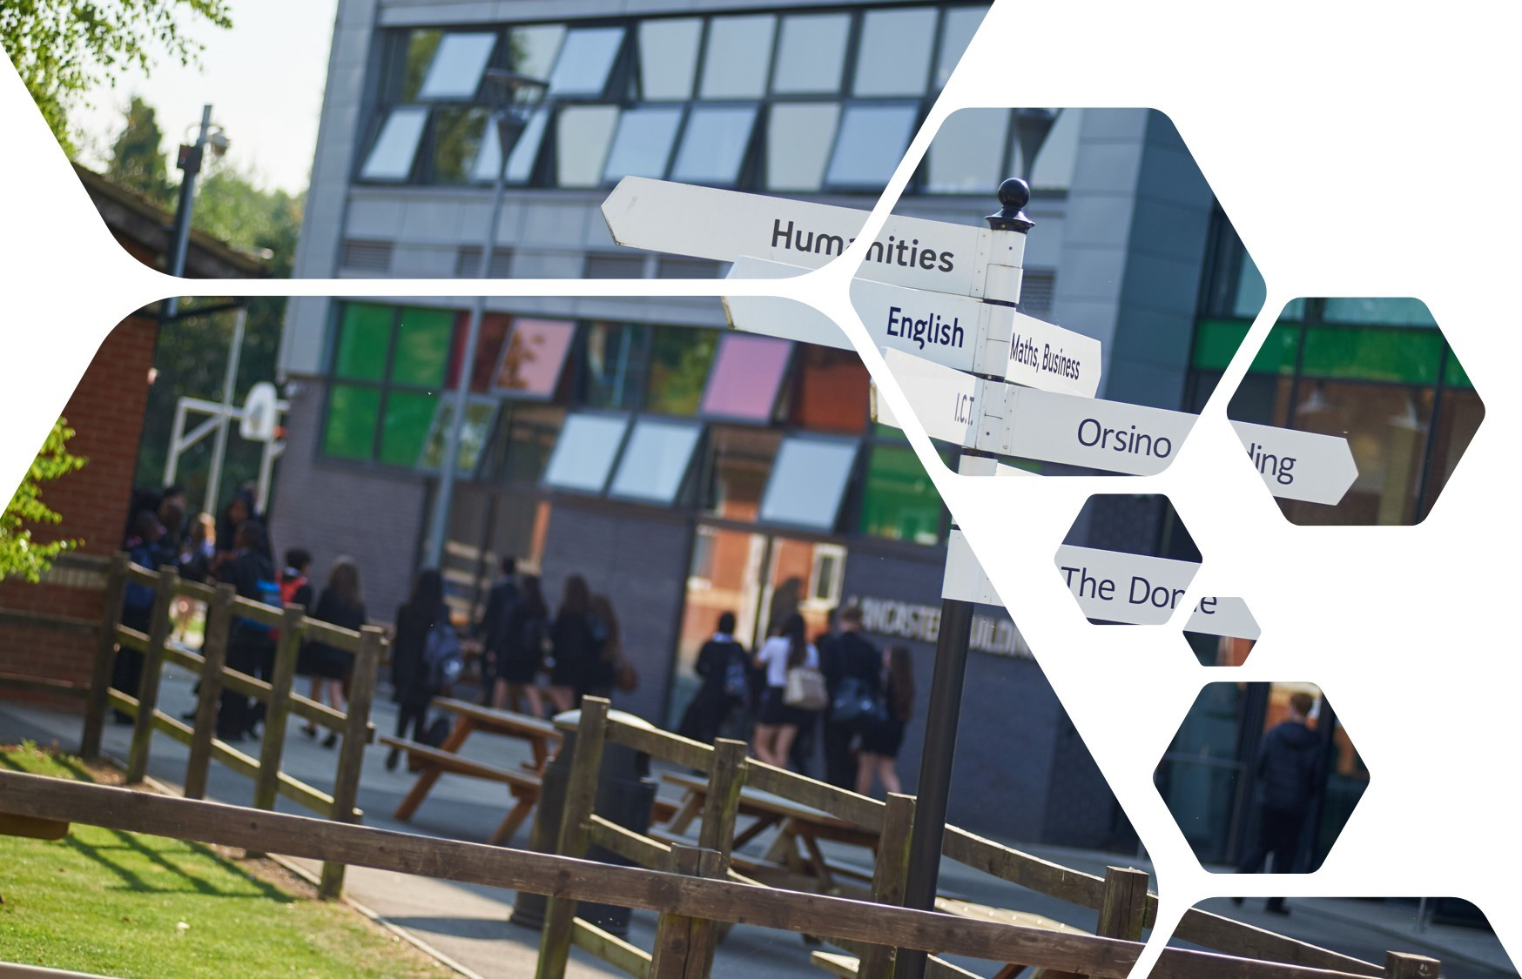

**Year 6 - 7**

**Preparing for secondary school**



Welcome to Uxbridge High School

Year 6 to Year 7

2020

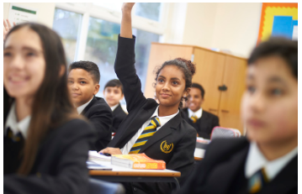

Welcome to Uxbridge High School

This booklet will help you to think about what you need to do over the summer in order to prepare for secondary school.

Being a high school student is different from being a student at primary school. Once you start high school you will have a lot more independence. You will be expected to organise most things for yourself. It will be your responsibility to arrive to school and to your lessons on time, fully equipped to learn. This booklet is designed to help you to start to develop the organisational skills that you will need to succeed.

We look forward to seeing you in September 😊

**Journey to school**

Moving to secondary school will mean your journey to and from school will change. You may also change how you travel.

This can be both exciting and scary. To ease those nerves, we suggest you plan your journey and maybe even do a trial run before you start to make sure you know where to go. To help you to plan your journey, answer the questions below together with your parent/carer:

## How will I get there?

How will you get to school? ___________________________

j0299811

You might **walk** or **cycle** sometimes, if you do then answer these questions:

|  |  |
| --- | --- |
| Do I know the way? |  |
| Will I have a friend to walk or cycle with? |  |
| Where will I put my bike? |  |



You might go by **car** sometimes, if you do then answer these questions:

|  |  |
| --- | --- |
| Will I go by car every day? |  |
| Who will drive me? |  |
| Will I get a lift home as well? |  |



You might go by **bus** or **train** sometimes, if you do then answer these questions:

|  |  |
| --- | --- |
| Where is the bus stop or train station? |  |
| What time is my bus/train to school? |  |
| What number is the bus? |  |
| Will I need money for the fare? |  |
| What time is my bus/train from school? |  |



j0346863

Answer these questions whether you will **walk**, **cycle**, go by **car**, **bus** or **train**.

|  |  |
| --- | --- |
| How long will my journey take? |  |
| What time must I leave home? |  |
| What time will I get home? |  |

## Planning your journey

It is important to plan your journey by bus or train so that you get to school on time.

Use a bus or train timetable to plan your journey.

|  |  |
| --- | --- |
| **Questions to ask** | **Answers** |
| Where do I want to go? |  |
| Which buses go there?  Or  Where is the nearest train station? |  |
| When do I want to arrive? |  |
| How long will the journey take? |  |
| Which bus/train will get me there in time? |  |
| How long will it take me to get to the bus stop or train station from my house? |  |
| What time do I need to leave my house? |  |
| Can I get a discount with a student card? |  |
| Can I buy a travel card for a week or a month’s journeys? |  |
| How much will the journey cost? |  |

**Remember it is important to also plan your return journey.**

**Planning your routine**

Before leaving for school in the morning there are a lot of things to think about.

We advise that you **pack your bag the night before and put it and any other equipment (homework, PE kit or Food Technology ingredients) in a memorable place, i.e. by the front door.**

Keeping to a regular routine can really help. Try the activities below to help work out your personal schedule.

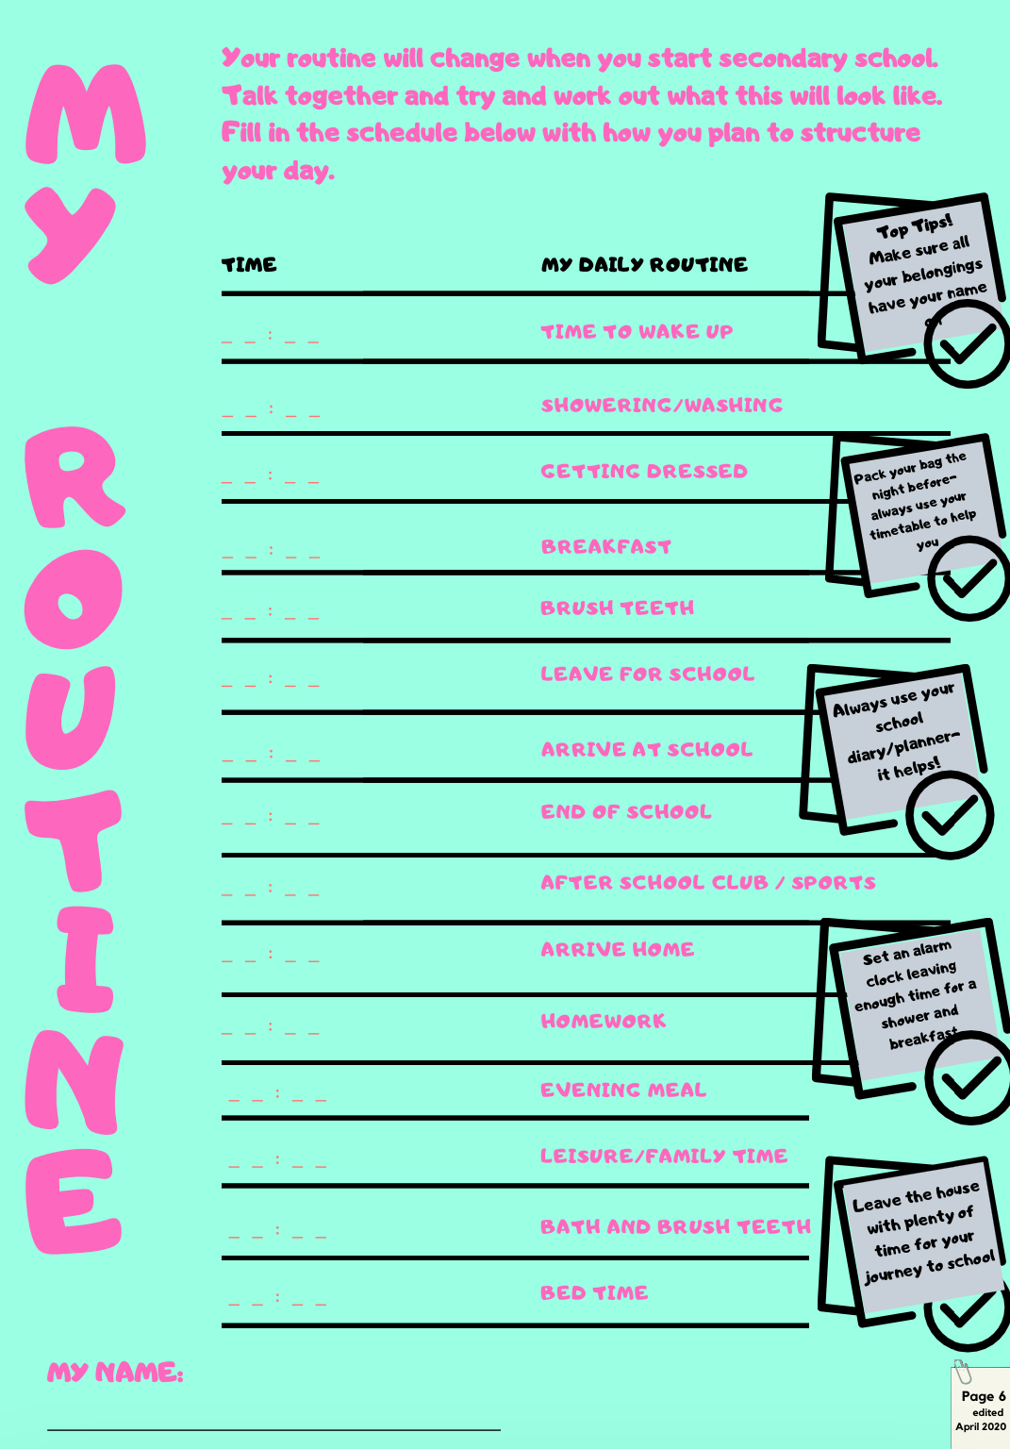

**Organisation at school**

## School times

8

7

10

11

9

5

4

1

2

6

12

Lunch time is at:

_ _: _ _

3

8

7

10

11

9

5

4

1

2

6

12

School starts at:

_ _: _ _

3

8

7

10

11

9

5

4

1

2

6

12

Break time is at:

_ _: _ _

3

8

7

10

11

9

5

4

1

2

6

12

School finishes at:

_ _: _ _

3

## School times

**Making Friends**

Making friends can be difficult, especially when starting a new school. Watch this video and use the resources below to help you gain the confidence to take that big step in friendship making.

<https://www.bbc.co.uk/bitesize/articles/znhf7nb>

Now, follow the instructions on the pages below and complete the tasks.

## Friendship skills

**Vocabulary practice**

Choose the right word to match the definitions.

advocate disagree trust respect empathy confidential

compliment advice command secret support apologise

1. _______________________ an opinion or recommendation you make about what someone should do

2. _______________________ to say you’re sorry for something you said or did

3. _______________________ private or secret

4. _______________________ someone who defends and supports you

5. _______________________ to have a different opinion from someone

6. _______________________ to say something nice about someone

7. _______________________ information that’s not meant to be shared with others

8. _______________________ to stand behind or encourage others

9. _______________________ understanding what someone feels

10._______________________ to rely or have confidence in someone

11._______________________ to hold someone in high esteem

12._______________________ a direct order to do something

## How to be a friend

Here are some positive things friends do for each other to keep their friendship strong.

* **Empathise**. Put yourself in your friend’s situation to understand what they’re going through.
* **Support**. You can show your support for your friends by just listening when they want to share.
* **Compliment**. Everyone likes to receive a compliment. Compliment your friend on a new hairstyle, a great score on a test, a smooth football move. Be specific and keep it simple. Choose the right moment to give the compliment.
* **Respect privacy.** Sharing secrets is a fun part of a friendship. It’s hard to regain your friend’s trust if you tell secrets you weren’t supposed to share.
* **Encourage.** Use encouraging statements like “You can do it”.



My friend looks unhappy

Are you ok?

When you wonder if you are being a good friend,

ask yourself this question:

**Am I treating my friend like I want my friend to treat me?**

## Making new friends

At secondary school there will be students from other schools and opportunities to make new friends. It can be difficult to get to know someone new.

It may help to act out meeting new people and use some of these suggestions.

* Smile when you say “**hello**”;
* Start the conversation by asking a question about what they are doing

“**What are you doing?**” or “**What are you reading?**”;

* Introduce yourself

“**By the way my name is ______________, what’s yours?**”;

* Ask some other questions to find out about them. Suitable topics may be:

School: **What lesson do you have next?**

**Who is your teacher?**

Home: **Where do you live?**

**How do you get to school?**

Interests: **What do you like doing?**

**What’s your favourite TV programme?**

**Do you go to any clubs?**

Family: **Have you got any brothers and sisters?**

* If they answer your question, then respond to some of the information they have told you;
* Do not ask about sensitive topics. These are topics that could make the other person upset;
* Don’t ask about something that makes the person look or sound different;
* Don’t ask about any problems he or she may have.

## Joining in situations

Here are some situations you might want to join in with. Try and plan what you may say or do. You could try acting these situations out.

1. You see three of your classmates playing football after school. You know one of them pretty well. You don’t know the other two. You’re quite good at being in goal.

What could you do? _________________________________________________________

_________________________________________________________

What could you say? ________________________________________________________

________________________________________________________

2. You hear two classmates talking about the latest PlayStation game. You were playing it last night.

What could you do? _________________________________________________________

_________________________________________________________

What could you say? ________________________________________________________

________________________________________________________

3. Two classmates are asking the teacher for permission to work on an art project during lunch hour. Art is your best subject and your project is already on display.

What could you do? _________________________________________________________

_________________________________________________________

What could you say? ________________________________________________________

**Joining in**

Joining in a conversation or a group activity can be scary, however it is one way to make new friends. Try these strategies for joining in:



**Watch and listen.** Observe what the group is doing. Listen to what the people are saying. Don’t interrupt.

**j0336476**

**Make a friendly comment or gesture.** Nod your head and smile. Make comments like “That’s a good idea” or “That looks great”.



**Find something you have in common with the group.** Think about your own experiences. You could say “I saw that movie” or “ I have that game at home”. Keep your comments short.

**j0297489**

**Ask to join the group.** Wait for a pause in the conversation. You could say “Can I walk with you?”, “Do you need any help?” or “Can I play?”

**j0311832**

**Accept ‘no’ for an answer.** Sometimes people don’t want you to be part of the group. Don’t argue or complain. Go and ask someone else.

