A-Level Handbook & Transition Summer Work Biology
Year 11 > Year 12
GCSE > AS-Level

Uxbridge High School, Science Department

Name:

Target Grade:

Contents:
Expectations and Learner Agreement p.1
Summer Tasks p.2
Exam Questions p.3-16
Answers p.17-22
Recommended Resources p.23
Final Words p.23

A-Level Expectations

A-Level Biology is MUCH more demanding than GCSE and requires a greater degree of commitment and independent learning. To enable you to cope with the demands of the course and achieve your target grades, it is essential that you fulfil the following expectations.

- Attendance = attainment. Attend all lessons, arrive on time and bring all the necessary books. Do not book appointments during lesson hours.
- Necessary equipment of pens, paper, and your working folders should be brought to EVERY lesson.
- Take responsibility for arriving on time to lessons after break or after a free period.
- No mobile phones in use or in view in the lesson.
- Work to the best of your ability in class and focus on the lesson.
- Listen respectfully to the views of other students.
- Complete all homework and classroom work.
- Read widely in your own time, including reading the complete set texts for each component as soon as possible.
- Attempt all work. If you are unsure of what to do, of course you may ask questions, but there are times when your teacher will want you to work independently without question. You must respect this.
- Take advantage of any extra lessons/revision sessions.
- Keep to deadlines.

Learner Agreement
As a dedicated student of Biology at Uxbridge High School, I promise to meet the expectations above. I understand that not doing so, will result in school sanctions, parent meetings, and most importantly, it will have a negative impact on my attainment.

Signed ______________________________________________

Print name ______________________________________________

Summer Tasks

The difficulty of the material covered at A-Level is MUCH GREATER than that at GCSE. As such, it is VITAL that you begin familiarising yourself with this material over the summer holidays. Completion of the following tasks will ensure that you begin Year 12 in the best way possible, giving yourself the best chance of success.

- Buy the textbook and read through the first chapter on your own.
You begin your A-Level Biology as soon as you arrive back to school after the summer holidays. The first chapter your teacher will cover with you from the AQA A-Level Biology Syllabus (7401), will be;
Chapter 1 – Biological Molecules.
BUY THE TEXTBOOK NOW! Read through Chapter 1 in the AQA A-Level Biology textbook (ISBN-10: 019835178X) on your own and make some notes.

- Answer the exam questions.
Once you’re done reading the chapter, try answering the exam questions (ANSWERS INCLUDED!) in this handbook. It’s fine to not be able to answer them well, but at least you are starting to get into the good habit of self-study. When school then begins in September, you will be so much better equipped to meet the challenges of A-Level.
- Ensure your maths is on par.
There is a greater maths demand in Biology at A-Level than at GCSE.
Make sure any weaknesses in your GCSE Maths are strengthened, and start looking through worked maths examples in your A-Level textbook.

Exam Questions

Chapter 1 – Biological Molecules

Q1.(a) Describe the difference between the structure of a triglyceride molecule and the structure of a phospholipid molecule.
.............................................................................................................................
.............................................................................................................................
.............................................................................................................................
(1)

(b) Describe how you would test for the presence of a lipid in a sample of food.
.............................................................................................................................
.............................................................................................................................
.............................................................................................................................
.............................................................................................................................
(2)

(c) Animal fats contain triglycerides with a high proportion of saturated fatty acids. If people have too much fat in their diet, absorption of the products of fat digestion can increase the risk of obesity. To help people lose weight, fat substitutes can be used to replace triglycerides in food.
Describe how a saturated fatty acid is different from an unsaturated fatty acid.
.............................................................................................................................
.............................................................................................................................
.............................................................................................................................
(1)

The diagram shows the structure of a fat substitute.
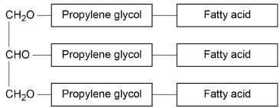
(d) This fat substitute cannot be digested in the gut by lipase.
Suggest why.
.............................................................................................................................
.............................................................................................................................
.............................................................................................................................
.............................................................................................................................
.............................................................................................................................
(2)

(e) This fat substitute is a lipid. Despite being a lipid, it cannot cross the cell-surface membranes of cells lining the gut.
Suggest why it cannot cross cell-surface membranes.
.............................................................................................................................
.............................................................................................................................
.............................................................................................................................
(1)
(Total 7 marks)

Q2.(a) The letters P, Q, R, S and T represent ways substances can move across membranes.
• P – diffusion through the phospholipid bilayer
• Q – facilitated diffusion
• R – active transport
• S – co-transport
• T – osmosis
For each of the following examples of transport across membranes, select the letter that represents the way in which the substance moves across the membrane.
Write the appropriate letter in each box provided.

Transport through a channel protein
Transport of small, non-polar molecules
Transport of glucose with sodium ions

(3)

The diagram shows how a plant cell produces its cell wall.
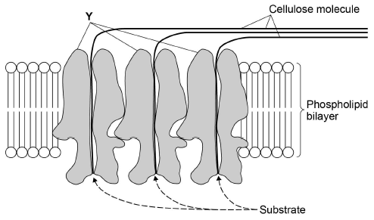
(b) Y is a protein. One function of Y is to transport cellulose molecules across the phospholipid bilayer.
Using information from the diagram, describe the other function of Y.
.............................................................................................................................
.............................................................................................................................
.............................................................................................................................
.............................................................................................................................
.............................................................................................................................
(2)

(c) What is the evidence in the diagram that the phospholipid bilayer shown is part of the cell-surface membrane?
.............................................................................................................................
.............................................................................................................................
(1)

(d) In the cell wall, bonds hold the cellulose molecules together side by side.
Tick (✔) one box that describes the type of bond that holds the cellulose molecules together side by side.

Ester
Hydrogen
Ionic
Peptide

(1)
(Total 7 marks)

Q3.The seeds of some plant species require chilling (exposure to low temperatures) before the embryos they contain grow into plants. During chilling, storage molecules in the seed that contain phosphate are broken down and phosphates are transported to the embryo. Scientists investigated the change in the mass of phosphate in the embryos of cherry seeds exposed to two different temperatures for 16 weeks.
The following graph shows their results.
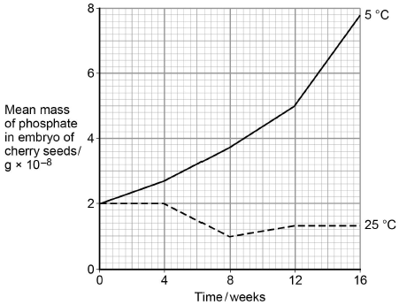
(a) Phospholipids are one of the storage molecules found in cherry seeds.
Name the type of reaction used to break down phospholipids to release phosphate.
.............................................................................................................................
(1)

(b) The scientists concluded that an increase in phosphate in the embryo was linked to growth of the embryo.
Suggest two reasons why an increase in phosphate can be linked to growth of the embryo.
1 ..........................................................................................................................
.............................................................................................................................
.............................................................................................................................
2 ..........................................................................................................................
.............................................................................................................................
.............................................................................................................................
(2)

(c) Calculate the ratio of the mean mass of phosphate found at 5 °C to the mean mass of phosphate found at 25 °C after 9 weeks of chilling.
Ratio = ..............................
(1)

(d) The chilling requirement of seeds of certain plant species is considered to be an adaptation for survival in countries with seasonal changes in environmental conditions.
Suggest how this adaptation may enable these plant species to survive and respond to seasonal changes.
.............................................................................................................................
.............................................................................................................................
.............................................................................................................................
.............................................................................................................................
.............................................................................................................................
.............................................................................................................................
.............................................................................................................................
.............................................................................................................................
.............................................................................................................................
.............................................................................................................................
(3)
(Total 7 marks)

Q4.Newborn babies can be fed with breast milk or with formula milk. Both types of milk contain carbohydrates, lipids and proteins.
• Human breast milk also contains a bile-activated lipase. This enzyme is thought to be inactive in milk but activated by bile in the small intestine of the newborn baby.
• Formula milk does not contain a bile-activated lipase.
Scientists investigated the benefits of breast milk compared with formula milk.
(a) The scientists used kittens (newborn cats) as model organisms in their laboratory investigation.
Other than ethical reasons, suggest two reasons why they chose to use cats as model organisms.
1 .....................................................................................................................
........................................................................................................................
2 .....................................................................................................................
........................................................................................................................
(2)

(b) Before starting their experiments, the scientists confirmed that, like human breast milk, cat’s milk also contained bile-activated lipase.
To do this, they added bile to cat’s milk and monitored the pH of the mixture.
Explain why monitoring the pH of the mixture could show whether the cat’s milk contained lipase.
........................................................................................................................
........................................................................................................................
........................................................................................................................
........................................................................................................................
(2)

The scientists then took 18 kittens. Each kitten had been breastfed by its mother for the previous 48 hours.
The scientists divided the kittens randomly into three groups of six.
• The kittens in group 1 were fed formula milk.
• The kittens in group 2 were fed formula milk plus a supplement containing bile-activated lipase.
• The kittens in group 3 were fed breast milk taken from their mothers.
Each kitten was fed 2 cm³ of milk each hour for 5 days.
The scientists weighed the kittens at the start of the investigation and on each day for 5 days.
The figure below shows the scientists’ results.
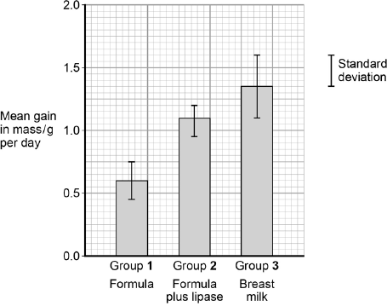
Type of milk given to kittens
(c) What can you conclude from the figure about the importance of bile-activated lipase in breast milk?
........................................................................................................................
........................................................................................................................
........................................................................................................................
........................................................................................................................
........................................................................................................................
........................................................................................................................
(Extra space) ................................................................................................
........................................................................................................................
........................................................................................................................
(3)
(Total 7 marks)

Q5.Figure 1 shows one base pair of a DNA molecule.
Figure 1
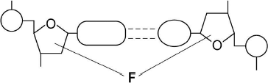
(a) Name part F of each nucleotide.
........................................................................................................................
(1)

(b) Scientists determined that a sample of DNA contained 18% adenine.
What were the percentages of thymine and guanine in this sample of DNA?

Percentage of thymine
Percentage of guanine

(2)
During replication, the two strands of a DNA molecule separate and each acts as a template for the production of a new strand.
Figure 2 represents DNA replication.
Figure 2
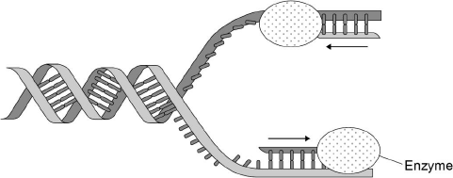
(c) Name the enzyme shown in Figure 2.
........................................................................................................................
(1)

The arrows in Figure 2 show the directions in which each new DNA strand is being produced.
(d) Use Figure 1, Figure 2 and your knowledge of enzyme action to explain why the arrows point in opposite directions.
........................................................................................................................
........................................................................................................................
........................................................................................................................
........................................................................................................................
........................................................................................................................
........................................................................................................................
........................................................................................................................
........................................................................................................................
(4)
(Total 8 marks)

Q6.(a) Describe the induced-fit model of enzyme action.
.............................................................................................................................
.............................................................................................................................
.............................................................................................................................
.............................................................................................................................
.............................................................................................................................
(2)

(b) A scientist investigated the hydrolysis of starch.He added amylase to a suspension of starch and measured the concentration of maltose in the reaction mixture at regular intervals.
His results are shown in the graph below.
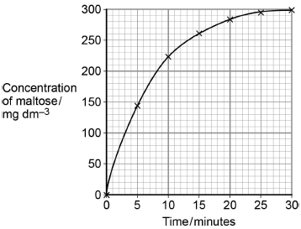
Determine the rate of the reaction at 10 minutes.
Show how you obtained your answer.
Rate of reaction .............................................. mg dm⁻³ min⁻¹
(2)

(c) Explain the results shown in the graph.
.............................................................................................................................
.............................................................................................................................
.............................................................................................................................
.............................................................................................................................
.............................................................................................................................
(2)

(d) A quantitative Benedict’s test produces a colour whose intensity depends on the concentration of reducing sugar in a solution. A colorimeter can be used to measure the intensity of this colour.
The scientist used quantitative Benedict’s tests to produce a calibration curve of colorimeter reading against concentration of maltose.
Describe how the scientist would have produced the calibration curve and used it to obtain the results in the graph.
Do not include details of how to perform a Benedict’s test in your answer.
.............................................................................................................................
.............................................................................................................................
.............................................................................................................................
.............................................................................................................................
.............................................................................................................................
.............................................................................................................................
.............................................................................................................................
.............................................................................................................................
.............................................................................................................................
.............................................................................................................................
.............................................................................................................................
(3)
(Total 9 marks)

Q7.(a) Describe how the structures of starch and cellulose molecules are related to their functions.
(5)
(b) Describe the processes involved in the transport of sugars in plant stems.
(5)
(Total 10 marks)

Q8. Read the following passage.

 | Herpes simplex virus (HSV) infects nerve cells in the face, including some near the lips. Like many other viruses, HSV can remain inactive inside the body for years. When HSV becomes active, it causes cold sores around the mouth.
 | Human cells infected with a virus may undergo programmed cell death. While HSV is inactive inside the body, only one of its genes is transcribed. This gene is the latency-associated transcript (LAT) gene that prevents programmed cell death of an infected nerve cell. | 5
 | Scientists have found that transcription of the LAT gene produces a microRNA.  This microRNA binds to some of the nerve cell’s own mRNA molecules. These mRNA molecules are involved in programmed cell death of nerve cells. The scientists concluded that production of this microRNA allows HSV to remain in the body for years. | 10

Use information from the passage and your own knowledge to answer the following questions.
(a) HSV infects nerve cells in the face (line 1). Explain why it infects only nerve cells.
........................................................................................................................
........................................................................................................................
........................................................................................................................
........................................................................................................................
........................................................................................................................
........................................................................................................................
(Extra space) .................................................................................................
........................................................................................................................
........................................................................................................................
(3)

(b) HSV can remain inactive inside the body for years (lines 2–3). Explain why this virus can be described as inactive.
........................................................................................................................
........................................................................................................................
........................................................................................................................
........................................................................................................................
(2)

(c) Suggest one advantage of programmed cell death (line 4).
........................................................................................................................
........................................................................................................................
(1)

(d) The scientists concluded that production of this microRNA allows HSV to remain in the body for years (lines 10–12).
Explain how this microRNA allows HSV to remain in the body for years.
........................................................................................................................
........................................................................................................................
........................................................................................................................
........................................................................................................................
........................................................................................................................
........................................................................................................................
........................................................................................................................
........................................................................................................................
(Extra space) .................................................................................................
........................................................................................................................
........................................................................................................................
........................................................................................................................
(4)
(Total 10 marks)

Answers

M1.(a) 1. In phospholipid, one fatty acid replaced by a phosphate;
Ignore references to saturated and unsaturated
Accept
Reject P/Phosphorus
Accept annotated diagrams
1

(b) 1. Add ethanol, then add water;
Reject ethanal/ethonal
Accept ‘Alcohol/named alcohol’
2. White (emulsion shows lipid);
Accept milky – Ignore ‘cloudy’
Sequence must be correct
If heated then DQ point 1
Reject precipitate
2

(c) Saturated single/no double bonds (between carbons)
OR
Unsaturated has (at least one) double bond (between carbons);
Accept hydrocarbon chain/R group for ‘between carbons’ for either
Accept Sat = max number of H atoms bound
‘It’ refers to saturated
1

(d) 1. (Fat substitute) is a different/wrong shape/not complementary;
OR
Bond between glycerol/fatty acid and propylene glycol different
(to that between glycerol and fatty acid)/no ester bond;
2. Unable to fit/bind to (active site of) lipase/no ES complex formed;
If wrong bond name given (e.g. peptide/glycosidic), then penalise once
2

(e) It is hydrophilic/is polar/is too large/is too big;
Ignore ‘Is not lipid soluble’
1
[7]

M2.(a)
Transport through a channel protein

1
Transport of small, non-polar molecules

1
Transport of glucose with sodium ions

1

(b) 1. (Y is) an enzyme/has active site/forms ES complex;
Accept catalyst
2. That makes cellulose/attaches substrate to cellulose/joins β glucose;
OR
3. Makes cellulose/forms glycosidic bonds;
4. From β glucose;
Mark in pairs (1&2 or 3&4)
2

(c) Cell wall forms outside cell-surface membrane/has cellulose on it
(on the outside);
1

(d) (Tick in box next to) Hydrogen;
1
[7]

M3.(a) Hydrolysis (reaction);
1

(b) 1. (Phosphate required) to make RNA;
2. (Phosphate required) to make DNA;
1 and 2. If neither DNA or RNA are named allow one mark for nucleotide/nucleic acid/phosphodiester bonds/sugar-phosphate backbone.
3. (Phosphate required) to make ATP/ADP;
4. (Phosphate required) to make membranes;
Ignore: phospholipids without reference to membranes.
5. (Phosphates required) for phosphorylation;
Accept: as additional mark points any named biological molecule containing phosphate e.g. NADP, AMP, RuBP.
2 max

(c) Accept answer in range from 3.7 : 1 to 4.1 : 1;
Reject any ratio not : 1.
1

(d) 1. Seeds/embryo remain dormant/inactive in winter/cold
OR
Growth/development of seed/embryo during winter/cold;
Ignore: hibernate.
Accept: ‘seed survives winter/cold’.
Reject: plant develops or seed germinates during winter/cold.
2. Seeds/plants develop in spring/summer
OR
Seeds/plants develop when temperature/light increases;
Accept: seeds/plants develop when more light or when temperature is higher.
Accept: seed germinates/’sprouts’ during spring/summer or when temp/light increases.
3. Plant photosynthesise (in spring/when warm);
4. Produce (more) seeds/offspring in spring/growing season;
3 max
[7]

M4.(a) Two suitable suggestions;
E.g.
1. (Are mammals so) likely to have same physiology / reactions as humans;
2. Small enough to keep in laboratory / produce enough milk to extract;
3. (Can use a) large number.
Ignore references to ethical issues
2 max

(b) 1. Hydrolysis of lipids produces fatty acids;
2. Which lower pH of mixture.
2

(c) 1. (Bile-activated lipase / it) increases growth rate (of kittens);
2. Results for formula with lipase not (significantly) different from breast milk / are (significantly) different from formula milk alone;
3. Showing addition of (bile-activated) lipase is the likely cause (of increased growth);
4. Lipase increases rate of digestion of lipids / absorption of fatty acids.
3 max
[7]

M5.(a) Deoxyribose.
1

(b) 1. Thymine 18 (%);
2. Guanine 32 (%).
2

(c) DNA polymerase.
1

(d) 1. (Figure 1 shows) DNA has antiparallel strands / described;
2. (Figure 1 shows) shape of the nucleotides is different / nucleotides aligned differently;
3. Enzymes have active sites with specific shape;
4. Only substrates with complementary shape / only the 3’ end can bind with active site of enzyme / active site of DNA polymerase.
4
[8]

M6.(a) 1. (before reaction) active site not complementary to/does
not fit substrate;
2. Shape of active site changes as substrate binds/as
enzyme-substrate complex forms;
Note. Points 1 and 2 may be made in one statement and ‘complementary’ introduced at any point.
Points 1&2 – active site mentioned once applies for both points
Point 2 – Ignore references to how shape change is caused
3. Stressing/distorting/bending bonds (in substrate leading to reaction);
2 max

(b) 1. Tangent to curve drawn;
Tangent drawn at about 10 minutes
2. Value in range of 8 to 11;
1 mark only for correct answer
2

(c) 1. (Rate of) increase in concentration of maltose slows as substrate/starch is used up
OR
High initial rate as plenty of starch/substrate/more E-S complexes;
Reject ref. to amylase being used up
2. No increase after 25 minutes/at end/levels off because no substrate/starch left;
Accept ‘little’
Ignore references to substrate a limiting factor
2

(d) 1. Make/use maltose solutions of known/different concentrations
(and carry out quantitative Benedict’s test on each);
2. (Use colorimeter to) measure colour/colorimeter value of each
solution and plot calibration curve/graph described;
Axes must be correct if axes mentioned, concentration on x-axis and colorimeter reading on y-axis
3. Find concentration of sample from calibration curve;
3
[9]

M7.(a) Starch (max 3)
1. Helical/ spiral shape so compact;
2. Large (molecule)/insoluble so osmotically inactive;
Accept: does not affect water potential/ψ.
3. Branched so glucose is (easily) released for respiration;
Ignore: unbranched.
4. Large (molecule) so cannot leave cell/cross cell-surface membrane;
Cellulose (max 3)
5. Long, straight/unbranched chains of β glucose;
6. Joined by hydrogen bonding;
Note: references to ‘strong hydrogen bonds’ disqualifies this mark point.
7. To form (micro/macro)fibrils;
8. Provides rigidity/strength;
5 max

(b) 1. (At source) sucrose is actively (transported) into the phloem/sieve element/tube;
Accept: ‘sugar/s’ for sucrose but reject other named sugars e.g. glucose.
Accept: co-transport (with H⁺ ions).
2. By companion/transfer cells;
3. Lowers water potential in phloem/sieve element/tube and water enters by osmosis;
4. (Produces) high (hydrostatic) pressure;
Accept: pressure gradient.
5. Mass flow/transport towards sink/roots/storage tissue;
Accept: sieve element/tube.
6. At sink/roots sugars are removed/unloaded;
Accept: at sink/roots sugars are used in respiration/stored.
5 max
[10]

M8.(a) 1. Outside of virus has antigens / proteins;
2. With complementary shape to receptor / protein in membrane of cells;
3. (Receptor / protein) found only on membrane of nerve cells.
Accept converse argument
3

(b) 1. No more (nerve) cells infected / no more cold sores form;
2. (Because) virus is not replicating.
2

(c) Prevents replication of virus.
1

(d) MicroRNA binds to cell’s mRNA (no mark)
1. (Binds) by specific base pairing;
2. (So) prevents mRNA being read by ribosomes;
3. (So) prevents translation / production of proteins;
4. (Proteins) that cause cell death.
4
[10]

Recommended Resources

The following is a list of resources that you will find helpful during your summer work. This list is by no means exhaustive. Please feel free to share other resources with each other.

1. Kerboodle AQA Biology A-Level Textbook - www.kerboodle.com
2. CGP revision guides.

3. Khan Academy Youtube channel - https://www.youtube.com/channel/UC4a-Gbdw7vOaccHmFo40b9g

Final Words
Year 12 AS-Level Biology is not simply a progression of GCSE. It is a step-up. You must step-up your attitude and work ethic.

A-Level Biology is one of the most challenging A-Levels anyone can undertake. As such, A-Level Biology is one of the most rewarding
A-Levels anyone can undertake.

If you are carrying on your Biology studies to A-Level, it is because your teachers feel you are able to rise to and meet the challenges of A-Level Biology. If you are carrying on your studies of Biology to A-Level, you have been given the opportunity to achieve something you will cherish for a life-time to come.

Work hard.
Look forward to all the amazing things you have yet to learn about.

Look forward to achieving something truly remarkable.
Enjoy your summer holidays!

