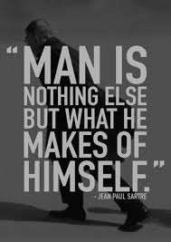

Philosophy
A-Level Handbook
Uxbridge High School

Name: ___________________________

Contents
- Course Expectations and Learner Agreement

- Summer Task

- Course Breakdown

- Assessment Objectives

Course Expectations
“Students will consider the big questions, such as: “What is knowledge?” and “What do good, bad, right and wrong really mean?” You will also explore further questions including: “Is the concept of God incoherent?” and “What and where is the mind?”’
The Philosophy A level course are taught as separate units over four interconnected parts. Each demands a great degree of commitment and independent learning. To enable you to cope with the demands of the course and achieve your target grades, it is essential that you fulfil the following expectations.
- Attendance to all lessons, arrive on time and bring all the necessary books.
- You should have a large folder to keep your lesson notes in for each lesson. Ensure you have pens and paper for each lesson.
- Arrive on time to the start of class – not after you have got your tea.
- Work to the best of your ability in class and focus on the lesson.
- Listen respectfully to the views of other students, be ready to give logical debate on any topic.
- Be on guard for ‘logical fallacies’ and embrace ‘existential dread’.
- Complete all homework – especially reading.
- Read widely in your own time, research online.
- Attempt all work. If you are unsure of what to do, of course you may ask questions, but there are times when your teacher will want you to work independently.
- Take a look through the “Stanford encyclopaedia of Philosophy”. It’s the Wikipedia for Philosophy.
- Take advantage of any extra lessons/revision sessions.
- Keep to deadlines.

Learner Agreement
As a dedicated student of Philosophy at Uxbridge High School, I promise to meet the expectations above. I understand that not doing so, will result in school sanctions and parent meetings, but most importantly it will have a negative impact on my attainment.
Signed ______________________________________________
Print name ______________________________________________

Year 11 > 12 Summer Project:
You are to create a folder of research giving arguments for and against two of the following. You should annotate the research with your own thoughts.
- The Problem of Evil
- The concept of ‘God’
- What is propositional knowledge?
- Can we truly ‘know’ anything?
- How is Descartes’ Scepticism the foundation of modern Philosophy?
This is due in for the first lesson back in September.
Course Breakdown
PHLS1:
Epistemology
- Perception and Scepticism
How do we know what we perceive is true if all knowledge comes from the senses?
- What is propositional knowledge?
What are the different types of knowledge and how can we logically deduce what we know as being true ‘knowledge’?
- The origin of Concepts
Are all experiences born from experience, or are some ideas innate to us from birth?
Philosophy of Religion
- The Concept of God
How does one know God? What are his Characteristics and what problems does this provide?
- Arguments relating to God
How have people tried to prove God’s existence from a logical standpoint?
- Religious Language
What does it mean to talk about God, Religion, Myth and Symbolism? Are Religious statements the same as other statements and what does this mean for conversations about Religion?

The A-Level is taught as a combined 2 year course with the same skills required in both year 12 and 13. Skills of logical argument taught in the first year will help with the Philosophy of the Mind and Ethics taught in year 13. Students study four topics over the course of the A-Level and final exams are taken at the end of year 13.
Assessment Objectives
Assessment objectives are the skills you will develop over the course of your AS. The examiner will be marking your exams based on similar criteria to those below:
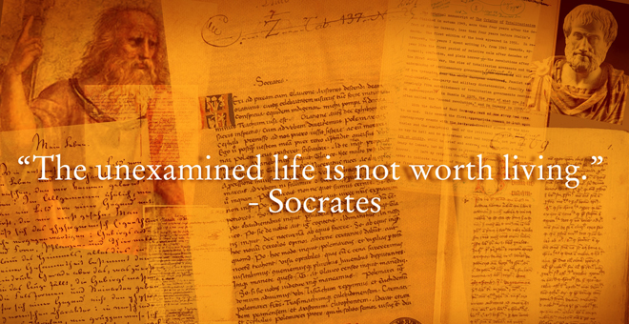
There will also be 3, 5, 12 and 25 mark questions requiring knowledge, logical deduction and essay debate skills. Most importantly you should be able to give a logical and relevant argument in a clear essay structure.

