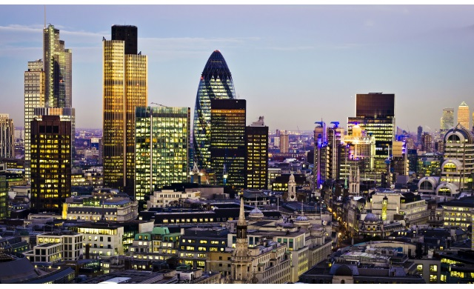
Business
A Level Handbook

Name: ______________________

Contents
- Course Expectations and Learner Agreement

- ‘Welcome to A-Level Business’ Course Overview

- Task One – Task Three: 4, 9, 16-mark exam questions

- Task Four: A-Level exam papers

- Task Five: Summer Business News Report

- Useful links

Course Expectations
The Business A Level course is the next step after successfully completing GCSEs. A Level is designed to build on your previous learning and knowledge and assist you in developing the necessary skills to complete the course. In order for you to excel at A Level and achieve yours and our expectations and targets you need to acknowledge and agree to the following;
- Attendance = attainment. Attend all lessons, arrive on time and bring all the necessary equipment and resources. Do not book appointments during lesson hours
- Necessary equipment of exercise books, pens, a calculator, and your textbook
- Take responsibility for arriving on time to lessons after break or after a free period
- No mobile phones in use or in view in the lesson
- Work to the best of your ability in class and focus on the lesson
- Listen respectfully to the views of other students and consider how your own views are developing
- Complete all homework on time – this includes printing out resources
- Keep up to date with business in the news either online or via newspapers, The Financial Times is recommended
- Complete all necessary research as directed
- Set up a social network group with others in your class – to encourage and support each other
- Attempt all work. If you are unsure of what to do, of course you may ask questions, but there are times when your teacher will want you to work independently without question. You must respect this.
- Take advantage of any extra lessons to work upstairs in Lancaster
- Keep to deadlines
Learner Agreement
As a dedicated student of Business at Uxbridge High School, I promise to meet the expectations above. I understand that not doing so, will result in school sanctions, parent meetings, and most importantly, it will have a negative impact on my attainment.
Signed ______________________________________________
Print name ______________________________________________

Welcome to A-Level Business

What will I be learning about on the course?
In the first year of the course you will cover six topics: ‘What is business?’; ‘Managers, leaders and decision making’; ‘marketing performance’; ‘operational performance’; ‘financial performance’; ‘human resource performance’. This is designed to give you an overview of the important functional areas in business. In the second year of the course you learn about businesses more holistically and how they come up with overall strategies.
How is the course structured?
For the majority of you, the course will be spread over two years and you will sit A-Level examinations at the end of the second year.
However, if you decide after the first year that you do not want to continue the course, you will only achieve the AS-level qualification.
How is the course assessed?

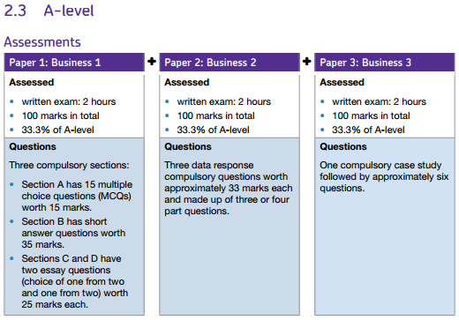
Will I need to buy and use a textbook?
Yes, the core textbook is:

Where else can I go for resources & help?
- http://www.tutor2u.net/business
A-Level Assessment:
This transition pack has been created to give you an overview of the skills required to successfully achieve a good grade on the Business A-Level. Throughout the qualification you will be required to demonstrate the following four skills:
Typical A-Level Exam Questions:
The exam questions on A-Level generally include:
- 4-6 mark ‘EXPLAIN’ questions
- 9 mark ‘ANALYSE’ questions
- 16-20 mark ‘EVALUATE’ questions
Transition Pack Overview:
In this A-level transition pack you have been given an example of each type of question to answer to practise your writing skills before September.
When you start the course formally in September, your teachers will go over your written work from these questions with you and help you to improve your extended writing.
Also, this transition pack includes screenshots of the website you can access to look at example exam papers. It is also a good idea to familiarise yourself with exam papers as early as possible so you know how they are structured.
Lastly, this transition pack includes a task for you to prepare a news report to deliver in one of the first lessons back after the summer holidays. You will be creating a PowerPoint presentation about a business which you find interesting, to show to your teacher(s) and other students in the class. This intends to engage you in the course and help you find out which areas of business interest you the most.

Transition Pack Checklist:
Task # | Task | Complete?
1 | Answer a 4 mark question about market mapping
2 | Answer a 9 mark question about Royal Mail
3 | Answer a 16 mark question about Dough-nuts
4 | Familiarise yourself with the A-Level exam papers
5 | Create a news report for a business of your choice

Task ONE: Answer a 4-mark question about marketing mapping

How to answer ‘EXPLAIN’ questions:
M – Make a point. What is the purpose of market mapping?
E – Explain this point. How does a business, such as a sports shop, use a market map?
E – Effect. How will the use of a market map effect the sports shop business?
L – Refer back to the sports shop or give an example of a shorts shop that could use a market map and how.

Task TWO: Answer a 9-mark question about ‘sectors’ and ‘Royal Mail’
The British Economy is divided into two sectors, the Private Sector and the Public Sector.
The Private Sector The private sector is made up of all the businesses operating in the UK. All the Sole Traders, Partnerships, Co-operatives LTDs and PLCs are in the private sector. The private sector encourages efficiency through competition. Competition gives us choices of where to shop and what to buy. Competition reduces prices, and improves quality. But the private sector is not effective in producing some goods and services which we need to make the whole economy become more productive and work better, and also fails in supplying some of our basic needs. This is why we have a public sector.
The Public Sector The public sector is made up of organisations that are owned and run by the government. This part of the economy is huge, and includes some of the largest employers in Europe as well as the UK. Why do we need a public sector? Some goods and services which we need in our everyday lives, would simply not be provided by the private sector looking to make profits. These necessities include street lighting, defence (army, navy, air force), and the police. The problem with these goods is that we can all benefit from them without paying for them.
Additional reading about the Royal Mail case study:
http://www.telegraph.co.uk/finance/11240417/Can-Royal-Mail-survive-in-the-private-sector.html
https://www.nao.org.uk/wp-content/uploads/2014/04/The-privatisation-of-royal-mail.pdf

How to answer ‘ANALYSE’ questions:
M – Make a point. How can a stakeholder group be affected by Royal Mail’s transfer to the private sector?
E – Explain this point. Why would the stakeholder group be affected?
E – Effects. What will the causes of this be on the stakeholder group?
L – Use evidence from the case study to back your point up.
Repeat the MEEL paragraph at least one more time for a different point.

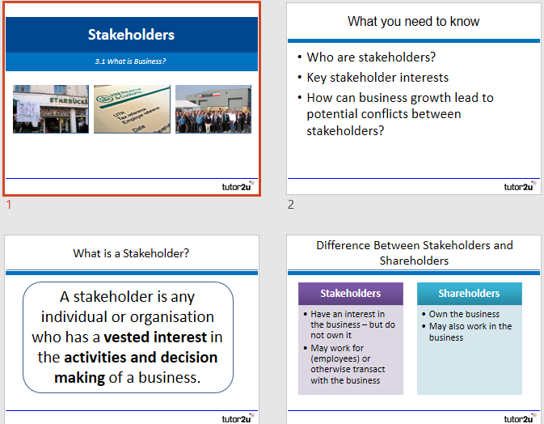
Task THREE: Answer a 16-mark question about ‘stakeholders’ and the business ‘Dough-nuts’
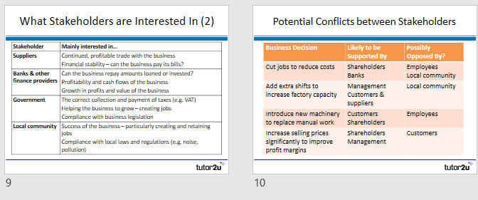
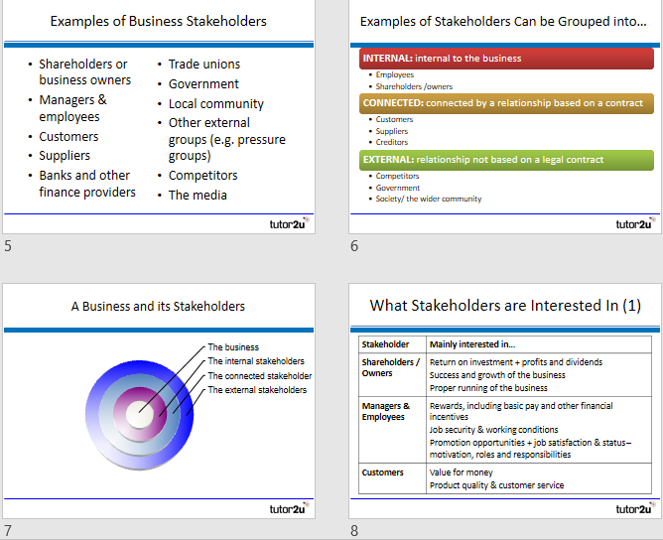
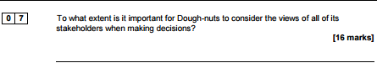
How to answer ‘TO WHAT EXTENT’ or ‘EVALUATE’ questions:
M – Make a point (advantage). What is one reason why it is important for Dough-nuts to consider views of stakeholders?
E – Explain this advantage. Why is this important?
E – Effects. What is the subsequent effects on the Dough-nuts business of considering views of stakeholders?
L – Use evidence from the case study to back your point up.
J – Judge how important this point is. How important is this point for Dough-nuts? However, what does this depend on?
Repeat the MEEL paragraph at least one more time for a different point / disadvantage.
Conclusion:
Answer the question – Overall, it is/it isn’t important for Dough-nuts to consider the views of stakeholders.
Important reason – The most important reason for this is...
Make a recommendation – What action(s) should Dough-nuts take in the short-term and in the long-term?
However, what does this depend on and why? However, this depends on…because…

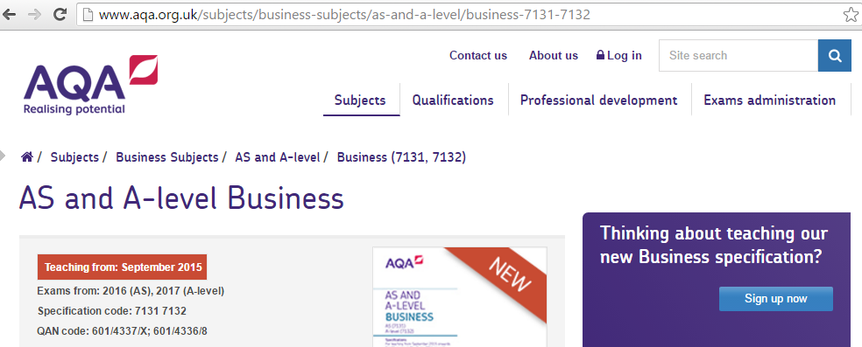
Task FOUR: Familiarise yourself with the A-Level exam papers
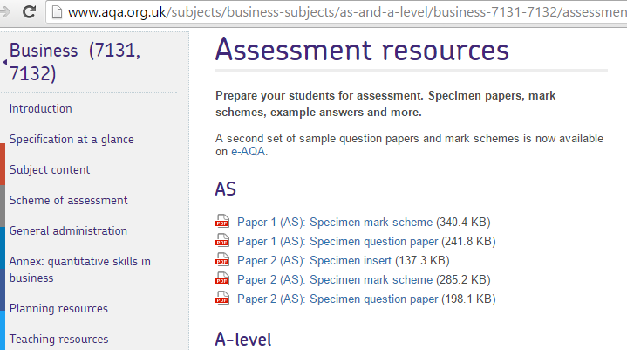

Task FIVE: Create a news report for a business of your choice
The final task of this transition pack involves you creating a news report for a business of your choice. Your task is as follows:
- Choose a business story that you are interested in that occurs during the summer holidays. I suggest looking at online websites such as BBC Business News to help you create ideas.

- Create a 5-minute presentation using PowerPoint to deliver a news story about what has happened to this business.

- Your presentation should include the following points:

  - An overview about the business
  - An explanation about what has happened to the business
  - An analysis about how this story has impacted your chosen business
  - A conclusion including recommendations for what the business should do
Useful Links:
https://www.youtube.com/channel/UCL7_sIS8IEJKL9LZLU7jiSQ
https://www.youtube.com/watch?v=rW5SOENyq5g&list=PLp8BSCLLWBUCTDvRtruUQE7Auli3N_kxk
http://www.aqa.org.uk/subjects/business-subjects/as-and-a-level/business-7131-7132
http://www.aqa.org.uk/subjects/business-subjects/as-and-a-level/business-7131-7132/assessment-resources
http://www.tutor2u.net/business
http://www.beebusinessbee.co.uk/
http://www.businessed.co.uk/
http://www.bbc.co.uk/news/business
https://www.theguardian.com/uk/business
http://uk.reuters.com/business

If you have any other enquiries about the course, please get in touch:

E-mail: pstopford@uhs.org.uk

We hope this transition pack helps you to prepare for your studies on the A-Level Business course from September 2016, and look forward to supporting you to successfully complete the course!

