Business
BTEC Handbook

Name: ______________________

Contents
- Course Expectations and Learner Agreement

- ‘Welcome to BTEC Level 3 Business’ Course Overview

- Task One – Unit 1 Assignment A ‘Exploring Business’

- Task Two – Unit 8 Assignment A ‘Recruitment & Selection’

- Task Three and Task Four – Revise and Practice Exam

- Useful links
Course Expectations
The Business BTEC Level 3 course is the next step after successfully completing GCSEs. BTEC is designed to build on your previous learning and knowledge and assist you in developing the necessary skills to complete the course. In order for you to excel at BTEC and achieve yours and our expectations and targets you need to acknowledge and agree to the following;
- Attendance = attainment. Attend all lessons, arrive on time and bring all the necessary equipment and resources. Do not book appointments during lesson hours
- Necessary equipment of exercise books, pens, your folder, coursework assignments in document wallets and your textbook
- Take responsibility for arriving on time to lessons after break or after a free period
- No mobile phones in use or in view in the lesson
- Work to the best of your ability in class and focus on the lesson
- Listen respectfully to the views of other students and consider how your own views are developing
- Complete all coursework on time and make sure it is printed and neatly organised in document wallets before being submitted
- Keep up to date with business in the news either online or via newspapers, BBC Business News is recommended
- Research effectively and make sure you reference sources you use in your coursework assignments by copying and pasting the links to articles
- Support classmates by sharing ideas but never send each other work or use other peoples’ work for ideas to get you started. If you are found to use the same work as another student, you WILL fail the coursework.
- Attempt all work and ask for support if you are unsure, but always try to find a solution yourself before relying on your teachers.
- Take advantage of any extra lessons to work upstairs in Lancaster
Learner Agreement
As a dedicated student of Business at Uxbridge High School, I promise to meet the expectations above. I understand that not doing so, will result in school sanctions, parent meetings, and most importantly, it will have a negative impact on my attainment.
Signed ______________________________________________
Print name ______________________________________________
Welcome to BTEC Business (Level 3)

What will I be learning about on the course?
In the first year of the course you will cover six topics: ‘What is business?’; ‘Managers, leaders and decision making’; ‘marketing performance’; ‘operational performance’; ‘financial performance’; ‘human resource performance’. This is designed to give you an overview of the important functional areas in business. In the second year of the course you learn about businesses more holistically and how they come up with overall strategies.
How is the course structured?
For the majority of you, the course will be spread over two years and you will sit A-Level examinations at the end of the second year.
However, if you decide after the first year that you do not want to continue the course, you will only achieve the AS-level qualification.
How is the course assessed?
What is the BTEC Level 3?
BTEC National qualifications provide a broad introduction that gives learners transferable knowledge and skills. These qualifications are for post-16 learners who want to continue their education through applied learning. The qualifications will prepare you for a range of higher education courses and job roles related to the business sector.
Which course will I be taking?
This will depend on your other A-level choices and timetable.
You will either be enrolled on the BTEC ‘Extended Certificate’ which is the equivalent of one A-Level qualification. This will involve you studying 4 units over the space of two years. These units will include:
  - Unit 1 - Exploring Business (coursework)
  - Unit 2 – Developing a Marketing Campaign (exam)
  - Unit 3 – Personal and Business Finance (exam)
  - Unit 8 – Recruitment and Selection Process (coursework)
Alternatively, you will be enrolled onto the BTEC ‘Diploma’ which is the equivalent of two A-Level qualifications. This will involve you studying 8 units over the space of two years. These units will include the ones above, as well as the following:
  - Unit 4 – Managing an Event (coursework)
  - Unit 5 – International Business (coursework)
  - Unit 6 – Principles of Management (exam)
  - Unit 18 – Creative Promotion (coursework)

How is the BTEC Business course graded?
For each unit you will receive one of the following four grades: Unclassified (fail); Pass; Merit; Distinction. All of the grades from your different units will be added together to give you an overall grade for the BTEC qualification.

How much coursework will I be expected to do?

Unit 1 has three assignments. The other coursework units usually have two assignments. It is hard to say what a ‘good’ assignment looks like because some involve written reports whereas others are assessed by practical work (groups; role play; presentations .etc.)

What are the exams going to be like?

For the first time this year, the BTEC course will have external exams. Exams can be sat in either January or June each year, and you will have one opportunity to re-sit each exam.
If you are completing a BTEC course worth one A-Level you will complete two exams (Unit 2 and Unit 3). Whereas if you are completing the course worth two A-Levels you will complete an additional exam (Unit 6).

Transition Pack Instructions:

In this transition pack you are going to be completing the following tasks. Please use the table beneath as a checklist and tick when you have completed each of the tasks. This will be checked by your teachers when you enrol on the course in September 2016.

# | Task | Complete?
1 | Attempt Unit 1 ‘Exploring Business’ Assignment A
2 | Attempt Unit 8 ‘Recruitment and Selection Process’ Assignment A
3 | Revise Unit 2 ‘Developing a Marketing Campaign’
4 | Practice a Unit 2 ‘Developing a Marketing Campaign’ exam

TASK ONE: READ THE UNIT 1 OVERVIEW
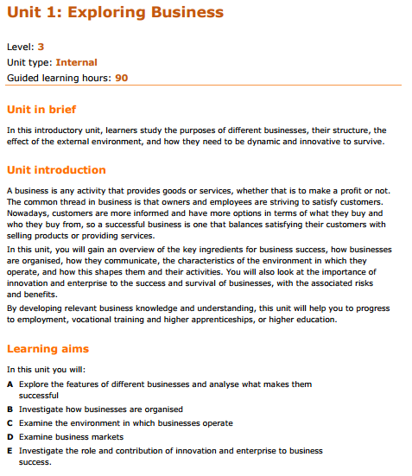

Each unit has an assignment brief which will be set by your teachers in class. This assignment brief is always presented like a checklist so that you also receive feedback. It is very important to stay organised and keep all of your work for each unit in a folder.

OVER TO YOU…
Complete the following tasks on the assignment brief for ‘Unit 1 Assignment A’:
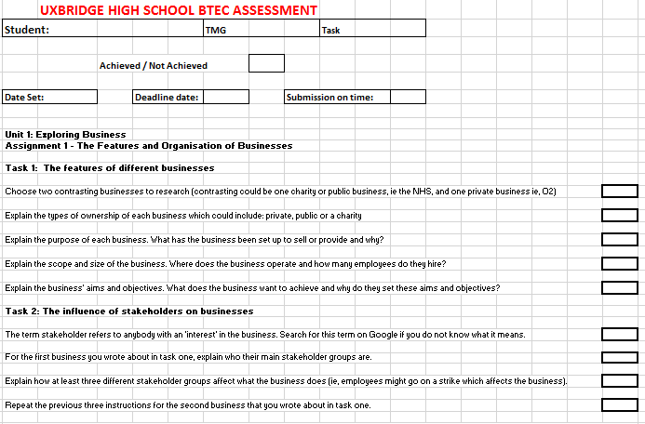

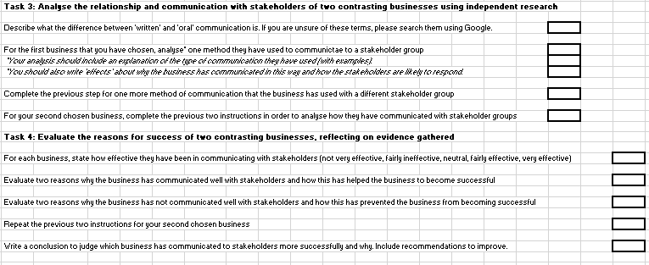
Writing Formats:
PASS TASKS
These tasks always start with the command verb ‘EXPLAIN’

How do I ‘EXPLAIN’ something?
M – Make a ‘point’
E – Explain this point in as much detail as possible
L – Make sure your explanation is ‘linked’ to the business

Sample ‘EXPLAIN’ Work:
Explain how a stakeholder influences ‘Manchester United Football Club’.
M – One stakeholder group which influences the business, ‘Manchester United Football Club’, is: the employees.
E – This is because the employees can help the business to become successful by working hard and trying to complete all of their tasks to the highest quality.
L – In Manchester United Football Club’s case, the main employees are coaches and managers. Jose Mourihno has recently been appointed the manager of the football club. According to the ‘Independent’ website Mourinho will earn £10 million a year which is double the amount the previous manager earned (http://www.independent.co.uk/sport/football/premier-league/jose-mourinho-to-be-confirmed-as-manchester-united-manager-on-thursday-on-10m-three-year-deal-a7049011.html). Also, according to the ‘Mirror’, Mourihno has been hired by the football club to build a solid defence to try to win the Premier League (http://www.mirror.co.uk/sport/football/news/what-jose-mourinhos-manchester-united-7052917) . This means that he will influence the business because if he selects a good team and motivates players to perform well, Manchester United could win a lot of trophies and make more revenue from people wanting to come and watch the football club at Old Trafford.

How do I ‘ANALYSE’ something?
M – Make a ‘point’
E – Explain this point in as much detail as possible
E – Analyse the effects of this explanation. ‘Effects’ mean you can either write about what caused something to happen or what will happen as a result of it.
L – Make sure your explanation is ‘linked’ to the business
MERIT TASKS
These tasks always start with the command verb ‘ANALYSE’

Sample ‘ANALYSE’ Work:
Analyse how John Lewis communicate with their stakeholder group, customers.
M – One way how John Lewis communicates with customers is television adverts.
E – This is because John Lewis advertise at Christmas time every year with an emotive advert to encourage people to think about the meaning of Christmas.
E – Therefore, customers are much more likely to shop with John Lewis if they have an emotional connection with them rather than shopping with Argos for example. As a result of this, John Lewis will make a lot more revenue over the Christmas period than their competitors.
L – In John Lewis’ case, according to ‘This Is Money’ the ‘Man on the Moon’ advert led to 5.1% increase in sales at John Lewis which came to nearly £1 billion in total sales which proves the advert was popular.

DISTINCTION TASKS
These tasks always start with the command verb ‘EVALUATE’
How do I ‘EVALUATE’ something?
M – Make a ‘point’ (advantage or disadvantage)
E – Explain this point in as much detail as possible
E – Analyse the effects of this explanation. ‘Effects’ mean you can either write about what caused something to happen or what will happen as a result of it.
L – Make sure your explanation is ‘linked’ to the business
J – Judge the importance of this point on the business and use ‘however, this depends on’ to consider the opposing point. Also, provide at least one ‘recommendation’ for what the business should do.

Sample ‘EVALUATE’ Work:
Evaluate one reason why ‘Pret’ give sandwiches away to homeless people at the end of each day.
M – One advantage of Pret giving away sandwiches at the end of each day is that the business is seen to be helping vulnerable people in society.
E – This means that other people will look upon Pret fondly and want to go there for coffee and snacks because they know some of their money is reinvested into helping poor people in the community.
E – Therefore, the managers of Pret not only feel happy that they are helping homeless people to eat food and be healthy but also the business will attract a wider amount of customers who can afford their products. As a result of this, Pret will have a better reputation than competing coffee chains such as Costa and Starbucks. Consequently, Pret will attract more employees to work in their stores because people like working with businesses who have good reputations as it motivates them to work well.
L – In Prets’ case, according to ‘The Guardian’ Pret’s profits rose by 14% to £52.4 million which shows that they are successfully attracting employees to buy their products.
J – I judge this to be very important for Pret because they operate in an industry with lots of strong competitors such as Starbucks and Costa. However, Pret have faced criticism because as they deliver the food to homeless people in vans they are driving a lot which emits harmful gases into the environment and contributes to global warming. I recommend the business to deliver food to homeless people using bicycles or food banks. This recommendation will mean the business still has a good reputation for feeding homeless people but they will overcome the challenge of being harmful to the environment at the same time.

TASK TWO: READ THE UNIT 8 OVERVIEW (BELOW)

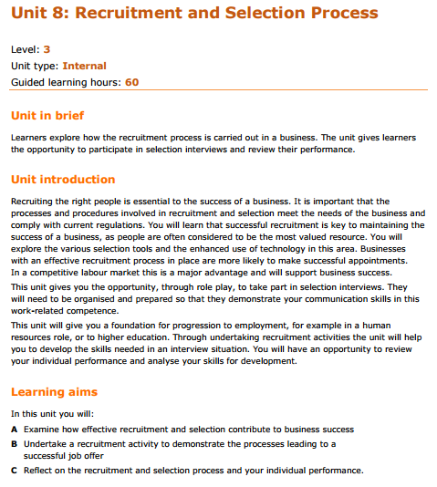

OVER TO YOU…
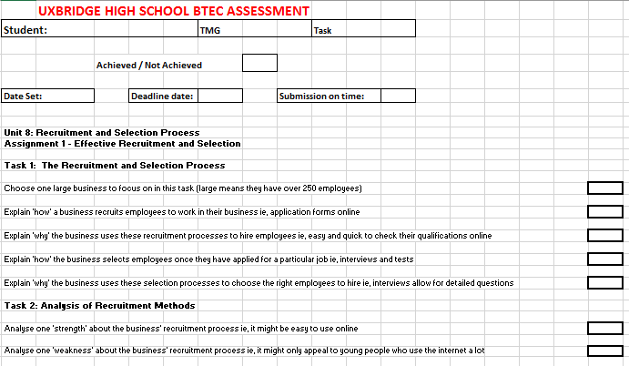
Complete the following tasks on the assignment brief for ‘Unit 1 Assignment A’:

TASK THREE: Revise Unit 2 ‘Developing a Marketing Campaign’
In order to revise this topic you will either need to use the internet or purchase a BTEC Business textbook. The textbook you will need to purchase can be bought on Amazon:
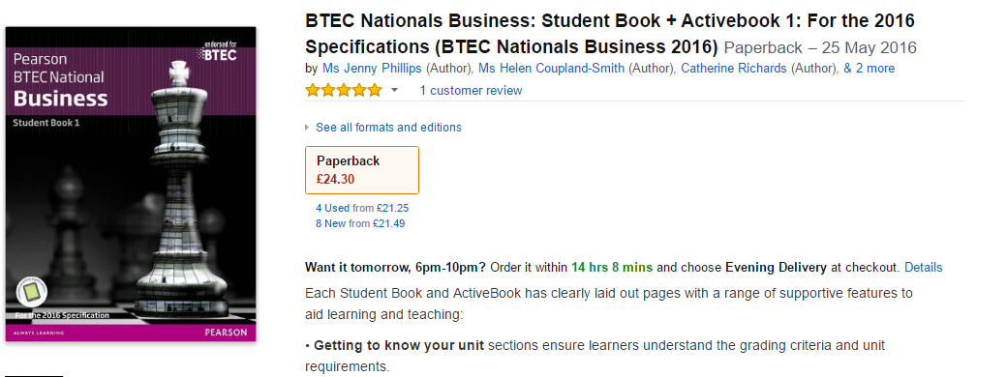
https://www.amazon.co.uk/BTEC-Nationals-Business-Activebook-Specifications/dp/1292126248/ref=sr_1_fkmr0_1?ie=UTF8&qid=1467575158&sr=8-1-fkmr0&keywords=BTEC+Nationals+Business+Student+Book+1+%2B+Activebook+Publisher%3A+Pearson
OVER TO YOU…
Revise the following topics:
- Principles and purposes of marketing
- Marketing aims and objectives
- Types of market
- Market segmentation
- Branding
- Influences on marketing activity
- Market Research
- Marketing campaigns
- The Marketing Mix
- SWOT Analysis
- PESTLE Analysis
- Target Market
- Competitor analysis

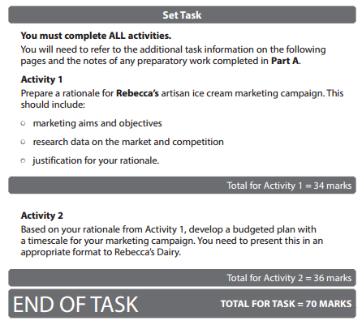
TASK FOUR: Practice a Unit 2 ‘Developing a Marketing Campaign’ exam

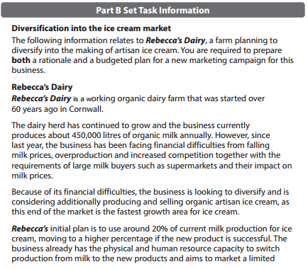
Useful Links:
https://www.youtube.com/channel/UCL7_sIS8IEJKL9LZLU7jiSQ
http://qualifications.pearson.com/en/qualifications/btec-nationals/business-2016.html
http://www.tutor2u.net/business
http://www.beebusinessbee.co.uk/
http://www.businessed.co.uk/
http://www.bbc.co.uk/news/business
https://www.theguardian.com/uk/business
http://uk.reuters.com/business

If you have any other enquiries about the course, please get in touch:
E-mail: pstopford@uhs.org.uk
We hope this transition pack helps you to prepare for your studies on the BTEC Level 3 Business course from September 2016, and look forward to supporting you to successfully complete the course!

