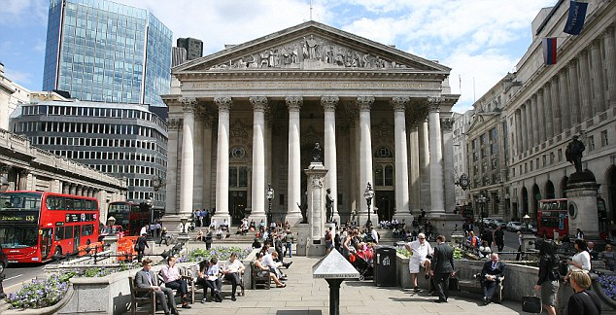
Economics
A Level Handbook

Name: ______________________

Contents
- Course Expectations and Learner Agreement

- ‘Welcome to A-Level Economics’ Course Overview

- Task One – Reading

- Task Two – 25-mark exam question about free school meals

- Task Three – G8 Summit Speech Presentation

- Task Four – A-Level exam questions (examples)

- Useful links

Course Expectations
The Business Economics course is the next step after successfully completing GCSEs. A Level is designed to build on your previous learning and knowledge and assist you in developing the necessary skills to complete the course. In order for you to excel at A Level and achieve yours and our expectations and targets you need to acknowledge and agree to the following;
- Attendance = attainment. Attend all lessons, arrive on time and bring all the necessary equipment and resources. Do not book appointments during lesson hours
- Necessary equipment of exercise books, pens, a calculator, and your textbook
- Take responsibility for arriving on time to lessons after break or after a free period
- No mobile phones in use or in view in the lesson
- Work to the best of your ability in class and focus on the lesson
- Listen respectfully to the views of other students and consider how your own views are developing
- Complete all homework on time – this includes printing out resources
- Keep up to date with economics in the news either online or via newspapers, The Economist is recommended
- Complete all necessary research as directed
- Set up a social network group with others in your class – to encourage and support each other
- Attempt all work. If you are unsure of what to do, of course you may ask questions, but there are times when your teacher will want you to work independently without question. You must respect this.
- Take advantage of any extra lessons to work upstairs in Lancaster
- Keep to deadlines
Learner Agreement
As a dedicated student of Economics at Uxbridge High School, I promise to meet the expectations above. I understand that not doing so, will result in school sanctions, parent meetings, and most importantly, it will have a negative impact on my attainment.
Signed ______________________________________________
Print name ______________________________________________

Welcome to A-Level Economics
What will I learn about on the course and how will I be assessed?
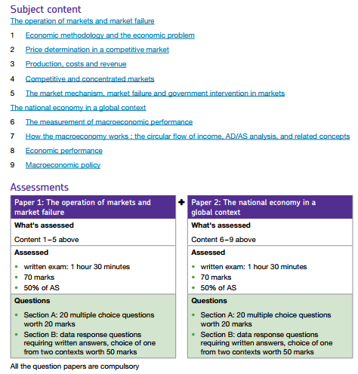

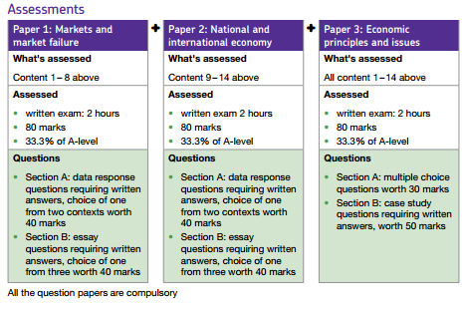
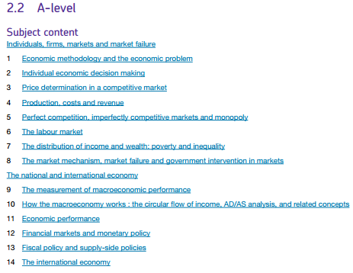
How does this differ from the A-Level course (second year)?
Will I need to buy and use a textbook?
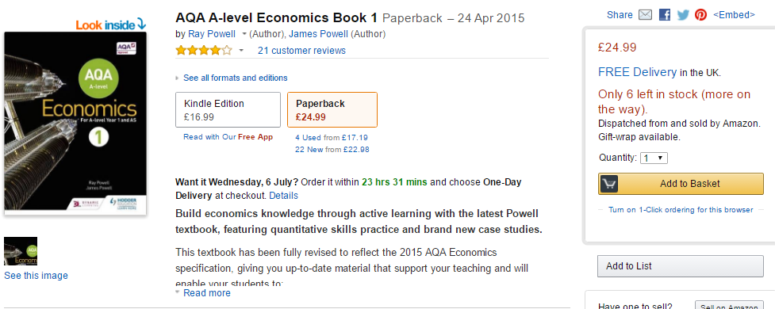
Yes, the core textbook is:

Where else can I go for resources & help?
- http://www.tutor2u.net/economics

Transition Pack Overview:
- In this A-level transition pack you have been given a first chapter reading to give you a taste for the type of theory that is covered in the A-level course.
- You have also been given a 25-mark question which you can treat as a mini-project to research and answer over the summer holidays. When you start the course formally in September, your teachers will go over your written work from these questions with you and help you to improve your extended writing.
- Also, this transition pack includes screenshots of the website you can access to look at example exam papers. It is also a good idea to familiarise yourself with exam papers as early as possible so you know how they are structured.
- Lastly, this transition pack includes a task for you to prepare a G8 summit speech to deliver in one of the first lessons back after the summer holidays. You will be creating a presentation to deliver to your teachers and fellow students during one of the first weeks back in September 2016.

A-Level Assessment:
This transition pack has been created to give you an overview of the skills required to successfully achieve a good grade on the Economics A-Level. Throughout the qualification you will be required to demonstrate the following skills:
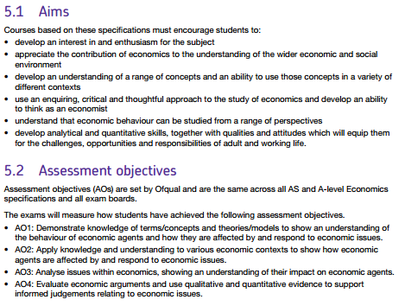

Transition Pack Checklist:
Task # | Task | Complete?
1 | Read the first chapter from the Economics A-Level
2 | Practise answering an A-Level economics exam question (free school meals)
3 | Speaking at the G8 Summit
4 | Familiarise yourself with the A-Level exam papers

Task ONE: Read the first chapter from the Economics A-Level
Basic Economic Problem: Scarcity and Choice
The Economist's Dictionary of Economics defines economics as
"The study of the production, distribution and consumption of wealth in human society"
The purpose of economic activity
It is often said that the central purpose of economic activity is the production of goods and services to satisfy our ever-changing needs and wants.
The basic economic problem is about scarcity and choice. Every society has to decide:
What goods and services to produce? Does the economy use its resources to build more hospitals, roads, schools or luxury hotels? Do we make more iPhones and iPads or double-espressos? Does the National Health Service provide free IVF treatment for childless couples?
How best to produce goods and services? What is the best use of our scarce resources? Should school playing fields be sold off to provide more land for affordable housing? Should we subsidise the purchase of solar panels for roofs?
Who is to receive goods and services? Who will get expensive hospital treatment - and who not? Should there be a minimum wage? Or perhaps a living wage? What are the causes and consequences of poverty in societies across the globe?

Scarcity
We are always uncovering of new wants and needs which producers attempt to supply by using factors of production. For a perspective on the achievements of countries in meeting people’s basic needs, the Human Development Index produced by the United Nations is worth reading. The economist Amartya Sen (Winner of the 1998 Nobel Prize for Economics) has written extensively on this issue.
Scarcity means we all have to make choices
Because of scarcity, choices must be made by consumers, businesses and governments. For example, over six million people travel into London each day and they make decisions about when to travel, whether to use the bus, the tube, to walk or cycle or work from home. Millions of decisions are taken, many of them are habitual – but somehow on most days, people get to work on time and they get home too in safety if not in comfort!
Trade-offs and Choices
Making a choice made normally involves a trade-off – this means that choosing more of one thing can only be achieved by giving up something else in exchange.
- Housing: Choices about whether to rent or buy a home – both decisions involve risk. People have to weigh up the costs and benefits of the decision.
- Working: Do you work full-time or part-time? Is it worth your while studying for a degree? How have these choices been affected by the introduction of university tuition fees?
- Transport and travel: The choice between using Euro-Tunnel, a low-cost ferry or an airline when travelling to Western Europe.
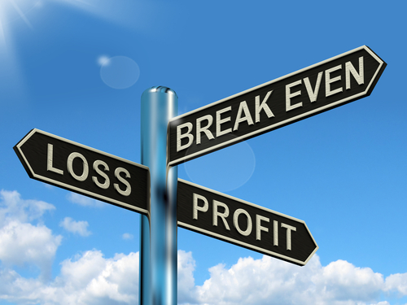

Objectives of Firms

The main economic objective of businesses in a market economy is most likely to be the maximisation of profits

Key Point: The Cost Benefit Principle
- In many decisions where people consider the costs and benefits of their actions – economists make use of the ‘marginal’ idea, for example what are the benefits of consuming a little extra of a product and what are the costs?
- Rational decision-makers weigh the marginal benefit one receives from an option with its marginal cost, including the opportunity cost.
- This cost benefit principle well applied will get you a long way in economics!
- But keep in mind that behavioural economics questions the rationality of many of our decisions!
Consumer Welfare and Rationality
What makes people happy? Why despite several decades of rising living standards, surveys of happiness suggest that people are not noticeably happier than previous generations?
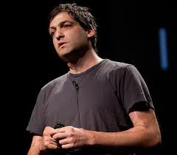
Typically we assume that, when making decisions people aim to maximise their welfare. They have a limited income and they allocate their money in a way that improves gives them the highest total satisfaction.
In reality consumers rarely behave in a well-informed and rational way. Often decisions are based on incomplete information which causes a loss of welfare not only for people themselves but which affect others and our society as a whole.
As consumers we have all made poor choices about which products to buy. Behavioural economics is an exciting strand of the subject that looks at whether we are rational in our everyday decisions. One of the best people to read is Dan Ariely (pictured).
Behavioural economics
Behavioural Economics is the name given to the discipline that tries to mix insights from Psychology with Economics, and looks at economic problems through the eye of a “Human”, rather than an “Econ”. It uses insights from psychology to explain why people make apparently irrational decisions such as why people eat too much and do not save enough for retirement. An Econ is said to be infinitely rational and immensely intelligent, emotionless being who can do cost-benefit analyses at will, and is never (ever) wrong. The reality is often very different. Most of us are not infinitely rational, but rather face “bounded rationality”, with people adopting rules of thumb instead of calculating optimal solutions for every decisionOpportunity Cost

Opportunity Cost In Health Care: UK rejects the meningitis B vaccine

The only vaccine to protect against a deadly form of meningitis should not be introduced in the UK, the body that advises governments on immunisation says. About 1,870 people contract meningitis B each year and one in 10 dies. The Joint Committee on Vaccination and Immunisation (JCVI) said the vaccine, Bexsero, was not cost-effective and should not yet be adopted by the NHS.

There are vaccines against other forms of meningitis, but the jab developed by Novartis is the only one thought to protect against meningitis B.Tests have suggested the vaccine is effective against 73% of the different strains of the disease. It was licensed for use in Europe in January 2013. So far no country has introduced the vaccine.
News reports, July 2013
In economics, “there is no such thing as a free lunch!” Even if we are not asked to pay money for something, scarce resources are used up in production and there is an opportunity cost involved.
Opportunity cost measures the cost of any choice in terms of the next best alternative foregone.
Work-leisure choices: The opportunity cost of deciding not to work an extra ten hours a week is the lost wages foregone. If you are being paid £7 per hour to work at the local supermarket, if you take a day off from work you might lose over £50 of income
Government spending priorities: The opportunity cost of the government spending nearly £10 billion on investment in National Health Service might be that £10 billion less is available for spending on education or improvements to the transport network.
Investing today for consumption tomorrow: The opportunity cost of an economy investing resources in capital goods is the production of consumer goods given up for today
Making use of scarce farming land: The opportunity cost of using farmland to grow wheat for bio-fuel means that there is less wheat available for food production causing food prices to rise and increasing the risks of food poverty and malnutrition for millions of the world’s most vulnerable people.

Economic Systems
An economic system is a network of organisations used by a society to resolve the basic problem of what, how much, how and for whom to produce.
- Free market economy: Where markets allocate resources through the price mechanism. An increase in demand raises price and encourages businesses to use more resources into the production of that good or service. The quantity of products consumed by people depends on their income and income itself depends on the market value of an individual’s work. In a free market economy there is a limited role for the government, indeed in a pure free market system, the government limits itself to protecting property rights of people and businesses using the legal system and protecting the value of money or the value of a currency.
- Planned or command economy: In a planned or command system associated with a socialist or communist system, scarce resources are owned by the government. The state allocates resources, and sets production targets and growth rates according to its own view of people's wants. Market prices play little or no part in informing resource allocation decisions and queuing rations scarce goods.
- Mixed economy: In a mixed economy, some resources are owned by the public sector (government) and some are owned by the private sector. The public (or state) sector typically supplies public, quasi-public and merit goods and intervenes in markets to correct perceived market failure. Nearly all economies in the world are mixed although that mix changes over time for example as some industries are privatised (sold to the private sector) or nationalised (taken back into state ownership).

Task TWO: Practice answering an A-Level Economics exam question
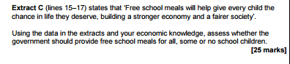
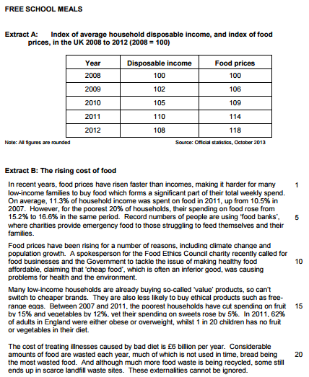

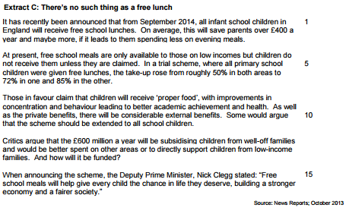
How to answer ’25-mark’ exam questions:
M – Make a point. Why should the government provide free school meals to all children?
E – Explain this point. Why would this be a good idea for the government to do?
E – Effects. What will the causes of this be on children and the wider society?
L – Use evidence from the case study to back your point up.
Repeat the MEEL paragraph at twice more, once for ‘some’ children and once for ‘no’ children
Conclusion:
Answer the question – Overall, who should the government provide free school meals to?
Important reason – The most important reason for this is...
Make a recommendation – What action(s) should the government take in order to do this?
However, what does this depend on and why? However, this depends on…because…

Task THREE: Speaking at the G8 Summit
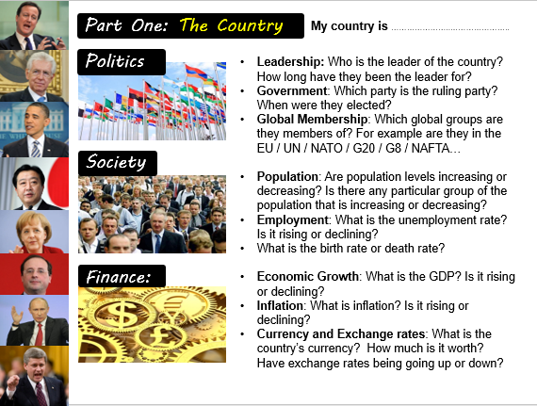
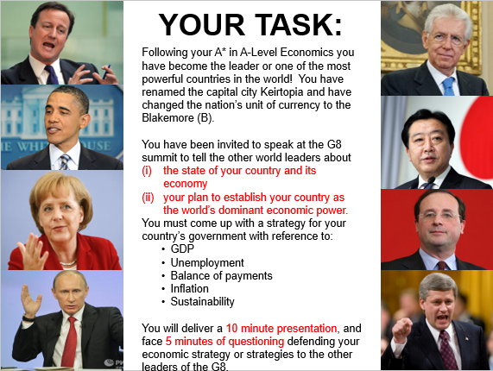
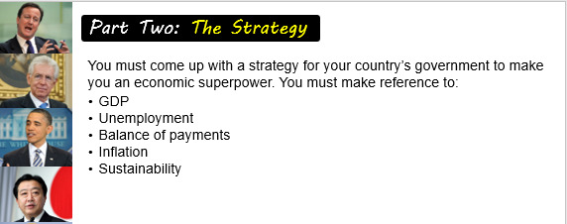
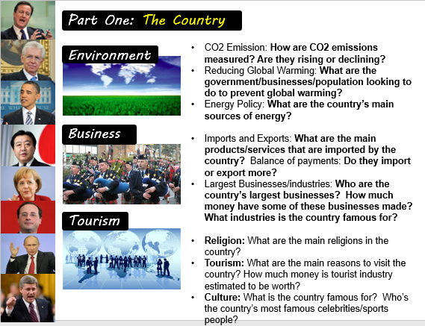

Task FOUR: Familiarise yourself with the A-Level exam papers
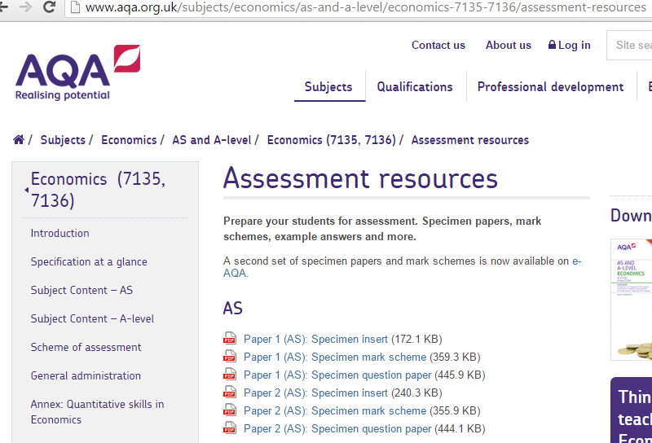

- Access the website above to view sample AS-Level exam papers.

- Before you begin the course in September, it will be useful to familiarise yourself with the AS-Level exam papers so you know what to expect.

Useful Links:
https://www.youtube.com/watch?v=HqVmqcleSRE&list=PLp8BSCLLWBUCG1PmQrkcDJINJ65p0I5C6
https://www.youtube.com/watch?v=Uc6IcbNmJBc&list=PLSNjK_WfuG9FGCmNIOg5de93X51rs5pyQ
http://www.aqa.org.uk/subjects/economics/as-and-a-level/economics-7135-7136
http://www.aqa.org.uk/subjects/economics/as-and-a-level/economics-7135-7136/assessment-resources
http://www.tutor2u.net/economics
http://www.tutor2u.net/economics/blog/economics-topic-study-notes
http://www.s-cool.co.uk/a-level/economics
http://www.economist.com/
http://www.bbc.co.uk/news/business/economy
https://www.theguardian.com/business/economics

If you have any other enquiries about the course, please get in touch: pstopford@uhs.org.uk
We hope this transition pack helps you to prepare for your studies on the A-Level Economics course from September 2016, and look forward to supporting you to successfully complete the course!

