**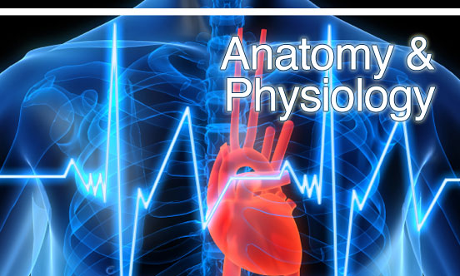**

**AS PE**

**Anatomy & Physiology Book 1**

**Joints, Muscles & Biomechanics**

**Name: \_\_\_\_\_\_\_\_\_\_\_\_\_\_\_\_\_\_\_\_\_\_\_\_\_\_\_\_\_\_\_\_\_\_**

**Learner Agreement**

As a dedicated student of PE at Uxbridge High School, I promise to meet the expectations above. I understand that not doing so, will result in school sanctions, parent meetings, and most importantly, it will have a negative impact on my attainment.

**Signed \_\_\_\_\_\_\_\_\_\_\_\_\_\_\_\_\_\_\_\_\_\_\_\_\_\_\_\_\_\_\_\_\_\_\_\_\_\_\_\_\_\_\_\_\_\_**

**Print name \_\_\_\_\_\_\_\_\_\_\_\_\_\_\_\_\_\_\_\_\_\_\_\_\_\_\_\_\_\_\_\_\_\_\_\_\_\_\_\_\_\_\_\_\_\_**

**Key Terms** you need to learn and understand for **Joints, Muscles** **& Mechanics of movement** section

|  |  |  |
| --- | --- | --- |
| **Key Term** | **Definition** | **Ref** |
| **Appendicular skeleton** | The bones of the upper & lower limbs and their girdles that join to the axial skeleton |  |
| **Axial skeleton** | This forms the long axis of the body and includes the bones of the skull, spine & rib cage |  |
| **Ligament** | A tough band of fibrous, slightly elastic connective tissue that attaches one bone to another. It binds the ends of bones together to prevent dislocation |  |
| **Tendon** | A very strong connective tissue that attaches skeletal muscle to bone |  |
| **Collagen** | A fibrous protein with great strength that is the main component of bone |  |
| **Calcium** | The mineral stored in bone that keeps it hard and strong. 99% of the body’s calcium is stored in bone |  |
| **Diaphysis** | The shaft of middle part of a long bone |  |
| **Epiphysis** | The end portion of a long bone |  |
| **Bone marrow** | Connective tissue found in the spaces inside bone that is the site of blood cell production and fat storage |  |
| **Growth Plate** | The area of growing tissue near the end of long bones in children and adolescents often referred to as the epiphyseal plate. When physical maturity is reached, the growth plate is replaced by solid bone. |  |
| **Articular cartilage** | A thin layer of glassy-smooth cartilage that is quite spongy and covers the end of bones at a joint |  |
| **Joint Cavity** | A space within a synovial joint that contains synovial fluid |  |
| **Planes of movement** | A flat surface running through the body within which different types of movement can take place about different types of synovial joint. There are three main planes that describe the movement of the human body |  |
| **Bursa** | A flattened fibrous sac lines with synovial fluid that contains a thin film of synovial fluid. Its function is to prevent friction at sites in the body where ligaments, muscles, tendons or bones might rub together |  |
| **Meniscus** | A wedge of white fibro cartilage that improves the fit between adjacent bone ends, making the joint more stable and reducing wear and tear on joint surfaces |  |
| **Pad of Fat** | A fatty pad that provides cushioning between the fibrous capsule and a bone or muscle |  |
| **Anatomical position** | An upright standing position with head, shoulders, chest, palms of hands, hips, knees and toes facing forwards |  |
| **Anterior** | Towards the front of the body |  |
| **Posterior** | Towards the back of the body |  |
| **Superior** | Towards the head or upper part of the body |  |
| **Inferior** | Towards the feet or lower part of the body |  |
| **Medial** | Towards the middle of the body |  |
| **Lateral** | Towards the outside of the body |  |
| **Origin** | Point of attachment of a muscle that remains relatively fixed during muscular contraction |  |
| **Insertion** | Point of attachment of a muscle that tends to move toward the origin during muscular contraction |  |
| **Antagonistic muscle action** | As one muscle shortens to produce movement, another muscle lengthens to allow that movement to take place |  |
| **Agonist muscle** | The muscle that is directly responsible for the movement at a joint |  |
| **Antagonist muscle** | The muscle that has an action opposite to that of the agonist and helps in the production of a coordinated movement |  |
| **Core stability** | The ability of your trunk to support the forces from your arms and legs during different types of physical activity. It enables joints and muscles to work in their safest and most efficient positions, therefore reducing the risk of injury |  |
| **Rotator Cuff** | The supraspinatus, infraspinatus, teres minor and subscapularis muscles make up the rotator cuff. They work to stabilise the shoulder joint to prevent the larger muscles from displacing the head of the Humerus during physical activity |  |
| **Isotonic contraction** | Tension is produced in the muscle while there is a change in muscle length. It is a dynamic contraction because the joint will move |  |
| **Isometric contraction** | Tension is produced in the muscle but there is no change in muscle length. It is a static contraction because the joint will stay in the same position |  |
| **Concentric contraction** | A type of isotonic contraction that involves the muscle shortening while producing tension |  |
| **Eccentric contraction** | A type of isotonic contraction that involves the muscle lengthening while producing tension |  |
| **Muscle fibre** | A long cylindrical muscle cell. Muscle fibres are held together in bundles to make up an individual skeletal muscle |  |
| **Slow twitch fibre** | A type of muscle fibre associated with aerobic work. It produces a small force over a long period of time: high resistance to fatigue. It is suited to endurance based activities, e.g. marathon running |  |
| **Fast twitch fibre** | A type of muscle fibre associated with anaerobic work. It produces a large force over a short period of time: low resistance to fatigue. It is suited to power-based activities e.g. sprinting, power lifting. There are 2 types: fast oxidative glycolytic (Type 2a / FOG) and fast glycolytic (Type 2b / FG). FOG fibres have a slightly greater resistance to fatigue than FG fibres |  |
| **Aerobic exercise** | Is performed in the presence of oxygen at a sub-maximal intensity over a prolonged period of time e.g. rowing |  |
| **Anaerobic exercise** | Is performed in the absence of oxygen at a maximal intensity that can only be sustained for a short period of time due to the build up of lactic acid e.g. sprinting |  |
| **Warm up** | Light aerobic exercise that takes place prior to physical activity, normally including some light exercise to elevate the heart rate, muscle and core body temperature, some mobilising exercises for the joints, some stretching exercises for the muscles and connective tissue and some easy rehearsal of the skills to follow |  |
| **Cool down** | Low intensity aerobic exercise that takes place after physical activity and facilitates the recovery process |  |
| **Osteoporosis** | Weakening of bones caused by a reduction of bone density making them prone to fracture |  |
| **Sedentary** | An inactive lifestyle with little or no exercise |  |
| **Osteoarthritis** | A degenerative joint disease caused by a loss of articular cartilage at the ends of long bones in a joint. It causes pain, swelling and reduced motion in your joints |  |
| **Bone spurs** | Are small projections of bone that form around joints due to damage to the joints surface, most commonly caused from the onset of osteoarthritis. They limit movement and cause pain in the joint |  |
| **Joint stability** | This refers to the resistance offered by various musculo-skeletal tissues that surround a joint |  |
| **Muscle Tone** | This continual sate of partial contraction of a muscle that helps to maintain posture |  |
| **Linear motion** | When a body moves in a straight or curved line, with all its parts moving the same distance, in the same direction and at the same speed |  |
| **Angular motion** | When a body or part of a body moves in a circle or part of a circle about a particular point called the axis of rotation |  |
| **General motion** | A combination of linear & angular motion |  |
| **Force** | A push or pull that alters, or tends to alter, the state of motion of a body |  |
| **Inertia** | The reluctance of a body to change its state of motion |  |
| **Acceleration** | The rate of change of velocity |  |
| **Centre of mass** | The point at which the body is balanced in all directions |  |
| **Stability** | Relates to how difficult it is to disturb a body from a balanced position |  |
| **Line of gravity** | A line extending from the centre of mass vertically down to the ground |  |
| **Eccentric force** | A force whose line of application passes outside the centre of mass of a body causing the resulting motion to be angular |  |
| **Direct force** | A force whose line of application passes through the centre of mass of a body causing the resulting motion to be linear |  |

**What you need to know.....**

**Movement Analysis / Rotator Cuff / Core Stability** - joint type / movement / muscle contraction / function / rotator cuff / core stability

**Fibre types / mix** - fibre type mix / structure / function / choice

**Warm-Up / Cool Down** - Warm-Up / Cool Down effects on S&F muscle contraction and vascular system

**Activity impact on muscle / bone health** - High impact / contact / repetitive activity on osteoporosis, arthritis, G-plate, joint stability, posture, alignment

**Mechanics of movement** - Centre of Mass / Motion / Newton’s Laws / force application

**Skeleton & Joints**

Label the skeleton..

Task

C:\Documents and Settings\taridam\Local Settings\Temporary Internet Files\Content.IE5\SQD2B4MK\MCSO02952_0000[1].wmf

**Functions of the skeleton**

* Support / Protection / Movement / Blood cell production / Mineral store

The human skeleton is divided into two different parts, axial & appendicular skeleton..

**Complete the table**

|  |  |
| --- | --- |
| **Axial skeleton** | **Appendicular skeleton** |
| Skull | Shoulder girdle & upper limbs |
|  |  |
|  |  |

**Structure of the bone**

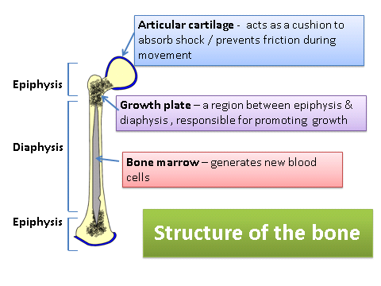

**Ossification process…….how does bone grow**

Initially made out of cartilage

ossification starts (in diaphysis then epiphysis)

a plate of cartilage is left between the diaphysis & epiphysis to allow growth

Once matured, plate fuses & becomes bone

**Why can this process be of risk to youngsters?**

**Types of joints** Complete the following table…

|  |  |  |  |
| --- | --- | --- | --- |
| **Type of joint** | **Mobility** | **Stability** | **Example** |
| Fibrous / immoveable | No movement | Most stable |  |
| Cartilaginous / semi moveable | Little movement | Stable |  |
| Synovial / freely moveable | Free movement | Least stable |  |

**Complete the following table**

|  |  |  |  |
| --- | --- | --- | --- |
| Type of synovial joint | Examples from skeleton | Description | Movements likely |
| Ball & Socket |  | 08_09a-cA ball shaped head of one bone articulates with a cup like socket of an adjacent bone |  |
| Hinge |  | 08_09d-f  A cylindrical protrusion of one bone articulates with a trough-shaped depression of an adjacent bone |  |
| Pivot |  | A rounded or pointed structure of one bone articulates with a ring-shaped structure of an adjacent bone. |  |
| Condyloid |  | 08_09a-c  Similar to a ball & socket joint but with much flatter articulating surfaces forming a much shallower joint |  |
| Gliding |  | Articulating surfaces are almost flat and of a similar size |  |

**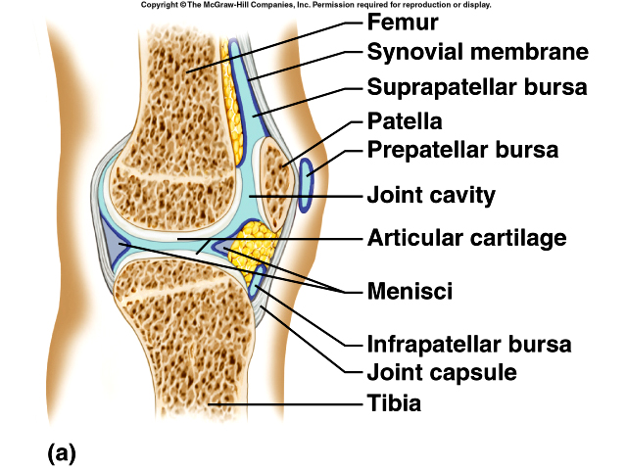Structures & functions to help stabilise synovial joints Structure of Synovial Joints**

|  |  |  |
| --- | --- | --- |
| **Feature** | **Structure** | **Stability Function** |
| **Joint capsule** | Fibrous tissue encasing the joint | Helps to strengthen the joint and add stability |
| **Ligaments** | Join bone to bone | Reinforce & strengthen the joint |
| **Meniscus** | Discs of fibro-cartilage improve the fit between the ends of long bones at a joint | Makes the joint more stable and minimises wear & tear |
| **Muscle tone** | Muscle tone | Keeps the tendons that cross a joint in a constant taut state, stabilising the joint |

**Structures & Functions to help mobility of synovial joints**

**Articular cartilage** - covers the articulating surfaces of the bones – prevents friction between ends of bone

**Joint capsule** – fibrous tissue encasing the joint – forming a capsule around the joints adds stability

**Synovial fluid** – a fluid that fills the joint capsule – nourishes and lubricates the articular cartilage

**Bursa** – a sac filled with synovial fluid between tendons & ligaments – reduce friction

Task

Rugby has the highest risk per player/hour of injury of all sports ([www.shoulderdoc.co.uk](http://www.shoulderdoc.co.uk/)) mainly to the shoulder which comprises 20% of all rugby injuries, followed by the knee

**In your groups, think of 3 different sports and look at the possible injuries at specific joints that could occur and explain your answers…**

Try and cover both structural and functional reasons for your choices…

**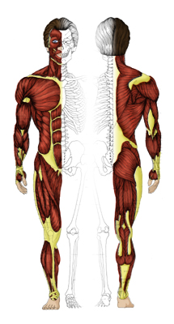Muscles Label the muscles**

Task

**Some of the muscles are made up of a variety of muscles, it is important that you know these**

Hamstings =

Quadriceps =

Gluteals =

Rotator Cuff =

It is important that you know and understand the movements that are made at each joint and the muscles that are used in order to create the movements.....

**Complete the following table.....**

|  |  |  |  |
| --- | --- | --- | --- |
| **Joint** | **Movements possible** | **Agonist** | **Antagonist** |
| **Wrist** | Flexion  Extension |  |  |
| **Radio/Ulnar** | Pronation  Supination |  |  |
| **Elbow** | Flexion  Extension |  |  |
| **Shoulder** | Flexion  Extension  Horizontal flexion  Horizontal extension  Abduction  Adduction  Rotation  Circumduction |  |  |
| **Spine** | Flexion  Extension  Lateral flexion |  |  |
| **Hip** | Flexion  Extension  Abduction  Adduction  Rotation |  |  |
| **Knee** | Flexion  Extension |  |  |
| **Ankle** | Dorsiflexion  Plantar flexion |  |  |

**Take it further......**

Pick 3 pictures of sporting movements and identify the movement at each of the joints above, mention the agonist muscle and type of contraction for each joint movement.

**Type of contraction**

Learn the following as this will help you understand type of contraction you need to know

|  |  |  |
| --- | --- | --- |
| **LENGTH** | **FUNCTION** | **CONTRACTION** |
| SHORTENING | AGONIST | CONCENTRIC |
| LENGTHENING | ANTAGONIST | ECCENTRIC |
| STATIC | FIXATOR | ISOMETRIC |

**Give an example of each......**

**Core Stability**

Understand your core.........core stability muscles contract to act as stabilisers, prior to movement.

**What are the core stability muscles?**



**A strong core stability gives you:**

* A more stable centre of gravity/mass
* Reduced risk of injury/pain (especially lower back)
* Improved posture and body/spine alignment
* Creates a more stable platform allowing more efficient movement

**Weak core muscles** can make you susceptible to poor posture, muscular instability/injuries, nerve irritation & lower back pain

**Give some examples of training you can do to help improve core stability......**

**Rotator Cuff**

The rotator cuff muscles work together to provide the shoulder joint with dynamic stability, helping control the joint during rotation.

**What are the rotator cuff muscles?**



Because a lot of sporting movements such as cricket bowling, swimming, kayaking etc involve rotation of the shoulder, the rotator cuff muscles are put under a lot of stress..

**Common injuries** include tears of the tendons/muscles and inflammation of structures in the joint.

**Give some examples of how the rotator cuff muscles can be strengthened.......**

**Exam questions**

1. Typically a tennis player will extend their shoulder joint when performing a serve. Complete the following joint analysis for extension of the shoulder joint.

|  |  |  |  |
| --- | --- | --- | --- |
| Joint type | Articulating bones | Agonist muscle | Type of contraction |
|  |  |  |  |

**[4 marks]**

1. Identify two structures of the hip joint and describe the role of each during the performance of physical activity **[4 marks]**
2. Identify the following:-
3. The type of contraction occurring in the bicep brachii during the downward phase of a bicep curl
4. The muscle that is performing a similar contraction during the downward phase of a sit up **[2 marks]**

**Muscle Fibre Types**

Muscle fibres are muscle cells. Each fibre is a single cylindrical cell containing several nuclei. Depending on what the percentage of muscle fibre type an athlete has (genetically determined), it will determine the type of activity that they are best suited to.

You will need to understand the structural & functional variations between each muscle fibre type and know which activity they are best suited to.

**Fill in the missing gaps....**

|  |  |  |  |
| --- | --- | --- | --- |
|  | **Slow Oxidative Fibres**  **SO – Type I** | **Fast Oxidative Glycolytic Fibres**  **FOG - Type IIa** | **Fast Glycolytic Fibres**  **FG - Type IIb** |
| **Structural variations**  Colour & Size  No of mitochondria  No of capillaries  Myoglobin concentrate  Glycogen Stores | Red & small  Many  High  Low | Red/Pink / intermediate  Many  Many  Intermediate | White/pale & large  Few  Low  High |
| **Functional variations**  Contractile speed  Contractile strength  Fatigue resistance  Aerobic capacity  Anaerobic capacity | Low  High  Low | Fast  Intermediate  Moderate | Fast  Low  High |
| **Best suited activities**  **Examples......** | Endurance, low intensity, high duration activity | Activities involving both low & high duration & intensity | High intensity, low duration, speed/power activities |

**Exam question**

The muscle fibre type that would be used during a maximal muscle contraction is the fast glycolytic (type IIb) fibre. Give two structural & two functional characteristics of this type of muscle fibre. **[4 marks]**

**Take it further** - Cut out a picture of three different performers and predict which muscle fibre type they are more likely to have a higher percentage of. Justify your answer with structural & functional characteristics of muscle fibres shown above.

**Warm Up & Cool Down**

Warm Up and Cool downs are crucial in sport. Muscles contain elastin, a protein which has an elastic property and a coiled effect, so that when you stretch muscle tissue, it returns to its original length. However, the warmer the muscle becomes, it will be able to stretch further and recoil with greater force, therefore performing better.

You need to know the physiological effects of a warm-up and cool-down on skeletal muscle..

**Warm Up Cool Down**

Increase speed & force of contraction Faster removal of lactic acid from fast

due to higher speed of nerve transmission twitch fibres

Improved economy of movement due to a A decrease in the risk of DOMS

reduction in muscle viscosity Improves flexibility / ROM

Increased flexibility that reduces risk of

injury

Greater strength of contraction

Production of synovial fluid

Decreased muscular tension

**Task**

**Research some of the latest ideas behind the importance of warming up and cooling down and create an information leaflet that can be used for athletes**

**Take it further**

**-** Read the article in PE Review April 2007, page 32

**Impact of different types of physical activity on skeletal / muscular systems**

As you get older, your bone tissue contains less collagen so the bone is less dense, which can result in brittle bones that damage easily. Participation in exercise can help delay or counteract this process. However, not all participation in activity has a positive effect on bone tissue. For your exam, you need to know what impact different types of activity have.

During bone growth, exercise is important to increase bone mineral density so to maximise peak bone mass. Continued exercise after bone growth will help maintain bone mass and reduce age-related bone loss, reducing the risk of osteoporosis. Exercise helps to preserve muscle strength and postural stability, reducing the risk of falling and possible bone fractures in later life.

The types of exercise that are important to bone health are as follows:- give examples

* Weight bearing activities
* Resistance activities

**Task**

Using the information above, information from the class text book, pages 35-45 & your own research from the internet, critically evaluate the impact of different types of physical activity on the skeletal & muscular systems (osteoporosis, osteoarthritis, growth plate, joint stability & posture/alignment) in relation to activity (contact sports, high impact sports, activities involving repetitive actions) in relation to lifelong involvement in an active lifestyle.

**In small groups, using specific sporting actions as examples, put together a presentation to present to the rest of the class showing the impact of sport on the muscular & skeletal systems**.

**Biomechanics**

Motion - is the process of changing place or position or, in other words, movement

There are three types of motion, linear, angular and general.

Linear

Angular

General

For a body (refers to any object, e.g. a ball, a bat, a person) to move, the force that acts on it must be large enough to overcome inertia of the body, so the force that makes a tennis ball move, will not necessarily make a medicine ball move.

Also, if a body is in motion, it will remain in motion until a force changes its state of motion.

What does a force do?

|  |  |  |  |  |
| --- | --- | --- | --- | --- |
| **Move it** | **Change it** | **Shape it** | **Slow it/ stop it** | **Accelerate it** |
| A snooker ball will remain still on the table until struck with a snooker cue | A forehand drive return in tennis will change direction of the ball | When landing on a trampoline, the bed changes shape | When the fielder catches the ball the flight of the ball is stopped | At the end of the run up, the long jumper applies more force on the ground to accelerate |

The effect of a force depends on three reasons...

* Size of force – refers to its weight. The force a muscle can exert is governed by the size and number of muscle fibres
* Where force is applied - if you apply a force slightly off the centre of mass, the motion produced will be angular motion
* Direction of force - If a force is applied through its centre of mass, the body will move in the same direction as the force.

**Force**

“A force who’s line of application passes through the COM causes LINEAR motion”

Example

“A force who’s line of application passes outside the COM of a body causes ANGULAR motion”

Example

**Newton’s Laws of Motion**

There are three laws of motion and all three can be applied to sports performance...

**Give examples...**

**Newton’s First Law of Motion (Law of Inertia)**

‘*a body continues in a state of rest or uniform velocity unless acted upon by an external force’*

**Newton’s Second Law of Motion (Law of Acceleration)**

‘*the acceleration of an object is directly proportional to the force causing it and is inversely proportional to the mass of the object’*

**Newton’s Third Law of Motion (Law of Reaction)**

*‘For every action, there is an equal and opposite reaction’*

**Task**

In **small groups** you will be given one of Newton’s Laws of Motion to research. Using the text books, articles etc, create a poster explaining your Law of Motion with sporting examples. You will then explain the poster to the rest of the group. The best poster for each Law will be put up for show.

**Centre of Mass**

Is where the mass of an object is concentrated. The Centre of Mass (COM) changes with body position as it is not fixed. Your COM will be different if you are sitting to if you were standing. In some sporting techniques, the COM is located outside of the body.

**Example** – when an athlete raises his arms, the COM is raised or if an athlete raises both arms whilst bearing a load, the centre of mass is raised even further as the mass concentrates towards the top of the body

**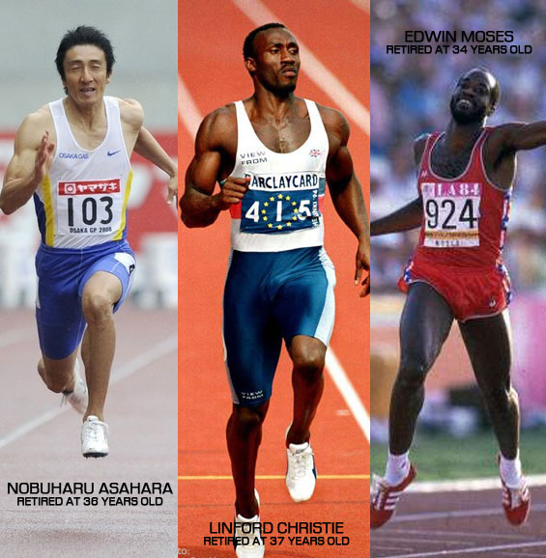Stability**

Stability is dependent upon four mechanical principles

* Position of athletes COM

Centre of Mass

* Athlete’s base of support
* Position of athletes line of gravity
* The mass of the athlete

Line of gravity

Base of support

**[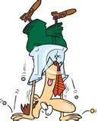](http://www.bing.com/images/search?q=Headstand+Clip+Art#focal=0672d40b9ac7a8df47086fe118dbed50&furl=http://www.chumpysclipart.com/images/illustrations/xsmall2/2055_picture_of_an_upside_down_man_hoping_money_will_fall_from_his_pockets.jpg)[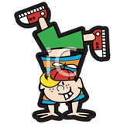](http://www.bing.com/images/search?q=handstand#focal=2cb4ad3195e77a0778b5893f3fcd198f&furl=http://www.clipartguide.com/_named_clipart_images/0511-0809-2216-2818_Little_Boy_Doing_a_Handstand_clipart_image.jpg)Example of stability**

The headstand is easier to hold than the handstand. This is because:

* There are .................................................................. of balance for the headstand
* This creates a .......................................................base of support that is more stable than the 2 points of balance for the handstand
* The centre of mass is ........................................ for the headstand. This makes it more stable than the handstand
* The centre of mass (line of gravity) for the headstand is ......................................... over the base of support

**Take it further**

**Read the ‘May the force be with you’ article in PE review Sept ‘07**

**Exam questions**

1. When hitting a ball in table tennis, an understanding of force is important. Explain how force can be exerted so that the ball:
2. Moves straight
3. Spins [2 marks]
4. Describe how the position of the centre of mass can directly affect the balance of a performer [3 marks]
5. Apply Newton’s Three Laws of Motion to performing a weightlifting exercise

[3 marks]