A-Level Handbook & Transition Summer Work Physics
Year 11 > Year 12
GCSE > AS-Level

Uxbridge High School, Science Department

Name:

Target Grade:

Contents:
Expectations and Learner Agreement p.1
Summer Tasks p.2
Exam Questions p.3-18
Answers p.19-27
Recommended Resources p.28
Final Words p.28

A-Level Expectations

A-Level Physics is MUCH more demanding than GCSE and requires a greater degree of commitment and independent learning. To enable you to cope with the demands of the course and achieve your target grades, it is essential that you fulfil the following expectations.

- Attendance = attainment. Attend all lessons, arrive on time and bring all the necessary books. Do not book appointments during lesson hours.
- Necessary equipment of pens, paper, and your working folders should be brought to EVERY lesson.
- Take responsibility for arriving on time to lessons after break or after a free period.
- No mobile phones in use or in view in the lesson.
- Work to the best of your ability in class and focus on the lesson.
- Listen respectfully to the views of other students.
- Complete all homework and classroom work.
- Read widely in your own time, including reading the complete set texts for each component as soon as possible.
- Attempt all work. If you are unsure of what to do, of course you may ask questions, but there are times when your teacher will want you to work independently without question. You must respect this.
- Take advantage of any extra lessons/revision sessions.
- Keep to deadlines.

Learner Agreement
As a dedicated student of Physics at Uxbridge High School, I promise to meet the expectations above. I understand that not doing so, will result in school sanctions, parent meetings, and most importantly, it will have a negative impact on my attainment.

Signed ______________________________________________

Print name ______________________________________________

Summer Tasks

The difficulty of the material covered at A-Level is MUCH GREATER than that at GCSE. As such, it is VITAL that you begin familiarising yourself with this material over the summer holidays. Completion of the following tasks will ensure that you begin Year 12 in the best way possible, giving yourself the best chance of success.

- Buy the textbook and read through the first chapter on your own.
You begin your A-Level Physics as soon as you arrive back to school after the summer holidays. The first chapter your teacher will cover with you from the AQA A-Level Physics Syllabus (7407), will be;
Chapter 6 – Forces in Equilibrium.
BUY THE TEXTBOOK NOW! Read through Chapter 6 in the AQA A-Level Physics textbook (ISBN-10: 0198351887) on your own and make some notes.

- Answer the exam questions.
Once you’re done reading the chapter, try answering the exam questions (ANSWERS INCLUDED!) in this handbook. It’s fine to not be able to answer them well, but at least you are starting to get into the good habit of self-study. When school then begins in September, you will be so much better equipped to meet the challenges of A-Level.
- Ensure your maths is on par.
There is a greater maths demand in Physics at A-Level than at GCSE.
Make sure any weaknesses in your GCSE Maths are strengthened, and start looking through worked maths examples in your A-Level textbook.

Exam Questions

Chapter 1 – Forces in Equilibrium

Q1. Complete the following table.

Quantity | Vector or  Scalar | S.I. Unit
Displacement | Vector | m
Velocity
Weight
Energy

(Total 3 marks)

Q2. The figure below shows a stationary gymnast suspended by his arms at the end of two ropes.
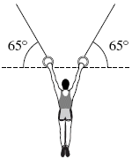
The tension in each rope is 4.1 × 10² N. The angle between each of the ropes and the horizontal is 65°.
Calculate the weight of the gymnast.
Give your answer to an appropriate number of significant figures.
...............................................................................................................................
...............................................................................................................................
...............................................................................................................................
...............................................................................................................................
...............................................................................................................................
weight of gymnast ...................................... N
(Total 3 marks)
Q3. The figure below shows an apparatus used to locate the centre of gravity of a non-uniform metal rod.
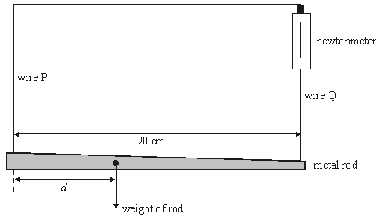
The rod is supported horizontally by two wires, P and Q and is in equilibrium.
(a) State two conditions that must be satisfied for the rod to be in equilibrium.
......................................................................................................................
......................................................................................................................
......................................................................................................................
......................................................................................................................
(2)

(b) Wire Q is attached to a newtonmeter so that the force the wire exerts on the rod can be measured. The reading on the newtonmeter is 2.0 N and the weight of the rod is 5.0 N.
Calculate
(i) the force that wire P exerts on the rod,
.............................................................................................................

(ii) the distance d.
.............................................................................................................
.............................................................................................................
.............................................................................................................
(3)
(Total 5 marks)
Q4. The figure below shows a river which flows from West to East at a constant velocity of
0.50 m s^{–1}. A small motor boat leaves the south bank heading due North at 1.80 m s^{–1}.
Find, by scale drawing or otherwise, the resultant velocity of the boat.
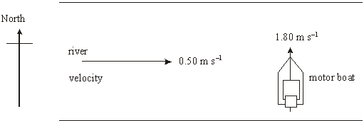

speed ............................
direction .............................
(Total 5 marks)

Q5. Figure 1 shows a skier being pulled by rope up a hill of incline 12° at a steady speed. The total mass of the skier is 85 kg. Two of the forces acting on the skier are already shown.
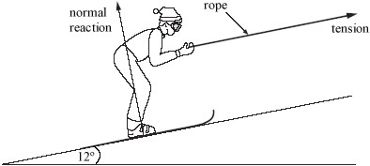
Figure 1
(a) Mark with arrows and label on Figure 1 a further two forces that are acting on the skier.
(2)

(b) Calculate the magnitude of the normal reaction on the skier.
gravitational field strength, g = 9.8 N kg⁻¹

Normal reaction = ................................
(3)

(c) Explain why the resultant force on the skier must be zero.
........................................................................................................................
........................................................................................................................
(1)
(Total 6 marks)

Q6. The diagram shows a 250 kg iron ball being used on a demolition site. The ball is suspended from a cable at point A, and is pulled into the position shown by a rope that is kept horizontal. The tension in the rope is 1200 N.
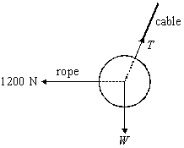
(a) In the position shown the ball is in equilibrium.
(i) What balances the force of the rope on the ball?
.............................................................................................................

(ii) What balances the weight of the ball?
.............................................................................................................
(2)

(b) Determine
(i) the magnitude of the vertical component of the tension in the cable,
.............................................................................................................

(ii) the magnitude of the horizontal component of the tension in the cable,
.............................................................................................................
.............................................................................................................

(iii) the magnitude of the tension in the cable,
.............................................................................................................
.............................................................................................................
.............................................................................................................
.............................................................................................................
.............................................................................................................
.............................................................................................................

(iv) the angle the cable makes to the vertical.
.............................................................................................................
.............................................................................................................
(6)
(Total 8 marks)

Q7. Horses were once used to power machinery in factories, mines and mills. The figure below shows two horses attached to a beam which turns a wheel. This wheel drives machinery.
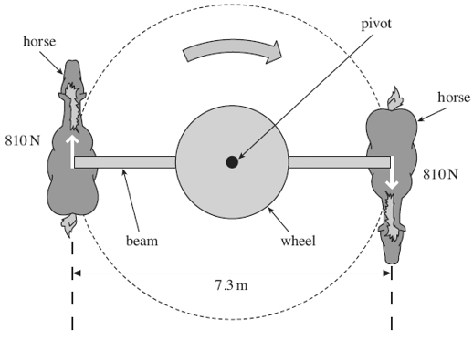
(a) Each horse exerts a force of 810 N and the length of the beam is 7.3 m.
(i) Define the moment of a couple.
.............................................................................................................
.............................................................................................................
.............................................................................................................
(2)

(ii) Calculate the moment of the couple exerted by the horses, stating an appropriate unit.

answer = ......................................
(2)

(b) The horses move at a constant speed of 0.91ms^{–1}. Calculate the combined power output of the two horses. Give your answer to an appropriate number of significant figures.

answer = ..................................... W
(3)

(c) During the Industrial Revolution in the 19th Century, James Watt became well known for developing and improving steam engines to replace horses. He defined the unit of power called ‘horsepower’ by studying a system similar to the one shown in the figure above.
Suggest why Watt decided to use horsepower as a unit of power.
......................................................................................................................
......................................................................................................................
......................................................................................................................
(1)
(Total 8 marks)

Q8.The diagram shows a uniform bar, AB, which is 1.6 m long and freely pivoted to a wall at B. The bar is maintained horizontal and in equilibrium by an angled string which passes over a pulley and which carries a mass of 2.0 kg at its free end.

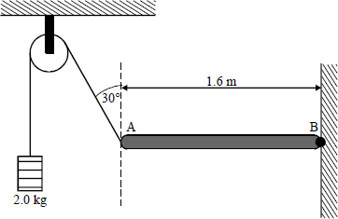

(a) The pulley is positioned as shown in the diagram, with the string at 30° to the vertical.
(i) Calculate the tension, T, in the string.
...............................................................................................................
...............................................................................................................
(ii) Show that the mass of the bar is approximately 3.5 kg.
...............................................................................................................
...............................................................................................................
...............................................................................................................
...............................................................................................................
...............................................................................................................
(4)

(b) A mass, M, is attached to the bar at a point 0.40 m from A. The pulley is moved horizontally to change the angle made by the string to the vertical, and to maintain the rod horizontal and in equilibrium.
Determine the largest value of the mass, M, for which this equilibrium can be maintained.
........................................................................................................................
........................................................................................................................
........................................................................................................................
(4)
(Total 8 marks)

Q9. A sprinter is shown before a race, stationary in the ‘set’ position, as shown in the figure below. Force F is the resultant force on the sprinter’s finger tips. The reaction force, Y, on her forward foot is 180 N and her weight, W, is 520 N. X is the vertical reaction force on her back foot.
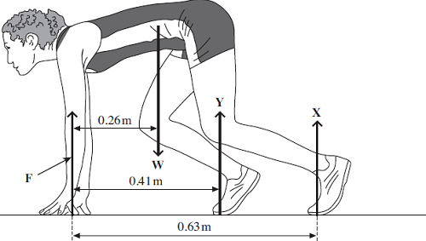
(a) (i) Calculate the moment of the sprinter’s weight, W, about her finger tips.
Give an appropriate unit.

answer = ..................................... unit .....................................
(2)

(ii) By taking moments about her finger tips, calculate the force on her back foot,marked X.

answer = ..................................N
(3)

(iii) Calculate the force F.

answer = ..................................N
(1)

(b) The sprinter starts running and reaches a horizontal velocity of 9.3 ms^{–1} in a distance
of 35 m.
(i) Calculate her average acceleration over this distance.

answer = .............................m s^{–2}
(2)

(ii) Calculate the resultant force necessary to produce this acceleration.

answer = ..................................N
(2)
(Total 10 marks)

Q10.A heavy sledge is pulled across snowfields. The diagram shows the direction of the force F exerted on the sledge. Once the sledge is moving, the average horizontal force needed to keep it moving at a steady speed over level ground is 300 N.
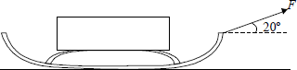

(a) Calculate the force F needed to produce a horizontal component of 300 N on the sledge.
........................................................................................................................
........................................................................................................................
(1)

(b) (i) Explain why the work done in pulling the sledge cannot be calculated by multiplying F by the distance the sledge is pulled.
...............................................................................................................
...............................................................................................................
...............................................................................................................

(ii) Calculate the work done in pulling the sledge a distance of 8.0 km over level ground.
...............................................................................................................
...............................................................................................................

(iii) Calculate the average power used to pull the sledge 8.0 km in 5.0 hours.
...............................................................................................................
...............................................................................................................
...............................................................................................................
(6)

(c) The same average power is maintained when pulling the sledge uphill. Explain in terms of energy transformations why it would take longer than 5.0 hours to cover 8.0 km uphill.
........................................................................................................................
........................................................................................................................
........................................................................................................................
........................................................................................................................
........................................................................................................................
(3)
(Total 10 marks)

Q11. The figure below shows a motorcycle and rider. The motorcycle is in contact with the road at A and B.
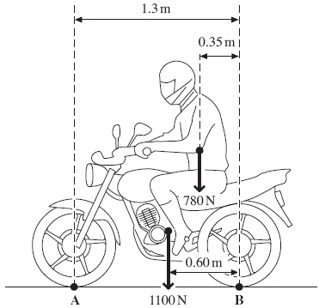
The motorcycle has a weight of 1100 N and the rider’s weight is 780 N.
(a) State the Principle of Moments.
......................................................................................................................
......................................................................................................................
......................................................................................................................
(2)

(b) Calculate the moment of the rider’s weight about B. Give an appropriate unit.

answer = ......................................
(2)

(c) By taking the moments about B, calculate the vertical force that the road exerts on the front tyre at A. State your answer to an appropriate number of significant figures.

answer = ................................. N
(4)

(d) Calculate the vertical force that the road exerts on the rear tyre at B.

answer = ................................. N
(1)

(e) The maximum power of the motorcycle is 7.5 kW and it has a maximum speed of
26 m s^{–1}, when travelling on a level road.
Calculate the total horizontal resistive force for this speed.

answer = ................................. N
(2)
(Total 11 marks)

Q12.(a) State the principle of moments.
........................................................................................................................
........................................................................................................................
........................................................................................................................
........................................................................................................................
(3)

(b) The diagram below shows a bicycle brake lever that has been pulled with a 35 N force to apply the brake.
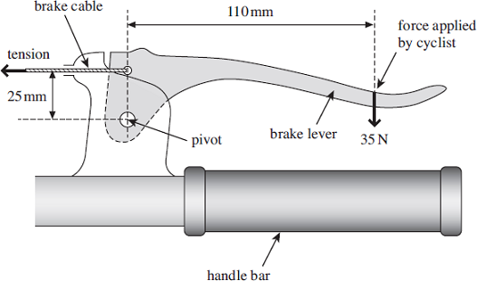
(i) Calculate the moment of the force applied by the cyclist about the pivot. State an appropriate unit.

moment = ............................unit .....................................
(3)

(ii) Calculate the tension in the brake cable. Assume the weight of the lever is negligible.

tension = ................................. N
(3)
(c) In order to maintain a constant velocity of 15 ms^{–1} downhill, the cyclist applies the brake. The power developed by the braking force is 2.8 kW.
Calculate the total average frictional force between the brake blocks and the wheel rim.

frictional force = ................................. N
(2)
(Total 11 marks)

Answers

M1. 1 mark each correct row
B3
[3]

M2. resolving one force correctly –410 sin (65) seen
C1
doubling the force (eg 743.1 or 346.5 seen)
C1
2 sf answer (740 (N) or 370 (N))
A1
[3]

M3. (a) resultant force zero (1)
resultant torque about any point zero (1)
2

(b) (i) force due to wire P = 5.0 - 2.0 = 3.0 N (1)
(ii) (moments give) 5.0 × d = 2.0 × 0.90 (1)
d= 0.36 m (1)
3
[5]

M4.
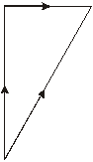

scale clearly stated
B1
correct triangle drawn
B1
all arrows shown
B1
1.8 m s⁻¹ < speed 2.0 m s⁻¹
B1
direction = N (16 +– 2)° E
B1
or unambiguous alternative
or use of c² = a² + b² or use of tanθ = a/b
C1
v² = 1.80² + 0.50²
C1
θ = tan⁻¹(0.50/1.80) or other valid angle
C1
speed = 1.87 ms⁻¹
A1
direction N 15.5° E
or unambiguous alternative
A1
[5]
M5. (a) air resistance (drag) /friction with correct arrow
from or towards body
B1
weight (force of gravity/ 838 N) not gravity with correct arrow
from somewhere on skier or ski -vertically downwards
B1

(b) clear attempt to resolve weight (not mass) or equate
normal reaction with component of weight (condone sin θ)
C1
Mgcos θ or substituted values
C1
815 (or 810 or 820) N
A1
3

(c) constant speed/velocity or zero acceleration
B1
1
[6]

M6. (a) (i) horizontal component of the tension in the cable (1)
(ii) vertical component of the tension in the cable (1)
2

(b) (i) T_{vert} = 250 × 9.81 = 2500 N (1) (2452 N)
(ii) T_{horiz} = 1200 N
(iii) T² = (1200)² + (2500)² (1)
T = (1.44 × 10⁶ + 6.25 × 10⁶)^{1/2} = 2800 N (1) (2773 N)
(if use of T_{vert} = 2450 N then T = 2730 N)
(allow C.E. for values from (b) (i) and (b)(ii))
(iv) tan θ = 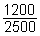 (1)

θ = 26° (1)
(allow C.E. for values from (b) (i) and (b)(ii))
6
[8]

M7. (a) (i) (one) force × distance between the forces
(one) force × perpendicular distance between
the lines of action or (one) force × perpendicular
distance between the (two) forces
2
(ii) (810 × 7.3 =) 5900 (5913) (or alternative correct method)
Nm
2

(b) P = Fv = (2 ×) 810 × 0.91
(1620 × 0.91) = 1500 (1474 W)
any number to 2 sf
3

(c) to enable comparison between steam and horses
or mill owners/engineers etc needed to know which steam
engine would be suitable
or would easily be able to compare the cost/time saved
or good marketing ploy for steam engines
or easily understood (by industrialists or the public)
or other suitable valid reason
1
[8]

M8.(a) (i) T = 2.0 × 9.8 = 19.6 N (1)

(ii) moments about B
19.6cos30° × 1.6 (1) = mg × 0.8 (1)
mass = 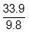 (1) (= 3.46 kg)
(4)

(b) maximum support when wire vertical (1)
moments about B
2.0 × 9.8 × 1.6 = (M × 9.8 × 1 .2) (1) + 33.9 × 0.8 (1)
∴ M = 0.36 kg (1)
[n.b. 0.33 kg if 3.5 used]
(4)
[8]

M9. (a) (i) (moment = 520 x 0.26) = 140 (135.2)
Nm
2

(ii) 180 x 0.41 and 0.63 X seen
135.2 = 180 x 0.41 + 0.63 X ecf from (a)(i)
(X = (135.2 – 73.8) / 0.63)
= 97 (N) (97.46) allow 105 from use of 140Nm ecf from (a)(i)
3

(iii) (520 – (180 + 97.46))
= 240 (242.5 N) ecf (or from correct moments calculation)
1

(b) (i) (v² = u² + 2as)
9.3² = 2 x a x 35 OR 9.3²=70a OR a = v²/2s
OR 9.3²/70
OR correct alternative approach
1.2 (1.2356) (m s^{–2})
2

(ii) (m = W/g) = 520/9.81 (= 53.0) (kg)
F = ma = 53 × 3bi (1.2356) = 65 (N) (65.49)
accept use of 1.2 giving 64(63.6) , allow 53 x 124 = 65.7
2
[10]

M10.(a) F cos 20 = 300 gives F = 319 N (1)
(1)

(b) (i) work done = force × distance moved in direction of force (1)
F is not in the direction of motion (1)

(ii) work done = force × distance = 300 × 8000 = 2.4 × 10⁶ J

(iii) 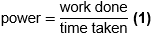
= 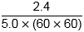 × 10⁶ (1) (allow e.c.f. for work done in (ii))
= 133 W (1) (allow e.c.f. for incorrect time conversion)
(6)

(c) on the level, work is done only against friction (1)
uphill, more work must be done to increase in potential energy (1)
sensible conclusion drawn
(e.g. increased work at constant power requires longer time) (1)
(3)
[10]

M11. (a) (sum of) clockwise moments (about a point) =(sum of) anticlockwise
moments (1)
(for a system) in equilibrium (1)
accept balanced not stationary
2
(b) (780 × 0.35 =) 270 (Nm) (1) (273)
Nm (1) or newton metre(s) accept Newton metre(s)
(not J, nm or nM, Nms, etc)
2

(c) (b) + (1100 × 0.60) (1)
(=) F_{A} × 1.3 (1) (F_{A} = 660 + 273/1.3 gets both marks)
(= 933/1.3) = 720 (N) (1) (717.7 or 715 for use of 930)
ecf (b)
2 sf only (1)
independent mark
4

(d) (780 + 1100 – (c)) = 1200 (1) (1162 N)
ecf (c)
1
(e) 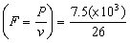(1)
must be arranged in this form
= 290 (N) (1) (288.46)
2
[11]

M12.(a) (sum of ) clockwise moment(s) = (sum of ) anticlockwise moment(s)
sum of clockwise moment s = sum of anticlockwise moment s (about any given point)
(for a system in) equilibrium allow 'balanced'
third mark depends upon the first
Don’t allow references to ‘forces’ being balanced.
Donߢt allow ‘stationary’.
Allow ‘total’, etc instead of sum
Ignore definitions of moment
3

(b) (i) 35 × 110 (×10⁻³)
(= 3.85) = 3.9 ( or 3.8)
allow 4 or 3.90 but not 4.0
(3.9) Nm / allow (3850, 3900) Nmm don't allow nm, NM
unit must match answer
3

(ii) 3.85 = T × 25 (×10⁻³) ecf from (bi)
Correct answer with no working gets 2 out of three.
T = 3.85 / 25 (×10⁻³ ) = 0.150 (×10³ ) ecf
Allow 156 (160) N from rounding error
= 150 (154 N)
3

(c) (P = Fv , F = P / v )
= 2.8(× 10³) / 15
= 190 (186.7 N)
2
[11]

Recommended Resources

The following is a list of resources that you will find helpful during your summer work. This list is by no means exhaustive. Please feel free to share other resources with each other.

1. Kerboodle AQA Physics A-Level Textbook - www.kerboodle.com
2. CGP revision guides.

3. A-Level Physics Online Youtube channel - https://www.youtube.com/channel/UCZzatyx-xC-Dl_VVUVHYDYw

Final Words
Year 12 AS-Level Physics is not simply a progression of GCSE. It is a step-up. You must step-up your attitude and work ethic.

A-Level Physics is one of the most challenging A-Levels anyone can undertake. As such, A-Level Physics is one of the most rewarding
A-Levels anyone can undertake.

If you are carrying on your Physics studies to A-Level, it is because your teachers feel you are able to rise to and meet the challenges of A-Level Physics. If you are carrying on your studies of Physics to A-Level, you have been given the opportunity to achieve something you will cherish for a life-time to come.

Work hard.
Look forward to all the amazing things you have yet to learn about.

Look forward to achieving something truly remarkable.
Enjoy your summer holidays!

