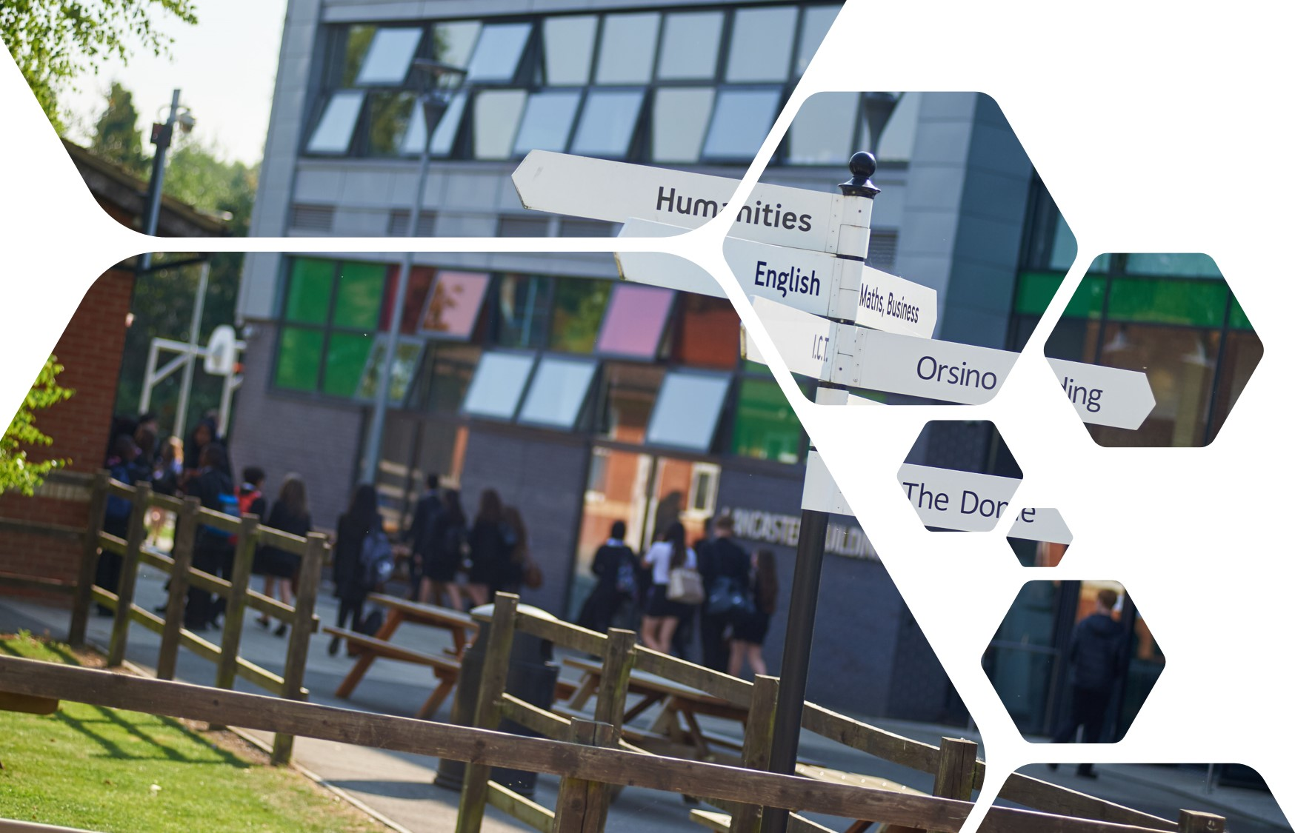

Sixth Form Transition Pack
DIGITAL MUSIC PRODUCTION

cOURSE INTRODUCTION

More than 90% of all the music we ever hear comes through a speaker, played back via a digitally-based device. The importance of music in our economy and way of life has never been greater; the list of purposes for music and sound in the fields of entertainment, business, healthcare, lifestyle, sport and fitness activities is endless.

Since 1981, the world of music and the music industry has moved almost exclusively to digital means to create, capture, process and produce sounds and music. The incredible power and capability of today’s computers and devices offers musicians unprecedented possibilities and potential. But at the heart of it all, you need to be a musician to compose and create end results that strike fire into hearts, and draw tears from eyes.

Digital Music Production is a new and contemporary course that has been designed by current industry professionals, to develop musically-talented young people with an aptitude and enthusiasm for technology into ‘digital musicians’, ready to create the next generation of exciting, engaging and successful sounds and styles.

Students will study five units, covering the following:

Music and Sound for Media

DAW Production

Remixing and Reworking

Mixing and Mastering Techniques

Commercial Music Production

This qualification enables students to acquire substantial practical musical skills, as performer, composer, listener and producer. It has strong links to Computing, Maths, Media, Psychology and Business.
Britain leads the world in digital music innovation. Music exports were worth £2.5 billion in 2021 and there remains huge growth potential in the UK music industry, with the value of the global recorded music market set to double by 2030 to around £30 billion. With both live and recorded sectors in growth, it’s a great time to be taking a step into the Music Industry!

Essential summer reading
Paul White – Creative Recording parts 1 and 2
How Music Works - David Byrne
Godric Wilkie – The Studio Musician’s Jargonbuster
Dennis DeSantis - Creative Strategies for Electronic Music Producers
Sound on Sound Magazine – Subscribe, buy and/or online https://www.soundonsound.com/
Computer Music Magazine – Available in good news outlets or online

Essential summer viewing/listening
Chris Denogean explains a 4-Mic set up:
https://www.youtube.com/watch?v=ghE1WagzEnw
Manu Nirvana explains how Dynamic and Capacitor Mic’s work: https://www.youtube.com/watch?v=eReuTkCISNc
Joe Chiccareli explains the positives and negatives of digital recording vs analogue tape
https://www.youtube.com/watch?v=7jYd0W9QKP4
Film-maker ‘IQ video’ explains many digital audio terms in the context of sound for film:
https://www.youtube.com/watch?v=S9cP1WHL0Zo

Task to be completed
Introduction
As a digital musician, you will need to develop the skill to hear the musical possibilities in any sounds that you hear. You also need to be able to create music that meets the needs of a real purpose, within a short space of preparation time.

Learning outcomes
- Understand the importance of listening with respect to the brief when capturing sounds
- Understand how to ensure that sound levels are optimal when recording, applying the key terms Signal, Noise, Gain, Bit Rate, Sample Rate, Peak
- Use a recognized music form to create structure and integrity in the musical end-result

Task 1: Analyse the Brief
Your brief is to create some music that is at least 3 minutes long, for use as background music during the ceremony to open the UK’s first Electrical Energy Sand Storage Battery facility. This is a new technology, you can read about it here: Sand Battery Info LINK
And also here: Sand Battery Further context
The students are interested in a wide range of courses, that cover issues such as the environment and climate change, scientific discovery and experimentation, sport and fitness, theatre art forms and the patterns and rules of mathematics. Your music has to somehow project a sense of these areas of interest.

If your piece is successful, it will be used as part of the Sixth Form Options event in the coming year ahead.

You should analyse the brief and decide on the following key elements of your music:
- Tempo
- Dynamic range
- Mood
- Harmony and Tonality – major, minor, alternative chords, or a mix?
- Structure – choose Binary AABB, Ternary ABA or Rondo form ABACADA

Task 2: Prepare a mobile digital recording device for use
- You must prepare a device to record sounds from different natural and man-made environments. A smartphone would be ideal for this. There are ways in which you can enhance the ability of a smartphone to record sound with it’s tiny microphone: Can you research to find out how you might use some of them?
- Download and install one of the free or cheaply available apps to record and edit sound on a smartphone. For iPhones, Voice Record PRO is highly regarded, as is the iOS version of Garageand. For android, Music Maker Jam is popular.

Task 3: Record a selection of at least 7 different environmental sounds
You should record at least 7 different environmental sounds, which can be from nature or man-made situations. While doing this, try to feel and hear what you want your end-product to sound like and how you can project the themes (ref. Task 1 paragraph 2).
When setting up to record, use your Smartphone App if possible, to adjust the GAIN settings, so that the recording level is as strong as possible without distorting (going into the red).
Walk around within the environment, get down low, stand up (safely) higher and record exactly where all the sounds you hear are balanced, clear and satisfying.

Task 4: Download your recorded sounds onto a Mac or PC
Export your sounds from your phone onto a Mac or PC.
TIP: Saving them to a cloud-based server might take a long time, you will find that having the audio files stored locally while working on them is less glitchy.

Task 5: Arrange and musically Combine your sounds to create your final piece: The Options
Once you have exported your sounds from your phone onto a Mac or PC, download the free software ‘Audacity’ https://www.audacityteam.org/
Use this software to arrange, combine, extend and experiment with your sounds. You should aim to structure the musical result so that it reflects the choices you made about the Task 1.

Challenge: If you have the budget or you already have a DAW app on your PC or MAC, you can export the whole 7mins+ mix from Audacity into this and then add more sounds, loops, effects and editing adjustments, to perfect the mix and enhance the appeal to the target audience of 16-17 year olds further.
OPTIONAL AUDIO SOFTWARE FOR APPLE MACS
Garageband (free with all macs) Logic X Pro (£199 – expensive but highly recommended)
OPTIONAL AUDIO SOFTWARE FOR PC’s
TRACKTION WAVEFORM: https://www.tracktion.com/products/waveform-free
ABLETON LIVE Lite https://www.ableton.com/en/products/live-lite/
MuLab Light (Free, but quite restricted) https://www.mutools.com/mulab-downloads.html

Task 6: Write a report
Explain and evaluate how you chose, recorded, arranged and finally produced the music ‘The Options’. Refer to your initial choices. How successful were you? How could you still improve the end-product? [700 words max]

DIGITAL MUSIC PRODUCTION

Transition work for continuing Y12 into Y13 students
Below you will find some essential vocabulary that you have been learning along the way during Year 12. The vocab features relatable adjectives that are assigned to specific frequency bands.

TASK 1: Combine what are in your view, the most essential terms eg. Honk, Sibilance, Crispness... into your own Chart, title of the chart is: Musical Adjectives I Use
You should aim to have at least 20 terms in your chart and use colour. Tip: Use Landscape
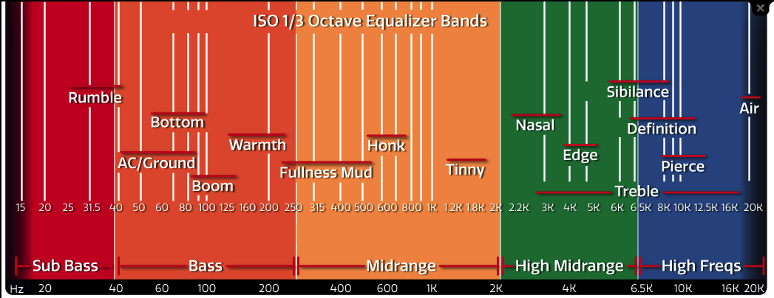
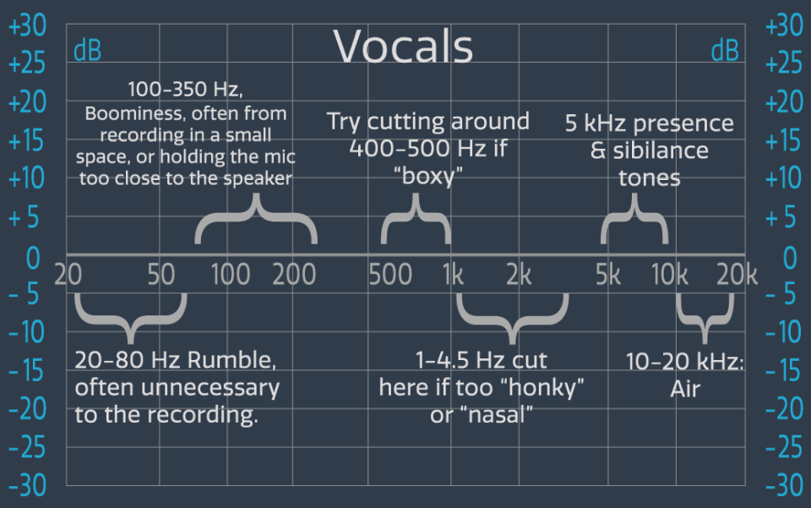
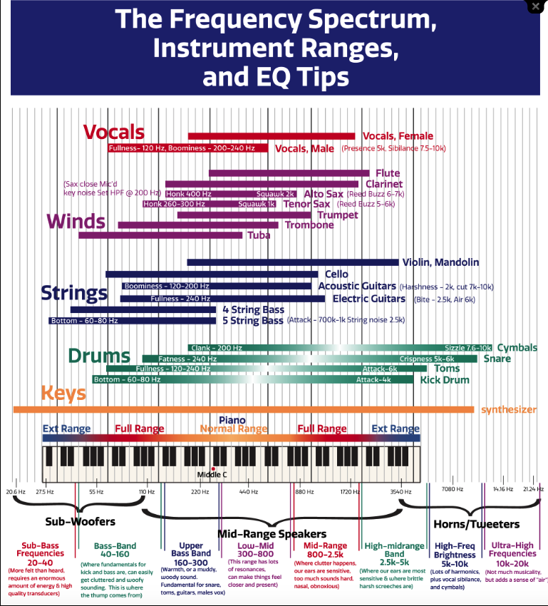

Scroll Down
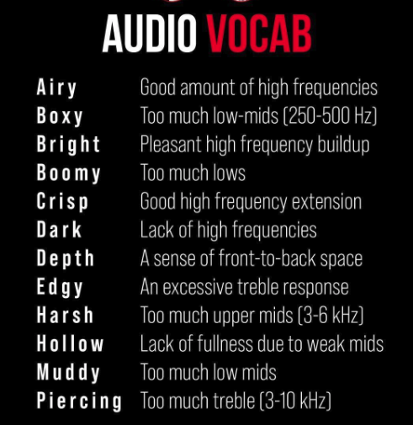

Scroll Down

TASK 2:
Listen to any 3 recordings from the website on the link below, and give a critical review in MS Word of the mix or each song, using your ‘Musical Adjectives I Use’ chart of vocab. The completed 3 critical reviews should be a minimum of 1000 words, and should ideally include charts, pictures that are referred to and annotated with arrows/labels etc.

You must include comments on these:
- The quality of the source sounds (singer’s voice, quality of drums used, etc.)
- How successful the microphone choice and the placement of the mic’s has been
- How eq has been used to refine and perfect the sound
- Is the result effective? Do the sounds ‘glue together’ and achieve ‘fullness’, ‘depth’ and ‘width’? Does the mix and balance suit the style?
- What changes do you think could be included to improve the mix? (Remember to use your ‘Musical Adjectives I Use’ chart.
https://www.telefunken-elektroakustik.com/livefromthelab_season/4/#download
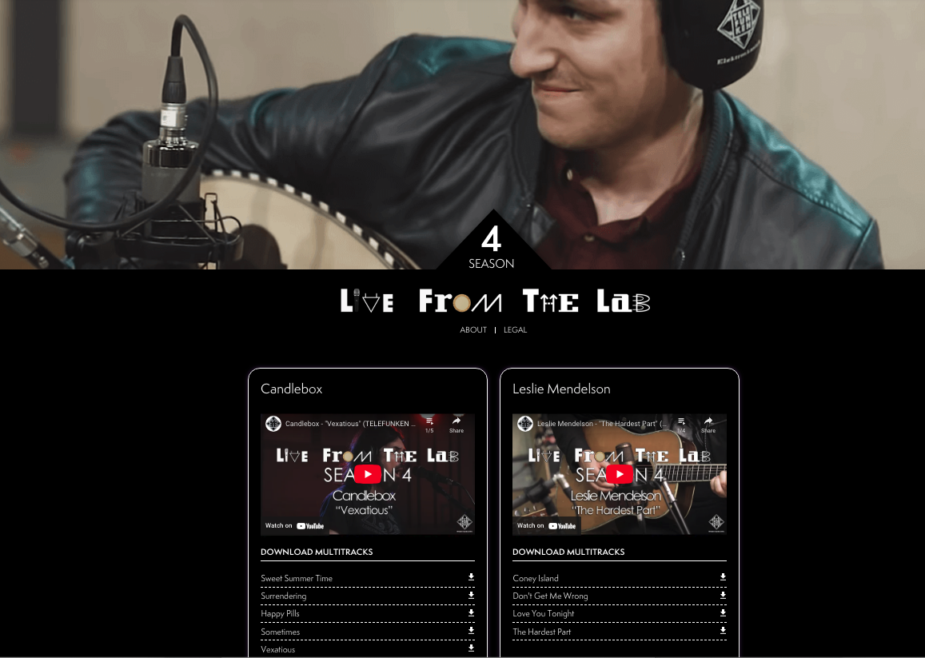

Handing-in and Deadline info:
Bring your completed critical reviews to the first lesson in September for Music Tech, or email to: jdawson@uhs.org.uk

