A-Level Handbook & Transition Summer Work Physics
Year 12 > Year 13
AS > A-Level

Uxbridge High School, Science Department

Name:

Target Grade:

Contents:
Expectations and Learner Agreement p.1
Summer Tasks p.2
Chapter 17 Exam Questions p.3-15
Chapter 26 Exam Questions p.16-32
Recommended Resources p.33
Final Words p.33

A-Level Expectations

The second year of your A-Level course is more demanding than the first and requires a greater degree of commitment and independent learning. To enable you to cope with the demands of the course and achieve your target grades, it is essential that you fulfil the following expectations.

- Attendance = attainment. Attend all lessons, arrive on time and bring all the necessary books. Do not book appointments during lesson hours.
- Necessary equipment of pens, paper, and your working folders should be brought to EVERY lesson.
- Take responsibility for arriving on time to lessons after break or after a free period.
- No mobile phones in use or in view in the lesson.
- Work to the best of your ability in class and focus on the lesson.
- Listen respectfully to the views of other students.
- Complete all homework and classroom work.
- Read widely in your own time, including reading the complete set texts for each component as soon as possible
- Attempt all work. If you are unsure of what to do, of course you may ask questions, but there are times when your teacher will want you to work independently without question. You must respect this.
- Take advantage of any extra lessons/revision sessions.
- Keep to deadlines.

Learner Agreement
As a dedicated student of Physics at Uxbridge High School, I promise to meet the expectations above. I understand that not doing so, will result in school sanctions, parent meetings, and most importantly, it will have a negative impact on my attainment.

Signed ______________________________________________

Print name ______________________________________________

Summer Tasks

There is much work to cover in Year 13 as part of your Physics A-Level. As such, it is VITAL that you begin covering this material over the summer holidays. Completion of the following tasks will ensure that you begin Year 13 in the best way possible, giving yourself the best chance of success.

- Finish off work begun.
You began your A-Level Physics in the final weeks of the Year 12 summer term. You must now ensure you finish off the following chapters;
Chapter 17 – Motion in a Circle, Chapter 26 – Radioactivity.
This will involve reading through the chapters in the Kerboodle A-Level AQA Physics textbook, and then answering the exam questions in this handbook. Markschemes have been included. It is your responsibility to ensure you understand these chapters thoroughly.

- Begin on work to come.
Read through the first two chapters that will be covered upon your return to Year 13 in the Autumn Term; Chapter 18 – Simple Harmonic Motion, Chapter 19 – Thermal Physics.
You are to make notes on these chapters from the Kerboodle A-Level AQA Physics textbook, and answer the summary questions.

- Ensure your maths is on par.
There is a greater maths demand in the Physics A-Level.
In the Kerboodle A-Level AQA Physics textbook, read through pages 529-543. Ensure you understand the worked examples.

Exam Question & Markschemes

Chapter 17 – Motion in a Circle
Q1. Figure 1 shows an amusement park ride in which two riders, A and B are positioned in cages at opposite ends of a supporting arm. The arm is rotated in a circle about a horizontal axis.
Each rider has a mass of 60.0 kg.
Figure 2 is an enlarged diagram of the lower cage A at the instant shown in Figure 1.

Figure 1 | Figure 2
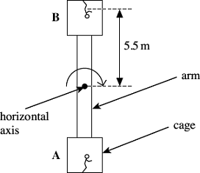 |  | 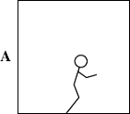

(a) (i) Mark on Figure 2 labelled arrows to show the forces acting on rider A at the instant shown.
(2)
(ii) Explain how rider B can remain in contact with the floor when upside down.
...............................................................................................................
...............................................................................................................
...............................................................................................................
...............................................................................................................
...............................................................................................................
(2)
(b) The period of rotation of the ride is 3.9 s.
(i) Calculate the angular velocity of the ride.
Give an appropriate unit for angular velocity.

angular velocity .......................................... unit ..........................
(2)
(ii) The centre of mass of each rider is 5.5 m from the axis of rotation.
Calculate the centripetal force acting on each rider.

centripetal force ......................................................... N
(1)

(iii) Calculate the normal reactions acting on riders A and B in the positions shown in Figure 1.

normal reaction on A ......................................................... N
normal reaction on B ......................................................... N
(3)
(Total 10 marks)

Q2. The figure below shows a car on a rollercoaster track. The car is initially at rest at A and is lifted to the highest point of the track, B, 35 m above A.
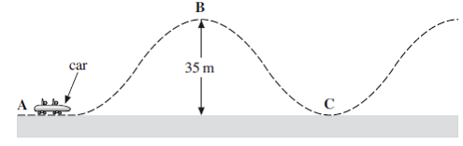
The car with its passengers has a total mass of 550 kg. It takes 25 s to lift the car from A to B. It then starts off with negligible velocity and moves unpowered along the track.
(a) Calculate the power used in lifting the car and its passengers from A to B.
Include an appropriate unit in your answer.
......................................................................................................................
......................................................................................................................
......................................................................................................................
......................................................................................................................
power.................................unit................................
(3)

(b) The speed reached by the car at C, the bottom of the first dip, is 22 ms^{–1}. The length of the track from B to the bottom of the first dip C is 63 m.
Calculate the average resistive force acting on the car during the descent.
Give your answer to a number of significant figures consistent with the data.
......................................................................................................................
......................................................................................................................
......................................................................................................................
......................................................................................................................
......................................................................................................................
......................................................................................................................
resistive force .............................................. N
(4)

(c) Explain why the resistive force is unlikely to remain constant as the car descends
from B to C.
......................................................................................................................
......................................................................................................................
......................................................................................................................
......................................................................................................................
......................................................................................................................
......................................................................................................................
(3)
(d) At C, a passenger of mass 55 kg experiences an upward reaction force of 2160 N when the speed is 22 ms^{–1}.
Calculate the radius of curvature of the track at C. Assume that the track is a circular arc at this point.
......................................................................................................................
......................................................................................................................
......................................................................................................................
......................................................................................................................
......................................................................................................................
......................................................................................................................
radius of curvature of the track ..................................... m
(3)
(Total 13 marks)

Q3. The figure below shows a schematic diagram of a swing carousel, or roundabout. The diagram shows two of the chairs in which passengers can ride. The chairs hang vertically when the ride is not moving and they move outwards when the ride rotates.
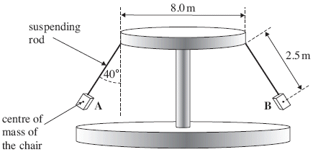
The figure above shows the position of the chairs when the frequency of rotation is a maximum.
The dimensions are shown on the diagram.
When the ride is operating
• the chairs, each of mass 6.5 kg, move in a horizontal circle
• the maximum angular speed is 1.21 rad s^{–1}
• the suspending rods are inclined at an angle of 40° to the vertical.
Ignore the effects of air resistance when answering the following questions.
(a) (i) Show on the figure above the direction of the resultant force acting on chair A.
(1)
(ii) Show and label on the figure above, the actual forces that are acting on chair B.
(2)
(iii) Calculate the magnitude of the resultant force acting on each chair when the ride is rotating at an angular speed of 1.21 rad s^{–1} with no passengers in the chairs.
.............................................................................................................
.............................................................................................................
.............................................................................................................
.............................................................................................................
.............................................................................................................
.............................................................................................................
resultant force .......................................................... N
(3)
(b) Calculate the maximum frequency of rotation of the ride in revolutions per minute.
......................................................................................................................
......................................................................................................................
......................................................................................................................
......................................................................................................................
......................................................................................................................
......................................................................................................................
......................................................................................................................
......................................................................................................................
frequency of rotation ..................................... revolutions per minute
(3)

(c) (i) The ride takes 25 s to accelerate from rest to the maximum angular speed of 1.21 rad s^{–1}.
Assume that the acceleration is uniform.
Calculate the angle, in radian, through which the ride turns before reaching the maximum angular speed.
.............................................................................................................
.............................................................................................................
.............................................................................................................
.............................................................................................................
.............................................................................................................
angle .............................................. radian
(3)

(Total 12 marks)

Q4. The diagram below shows one type of playground roundabout. It consists of a rigid, hollow, metal ring supported by eight ropes arranged symmetrically around the ring. Two of the ropes are shown. The ring is of average radius 1.26 m and has a mass of 27.0 kg. The vertical distance from the ring to the hub where the ropes are attached is 3.60 m.
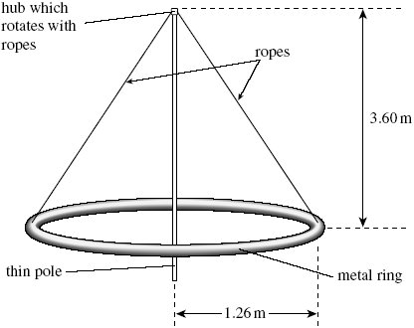

(a) (i) The metal ring is uniform and its weight is distributed evenly amongst the eight ropes.
Calculate the tension in one of the ropes when the roundabout is stationary.
.............................................................................................................
.............................................................................................................
.............................................................................................................
.............................................................................................................
.............................................................................................................
tension .............................. N
(4)

(ii) The roundabout is set in motion. The metal ring freely rotates at a steady rate in a horizontal plane about the thin pole.
State and explain whether the tension in the ropes changes.
.............................................................................................................
.............................................................................................................
.............................................................................................................
.............................................................................................................
(2)

(b) Two children, each of mass 22 kg, sit facing each other on the ring. The roundabout is rotated about the thin pole with a period of 6.4 s. The children do not slip.
Calculate the horizontal force acting on each child.
......................................................................................................................
......................................................................................................................
......................................................................................................................
......................................................................................................................
......................................................................................................................
......................................................................................................................
force ....................... N
(3)

(c) The children turn around and now sit with their legs on the outside of the ring without holding a rope.
Explain why they are likely to slip off the roundabout when it is rotating quickly.
......................................................................................................................
......................................................................................................................
......................................................................................................................
......................................................................................................................
......................................................................................................................
(2)

(Total 11 marks)

M1. (a) (i) reaction and weight labelled
B1
sensible positions and directions
B1
2

(ii) mention of reaction contributing (‘providing’) centripetal force
B1
providing rider moves fast enough weight will not exceed the
required centripetal force
B1
2
(b) (i) 1.6(1)
B1
rad s^{–1}
B1
2

(ii) 840 – 860 (N)
B1
1

(iii) for A R – mg – centripetal force or
C1
for B mg + R = centripetal force
for A 1400 – 1500 (N)
A1
for B 240 – 270 (N)
A1
3

[10]
M2. (a) attempt to use power = mgh/t or P = Fv and v = s/t
C1
7546/7550/7600
A1
W (allow J s^{–1} and condone N ms^{–1})
B1
3

(b) loss of GPE = 550 × 9.81 × 35 = 189 kJ
C1
gain in KE = 0.5 × 550 × 22² = 133 kJ
C1
resistance force = their difference/63 (890 N if correct)
A1
answer to 2 sf (allow if answer is from working even
if incorrect)
B1
4

(c) air resistance varies/increases
B1
frictional force varies/increases
B1
further detail: air resistance increases with speed/v
or normal reaction force varies with angle of the slope
B1
3

(d) use of F = mv²/r
C1
arrives at r = 12 m (ignoring the weight)
C1
16.4 m
A1
3
[13]

M3. (a) (i) force shown horizontal
B1
1

(ii) arrow labelled ‘weight’, ‘W’ or ‘mg’ (not gravity)
B1
arrow on rod labelled ‘tension’ (allow T)
B1
2

(iii) F = mrω² (attempt using) or mg = Tcos 40
or T = 83.2 N
or F = mg tan 40
C1
r = 4.0 + 2.5 sin 40 or 5.61 m seen or
F = their T sin 40 (allow 8.0 + 2.5 sin 40)
C1
53.4 N (allow 2 for 38 N) or 53.5 N
A1
3

(b) angular speed ω = 2πf
B1
revs per second = 0.193
B1
angular speed = 11.6
B1
3
(c) (i) θ = ½ ωt (average angular speed × time)
or use of
C1
½ × 1.21 × 25 or acceleration a = 1.21/25
C1
15.1 (radian)
A1
3

[12]

M4. (a) (i) calculation of angle from tanθ
C1
θ = 19.3°/70.7°
C1
recognition that Tcos θ = mg/8 = 265/8
or sine equivalent
C1
35.1 (N)
A1
4

(ii) centripetal force needed
B1
(horizontal component and therefore) tension increases
B1
2

(b) ω = 0.98 (rad s^{–1}) or v = 1.24 (m s^{–1})
C1
use of mω²r or v²/r – ie candidates values substituted
C1
26.7 (N) not 27.2 (ω not squared)
A1
3

(c) need for centripetal force
B1
friction insufficient/nothing to provide centripetal force
B1
2

[11]

Chapter 26 – Radioactivity
Q1.The diagram shows the path of an α particle deflected by the nucleus of an atom. Point P on the path is the point of closest approach of the α particle to the nucleus.
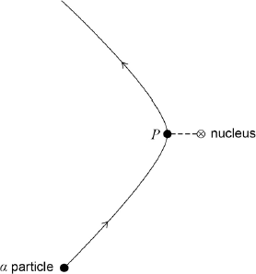
Which of the following statements about the α particle on this path is correct?

 | A | Its acceleration is zero at P.
 | B | Its kinetic energy is greatest at P.
 | C | Its potential energy is least at P.
 | D | Its speed is least at P.

(Total 1 mark)

Q2.The actinium series of radioactive decays starts with an isotope of uranium, nucleon (mass) number 235, proton (atomic) number 92.
Which line in the table shows the nucleon number and proton number of the isotope after the emission of 5 α particles and 2 β– particles?

 |  | Nucleon number | proton number
 | A | 213 | 82
 | B | 215 | 80
 | C | 215 | 84
 | D | 227 | 87

(Total 1 mark)

Q3.Which of the following best describes the decay constant for a radioisotope?

 | A | The reciprocal of the half-life of the radioisotope.
 | B | The rate of decay of the radioisotope.
 | C | The constant of proportionality which links half-life to the rate of decay of nuclei.
 | D | The constant of proportionality which links rate of decay to the number of undecayed nuclei.

(Total 1 mark)

Q4.Which of the following is equal to 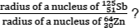?

 | A | 1.19
 | B | 1.25
 | C | 1.33
 | D | 1.40
(Total 1 mark)
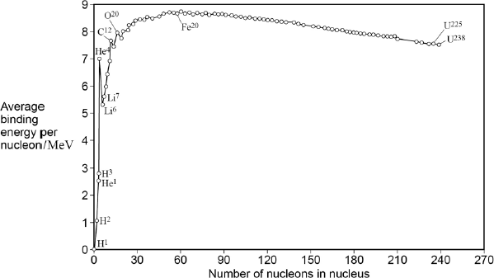
Q5.The graph shows how the binding energy per nucleon varies with the nucleon number for stable nuclei.
What is the approximate total binding energy for a nucleus of ?
 | A | 1.28 pJ
 | B | 94.7 pJ
 | C | 103 pJ
 | D | 230 pJ

(Total 1 mark)
Q6.For a nuclear reactor in which the fission rate is constant, which one of the following statements is correct?
A There is a critical mass of fuel in the reactor.
B For every fission event, there is, on average, one further fission event.
C A single neutron is released in every fission event.
D No neutrons escape from the reactor.
(Total 1 mark)

Q7. The table below gives the values for the activity of a radioactive isotope over a period of a few minutes.

time/s | 0 | 60 | 120 | 180 | 240 | 300
activity/Bq | 480 | 366 | 280 | 214 | 163 | 124
(a) Complete the graph below by plotting the remaining points and drawing an appropriate curve.
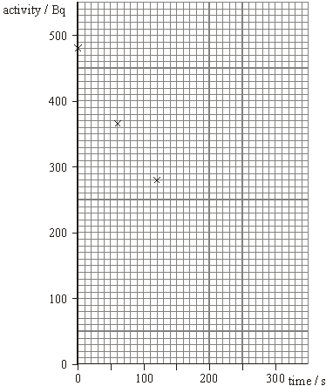
(3)
(b) Use the graph to determine the half-life of the isotope.

half-life ......................................
(3)

(c) Initially there were 1.1 × 10⁵ atoms of the isotope present. Calculate the decay probability of the isotope.

decay probability.......................................
(2)
(Total 8 marks)

Q8. The isotope of uranium, , decays into a stable isotope of lead, , by means of a series of α and β– decays.
(a) In this series of decays, α decay occurs 8 times and β– decay occurs n times.
Calculate n.

answer = ...........................................
(1)

(b) (i) Explain what is meant by the binding energy of a nucleus.
...............................................................................................................
...............................................................................................................
...............................................................................................................
(2)

(ii) Figure 1 shows the binding energy per nucleon for some stable nuclides.
Figure 1
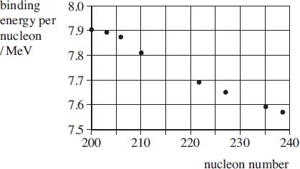

Use Figure 1 to estimate the binding energy, in MeV, of the nucleus.

answer = ................................. MeV
(1)

(c) The half-life of is 4.5 × 10⁹ years, which is much larger than all the other half-lives of the decays in the series.
A rock sample when formed originally contained 3.0 × 10²² atoms of and no atoms.
At any given time most of the atoms are either or with a negligible number of atoms in other forms in the decay series.
(i) Sketch on Figure 2 graphs to show how the number of atoms and the number of atoms in the rock sample vary over a period of 1.0 × 10¹⁰ years from its formation.
Label your graphs U and Pb.
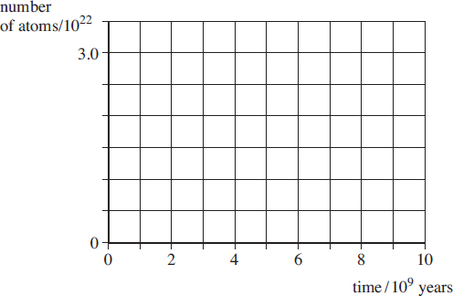
Figure 2

(2)

(ii) A certain time, t, after its formation the sample contained twice as many atoms as atoms.
Show that the number of atoms in the rock sample at time t was 2.0 × 10²².

(1)

(ii) Calculate t in years.

answer = ................................. years
(3)
(Total 10 marks)

Q9. (a) Bi can decay into Pb by a β– followed by an α decay, or by an α followed by a β– decay. One or more of the following elements is involved in these decays:
Write out decay equations showing each stage in both of these decays.

First decay path | Second decay path

(6)

(b) (i) Describe how you would perform an experiment that demonstrates that gamma radiation obeys an inverse square law.
.............................................................................................................
.............................................................................................................
.............................................................................................................
.............................................................................................................
.............................................................................................................
.............................................................................................................
.............................................................................................................
.............................................................................................................
.............................................................................................................
.............................................................................................................

(ii) Explain why gamma radiation obeys an inverse square law but alpha and beta radiation do not.
.............................................................................................................
.............................................................................................................
.............................................................................................................
.............................................................................................................
.............................................................................................................
(9)
(Total 15 marks)

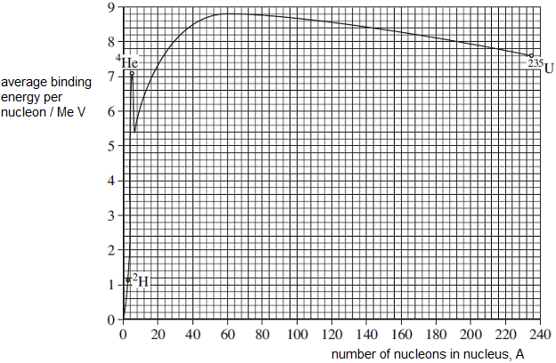
Q10.The figure below shows the variation in binding energy per nucleon with nucleon number.

(a) A uranium-235, ²³⁵U, nucleus fissions into two approximately equally sized products. Use data from the graph to show that the energy released as a result of the fission is approximately 4 × 10^{–11}J.
Show on the graph how you have used the data.

Q (4)
(b) Using the data below, show that the energy available from the fusion of two hydrogen-2,²H, nuclei to make a helium-4,⁴He, nucleus is approximately 3.7 × 10⁻¹² J.
mass of ²H = 2.0135 u
mass of ⁴He = 4.0026 u

(4)

(c) Compare the energy available from the complete fission of 1 kg of uranium-235 with the energy available from the fusion of 1 kg of hydrogen-2.

........................................................................................................................
........................................................................................................................
(3)

(d) Fission and fusion reactions release different amounts of energy. Discuss other reasons why it would be preferable to use fusion rather than fission for the production of electricity, assuming that the technical problems associated with fusion could be overcome.
........................................................................................................................
........................................................................................................................
........................................................................................................................
........................................................................................................................
(2)
(Total 13 marks)

Q11.(a) When an α particle is emitted from a nucleus of the isotope , a nucleus of thallium, Tl, is formed. Complete the equation below.
→ α + Tl
(2)

(b) The α particle in part (a) is emitted with 6.1 MeV of kinetic energy.
(i) The mass of the α particle is 4.0 u. Show that the speed of the α particle immediately after it has been emitted is 1.7 × 10^{–7} m s^{–1}. Ignore relativistic effects.
...............................................................................................................
...............................................................................................................
...............................................................................................................
...............................................................................................................
...............................................................................................................
...............................................................................................................

(ii) Calculate the speed of recoil of the daughter nucleus immediately after the α particle has been emitted. Assume the parent nucleus is initially at rest.
...............................................................................................................
...............................................................................................................
...............................................................................................................
...............................................................................................................
...............................................................................................................
...............................................................................................................
(6)
(Total 8 marks)

M1.D
[1]
M2.C
[1]
M3.D
[1]
M4.B
[1]
M5.D
[1]
M6.B
[1]

M7. (a) all plots correct to ½ small square
deduct 1 mark for one incorrect, 2 marks for 2+ incorrect
B2
line appropriate
B1
3

(b) one correct determination from correct numbers
B1
154 ± 10 s
B1
two correct determinations and average
B1
3

(c) (use of A = λN) 480 = λ × 1.1 × 10^{–5}

[allow λ = ln 2/t _{½} ]
C1
4.4 × 10^{–3} s^{–1} [4.36]
A1
2
[8]

M8. (a) 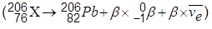
β = 6
1

(b) (i) the energy required to split up the nucleus
into its individual neutrons and protons/nucleons
(or the energy released to form/hold the nucleus
from its individual neutrons and protons/nucleons )
2

(ii) 7.88 × 206 = 1620 MeV (allow 1600-1640 MeV)
1

(c) (i) U, a graph starting at 3 × 10²² showing exponential fall passing through
0.75 × 10²² near 9 × 10⁹ years
Pb, inverted graph of the above so that the graphs cross at 1.5 × 10²² near
4.5 × 10⁹ years
2

(ii) (u represents the number of uranium atoms then)
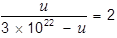
u = 6 × 10²² – 2u
u = 2 × 10²² atoms
1

(iii) (use of N = N_{o} e^{-λt})
2 × 10²² = 3 × 10²² × e^{-λt}
t = ln 1.5 / λ
(use of λ = ln 2 / t_{1/2})
λ = ln 2 / 4.5 × 10⁹ = 1.54 × 10⁻¹⁰
t = 2.6 × 10⁹ years (or 2.7 × 10⁹ years)
3
[10]

M9. (a) number correct for alpha (1)
number correct for beta (1)
alpha decay first goes via Tl (1)
numbers correct for Tl (208, 81) (1)
beta decay first goes via Po (1)
numbers correct for Po (212, 84) (1)
6

(b) (i) use of GM tube + counter/rate-meter (1)
measurement of count rate (1)
at range of distances + suitable ruler or tape measure (1)
specifies suitable range (1)
determines background & corrects (1)
safety precaution given (1)
graph of count rate or corrected count rate against 1/d² (1)
max 6

(ii) gamma not absorbed (1)
spreads uniformly from a point
source/spherically symmetrically (1)
area over which it spreads is proportional
to radius squared (1)
alpha and beta are absorbed in addition to spreading out (1)
max 3
[15]

M10.(a) Draws appropriate triangle on graph or other mark on graph at ~ 118
B1
Change of approx 1 Me V per nucleon is multiplied by 235
B1
Multiplies by 1.6 × 10⁻¹³
B1
Quotes their answer of approx 3.8 × 10⁻¹¹ to more than 2 sf
B1
4

(b) (2 × 2.0135) – 4.0026 seen or 0.0244 (u)
C1
Multiplies u by 1.7 × 10⁻²⁷
C1
E = mc² seen or multiplies by (3 × 10⁸)²
C1
3.67 × 10⁻¹²J
A1
4

(c) Multiplies 3.8 × 10⁻¹¹ or their (b) by 6 × 10²³
M1
attempts to convert to energy per kg by multiplying by 1000 / 4 or
1000 / 235
M1
Compares 5.5 × 10¹⁴ (J) (Hydrogen) with 9.6 × 10¹³ (J) (Uranium) in some
way eg by stating that the fusion reaction gives more energy (per kg) than
the fission or very similar values – must be consequent on some correct analysis
A1
3

(d) Availability of fuel easier for fusion
B1
Doesn’t produce radioactive fission products / no waste management
problem
B1
2
[13]

M11.(a)
either (1) (for both atomic mass numbers, 4 and 208)
and (1) (for both atomic numbers, 2 and 81)
[or (1) for Tl and incorrect α]
2

(b) (i) E_{k} = (½mv²) = 6.1 × 10⁶ × 1.6 × 10⁻¹⁹(J) (1)
substitution for m = 4.0 × 1.66 × 10⁻²⁷(kg) (1)
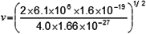 (1) (= 1.7 × 10⁷m s⁻¹)
(ii) correct use of conservation of momentum m_{Tl} v_{recoil} = m_{α} v (1)
substitution of m_{Tl} = 208u (1)
(allow C.E. for mass = 208)
v_{recoil} = 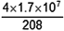 = 3.3 × 10⁵ m s⁻¹ (1)
(allow C.E. for value of v)
6
[8]

Recommended Resources

The following is a list of resources that you will find helpful during your summer work. This list is by no means exhaustive. Please feel free to share other resources with each other.

1. Kerboodle AQA Physics A-Level Textbook - www.kerboodle.com
2. CGP revision guides.

3. A-Level Physics Online Youtube channel - https://www.youtube.com/channel/UCZzatyx-xC-Dl_VVUVHYDYw

Final Words
Year 13 A-Level Physics is not simply a progression of Year 12. It is a step-up. You must step-up your attitude and work ethic.

A-Level Physics is one of the most challenging A-Levels anyone can undertake. As such, A-Level Physics is one of the most rewarding
A-Levels anyone can undertake.

If you are carrying on your A-Level Physics into Year 13, it is because you have been allowed to do so by your teachers, who feel you are worthy of the challenge. If you are carrying on your A-Level Physics into Year 13, you have been given the opportunity to achieve something you will cherish for a life-time to come.

Work hard.
Look forward to all the amazing things you have yet to learn about.

Look forward to achieving something truly remarkable.
Enjoy your summer holidays!

