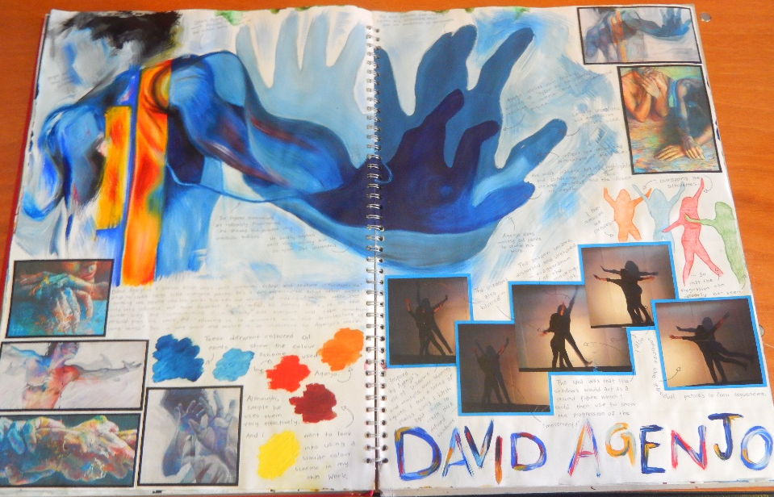
Art and Design
Yr 12 >13 Handbook

Name: ______________________

Contents
- Course Expectations and Learner Agreement

- Summer Task: Personal Study

- Course Breakdown

- Assessment Objectives

- Useful links

Course Expectations
The Art and Design A Level course is the next step after successfully completing AS level. A Level is designed to build on your previous learning and knowledge and assist you in developing the necessary skills to complete the course. In order for you to excel at A Level and achieve yours and our expectations and targets you need to acknowledge and agree to the following;
- Attendance = attainment. Attend all lessons, arrive on time and bring all the necessary equipment and resources. Do not book appointments during lesson hours.
- Necessary equipment of sketchbook, printed photographs, pencils, library books as required
- Take responsibility for arriving on time to lessons after break or after a free period.
- No mobile phones in use or in view in the lesson.
- Work to the best of your ability in class and focus on the lesson
- Listen respectfully to the views of other students and consider how your own views are developing
- Complete all homework on time – this includes printing out resources
- Keep up to date with developments, exhibitions and articles about contemporary and historical art (see Useful Links section of this guide)
- Complete all necessary research as directed
- Set up a social network group with others in your class – to encourage and support each other
- Attempt all work. If you are unsure of what to do, of course you may ask questions, but there are times when your teacher will want you to work independently without question. You must respect this.
- Take advantage of any extra lessons to work in the VI Form Art are
- Keep to deadlines
Learner Agreement
As a dedicated student of Art and Design at Uxbridge High School, I promise to meet the expectations above. I understand that not doing so, will result in school sanctions, parent meetings, and most importantly, it will have a negative impact on my attainment.
Signed ______________________________________________
Print name ______________________________________________
Year 12 >13 Summer Homework
Over the summer period, you will be expected to develop a project based on your chosen theme. Currently, this theme is quite broad and over the summer you will need to explore a focus within it. You will be expected to develop personal and detailed responses. We want you to think outside of the box and experiment with materials and compositions. It is worth looking at Pinterest for ideas that students have already explored.
You will be expected to present your project to the rest of your class in your first week of teaching. As this will help you to clarify in your own mind what your Personal Study will be.
Below are the components of your project:
- Explanation of your theme
- Primary resources that explore your theme – including photographs (which must be printed)
- Secondary sources as back up to your primary sources
- Evidence of at least two gallery visit relating to your theme
- At least 20 recordings in any material working from primary or secondary resources (at least half must be from life) All studies must be at least A4
- Research, completed artist studies and interpretations into the work of at least 5 artists of your choice that link to your theme

Course Breakdown
Within A Level there are two units.
Unit 1: Personal Study (60% of A Level mark)
This Unit incorporates three major elements: supporting studies, practical work and a personal written study with a minimum of 1000 words. All three parts are equally connected and should demonstrate a detailed and ongoing project. Supporting studies may combine investigation and research for both the practical work and personal study, this will include all your sketch book work and anything completed in your portfolio. The practical work and essay may be approached in any order, or may progress simultaneously. The purpose of the Personal Study is to develop a portfolio of practical work and a minimum 1000 words of continuous prose that shows critical understanding in relation to the practical portfolio. Work produced will be based around themes and subject matter developed from personal starting points.
Unit 2: Externally Set Assignment (40% of A Level mark)
This Unit is set by Edexcel and will be given to you in the form of an exam paper similar to AS Level. The theme is broad and the paper will suggest various starting points, to which you can add your own. Your work will be presented in a sketchbook and portfolio. This Unit culminates in a 15 hour exam.
All work is marked by your teachers and is moderated by an Edexcel examiner.

Assessment Objectives
The Assessment Objectives (AO) for AS Level and A Level are the same. Each AO is worth 25% and can be awarded up to 18 marks.
AO1 | AO2 | AO3 | AO4
Develop ideas through sustained and focused investigations informed by contextual and other sources, demonstrating analytical and critical understanding | Explore and select appropriate resources, media, materials, techniques and processes, reviewing and refining ideas as work develops | Record ideas, observations and insights relevant to intentions, reflecting critically on work and progress | Present a personal and meaningful response that realises intentions and, where appropriate, makes connections between visual and other elements
What do these actually mean?
Different ideas are developed from different starting points or sub-themes. Investigations are thorough and explore many options within the ideas. Artist studies and gallery visits are in depth and improve your knowledge and understanding. Your language is critical and your analysis of artist’s work is detailed and includes your own and others’ opinions. | All materials should be explored over many different studies. You do not have to use a wide range of materials but you have to show how your skills are developing with each material. Techniques should be analysed – for example ways of working with oil paint. Your sketchbook and portfolio will show how you have refined your skills to make improvements to your ideas. | Through drawing, painting, sculpture, printing and photography you will observe and record the world around you from primary sources. In addition, you will do the same with secondary resources where it is appropriate. Standards should be consistent and development of skills should be evident as time progresses. You will show in your sketchbook how you are refining your skills. | Outcomes are personal to you, clearly developed through your sketchbook and portfolio and clearly realise your intentions. They may make connections with artist studies you have completed but must not be artist interpretations. These are your own final pieces and should be the pinnacle of your success.

There are 6 marking bands – each with 3 marks. A performance calculator is used to place your work in a particular mark band for each AO.
Level 1 | Level 2 | Level 3 | Level 4 | Level 5 | Level 6
Limited ability | Basic ability | Emerging competent ability | Competent and consistent ability | Confident and assured ability | Exceptional ability
partial, inconsistent, literal, elementary, minimal, rushed, sporadic, naïve, lacks skills, little creative intent, disjointed, pedestrian, credible, worthy | straightforward, deliberate, just adequate, methodical, superficial, unrefined, lacks understanding and focus, crude visual language, simplistic reflection, weak connections, plays safe, unresolved | predictable, broadening, makes progress, relevant, description not explanation, demonstrates intentions, appropriate, sufficient, control, emerging individuality, thorough, developing skills, adequate, lacks perception, signs of understanding | diverse, effective, purposeful, consistent, skilful, coherent, imaginative, informed, some perception, satisfies creative intent, engaged | independent, realised, sensitive, creative, sustained, highly inventive, critical, perceptive, comprehensive, in-depth, insightful, original, genuine creative journey, refined, highly skilled, in-depth reflection, pertinent connections, exciting | inspired, surprising, unique, authoritative, genuine discovery, adventurous, accepting of the unexpected, challenging, synthesis of ideas, fully informed, questioning, sophisticated, dexterous, fluent skills, erudite, intuitive, daring
1-3 marks | 4-6 marks | 7-9 marks | 10-12 marks | 13-15 marks | 16-18 marks

Unit 1: Developing a theme and question for investigation
Unit 1 Outline of study: Proposal and Expectations
Aim of Unit 1
To explore an aspect of Art and Design making reference to and showing learning from a range of contextual sources.
Unit 1 title: An Investigation into…

Proposal

Expectations

Contextual References: Identification of historical artists within the aspect – justify your choices. Identification of contemporary artists within the aspect – justify your choices.
Artist’s work to be studied should be chosen carefully. Consider how their work reflects the aspect you have chosen. Choose artists that have worked in different ways – for example sculptors that have worked in different materials and with different themes. Make sure that you can find APPROPRIATE resources and have a broad variety of them.
Artist | Sources of research (articles, books, websites, gallery sites, catalogues) | Reason for choosing

Planning Practical and written analysis of the artist’s work
Working from Contextual references implies thorough research, learning and practical understanding – your work will change, evolve and develop as a result. You must have reasons for exploring a contextual reference – make sure you know why you are doing something.
Practical: Practical work should not necessarily copy whole pieces but rather master a technique or process. Studies should use appropriate materials and be realistically sized. If you know the artist works on a particular scale consider this. You are learning from doing – don’t just copy for the sake of it.
Written: For this you will need colour printed versions of work for each artist. (If you need catalogues and books scanned please ask.) Each image should be large enough to analyse. Place the images into your book leaving room around each one for annotation. The written analysis here will help form the basis for your essay. You are looking to include information about the work as well as expressing your opinion or simply writing words that come to mind when observing the piece. The following prompts may help;
- General themes and subject matter seen in the work
- What does the title suggest about the theme of the work?
- Overall use of colour
- Overall use of line
- Overall use of materials – are they significant in understanding the work?
- Adjectives that describe the work
- Your reactions as a viewer
- What significance is scale?
- Words to describe atmosphere or mood
- Critics reactions to the artist’s work – you may need extra research for this
- Connections with things you have seen/experienced before (memories etc.)
You may benefit from discussing the work being studied by other students, do not be afraid to share your opinions. Everyone’s experiences work in different ways and will rouse personal connections in different ways so be open to all suggestions.
Some background knowledge about the reference and any historical information that impacts on the work will be necessary to record in your books too – make sure all writing is in your own words and nothing is copied.
Writing your essay
Use this essay plan, it will help you to organise your thoughts and opinions. Write bullet points to begin with and then expand on these. Your use of the English language, punctuation and grammar will be marked.

Essay plan:
Introduction:
Briefly describe the intention of your essay. Briefly describe the genre you have chosen to study and the reasons for your choice. Name your artists you have studied and briefly describe their role within the genre. Describe, briefly, your reaction to their work and ideas. Discuss the possibilities for an outcome that would show your understanding of the artists and illustrate your own creativity.

Artist analysis:
Using the analysis from Task 4 draw out the main points that define your chosen genre. Use your historical artists to contextualise your points. Move away from a description of the artists’ work and instead discuss the broader aspects of it. By all means make reference to particular pieces of work to illustrate your points and even include these within the text. The point of this section is to discuss the artist’s work together, including expressing your opinion and reactions to it. Quotes by artists or commentators can be very helpful but must be analysed.

Artist analysis:
Similarly to the previous paragraph discuss how your chosen contemporary artists have contributed to the development and evolving of the genre. Discuss how trends and ideas may have changed and been modernised. Add your own opinion of these developments and propose ideas as to how you think it will develop in the future. Again, if helpful, make reference to particular pieces of work and artist or commentator quotes.

Development of your personal responses:
This section is where you start to show your own ideas that have been inspired by the artists. It is helpful to look back at your practical work at this point. Discuss what you have learnt from doing these and whether you feel that you have a better understanding of the genre and the artists’ work and ideas as a result. You will have developed your own ideas and these must be discussed and communicated too. It is likely that your outcome is one of many possibilities, so do not simply describe the one you have chosen. Use artist quotes if they are helpful in illustrating your points. Also discuss what you intend to be the viewer’s role in your work.

Conclusion:
Evaluate the success of your investigation, from your initial thoughts to your final outcome. Refer back to key points about the artists and ensure that you have summarised the initial question that was posed.

Useful links
https://www.youtube.com/watch?v=rKkmIl_ydxE – GCE A2 exemplar sketchbook – A*
https://www.youtube.com/watch?v=WJ5kojvyv8s – GCE AS exemplar sketchbook – A
https://www.youtube.com/watch?v=wFYPYJKCk1w – GCE AS exemplar sketchbook – A
http://www.studentartguide.com/ - exemplar sketchbooks
https://www.youtube.com/user/webArtAcademy - Web Art Academy – multiple tutorials
https://www.youtube.com/user/tate - Tate Gallery - multiple videos about art / artists
https://www.youtube.com/user/MoMAvideos - Museum of Modern Art, New York
https://www.youtube.com/user/nationalgalleryuk - National Gallery, London
http://www.saatchigallery.com/ - Saatchi Gallery – contemporary art gallery, London
http://www.tate.org.uk/ - Tate Galleries – London, Liverpool, St Ives
https://www.royalacademy.org.uk/ - Royal Academy of Art – London
http://whitecube.com/ - White Cube galleries – London / Hong Kong
http://www.camdenartscentre.org/ - Camden Arts Centre – exhibitions / workshops
http://www.whitechapelgallery.org/ - Whitechapel Gallery – exhibitions / workshops
http://www.npg.org.uk/ - National Portrait Gallery – London
http://www.nationalgallery.org.uk/ - National Gallery – London
http://thephotographersgallery.org.uk/ - Photographers Gallery - London

