Uxbridge High School
A2 Handbook & Transition Summer Project Philosophy
Year 12 > Year 13
AS > A2
Name: _____________________________

Target Grade: ________________________

Contents:
Expectations and Learner Agreement p.1
Summer Task p.2
Outline of the Year p.2
Required Reading p. 3-4

A2 Expectations

Students continuing at A-level will explore questions including: “Is the concept of God incoherent?” and “What is mind?”

Philosophy AS and A level courses are taught as separate units over four parts. Each demands a great degree of commitment and independent learning. To enable you to cope with the demands of the course and achieve your target grades, it is essential that you fulfil the following expectations.

- Attendance to all lessons, arrive on time and bring all the necessary books.
- You should have a large folder to keep your lesson notes in for each year. Ensure you have pens and paper for each lesson.
- Arrive on time to the start of class – not after you have got your tea.
- Work to the best of your ability in class and focus on the lesson.
- Listen respectfully to the views of other students, be ready to give logical debate on any topic.
- Be on guard for ‘logical fallacies’ and embrace ‘existential dread’.
- Complete all homework – especially reading.
- Read widely in your own time, including reading.
- Attempt all work. If you are unsure of what to do, of course you may ask questions, but there are times when your teacher will want you to work independently.
- Take a look through the “Stanford encyclopaedia of Philosophy”.
- Take advantage of any extra lessons/revision sessions.
- Keep to deadlines.

Learner Agreement
As a dedicated student of Philosophy at Uxbridge High School, I promise to meet the expectations above. I understand that not doing so, will result in school sanctions and parent meetings, but most importantly it will have a negative impact on my attainment.
Signed ______________________________________________

Print name ______________________________________________

AS > A2 Summer Project Task

You are to create a folder of research giving arguments for and against two of the following. You should annotate the research with your own thoughts.
- Dualism, a short History
- Qualia and the problems it causes
- Utilitarianism – two types
- “If we cannot agree on Language – how can we hope to decide if something is Ethical?
- Are we just Philosophical Zombies?
This is due in for the first lesson back in September.

Course Breakdown
PHLS1:
Philosophy of the Mind / The Mind-Body problem
- Dualism – the mind being distinct from the physical.
- Property dualism, the argument of ‘Philosophical Zombies’ and of Qualia
- The issues of dualism
- Materialism, logical behaviourism.
- Identity theory and Eliminative materialism.
Ethics
- Ethical Theories, including Utilitarianism, deontological ethics and Virtue Ethics
- Ethical Language
- Cognitivism and non-cognitivism

Required Reading
Students are required to demonstrate an understanding of, and the ability to make a reasoned evaluation of, the arguments set out in the following texts;
Texts in bold are required reading.

Philosophy of the Mind
Letter from Princess of Bohemia to Descartes, May 1643
Block, N (1980), ‘Troubles with functionalism’ in Readings in Philosophy ofc Psychology, Volume 1, Harvard University Press, 275–278 – section 1.2
Chalmers, D (2003), ‘Consciousness and its place in nature’ in Blackwell Guide to the Philosophy of Mind, Blackwell
Churchland, PM (1981), ‘Eliminative Materialism and the Propositional Attitudes’, Journal of Philosophy 78, 67–90 (Section 2 Why folk psychology might (really) be false)
Descartes, R (1641), Meditations on First Philosophy, 6 (expressed without reference to God)
Jackson, F (1982), ‘Epiphenomenal Qualia’, Philosophical Quarterly 32, 127–136
Jackson, F (1986), ‘What Mary Didn’t Know’, Journal of Philosophy 83, 291–295
Jackson, F (1995), ‘Postscript on “What Mary didn’t know”’, in Moser, P and J Trout (1995),
Contemporary Materialism, London, Routledge, 184–189
Jackson, F (1998), ‘Postscript on Qualia’, in Mind, Methods and Conditionals, London, Routledge. 16
Putnam, H (1967) Psychological predicates, in WH Capitan and DD Merrill (eds.), Art, Mind, and Religion, University of Pittsburgh Press
Ryle, G (1949/2000) The Concept of Mind, London, Penguin Classics edition (introduction by Daniel Dennett)
Smart, JJC (1959) ‘Sensations and brain processes’, The Philosophical Review, 68 (2),
141–156

Ethics
Aristotle, Nicomachean Ethics: Books 1, 2, 3, 5, 6, 7, 10
Ayer, AJ (1973/1991), The Central Questions of Philosophy, London, Penguin, 22–29
Ayer, AJ (1946), Language, Truth and Logic, 2nd Edition, New York, Dover, (esp. chapters 1 and 6)
Bentham, J (1879), ‘The Principle of Utility’ in Introduction to the Principles of orals and Legislation, Oxford, Clarendon Press
Hare, RM (1952), The Language of Morals, Oxford, Clarendon Press, (for prescriptivism)
Hume, D (1739–40), Treatise of Human Nature, Book III, Part 1 (for Emotivism)
Kant, I (1785) Foundations of the Metaphysics of Morals
Mackie, JL (1990), ‘The Argument from Queerness in Ethics’ Inventing Right and Wrong, Penguin
Mill, JS (1863), Utilitarianism
Moore, GE (1903), Principia Ethica, Cambridge University Press
Rachels, J (1993), The Elements of Moral Philosophy, 2nd Edition, McGraw-Hill (on Kant)
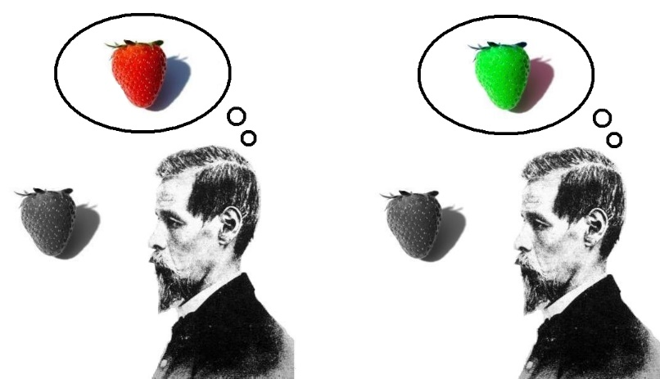
Warnock, GJ (1967) Contemporary Moral Philosophy, New Studies In Ethics, (Intuitionism, Emotivism, Prescriptivism) Macmillan – Chapters 1, 3 and 4

‘Qualia’

