AS- year 12 Geography
Summer work booklet 2017
Read the articles and answer the questions.
This will help with comprehension in September.
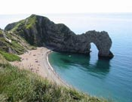
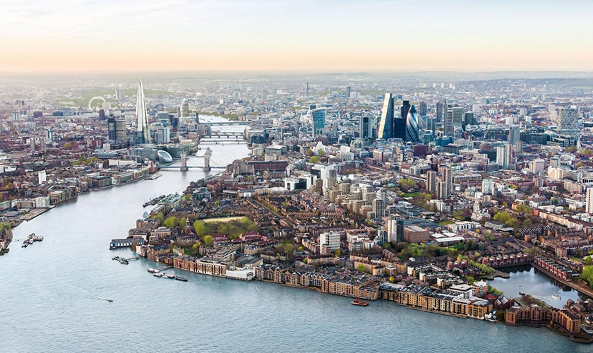
Topic 2B
Coastal development

Text 1

Coastal erosion
The sea shapes the coastal landscape. Coastal erosion is the wearing away and breaking up of rock along the coast. Destructive waves erode the coastline in a number of ways:
- Hydraulic action. Air may become trapped in joints and cracks on a cliff face. When a wave breaks, the trapped air is compressed which weakens the cliff and causes erosion.
- Abrasion. Bits of rock and sand in waves grind down cliff surfaces like sandpaper.
- Attrition. Waves smash rocks and pebbles on the shore into each other, and they break and become smoother.
- Solution. Acids contained in sea water will dissolve some types of rock such as chalk or limestone.

Transport
There are various sources of the material in the sea. The material has been:
- eroded from cliffs
- transported by longshore drift along the coastline
- brought inland from offshore by constructive waves
- carried to the coastline by rivers
Waves can approach the coast at an angle because of the direction of the prevailing wind. The swash of the waves carries material up the beach at an angle. The backwash then flows back to the sea in a straight line at 90°. This movement of material is called transportation.
Continual swash and backwash transports material sideways along the coast. This movement of material is called longshore drift and occurs in a zigzag.
You have an old or no version of flash - you need to upgrade to view this funky content!
Go to the WebWise Flash install guide

Coastal transport
There are four ways that waves and tidal currents transport sediment. These can then contribute to the movement of sediment by longshore drift.

Deposition
When the sea loses energy, it drops the sand, rock particles and pebbles it has been carrying. This is called deposition. Deposition happens when the swash is stronger than the backwash and is associated with constructive waves.
Deposition is likely to occur when:
- waves enter an area of shallow water.
- waves enter a sheltered area, eg a cove or bay.
- there is little wind.
- there is a good supply of material.

Question: Make diagrams that show with labels the different Coastal erosion processes
Coastal erosion

Coastal Transportation and longshore drift

Coastal deposition

Text 2:

Factors Affecting the Rate of Erosion
The biggest factor affecting coastal erosion is the strength of the waves breaking along the coastline. A wave’s strength is controlled by its fetch and the wind speed. Longer fetches & stronger winds create bigger, more powerful waves that have more erosive power. As waves approach a coastline they lose energy though because friction with the seabed increases. This means that the bathymetry (the underwater elevation) of the ocean or sea bed also impacts the strength of waves.
Certain landforms further reduce wave’s erosive power. Beaches increase the distance a wave travels before it reaches the coastline’s cliffs and so reduces its energy. Headlands refract waves around them, reducing their erosive power at one location while increasing it at another.
Weathering also plays a role in the rate of erosion by creating weaknesses in rocks that are exploited by the processes of erosion. Freeze-thaw weathering, for example, creates cracks in rocks, increasing the rock’s susceptibility to hydraulic action.
As always, humans have an impact on coastal erosion. Human activities have a variety of complex effects on coastal erosion but most commonly the activities increase the strength of waves. One activity, dredging, is commonly carried out to improve shipping capacities but it reduces the amount of energy dissipated from incoming waves and so increases erosion².

Lithology
Lithology refers to the physical properties of a rock such as its resistance to erosion. The lithology of a coastline affects how quickly it’s eroded. Hard rocks (e.g., Gabbro) are resistant to weathering & erosion so a coastline made of granite (e.g., Land’s End) will change slowly. Soft rocks (e.g., Limestone) are more susceptible to weathering & erosion so a coastline made of chalk (e.g., Dorset) will change relatively quickly.
If you looked down on a coastline from above and saw the geology of the area, you’d be able to see that the rock type changes as you approach the coastline and that the different rocks are arranged in bands. The angle these bands make with the coastline makes it either a concordant or discordant coastline.
Concordant coasts have alternating layers of hard and soft rock that run parallel to the coast. The hard rock acts as a protective barrier to the softer rock behind it preventing erosion. If the hard rock is breached though, the softer rock is exposed and a cove can form (e.g., Lulworth Cove).

Cliff Profiles & Bedding Layers
Rocks tend to form in layers of different rock types known as beds. These beds are subjected to tectonic forces that tilt and deform them so they dip at an angle. The angle the beds dip at affects how they are eroded and the profile of the resulting cliffs. Horizontal beds produce steep cliffs with notches where differential erosion has taken place. Near vertical beds (with a dip of ~90˚) also produce steep cliffs but differential erosion is less prevalent in these structures. Beds that dip seaward produce gentler cliffs but are less stable because loose material can slide down the bedding planes in mass movements. Landward dipping beds produce stabler& steeper cliffs.
Sub-aerial processes are land based processes which alter the shape of a coastline. They’re a combination of both weathering and mass movement.
Question 2:
- Explain how factors affect Coastal erosion rates:
- Why is Lithology important when considering coastal erosion rates?
- Explain the different types of cliff profiles?

Text 3:Weathering

Freeze Thaw
Freeze thaw weathering involves water entering cracks in rocks and freezing. When the water freezes it expands, fracturing the rock.

Exfoliation
The repeated action of heating and cooling rocks causing them to “shed” off layers.

Biological Weathering
Plant seeds get into cracks in rocks and begin growing. As they grow, they exert pressure on the rocks, causing them to fracture. Seaweed, under the sea, can attach itself to rocks so that, as the sea moves the seaweed, chunks of rock are pulled away.

Chemical Weathering
Corrosion is technically a form of weathering and not erosion. Processes such as hydrolysis and oxidation can weather away rocks. Hydrolysis involves the splitting of minerals due to their reactivity with water. Oxidation is, basically, rusting. Elements such as iron are susceptible to oxidation and can be found within minerals on coastlines.

Mass Movement
Mass movement can be defined as the large scale movement of weathered material in response to gravity. Essentially, it’s when a cliff or other structure that is not horizontally orientated has been weathered to the point at which it starts to collapse. There’s five types of mass movement: rockfall, soil creep, landslides, mudflow and slumping.

Rockfalls
Freeze thaw weathering on a cliff breaks the rocks up into smaller pieces which can then free fall. This occurs commonly on cliffs with lots of joints as the joints make it easier to break up the rock. If the cliff is undercut by the sea, it can loose some of its stability, increasing the likelihood that a rockfall will occur.

Soil Creep
Soil creep is an incredibly slow process. It occurs on very gentle slopes and produces an undulated (wavy) surface. Damp soil moves very slowly down hill due to the increase in its mass (since it’s wet).

Landslides
After being soaked by water, cliffs made from soft rock will begin to slip due to the rock being lubricated. Landslides are very similar to slumps.

(Rotational) Slumping
Slumping happens for similar reasons to landslides. Heavy rainfall makes the rock heavier due to it absorbing the water and the water also acts as a lubricant. The difference with slumping is that it happens on a concave surface, which causes the cliff to form a crescent shape.

Mudflow
Mudflow is a very dangerous form of mass movement which occurs on steep slopes with saturated soil and little vegetation. The lack of vegetation means that there is nothing to bind the soil together, promoting mass wasting. The saturated soil becomes heavier and is lubricated, leading to the rapid movement of a lot of mud downhill.
Question 4: Draw each type of mass movement and each type of weathering with labels.

Hard Engineering In New Brighton
New Brighton was a very important coastal tourist destination on the Wirral however over the past 30 years the are has fallen into decline. In more recent years, the area has been rejuvenated and many new structures have been constructed along New Brighton making protecting New Brighton from the sea incredibly important. Land uses in New Brighton include economic and residential uses. In recent years a new theatre has been constructed in New Brighton known as the “Floral Pavilion”. This venue is of particular importance to New Brighton as it is the primary source of visitors to the area and has received much recognition including a visit from The Queen.
New Brighton is at particular risk of coastal flooding and erosion due to its location. Located on the North West tip of Wirral, New Brighton receives a pounding from the sea. Waves that impact New Brighton are very energetic as they’ve got a strong fetch from the approximately 200km of water (the Irish Sea) that the New Brighton coast faces. In addition, a low pressure system around New Brighton means that storm surges are a common occurrence making the area particularly susceptible to flooding. This is worsened by the fact that most of New Brighton is only a few metres above sea level so only a relatively small storm surge would be needed to flood a large section of New Brighton.
In order to protect New Brighton, several sea defences have been employed. In order to protect against both coastal erosion and flooding, a large sea wall was constructed in the 1930s, known as the King’s Parade Sea Wall. The wall is 4m tall and stretches along 2.3km of coastline. It was constructed using leftover material from the construction of the Queensway tunnel. The wall is specially designed in order to reduce the impact of waves as much as possible and increase its lifespan at the same time. The top of the wall is curved slightly in order to reflect back waves that impact it and dissipate their energy. This helps reduce the rate at which the sea wall is worn down since it is, slowly, being worn away. This is one of the main issues with the wall, it requires a lot of attention and is expensive.
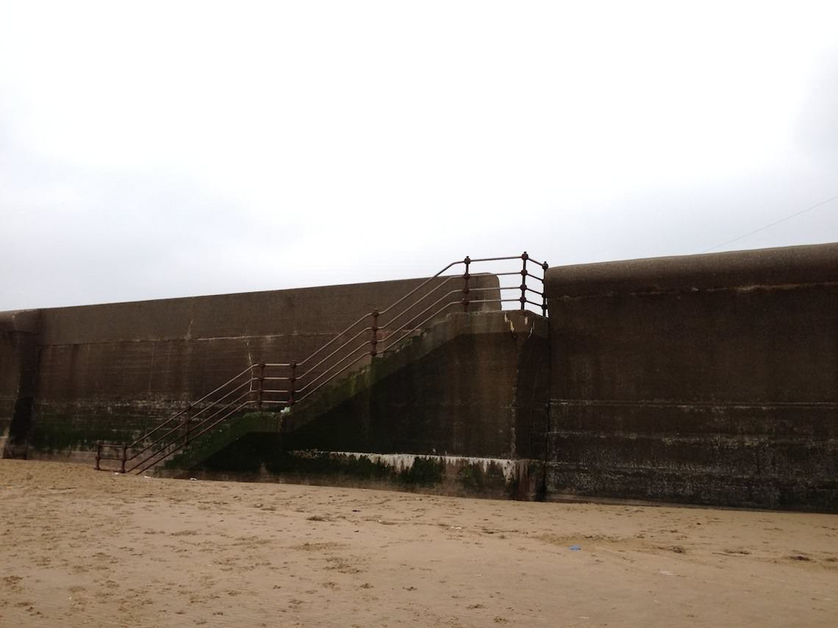
The King’s Parade Sea Wall
The King’s Parade Sea Wall.
It has, however, been very effective at preventing both coastal erosion and flooding. The wall has produced 100m of ‘new’ land. In reality, this is land that was submerged by the sea but is no longer submerged since the sea can’t access it any more. In addition to this reclaimed land, there have been no cases of cliff collapse in many years and there have been no major floods either, suggesting that the wall is effective at preventing flooding.
In tandem with the sea wall, coastal zoning has taken place along New Brighton in an attempt to reduce the risk of flooding should the sea wall. The aforementioned 100m of reclaimed land is almost completely undeveloped, with the exception of a few parks, since it’s very low lying land and should the sea wall be breached it would be flooded very rapidly. Pretty much all residential developments are placed on top of the relic cliffs so that they have a little bit of protection in the event of a flood.

Soft Engineering - Thursaston
Thursaston is located on the opposite side of the Wirral and is the exact opposite to New Brighton in terms of development and importance (to some people). Thursaston has very little in terms of human developments. The area is in fact a SSSI (Site of Special Scientific Interest) and is mostly just plants and wildlife with some interesting sandstone landforms. Given that Thursaston lacks human development, little has been done to prevent coastal erosion here. What has been done, though, is all soft engineering.
The cliffs along Thursaston are very susceptible to erosion despite the fact that the waves washing ashore are relatively weak constructive waves. The reason for their susceptibility is their composition. They’re primarily weak sandstone and boulder clay and the bedding layers of the cliffs dip towards the sea, so they’re not particularly stable. The cliffs are also susceptible to sub-aerial weathering and mass movements are frequently take place along them.
Given the low-value land that lies behind these cliffs, the local council and environmental agency has done little in terms of trying to protect these cliffs and what has been done wasn’t particularly effective.
Gabions were placed around the bases of the cliffs and can still be found there today. The idea was to reduce undercutting of the cliffs by the sea but they haven’t been all too successful since the cliffs are still collapsing today. Now days, the main benefit of the gabions is that they provide a (small) habitat for several species of plant and insect, that’s about it. The plants that have colonised the gabions help to make the gabions appear to blend into the environment a bit better too.
Another soft engineering technique that was employed was the introduction of drainage pipes into the cliffs. Given that the cliffs are made of boulder clay, if they became saturated with water they’d become lubricated quickly and mass movements would begin to take place. The drainage pipe was supposed to remove water from the cliffs stopping them from becoming saturated but it has proved to be totally ineffective. This is evident from the fact that a severed pipe bound in concrete can be found just lying on the beach. The cliff collapsed and the pipe fell out and was left on the beach. This is a testimony to both the effectiveness of the pipe and how much the council cares about the cliffs.
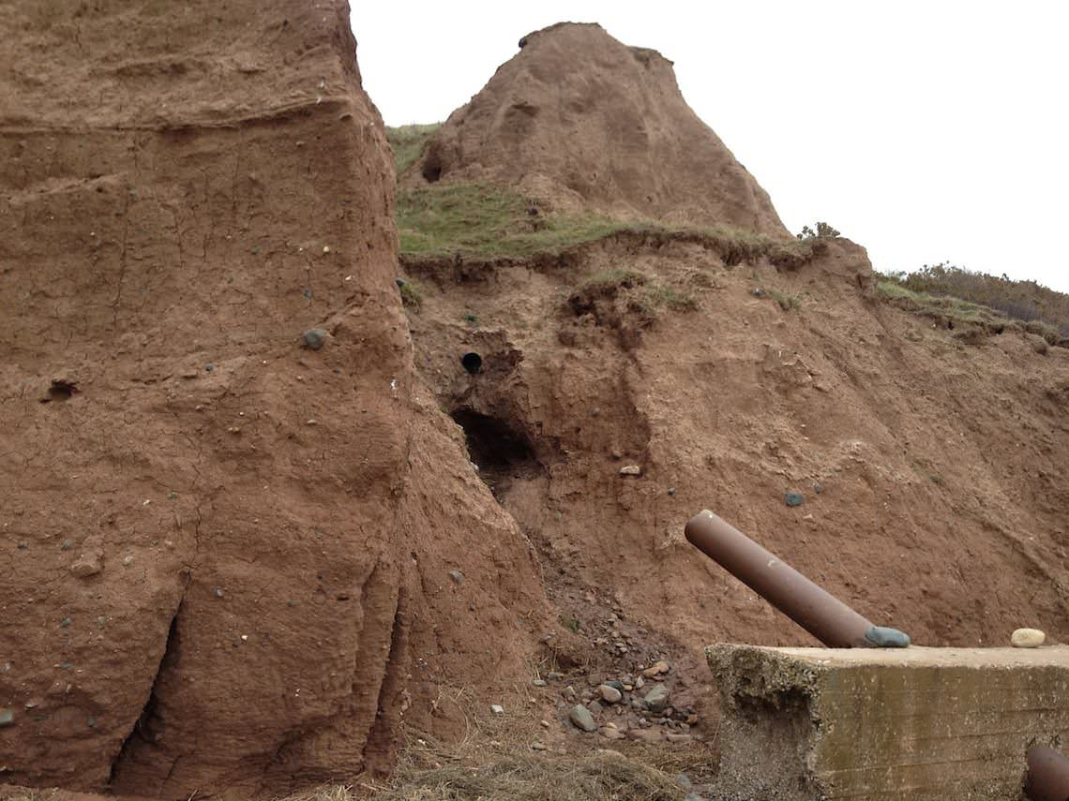The ‘Fail Pipe’
The cliffs are likely to continue collapsing at Thursaston however there is one thing that may save them. A salt marsh appears to be developing before the cliffs and, with a little help from some humans, could be enough to stop the cliffs from collapsing. Unfortunately nobody is helping the marsh to develop and people are going around and removing many of the plants that are growing there as if a salt marsh was to develop, it would prove to be a problem for the sailing groups located nearby.

Question 3: Explain the difference between both types of engineering
Topic 4A
Regeneration of Places

We need to talk about urban regeneration
Successful regeneration projects need to ensure affordability, access to facilities and involve local communities and residents, said participants at a recent Guardian roundtable
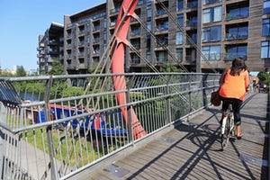
East London’s Hackney Wick. Photograph: Alamy Stock Photo Monday 10 April 2017 10.10 BST
Any attempt to change the urban landscape is a messy, complex process. Deliberate efforts to revitalise districts in decline or disrepair have often been met with suspicion, cynicism, and in some cases even outright hostility.
But if regeneration has become a loaded, contested term, the transformation of towns and cities remains an endlessly compelling idea. Big renewal projects hold out the promise of making rundown neighbourhoods attractive and vibrant again, and offer up the chance to find new purposes for underused or neglected spaces. Manchester, for example, boasts a city centre almost unrecognisable from its drab incarnation of the early 1980s – a renaissance made possible by rejuvenating old industrial buildings, as well as attracting the investment to create new commercial and cultural landmarks.

So what makes for a successful regeneration project? How should such interventions be pursued and managed, ideally? The Guardian, supported by Lend lease, recently hosted a roundtable discussion of business leaders and experts to consider how current and future schemes might succeed. Everyone on the panel agreed that regeneration takes time – usually a great deal of it. And most agreed that having a clear, shared vision outlined at the beginning of the process is vital. “In Manchester you had a level of political stability over time and a deeply experienced town hall,” said Jason Prior, regeneration consultant at Prior Associates. “They had a plan, a direction, a goal – even if you have to be flexible in how you deliver it.”Delivering new buildings is often the main focus of major regeneration projects, but construction isn’t everything. Prior believes every good regeneration project requires foresight for the spaces in between buildings and how people use them.“We’re not always thinking enough about the quality of the public realm, and how to look after it,” he said, adding: “There is no stronger indication of success or failure of a scheme than the quality of the streetscape, the parks, the play spaces.”

Pam Alexander, chair of the Covent Garden Market Authority, also believes regeneration schemes should be adaptable enough to give residents a genuine voice. She cites the localism model of Portuguese capital Lisbon, where each parish council is involved in “participatory” budgeting. “Individual neighbourhoods are given real money and real power to make decisions about what bits of community infrastructure they want, rather than have it done to them,” she explained. “Empowerment is important.”Developers should be willing to compromise, and a good regeneration project should allow the existing community “to take it on and grow into it”, said Andy Rowland, development director at housing association L&Q. “You have to be prepared in the early stages, and for many years afterwards, for people to occupy spaces that aren’t necessarily going to deliver high value.”For example, while most of the panel hailed King’s Cross in London as a successful regeneration scheme, Rowland said the area hadn’t benefited from much affordable housing. “I have a bit of a concern that it’s too antiseptic. What has it done for people on low incomes on the Caledonian Road?”

One of the major concerns shared by many members of the panel was whether enough regeneration projects were fostering a healthy variety of uses. Some fear the huge demand for housing and pressure to maximise profit through high-density residential schemes has led to a lack of shops, offices, community facilities, and spaces for arts and leisure activities that make places liveable.“I walk around some new developments and it’s very mono, very residential,” said Jonathan Emery, managing director of property at Lendlease. “The use of retail and other things is just devastatingly appalling. We want to see that diversity of use, that animation of a place – the mixture of night-time and daytime use, the mixture of retail, office and community infrastructure.”

Rowland thinks Hackney Wick and Fish Island in east London is an excellent example of people being able to live and work in close proximity. He would like to see more regeneration schemes protect or create spaces for artists, entrepreneurs and small and medium-sized businesses. “I think it’s incumbent on developers to provide affordable work spaces – properly low-cost work spaces,” he said. “It’s what provides an area with its dynamism.”Developers may want to focus on making new things possible, but the clearing away of long-established housing estates has proved the most unpopular part of big regeneration projects, especially in London, where many residents’ groups have formed campaigns to fight against demolition.Mayor Sadiq Khan recently released a good practice guide for regeneration. He recommended residents take part in shaping plans at an early stage.

Yet the consultation process remains a common complaint. It has been criticised as a tokenistic exercise, conducted alongside a PR drive to persuade residents of the merits of a plan already decided without them. Nicholas Boys Smith, founding director of the social enterprise Create Streets, believes the failure to listen to existing residents is a missed opportunity to get good ideas and “co-design” things together with other stakeholders. “Quite often residents are rightly cynical about consultation,” said Boys Smith. “You get the other problem, where developers are scared of residents, scared of showing them any option that isn’t definitely viable.”Then what should Britain’s housing estates look like in the 21st century? Create Streets has advocated a return to more traditional street patterns so estates can reconnect and blend in with the surrounding area. But with so many new developments opting for large, high-rise apartment blocks, Boys Smith said he feared “we could be recreating some of the problems we created in big residential buildings 20 or 30 years ago”.“There is a measurable disconnect between what professional designers and developers tend to like, aesthetically, and what most of the rest of population likes,” he added.Debbie Jackson, assistant director of regeneration for the Greater London Authority, worries that some new housing developments feel “imported” from fashionable neighbourhoods, and are not always suitably tailored to existing communities.“It’s worth asking whether we are unwittingly creating places that some communities think aren’t for them, purely in their look and feel,” she said. “Is the design community perpetuating a design language – whether it’s the paving, the artwork – that some communities don’t find accessible? Sometimes developments can look like they’ve been imported from Hackney or Shoreditch or Brixton.”

If some schemes need to be aware of local sensitivities, others have aimed to make big, bold, exhibitionist statements. What is the role of eye-catching new architectural landmarks and big-ticket cultural attractions in the urban regeneration process?Alexander points towards Bradford’s City Park development, where a huge mirror pool was installed in front of the old town hall, serving as a popular space for families during the day and animated by water fountains and light displays at night. “It’s become a fantastic resource for the community and has given them confidence and pride in a town that still has work to do to turn around its economy,” she said. “So sometimes a major intervention – even if its cultural or playmaking – can be hugely beneficial in giving a place confidence to go forward.”Richard Blakeway, chief adviser at the Policy Exchange thinktank, said the best schemes tend to grow in an “organic” fashion. “A good regeneration scheme starts with what already exists – whether that’s people, landscape or existing buildings,” he said.

Like several members of the panel, Blakeway has been highly impressed by Stockholm’s Hammarby Sjöstad project. The ecologically sensitive development of 1,000 apartments is based around a lake, uses purified waste water in its district heating system, provides plenty of green space and easy walkability between transport connections. “One of the striking things about many successful schemes is that water plays a significant role,” he reflected.Planners, architects, builders and local authority bosses all have a shared interest in getting regeneration right. But the stakes are highest for the people who live, work and make use of a redeveloped neighbourhood. It is they who will shape its future and determine whether it thrives.“If you create a meaningful sense of place then people will look after it and take ownership of it, and that will lead to long-term success,” said Adrian Griffiths, board director at architectural practice Chapman Taylor. “If the developments going up now get demolished in 30 years time, then we will have failed.”

Question 5: Read the article and fill out the advantages and disadvantages of Regeneration
Advantages Disadvantages

UIC - London - Regeneration
The London Olympics of 2012 was a fantastic sporting spectacle and put the spotlight of the World on our capital city. Part of the aims of the Olympics was to completely transform an area of East London that is lagging behind the rest, East London. The idea was to leave a lasting legacy or impact not just for sport but for the urban area in the East of London.
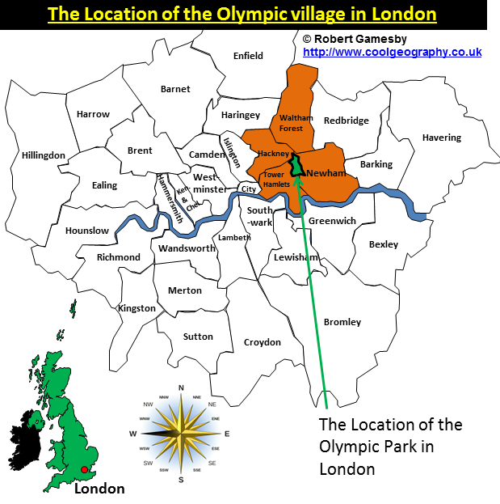
The London 2012 Olympic Legacy was a plan to make sure that the 2012 Olympic and Paralympic Games had LONG TERM BENEFITS.
This legacy was to cover 4 main areas;
1. Economic – supporting new jobs and skills, encouraging trade, inward investment and tourism
2. Sports – continuing elite success, development of more sports facilities and encouraging participation in schools sports and wider
3. Social and volunteering – inspiring others to volunteer and encouraging social change
4. Regeneration – reuse of venues, new homes, and improved transportation
The key for this unit is Legacy point 4 – urban regeneration. Urban Regeneration is the whole sale improvement of the buildings and infrastructure of an area. The Olympic athletes village was converted to a new housing area in London.
The areas hosting the Olympics like Stratford and nearby Tower Hamlets were in dire need of regeneration as they had;
• a lot of abandoned old industrial sites,
• low achievement at school in terms of GCSE points score
• industrial wastelands,
• higher than average unemployment than the rest of London and
• higher deprivation and poverty for the people that lived there
• Lower household incomes then the London average as shown on the map below
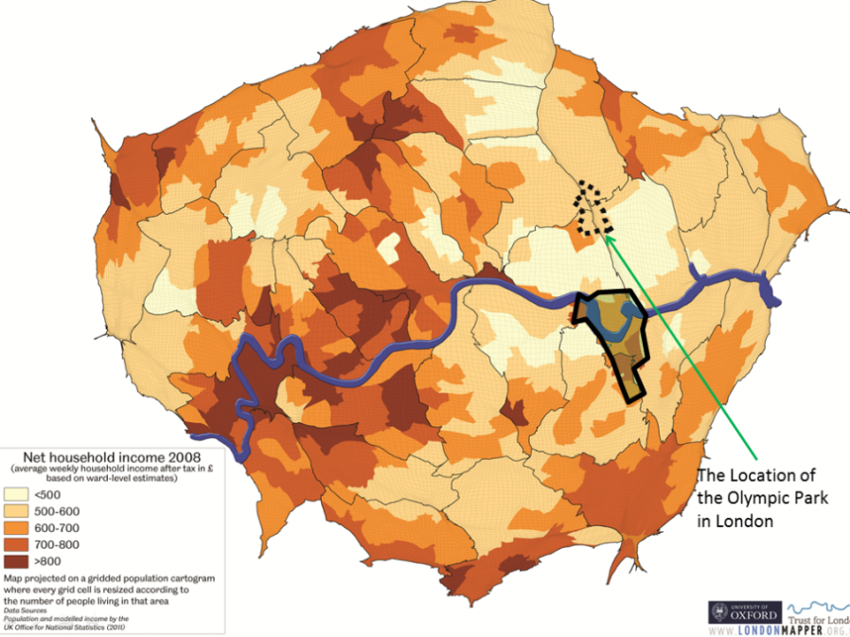
 | Pros | Cons
Socially | The athletes’ village has been relaunched as a housing estate called the East Village, the rooms have had kitchens added and walls knocked through. Almost half of these 2,818 new homes (40%) will be affordable. Eventually the whole Olympic Parkland will become five new neighbourhoods housing 8,000 people.  The Olympics has helped schools in the area – there was a shortage of spaces but a new school opened in the grounds of the park. Chobham Academy will cover all levels of education.  The aquatics centre now uses its 50m pools as facilities for the community and schools, as well as elite athletes.  Unemployment OVERALL fell across London during the Olympic period | Anne Power at the London School of Economics said “The ‘affordable rents’ for the 2,800 new homes will be unaffordable to Newham’s poorest households.”  Rushanara Ali, MP in the Olympic borough of Tower Hamlets, said: “The impact of the infrastructure investment has been really fantastic... But – and there’s a big but – in my borough unemployment actually went up during the Olympics.”  During the construction of the Olympics, very few jobs were created for local people. There are still high levels of unemployment in the borough and it was a missed opportunity to train people up for work. Tower Hamlets got very little out of the Olympics. (Rushanara Ali, MP)  Many people in the boroughs surrounding the Olympic Park remain in poverty  Properties for poorer people had to be demolished to make way for the site, 450 Housing Association flats were torn down for example.
Economic | Stratford got a Tube station to help connect the area to the rest of London - Stratford is now second only to King’s Cross as the most connected part of London.  The infrastructure has been improved. As well as two Underground lines, a high-speed “javelin” train to King’s Cross and the Docklands Light Railway, it may soon be a stop-off for the Eurostar to Paris.  The Olympics brought more than £9bn of investment to east London, much of which went into transport. Lloyds TSB estimated that the Olympics will generate £10 billion in extra income for the UK economy  ALL of the Olympic venues have been sold. The final building to be sold off was the £300m media centre, which will now primarily house Infinity – a data company who want to store information for large corporations. | The Olympic stadium is estimated to have cost £701 million pounds, almost 3 times the original estimate (source). This angered many local people.  The total bill for the Olympics was £8.77 billion of tax payer’s money. That was £5billion over budget.  Existing businesses had to move, including H. Forman and Sons, a salmon-smoking factory with 50 employees  Rents and property prices have gone up as a result of the Games
Environmentally | Many of the grounds in the Olympic Park have been kept as parkland and are open to the public for use as a picnicking and play area. New green spaces and wildlife habitats were created, including ponds, woodlands, and artificial otter holes.  The stadiums were made of at least 25% recycled materials  The River Lea that runs through the Olympic Park was improved as has the quality of its water. Green areas were placed along the banks of the river.  The urban wasteland of the Lower Lea Valley was cleaned up, with soil being cleaned on site.  The Olympic Site was built largely on 560 acres of brownfield land, property that had been neglected, unused, and contaminated.  Researchers helped choose sustainable & biodiverse vegetation suited to an urban environment, including 4,000 trees, 74,000 plants and 60,000 bulbs and 300,000 wetland plants | Much wildlife had to be relocated; 4,000 smooth newts, 100 toads and 300 common lizards as well as fish including pikes and eels were moved by the Olympic Delivery Authority.  Many of the materials for the stadiums and the Olympic Park came from overseas  The games produced 3.3 million tons of CO2

Question 6: Using the information provided about the Olympic scheme, assess the success of the Regeneration. (12 mark question)

Question 7: Watch the following youtube and list the stakeholders and how they are impacted by the Olympic regeneration
https://www.youtube.com/watch?v=l2P05qHxrT0

Specification

