Art and Design
Year 11 >12 Handbook

Name: __________________

Contents
- Course Expectations and Learner Agreement

- Summer Task: Transformation

- Course Breakdown

- Assessment Objectives

- Useful links

Course Expectations
The Art and Design AS and A Level are demanding courses designed to challenge your skills, ideas and creativity. In order for you to excel in the course and achieve yours and our expectations and targets you need to acknowledge and agree to the following;
- Attendance = attainment. Attend all lessons, arrive on time and bring all the necessary equipment and resources. Do not book appointments during lesson hours.
- Necessary equipment of sketchbook, printed photographs, pencils, library books as required
- Take responsibility for arriving on time to lessons after break or after a free period.
- No mobile phones in use or in view in the lesson.
- Work to the best of your ability in class and focus on the lesson
- Listen respectfully to the views of other students and consider how your own views are developing
- Complete all homework on time – this includes printing out resources
- Keep up to date with developments, exhibitions and articles about contemporary and historical art (see Useful Links section of this guide)
- Complete all necessary research as directed
- Set up a social network group with others in your class – to encourage and support each other
- Attempt all work. If you are unsure of what to do, of course you may ask questions, but there are times when your teacher will want you to work independently without question. You must respect this.
- Take advantage of any extra lessons to work in the VI Form Art are
- Keep to deadlines
Learner Agreement
As a dedicated student of Art and Design at Uxbridge High School, I promise to meet the expectations above. I understand that not doing so, will result in school sanctions, parent meetings, and most importantly, it will have a negative impact on my attainment.
Signed ______________________________________________
Print name ______________________________________________
Year 11 > 12 Summer Project: Transformation
Over the summer period, you will be expected to develop a project based on the theme Transformation. This was the exam paper for Year 12 this year which gives you an idea of the resources you will receive on the course.
The paper sets out for you various starting points but of course there are many more. It is worth looking at Pinterest for ideas that students have already explored.
You will be expected to present your project to the rest of your class in your first week of teaching. Your project can be presented as you wish; in a sketchbook, on display boards, or digitally (but practical work must be shown separately).
Below are the components of your project:
- Sub-theme of Transformation including an explanation of why you have chosen it
- Primary resources that explore your sub theme – including photographs
- Secondary sources as back up to your primary sources
- Evidence on at least one gallery visit relating to your sub-theme
- At least 10 recordings in any material working from primary or secondary resources (at least half must be from life) All studies must be at least A4
- Research and interpretations into the work of an artist of your choice
- Development of an outcome relating to your ideas and linked with your chosen artist
- Production of your outcome – this can be in the material of your choice

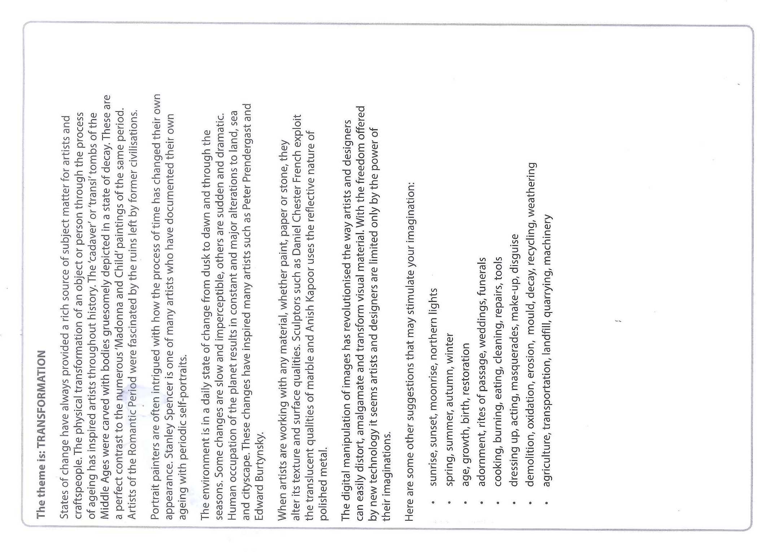

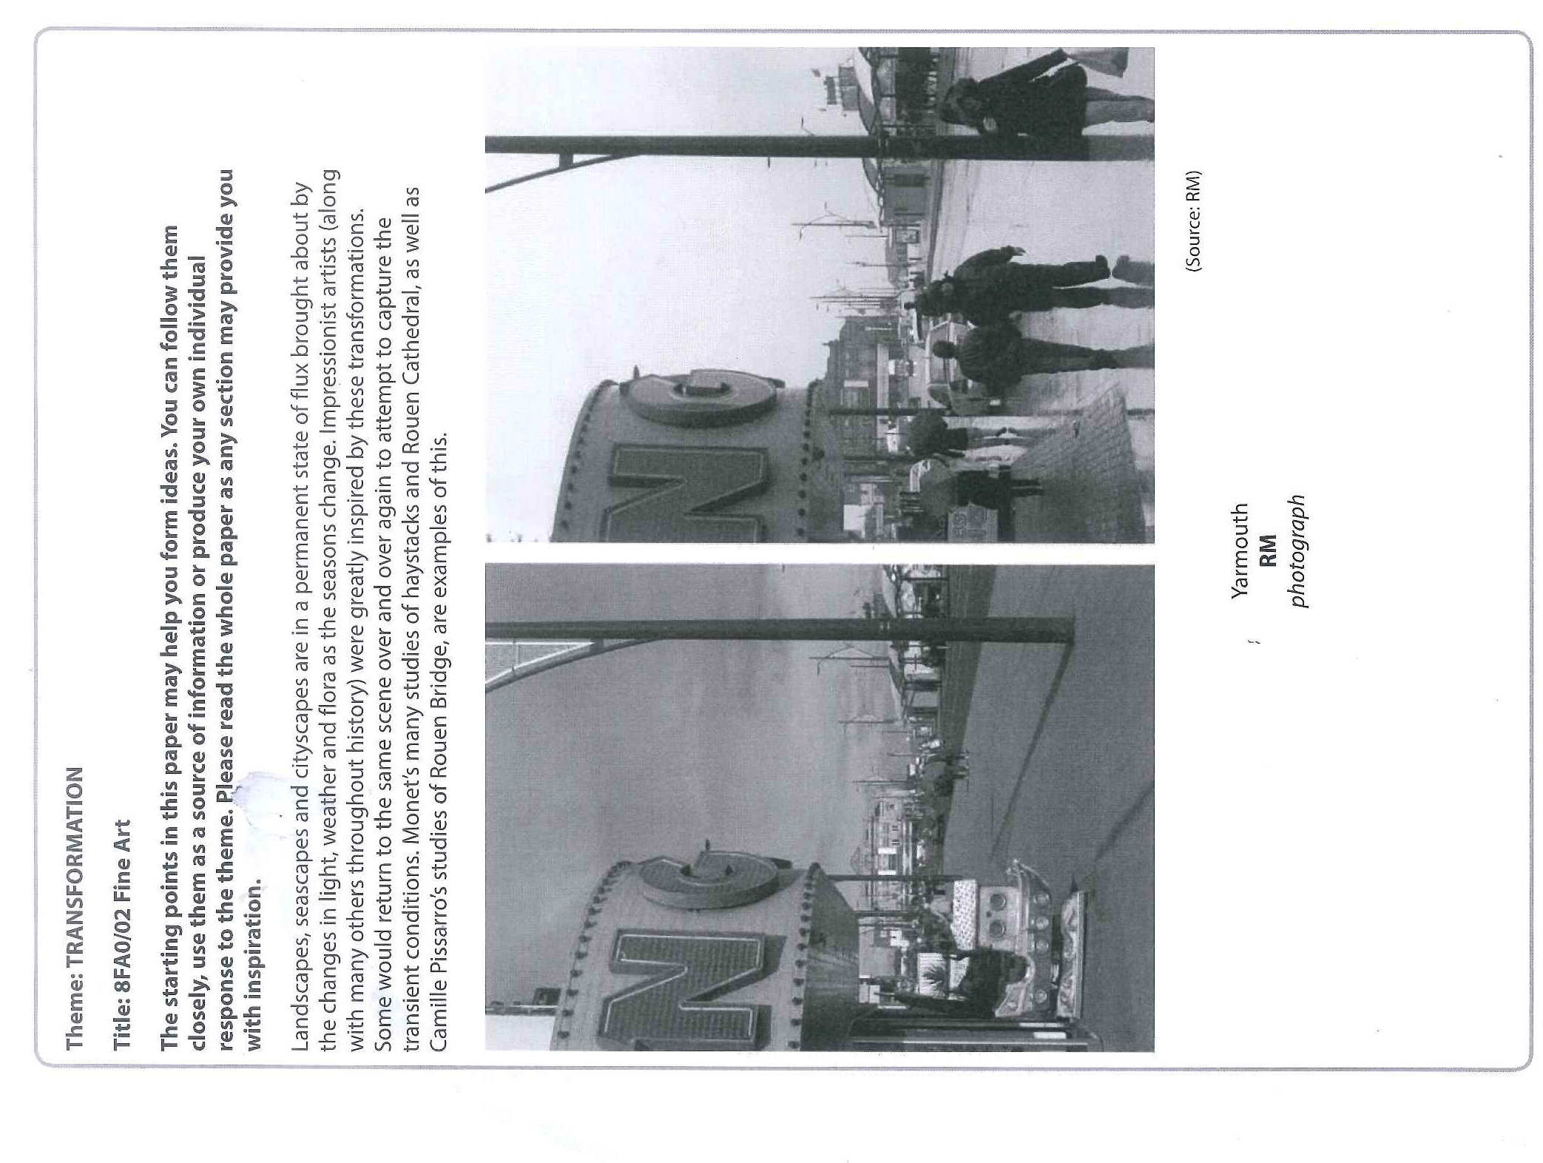

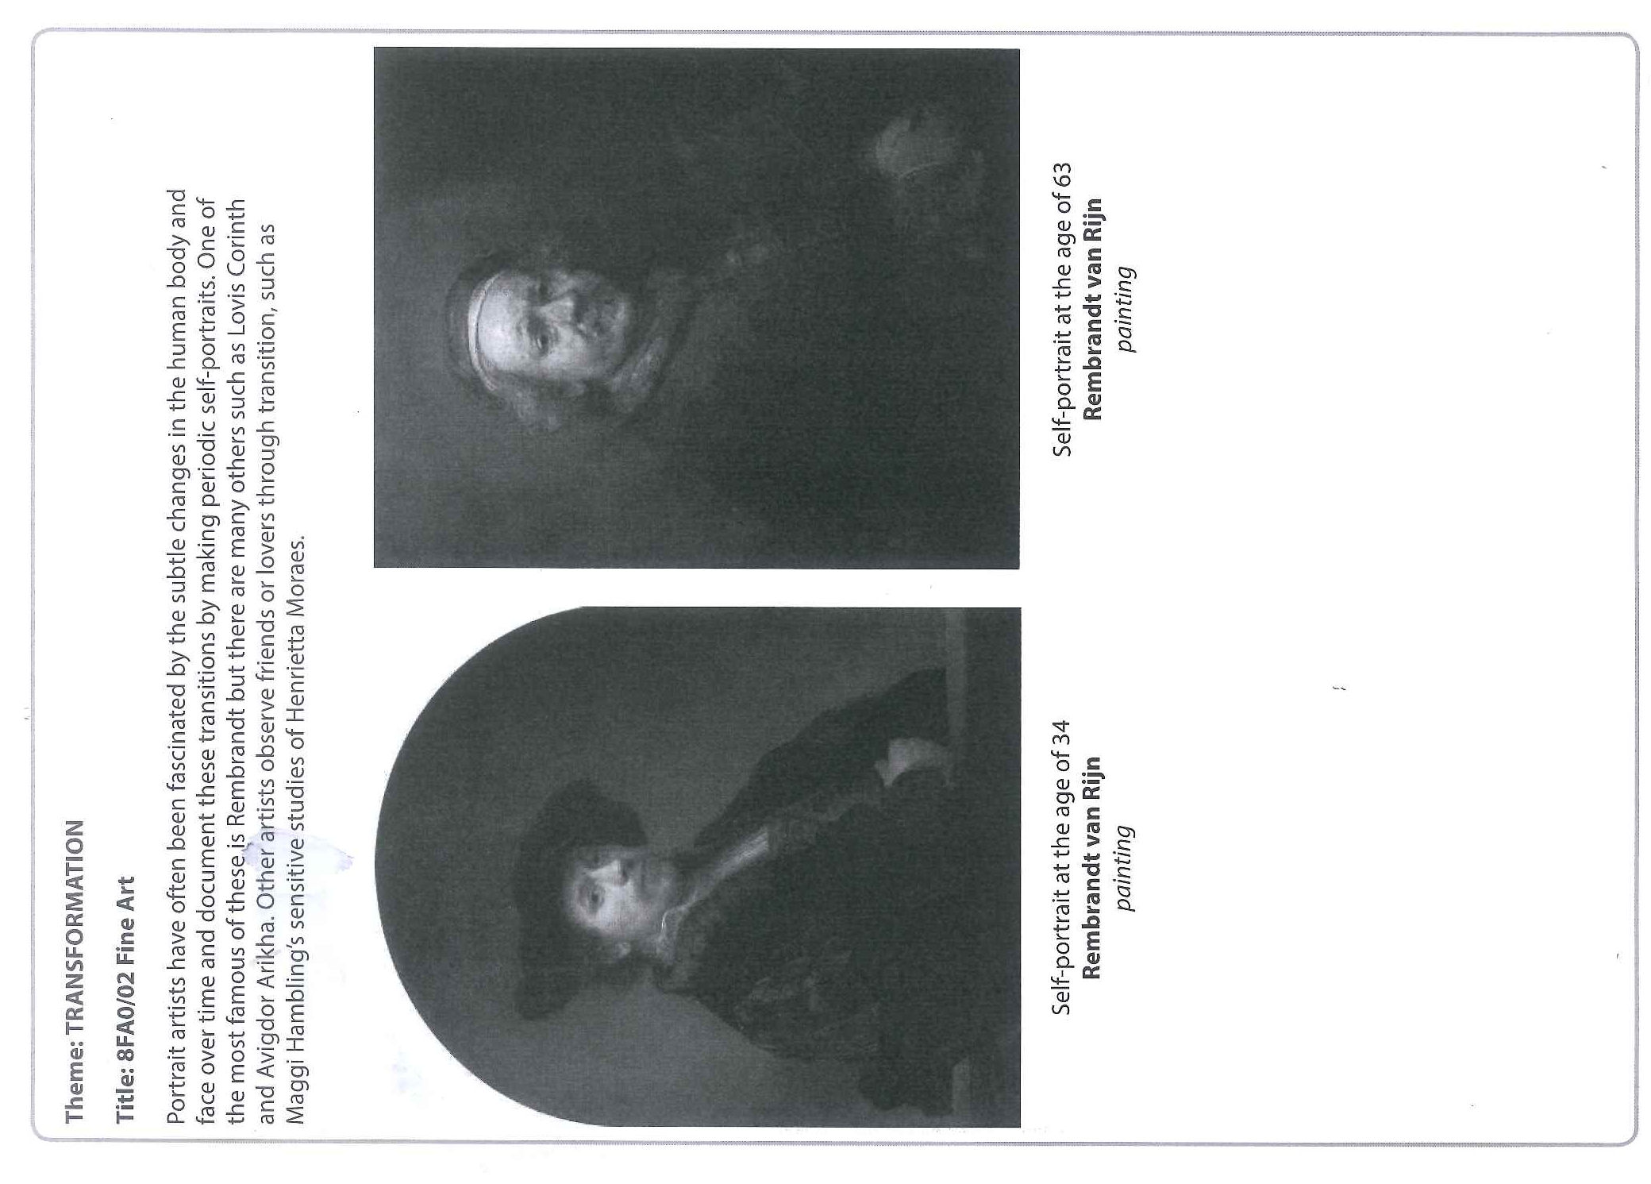

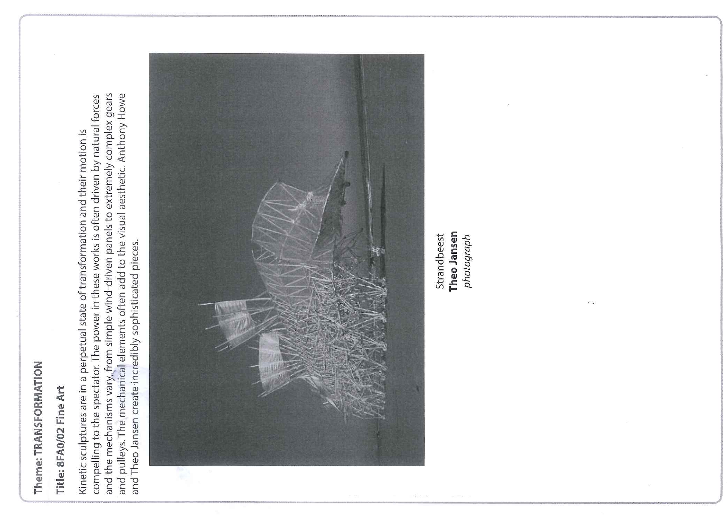

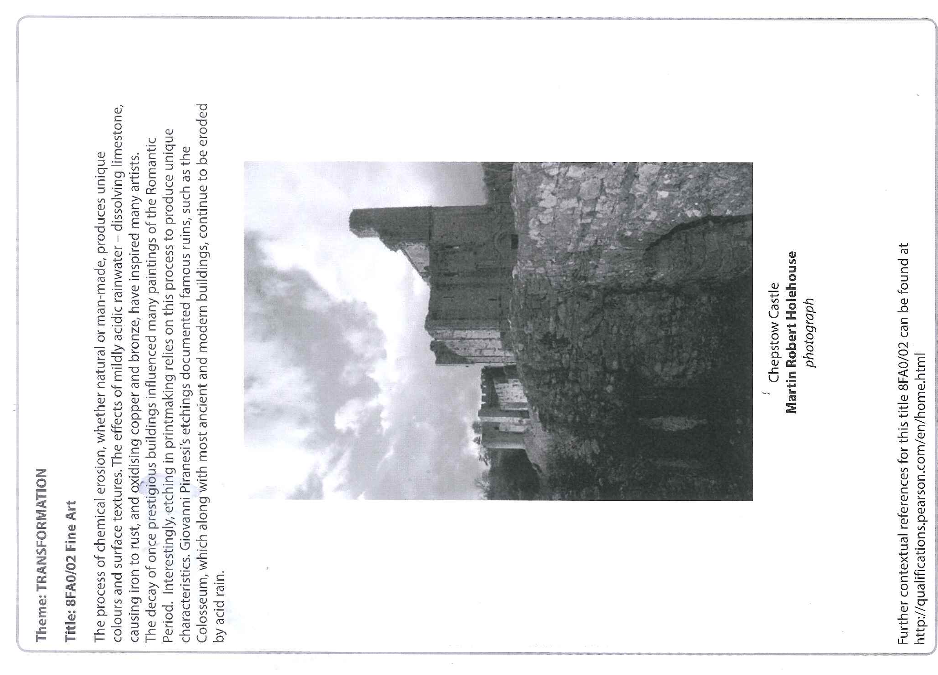

Course Breakdown
Within AS Level there are two units.
Unit 1: Personal Investigation (50% of AS Level mark)
This Unit will continue to explore differing aspects of Transformation. It will extend on your summer project as well as develop a wide variety of other leads. Your work will be based around a sketchbook and portfolio. Fine Art includes painting (acrylic, watercolour, inks, oils), drawing (in any media), printing, sculpture and photography. Artist investigation provides a secure understanding of how artist’s work, configuer their ideas and develop their responses to a theme. You will grow in confidence as the Unit progresses and, when ready, will be given greater independence to develop your own style of work.
Unit 2: Externally Set Assignment (50% of AS Level mark)
This Unit is set by Edexcel and will be given to you in the form of an exam paper similar to GCSE. The theme is broad and the paper will suggest various starting points, to which you can add your own. Your work will be presented in a sketchbook and portfolio. This Unit culminates in a 10 hour exam.
All work is marked by your teachers and is moderated by an Edexcel examiner.
How does the AS Level link with the A Level?
The AS Level and A Level are two separate qualifications. There are three options and you will be guided as to which option is best for you based on your progress. Unit 1 has the same content for both AS and A Level but is extended for A Level.
Option 1: AS Level after 1 year (Unit 1 50% + Unit 2 50%)
Option 2: AS Level after 2 years (Unit 1 50% + Unit 2 50%)
Option 3: A Level after 2 years (Unit 1 60% + Unit 2 40%)
There is no need to take the AS Level qualification in order to progress onto the A Level qualification.

Assessment Objectives
The Assessment Objectives (AO) for AS Level and A Level are the same. Each AO is worth 25% and can be awarded up to 18 marks.
AO1 | AO2 | AO3 | AO4
Develop ideas through sustained and focused investigations informed by contextual and other sources, demonstrating analytical and critical understanding | Explore and select appropriate resources, media, materials, techniques and processes, reviewing and refining ideas as work develops | Record ideas, observations and insights relevant to intentions, reflecting critically on work and progress | Present a personal and meaningful response that realises intentions and, where appropriate, makes connections between visual and other elements
What do these actually mean?
Different ideas are developed from different starting points or sub-themes. Investigations are thorough and explore many options within the ideas. Artist studies and gallery visits are in depth and improve your knowledge and understanding. Your language is critical and your analysis of artist’s work is detailed and includes your own and others’ opinions. | All materials should be explored over many different studies. You do not have to use a wide range of materials but you have to show how your skills are developing with each material. Techniques should be analysed – for example ways of working with oil paint. Your sketchbook and portfolio will show how you have refined your skills to make improvements to your ideas. | Through drawing, painting, sculpture, printing and photography you will observe and record the world around you from primary sources. In addition, you will do the same with secondary resources where it is appropriate. Standards should be consistent and development of skills should be evident as time progresses. You will show in your sketchbook how you are refining your skills. | Outcomes are personal to you, clearly developed through your sketchbook and portfolio and clearly realise your intentions. They may make connections with artist studies you have completed but must not be artist interpretations. These are your own final pieces and should be the pinnacle of your success.

There are 6 marking bands – each with 3 marks. A performance calculator is used to place your work in a particular mark band for each AO.
Level 1 | Level 2 | Level 3 | Level 4 | Level 5 | Level 6
Limited ability | Basic ability | Emerging competent ability | Competent and consistent ability | Confident and assured ability | Exceptional ability
partial, inconsistent, literal, elementary, minimal, rushed, sporadic, naïve, lacks skills, little creative intent, disjointed, pedestrian, credible, worthy | straightforward, deliberate, just adequate, methodical, superficial, unrefined, lacks understanding and focus, crude visual language, simplistic reflection, weak connections, plays safe, unresolved | predictable, broadening, makes progress, relevant, description not explanation, demonstrates intentions, appropriate, sufficient, control, emerging individuality, thorough, developing skills, adequate, lacks perception, signs of understanding | diverse, effective, purposeful, consistent, skilful, coherent, imaginative, informed, some perception, satisfies creative intent, engaged | independent, realised, sensitive, creative, sustained, highly inventive, critical, perceptive, comprehensive, in-depth, insightful, original, genuine creative journey, refined, highly skilled, in-depth reflection, pertinent connections, exciting | inspired, surprising, unique, authoritative, genuine discovery, adventurous, accepting of the unexpected, challenging, synthesis of ideas, fully informed, questioning, sophisticated, dexterous, fluent skills, erudite, intuitive, daring
1-3 marks | 4-6 marks | 7-9 marks | 10-12 marks | 13-15 marks | 16-18 marks

Useful links
https://www.youtube.com/watch?v=rKkmIl_ydxE – GCE A2 exemplar sketchbook – A*
https://www.youtube.com/watch?v=WJ5kojvyv8s – GCE AS exemplar sketchbook – A
https://www.youtube.com/watch?v=wFYPYJKCk1w – GCE AS exemplar sketchbook – A
http://www.studentartguide.com/ - exemplar sketchbooks
https://www.youtube.com/user/webArtAcademy - Web Art Academy – multiple tutorials
https://www.youtube.com/user/tate - Tate Gallery - multiple videos about art / artists
https://www.youtube.com/user/MoMAvideos - Museum of Modern Art, New York
https://www.youtube.com/user/nationalgalleryuk - National Gallery, London
http://www.saatchigallery.com/ - Saatchi Gallery – contemporary art gallery, London
http://www.tate.org.uk/ - Tate Galleries – London, Liverpool, St Ives
https://www.royalacademy.org.uk/ - Royal Academy of Art – London
http://whitecube.com/ - White Cube galleries – London / Hong Kong
http://www.camdenartscentre.org/ - Camden Arts Centre – exhibitions / workshops
http://www.whitechapelgallery.org/ - Whitechapel Gallery – exhibitions / workshops
http://www.npg.org.uk/ - National Portrait Gallery – London
http://www.nationalgallery.org.uk/ - National Gallery – London
http://thephotographersgallery.org.uk/ - Photographers Gallery - London

