

DEPARTMENT OF MATHEMATICS

Bridging the gap to A Level Maths

INDUCTION BOOKLET

SUMMER 2017

INTRODUCTION

The Mathematics Department is fully committed to ensuring that you make good progress throughout your A Level course. Some students find the transition from GCSE to A Level really tough so in order for you to make the best possible start to the course, we have prepared this booklet.

All students will be expected to complete this ‘Bridging the gap to A-Level’ booklet over the summer holidays. The aim of this booklet is help you understand grades 7-9 GCSE work, which is the foundation of the maths you will be studying at A-Level. It is vital that you start your A-Level course with a thorough grasp of the topics in this booklet. For each topic, there are explanations and worked examples. There are also questions for you to complete with answers in the back to allow you to check and correct your work.

There are also good revision lessons available on the mymaths website (Username: Uxbridge and Password: Equation4)

You will be assessed on these and other topics at the start of term, and you need to gain at least 80% to pass and take A Level Mathematics.

Good luck
The Maths Department

CONTENTS

Chapter 1 Removing brackets page 4
Chapter 2 Linear equations 6
Chapter 3 Simultaneous equations 10
Chapter 4 Factorising 12
Chapter 5 Change the subject of the formula 15
Chapter 6 Solving quadratic equations 18
Chapter 7 Indices 20
Chapter 8 Surds 23
Chapter 9 Straight lines 25

Solutions to the exercises 29

Chapter 1: REMOVING BRACKETS

To remove a single bracket, we multiply every term in the bracket by the number or the expression on the outside:

Examples

1) 3 (x + 2y) = 3x + 6y

2) -2(2x - 3) = (-2)(2x) + (-2)(-3)
= -4x + 6

To expand two brackets, we must multiply everything in the first bracket by everything in the second bracket. We can do this in a variety of ways, including
* the smiley face method
* FOIL (Fronts Outers Inners Lasts)
* using a grid.

Examples:

1) (x + 1)(x + 2) = x(x + 2) + 1(x + 2)

or
(x +1)(x + 2) = x² + 2 + 2x + x = x² + 3x +2

or
 | x | 1  (x +1)(x + 2) = x² + 2x + x + 2 = x² + 3x +2
x | x² | x
2 | 2x | 2

2) (x - 2)(2x + 3) = x(2x + 3) - 2(2x +3) = 2x² + 3x – 4x - 6
= 2x² – x – 6

or
(x - 2)(2x + 3) = 2x² – 6 + 3x – 4x = 2x² – x – 6

or
(2x +3)(x - 2) = 2x² + 3x - 4x - 6 = 2x² - x - 6
 | x | -2
2x | 2x² | -4x
3 | 3x | -6

EXERCISE A Multiply out the following brackets and simplify.

- 7(4x + 5)
- -3(5x - 7)
- 5a – 4(3a - 1)
- 4y + y(2 + 3y)
- -3x – (x + 4)
- 5(2x - 1) – (3x - 4)
- (x + 2)(x + 3)
- (t - 5)(t - 2)
- (2x + 3y)(3x – 4y)
- 4(x - 2)(x + 3)
- (2y - 1)(2y + 1)
- (3 + 5x)(4 – x)

Two Special Cases
Perfect Square: Difference of two squares:
(x + a)² = (x + a)(x + a) = x² + 2ax + a² (x - a)(x + a) = x² – a²
(2x - 3)² = (2x – 3)(2x – 3) = 4x² – 12x + 9 (x - 3)(x + 3) = x² – 3²
= x² – 9

EXERCISE B Multiply out

1. (x - 1)²
2. (3x + 5)²
3. (7x - 2)²
4. (x + 2)(x - 2)
5. (3x + 1)(3x - 1)
6. (5y - 3)(5y + 3)

Chapter 2: LINEAR EQUATIONS

When solving an equation, you must remember that whatever you do to one side must also be done to the other. You are therefore allowed to
- add the same amount to both side
- subtract the same amount from each side
- multiply the whole of each side by the same amount
- divide the whole of each side by the same amount.

If the equation has unknowns on both sides, you should collect all the letters onto the same side of the equation.

If the equation contains brackets, you should start by expanding the brackets.

A linear equation is an equation that contains numbers and terms in x. A linear equation does not contain any 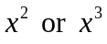 terms.

Example 1: Solve the equation 64 – 3x = 25

Solution: There are various ways to solve this equation. One approach is as follows:

Step 1: Add 3x to both sides (so that the x term is positive): 64 = 3x + 25

Step 2: Subtract 25 from both sides: 39 = 3x

Step 3: Divide both sides by 3: 13 = x

So the solution is x = 13.

Example 2: Solve the equation 6x + 7 = 5 – 2x.

Solution:
Step 1: Begin by adding 2x to both sides 8x + 7 = 5
(to ensure that the x terms are together on the same side)

Step 2: Subtract 7 from each side: 8x = -2

Step 3: Divide each side by 8: x = -¼

Exercise A: Solve the following equations, showing each step in your working:

1) 2x + 5 = 19 2) 5x – 2 = 13 3) 11 – 4x = 5

4) 5 – 7x = -9 5) 11 + 3x = 8 – 2x 6) 7x + 2 = 4x – 5
Example 3: Solve the equation 2(3x – 2) = 20 – 3(x + 2)

Step 1: Multiply out the brackets: 6x – 4 = 20 – 3x – 6
(taking care of the negative signs)

Step 2: Simplify the right hand side: 6x – 4 = 14 – 3x

Step 3: Add 3x to each side: 9x – 4 = 14

Step 4: Add 4: 9x = 18

Step 5: Divide by 9: x = 2

Exercise B: Solve the following equations.

1) 5(2x – 4) = 4 2) 4(2 – x) = 3(x – 9)

3) 8 – (x + 3) = 4 4) 14 – 3(2x + 3) = 2

EQUATIONS CONTAINING FRACTIONS

When an equation contains a fraction, the first step is usually to multiply through by the denominator of the fraction. This ensures that there are no fractions in the equation.

Example 4: Solve the equation 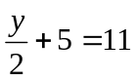

Solution:
Step 1: Multiply through by 2 (the denominator in the fraction): 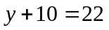

Step 2: Subtract 10: y = 12

Example 5: Solve the equation 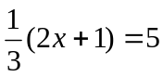

Solution:
Step 1: Multiply by 3 (to remove the fraction) 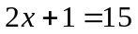

Step 2: Subtract 1 from each side 2x = 14

Step 3: Divide by 2 x = 7

When an equation contains two fractions, you need to multiply by the lowest common denominator. This will then remove both fractions.

Example 6: Solve the equation 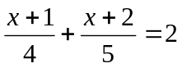

Solution:
Step 1: Find the lowest common denominator: The smallest number that both 4 and 5 divide into is 20.

Step 2: Multiply both sides by the lowest common denominator 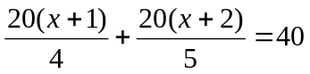

Step 3: Simplify the left hand side: 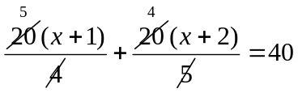
5(x + 1) + 4(x + 2) = 40

Step 4: Multiply out the brackets: 5x + 5 + 4x + 8 = 40

Step 5: Simplify the equation: 9x + 13 = 40

Step 6: Subtract 13 9x = 27

Step 7: Divide by 9: x = 3

Example 7: Solve the equation 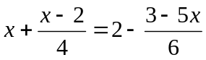
Solution: The lowest number that 4 and 6 go into is 12. So we multiply every term by 12:
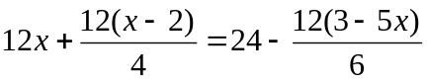
Simplify 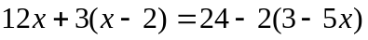
Expand brackets 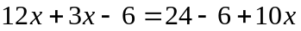
Simplify 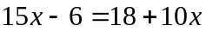
Subtract 10x 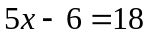
Add 6 5x = 24
Divide by 5 x = 4.8

Exercise C: Solve these equations

1) 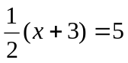 2) 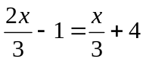

3) 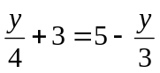 4) 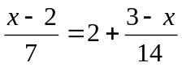
Exercise C (continued)

5) 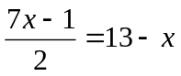 6) 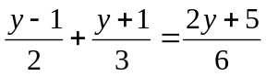

7) 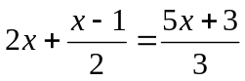 8) 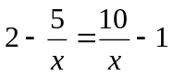

Chapter 3: SIMULTANEOUS EQUATIONS

An example of a pair of simultaneous equations is 3x + 2y = 8 ①
5x + y = 11 ②

In these equations, x and y stand for two numbers. We can solve these equations in order to find the values of x and y by eliminating one of the letters from the equations.

In these equations it is simplest to eliminate y. We do this by making the coefficients of y the same in both equations. This can be achieved by multiplying equation ② by 2, so that both equations contain 2y:
3x + 2y = 8 ①
10x + 2y = 22 2×② = ③

To eliminate the y terms, we subtract equation ③ from equation ①. We get: 7x = 14
i.e. x = 2

To find y, we substitute x = 2 into one of the original equations. For example if we put it into ②:
10 + y = 11
y = 1
Therefore the solution is x = 2, y = 1.

Remember: You can check your solutions by substituting both x and y into the original equations.

Example: Solve 2x + 5y = 16 ①
3x – 4y = 1 ②

Solution: We begin by getting the same number of x or y appearing in both equation. We can get 20y in both equations if we multiply the top equation by 4 and the bottom equation by 5:
8x + 20y = 64 ③
15x – 20y = 5 ④

As the signs in front of 20y are different, we can eliminate the y terms from the equations by ADDING:
23x = 69 ③+④
i.e. x = 3

Substituting this into equation ① gives:
6 + 5y = 16
5y = 10
So… y = 2
The solution is x = 3, y = 2.

Exercise:

Solve the pairs of simultaneous equations in the following questions:

1) x + 2y = 7 2) x + 3y = 0
3x + 2y = 9 3x + 2y = -7

3) 3x – 2y = 4 4) 9x – 2y = 25
2x + 3y = -6 4x – 5y = 7

5) 4a + 3b = 22 6) 3p + 3q = 15
5a – 4b = 43 2p + 5q = 14

Chapter 4: FACTORISING

Common factors

We can factorise some expressions by taking out a common factor.

Example 1: Factorise 12x – 30

Solution: 6 is a common factor to both 12 and 30. We can therefore factorise by taking 6 outside a bracket:
12x – 30 = 6(2x – 5)

Example 2: Factorise 6x² – 2xy

Solution: 2 is a common factor to both 6 and 2. Both terms also contain an x.
So we factorise by taking 2x outside a bracket.
6x² – 2xy = 2x(3x – y)

Example 3: Factorise 9x³y² – 18x²y

Solution: 9 is a common factor to both 9 and 18.
The highest power of x that is present in both expressions is x².
There is also a y present in both parts.
So we factorise by taking 9x²y outside a bracket:
9x³y² – 18x²y = 9x²y(xy – 2)

Example 4: Factorise 3x(2x – 1) – 4(2x – 1)

Solution: There is a common bracket as a factor.
So we factorise by taking (2x – 1) out as a factor.
The expression factorises to (2x – 1)(3x – 4)

Exercise A
Factorise each of the following

1) 3x + xy

2) 4x² – 2xy

3) pq² – p²q

4) 3pq - 9q²

5) 2x³ – 6x²

6) 8a⁵b² – 12a³b⁴

7) 5y(y – 1) + 3(y – 1)
Factorising quadratics

Simple quadratics: Factorising quadratics of the form 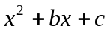
The method is:
Step 1: Form two brackets (x … )(x … )
Step 2: Find two numbers that multiply to give c and add to make b. These two numbers get written at the other end of the brackets.

Example 1: Factorise x² – 9x – 10.

Solution: We need to find two numbers that multiply to make -10 and add to make -9. These numbers are -10 and 1.
Therefore x² – 9x – 10 = (x – 10)(x + 1).

General quadratics: Factorising quadratics of the form 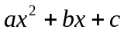
The method is:
Step 1: Find two numbers that multiply together to make ac and add to make b.
Step 2: Split up the bx term using the numbers found in step 1.
Step 3: Factorise the front and back pair of expressions as fully as possible.
Step 4: There should be a common bracket. Take this out as a common factor.

Example 2: Factorise 6x² + x – 12.

Solution: We need to find two numbers that multiply to make 6 × -12 = -72 and add to make 1. These two numbers are -8 and 9.

Therefore, 6x² + x – 12 = 6x² - 8x + 9x – 12

= 2x(3x – 4) + 3(3x – 4) (the two brackets must be identical)

= (3x – 4)(2x + 3)

Difference of two squares: Factorising quadratics of the form 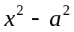

Remember that = (x + a)(x – a).

Therefore: 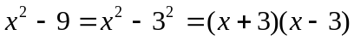

Also notice that: 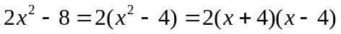
and

Factorising by pairing
We can factorise expressions like 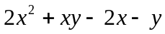 using the method of factorising by pairing:

= x(2x + y) – 1(2x + y) (factorise front and back pairs, ensuring both brackets are identical)
= (2x + y)(x – 1)

Exercise B

Factorise

1) 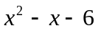

2) 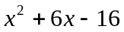

3) 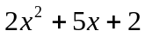

4) 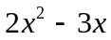 (factorise by taking out a common factor)

5) 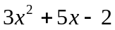

6) 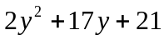

7) 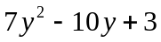

8) 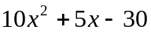

9) 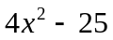

10) 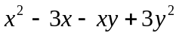

11) 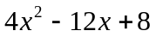

12) 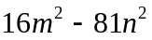

13) 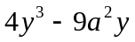

14) 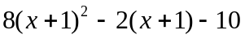

Chapter 5: CHANGING THE SUBJECT OF A FORMULA

We can use algebra to change the subject of a formula. Rearranging a formula is similar to solving an equation – we must do the same to both sides in order to keep the equation balanced.

Example 1: Make x the subject of the formula y = 4x + 3.

Solution: y = 4x + 3
Subtract 3 from both sides: y – 3 = 4x
Divide both sides by 4; 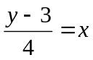
So 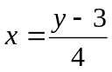 is the same equation but with x the subject.

Example 2: Make x the subject of y = 2 – 5x

Solution: Notice that in this formula the x term is negative.
y = 2 – 5x
Add 5x to both sides y + 5x = 2 (the x term is now positive)
Subtract y from both sides 5x = 2 – y
Divide both sides by 5 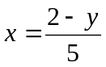

Example 3: The formula 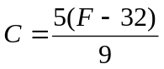 is used to convert between ° Fahrenheit and ° Celsius.
We can rearrange to make F the subject.
Multiply by 9 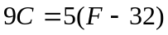 (this removes the fraction)
Expand the brackets 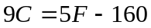
Add 160 to both sides 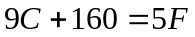
Divide both sides by 5 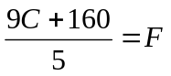
Therefore the required rearrangement is 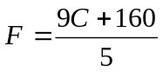.

Exercise A

Make x the subject of each of these formulae:

1) y = 7x – 1 2) 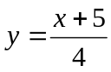

3) 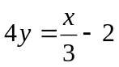 4) 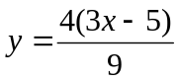
Rearranging equations involving squares and square roots

Example 4: Make x the subject of 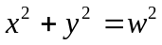

Solution:
Subtract 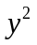 from both sides: 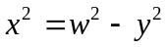 (this isolates the term involving x)
Square root both sides: 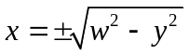

Remember that you can have a positive or a negative square root. We cannot simplify the answer any more.

Example 5: Make a the subject of the formula 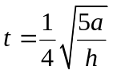

Solution:
Multiply by 4 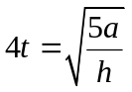
Square both sides 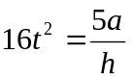
Multiply by h: 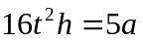
Divide by 5: 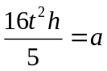

Exercise B:

Make t the subject of each of the following

1) 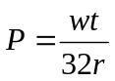 2) 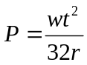

3) 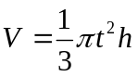 4) 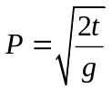

5) 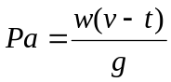 6) 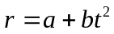
More difficult examples

Sometimes the variable that we wish to make the subject occurs in more than one place in the formula. In these questions, we collect the terms involving this variable on one side of the equation, and we put the other terms on the opposite side.

Example 6: Make t the subject of the formula 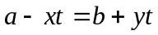

Solution:
Start by collecting all the t terms on the right hand side:
Add xt to both sides: 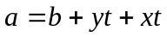
Now put the terms without a t on the left hand side:
Subtract b from both sides: 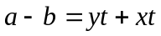
Factorise the RHS: 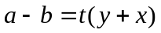
Divide by (y + x): 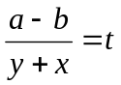
So the required equation is 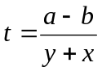

Example 7: Make W the subject of the formula 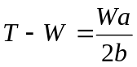

Solution: This formula is complicated by the fractional term. We begin by removing the fraction:
Multiply by 2b: 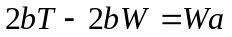
Add 2bW to both sides: 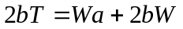 (this collects the W’s together)
Factorise the RHS: 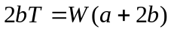
Divide both sides by a + 2b: 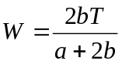

Exercise C

Make x the subject of these formulae:

1) 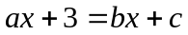 2) 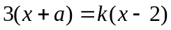

3) 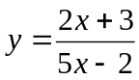 4) 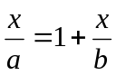

Chapter 6: SOLVING QUADRATIC EQUATIONS

A quadratic equation has the form 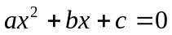.

There are two methods that are commonly used for solving quadratic equations:
* factorising
* the quadratic formula

Note that not all quadratic equations can be solved by factorising. The quadratic formula can always be used however.

Method 1: Factorising

Make sure that the equation is rearranged so that the right hand side is 0. It usually makes it easier if the coefficient of x² is positive.

Example 1 : Solve x² –3x + 2 = 0

Factorise (x –1)(x – 2) = 0
Either (x – 1) = 0 or (x – 2) = 0
So the solutions are x = 1 or x = 2

Note: The individual values x = 1 and x = 2 are called the roots of the equation.

Example 2: Solve x² – 2x = 0

Factorise: x(x – 2) = 0
Either x = 0 or (x – 2) = 0
So x = 0 or x = 2

Method 2: Using the formula

Recall that the roots of the quadratic equation are given by the formula:
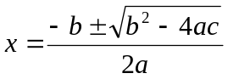

Example 3: Solve the equation 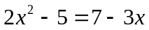

Solution: First we rearrange so that the right hand side is 0. We get 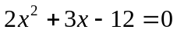
We can then tell that a = 2, b = 3 and c = -12.
Substituting these into the quadratic formula gives:
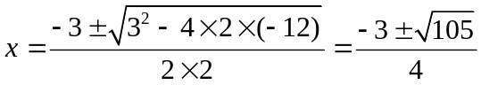 (this is the surd form for the solutions)
If we have a calculator, we can evaluate these roots to get: x = 1.81 or x = -3.31

EXERCISE

1) Use factorisation to solve the following equations:
a) x² + 3x + 2 = 0 b) x² – 3x – 4 = 0

c) x² = 15 – 2x

2) Find the roots of the following equations:
a) x² + 3x = 0 b) x² – 4x = 0

c) 4 – x² = 0

3) Solve the following equations either by factorising or by using the formula:

a) 6x² - 5x – 4 = 0 b) 8x² – 24x + 10 = 0

4) Use the formula to solve the following equations to 3 significant figures. Some of the equations can’t be solved.

a) x² +7x +9 = 0 b) 6 + 3x = 8x²

c) 4x² – x – 7 = 0 d) x² – 3x + 18 = 0

e) 3x² + 4x + 4 = 0 f) 3x² = 13x – 16
Chapter 7: INDICES
Basic rules of indices

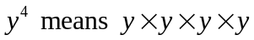. 4 is called the index (plural: indices), power or exponent of y.

There are 3 basic rules of indices:

1) 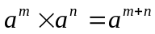 e.g. 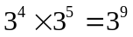
2) 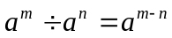 e.g. 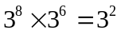
3) 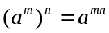 e.g. 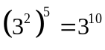

Further examples

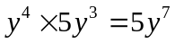
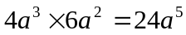 (multiply the numbers and multiply the a’s)
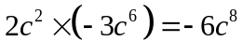 (multiply the numbers and multiply the c’s)
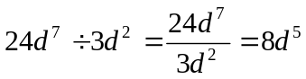 (divide the numbers and divide the d terms i.e. by subtracting the powers)

Exercise A
Simplify the following:

1) 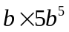 = (Remember that 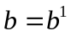)

2) 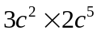 =

3) 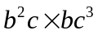 =

4) 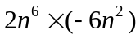=

5) 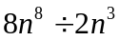 =

6) 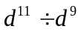 =

7) 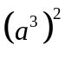 =
8) 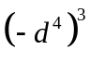 =

More complex powers

Zero index:
Recall from GCSE that
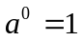.
This result is true for any non-zero number a.

Therefore 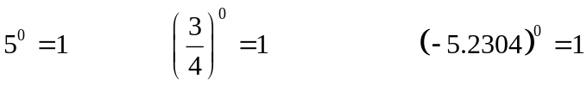

Negative powers
A power of -1 corresponds to the reciprocal of a number, i.e. 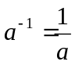
Therefore 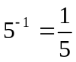
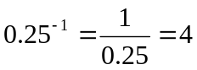
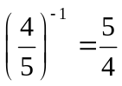 (you find the reciprocal of a fraction by swapping the top and bottom over)

This result can be extended to more general negative powers: 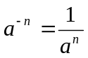.
This means:
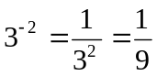
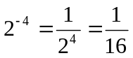
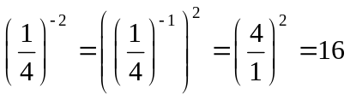

Fractional powers:
Fractional powers correspond to roots:
In general:
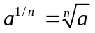
Therefore:
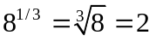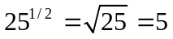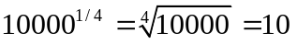

A more general fractional power can be dealt with in the following way: 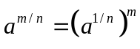
So 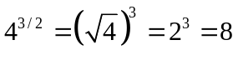
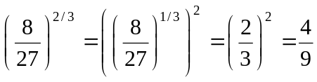
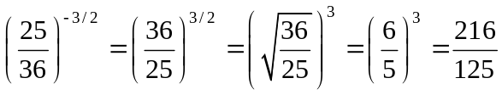

Exercise B:

Find the value of:

1) 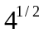

2) 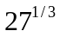

3) 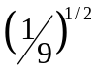

4) 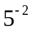

5) 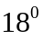

6) 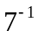

7) 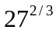

8) 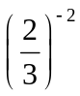

9) 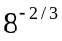

10) 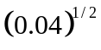

11) 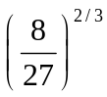

12) 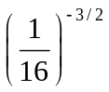

Simplify each of the following:

13) 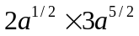

14) 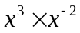

15) 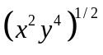

Chapter 8: SURDS
Surds are square roots of numbers which don’t simplify into a whole (or rational) number: e.g. 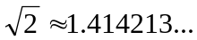 but it is more accurate to leave it as a surd: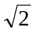
General rules
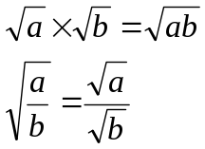
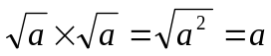

But you cannot do:
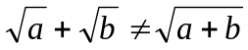
These are NOT equal
Simplifying Surds

Find the largest square numbers and simplify as far as possible

Worked Examples
Careful - this is “3 times the square root of 2” NOT “the cube root of 2”
Rationalising the Denominator
This is a fancy way of saying getting rid of the surd on the bottom of a fraction. We multiply the fraction by the denominator (or the denominator with the sign swapped)

Worked Examples
1. 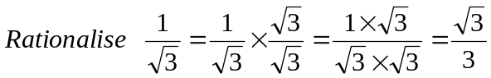 we multiply by 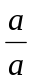 which is the same as multiplying by 1, which means we don’t fundamentally change the fraction.
2. 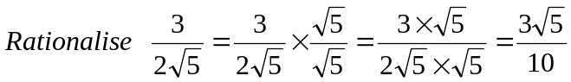
3.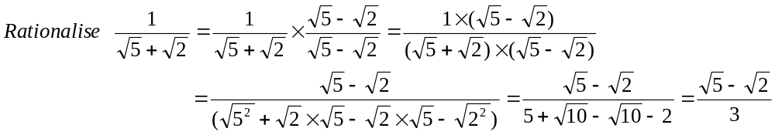
4. 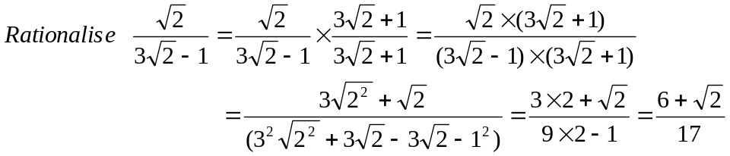
Exercise A:
Simplify the surds

- 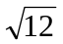
- 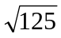
- 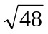
- 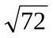
- 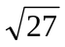

Exercise B:
Expand and simplify
- 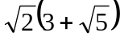
- 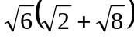
- 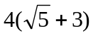
- 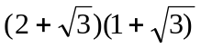
- 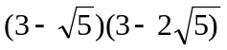
- 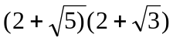
- 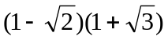
- 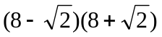
- 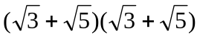

Exercise C:
Rewrite the following expressions with rational denominators
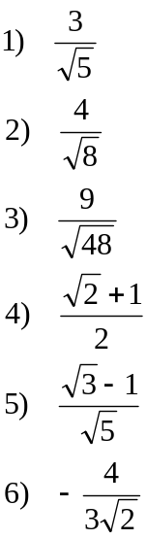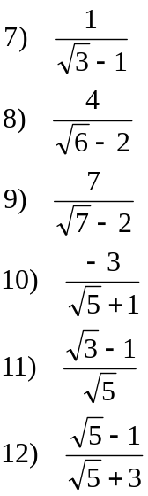

Chapter 9: Straight line graphs

Linear functions can be written in the form y = mx + c, where m and c are constants.
A linear function is represented graphically by a straight line, m is the gradients and c is the y-intercept of the graph.

Example 1: Draw the graph of y = 2x + 1

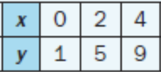
Solution:
Step 1: Make a table of values
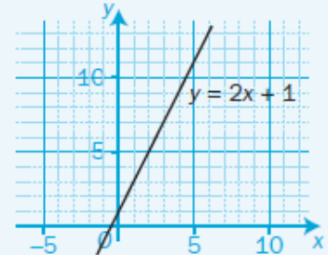

Step 2: Use your table to draw the straight line graph

Example 2: Plot the straight line using the gradient and y intercept

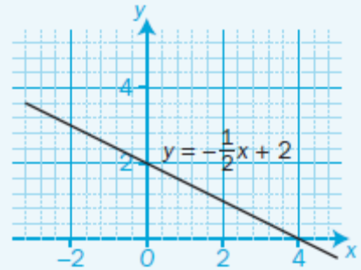
Solution:

Step 1: Mark on the y axis the y-intercept = 2

Step 2: The gradient= 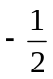 so start from the y– intercept
for every 1unit across to the right go down by half a unit
and mark a second point there.

Step 3: Join the y intercept with the new point with a line and extend form both sides.

.
Here are some examples of linear functions not all of them in the form y = mx + c. You need to be confident into rearranging the functions making y the subject in order to identify the gradient and y- intercept.
y = 2x + 3 3x - 2y + 1 = 0 4y - x = 3
so 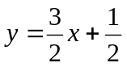 so 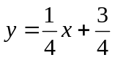
gradient= 2 gradient=  gradient=
y-intercept= 3 y-intercept=  y-intercept= 

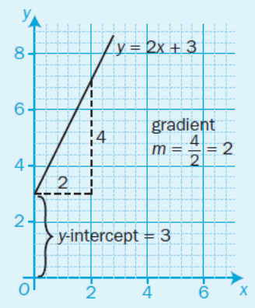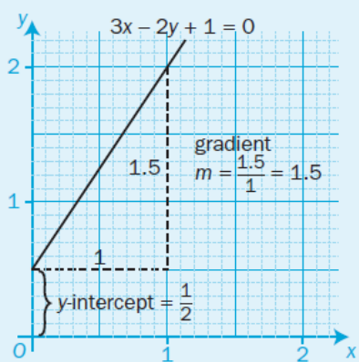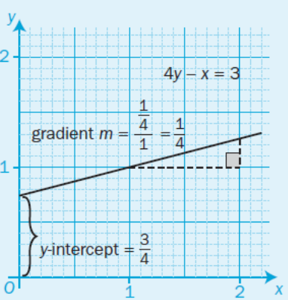

To find the y-axis crossing, substitute x = 0 into the linear equation and solve for y.
To find the x-axis crossing, substitute y = 0 into the linear equation and solve for x.

Example 3: Rewrite the equation 3y - 2x = 5 into the form y = mx + c, find the gradient and the y-intercept
Solution:

Step 1: Add 2x to both sides (so that the x term is positive): 3y = 5 + 2x

Step 2: Divide by 3 both sides: 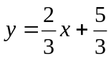

Step 3: Identify the gradient and y-intercept gradient=  y-intercept=

Example 4: Find the gradient of the line which passes through the points A (1, 4) and B (-3, 2)

Solution:

Step 1: Use the x and y values of A 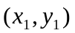and B 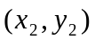 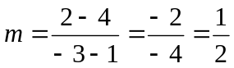
Step 2: find the gradient 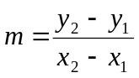

Finally you need to be able to find the equation of a line from a graph.

Example 5: Find the equation of the straight line which passes through the point (1, 3) and has gradient 2
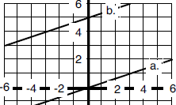
Solution:
Step 1: Find where the line crosses the y axis.
This is the y intercept, c.
Line crosses y axis at 5,
so y-intercept c=5

Step 2: Draw a triangle below the line from the intercept to a point you know
And work out the gradient between the two points 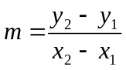
Gradient triangle from (-6,3) to (0,5) so 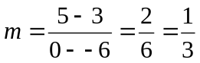

Step 3: Write in the form y = mx + c 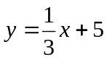

Exercise A: Plot the graph of each function taking the given values
- y= x - 3 ( x = -2 to 4)

- y=- x + 4 ( x = -2 to 5)

- y = 2x – 3 ( x = -1 to 5)

- y= -3x + 5 ( x = -2 to 3)

Exercise B:
Rewrite the equations below into the form y = mx + c, find the gradient and the y-intercept

a)3x – 2y – 2 = 0 b) x + 2y – 8 =0 c) 5 = 4x – 2y

Then plot the graph of each equation

Exercise C:
Work out the gradient between the sets of coordinates

- A ( 0, 2) and B( 3, 6)
- A ( 1, 0) and B( 3, -2)
- A ( 1, -3) and B( 2, -4)
- A ( -4, 2) and B( 3, 5)
- A ( 1, 0.5) and B( 5, -2)
- A ( -7, -3) and B( -2, -6)

Exercise D:
Find the equation of these lines in the form

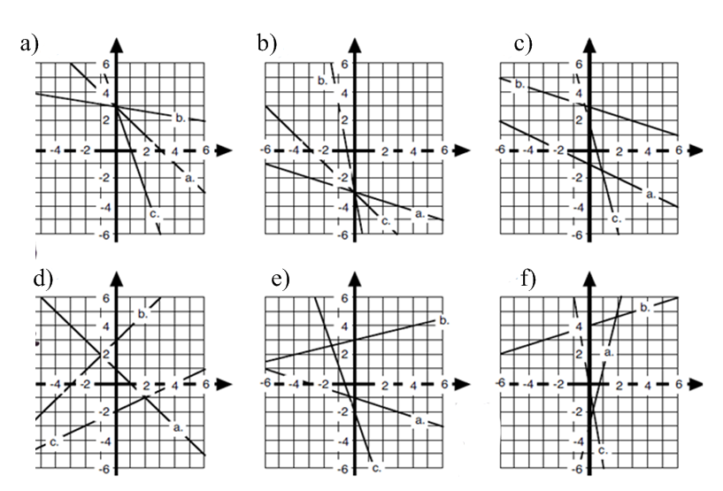

SOLUTIONS TO THE EXERCISES

CHAPTER 1:
Ex A
1) 28x + 35 2) -15x + 21 3) -7a + 4 4) 6y + 3y² 5) 2x – 4
6) 7x – 1 7) x² + 5x + 6 8) t² – 3t – 10 9) 6x² + xy – 12y²
10) 4x² + 4x – 24 11) 4y² – 1 12) 12 + 17x – 5x²
Ex B
1) x² – 2x + 1 2) 9x² + 30x + 25 3) 49x² – 28x + 4 4) x² – 4
5) 9x² -1 6) 25y² – 9

CHAPTER 2
Ex A
1) 7 2) 3 3) 1½ 4) 2 5) -3/5 6) -7/3
Ex B
1) 2.4 2) 5 3) 1 4) ½
Ex C
1) 7 2) 15 3) 24/7 4) 35/3 5) 3 6) 2 7) 9/5 8) 5
Ex D
1) 34, 36, 38 2) 9.875, 29.625 3) 24, 48

CHAPTER 3
1) x = 1, y = 3 2) x = -3, y = 1 3) x = 0, y = -2 4) x = 3, y = 1
5) a = 7, b = -2 6) p = 11/3, q = 4/3

CHAPTER 4
Ex A
1) x(3 + y) 2) 2x(2x – y) 3) pq(q – p) 4) 3q(p – 3q) 5) 2x²(x - 3) 6) 4a³b²(2a² – 3b²)
7) (y – 1)(5y + 3)
Ex B
1) (x – 3)(x + 2) 2) (x + 8)(x – 2) 3) (2x + 1)(x + 2) 4) x(2x – 3) 5) (3x -1 )(x + 2)
6) (2y + 3)(y + 7) 7) (7y – 3)(y – 1) 8) 5(2x – 3)(x + 2) 9) (2x + 5)(2x – 5) 10) (x – 3)(x – y)
11) 4(x – 2)(x – 1) 12) (4m – 9n)(4m + 9n) 13) y(2y – 3a)(2y + 3a) 14) 2(4x + 5)(x – 4)

CHAPTER 5
Ex A
1) 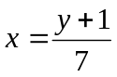 2) 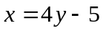 3) 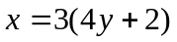 4) 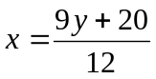
Ex B
1) 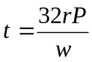 2) 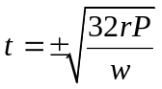 3) 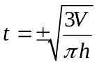 4) 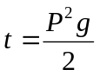 5) 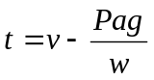 6) 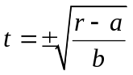
Ex C
1) 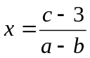 2) 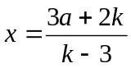 3) 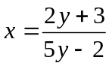 4) 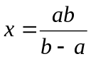

CHAPTER 6
1) a) -1, -2 b) -1, 4 c) -5, 3 2) a) 0, -3 b) 0, 4 c) 2, -2
3) a) -1/2, 4/3 b) 0.5, 2.5 4) a) -5.30, -1.70 b) 1.07, -0.699 c) -1.20, 1.45
d) no solutions e) no solutions f) no solutions

CHAPTER 7
Ex A
1) 5b⁶ 2) 6c⁷ 3) b³c⁴ 4) -12n⁸ 5) 4n⁵ 6) d² 7) a⁶ 8) -d¹²
Ex B
1) 2 2) 3 3) 1/3 4) 1/25 5) 1 6) 1/7 7) 9 8) 9/4 9) ¼ 10) 0.2 11) 4/9 12) 64
13) 6a³ 14) x 15) xy²
CHAPTER 8
ExA
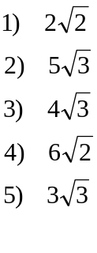
ExB
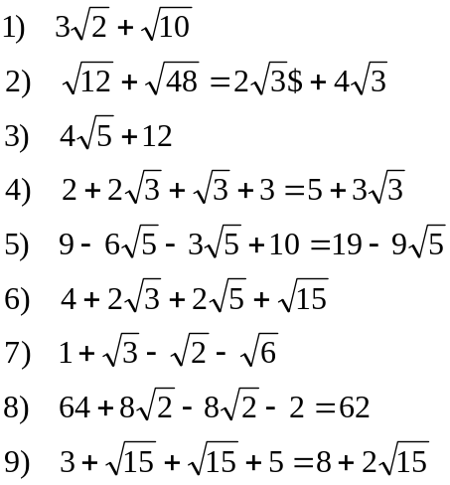

Ex C
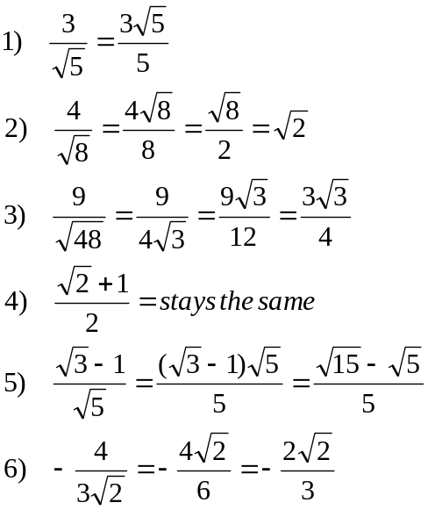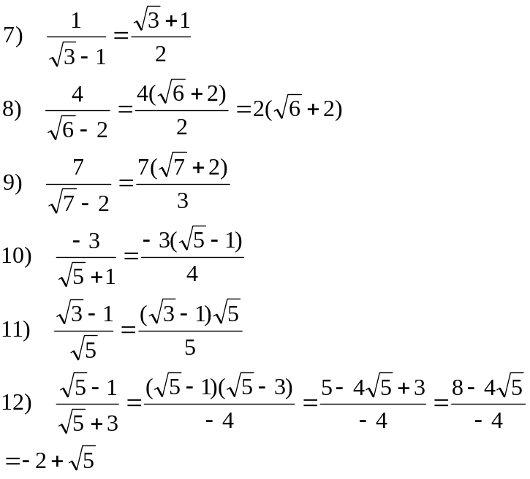

CHAPTER 9
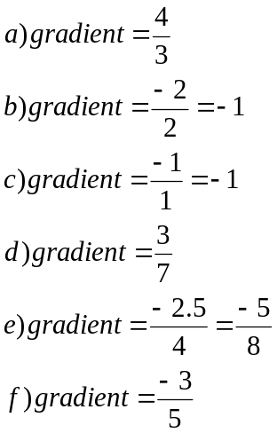ExB : 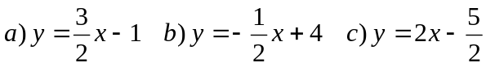

ExC :

Ex D : a) a. y = -x+3 b. y = -0.25x+3 c. y = -3x+3
b) a. y = -x-3 b. y = -6x – 3 c. y = -x – 3
c) a. y = -0.5x -1 b. y = -x + 3 c. y = -4x +2
d) a. y = -x +1 b. y = x + 3 c. y = 0.5x - 2
e) a. y = -x – 1 b. y = 0.25x + 3 c. y = -3x - 2
f) a. y = 4x -2 b. y = x + 4 c. y = -6x

